Activity Book

Table of Contents (refers to table of contents in the pdf version)

About EU Universe Awareness  Introductory Note  About Universe in a Box  Objectives & Goals  Audience  Approach  Handbook  Materials  Keys  Training  Credit  Module 1: Our Fascinating Moon  Introduction  1.1 Fact File on the Moon  1.2 Distance to the Moon  1.3 Lunar day  1.4 Lunar Landscape  1.5 Reflecting Moon  1.6 Lunar Phases Visualised  1.7 Lunar Phases Box Model  1.8 Lunar Phases in Action  1.9 Multicultural Moon  1.10 Moon Storytelling  1.11 Mini Research Project:  Revolution of the Moon and  Lunar Phases  Module 2: The Earth, Our Home  Planet  Introduction  2.1 Spherical Earth  2.2 Up or Down  2.3 Our Home Planet  2.4 Day and Night  2.5 Seasons  2.6 Solar Eclipse  2.7 Lunar Eclipse  Module 3: The Sun, Our Home  Star  Introduction  3.1 Apparent Size  3.2 Invisible Light  3.3 Sun’s Shadow  3.4 Sun’s Path and a Sundial  3.5 Varying day lengths  3.6 Solar Surface  3.7 Mini Research Project: Sun’s  Rotation  Ideas for incorporating the Sun into  other subjects  Module 4: Our Solar System  Introduction  4.1 Know Your Planets  4.2 Solar System Model  4.3 Seeing Planets  4.4 Asteroids  4.5 Planetary Orbits  4.6 Distances and Paths  4.7 Journey to Planets  4.8 Lighter or Heavier  Related Subject Ideas  Module 5: The World of  Constellations  Introduction  5.1 Visibility of the Constellations  5.2 The Zodiac and Planetary  Movements  5.3 Planisphere: A Turnable Star  Map  5.4 Constellation Shapes  5.5 Viewing Constellations  through Stories  Appendix | 3  4  5  5  5  5  6  7  7  8  8  9  10  13  15  17  19  23  25  27  29  31  33  35  39  40  43  45  49  51  55  61  65  67  68  71  75  79  81  87  91  95  99  101  102  105  111  113  117  121  125  129  133  137  139  140  143  147  149  153  157  161

About EU Universe Awareness

EU Universe Awareness (EU-UNAWE) uses the beauty and grandeur of the Universe to encourage young children, particularly those from underprivileged communities, to take an interest in science and technology and to foster their sense of global citizenship from an early age. In its few years of existence, the UNAWE network is already active in over 54 countries and consists of more than 500 astronomers, teachers and educators.

EU-UNAWE, 2012

This handbook is licensed under a Creative Commons Attribution-Non-Commercial-Share Alike 3.0 Unported License. It was produced by funding from the European Community’s Seventh Framework Programme (FP7/2007-2013) under the grant agreement number 263325.

Introductory Note

In all cultures of the world, tales and myths familiarise young children with the Sun, Moon, planets and stars. Through these stories, children develop concepts of our Earth, concepts which have a formative influence. These tales are often a child’s first experience with science and our Universe. Recognising the educational potential of astronomy, we at Haus der Astronomie (House of Astronomy) in Heidelberg, Germany, in collaboration with the EU-UNAWE programme, have been developing suitable materials to inspire young children to take an interest in science and technology and to foster their sense of global citizenship from an early age.

Universe in a Box is an educational activity kit originally developed under the MINT Box program for science education in Germany. It explains the difficult and sometimes abstract concepts of astronomy to young children (4 to 10 years) by providing practical activities as well as the materials and models required to do them. Based upon the experiences gained during seven pilot projects in the past seven years, we are positive that many children, primary school teachers, educators and families across the world will be happy to use Universe in a Box.

Universe in a Box provides different fascinating learning contexts, because astronomy is interdisciplinary in nature. The fact that all of us share the same (small) Earth is central throughout the activities. As a result, the child’s world view is extended and cultural borders are opened. From our experience, children are naturally fascinated by astronomical phenomena and don’t need much incentive to learn from participation in activities around them. In order to explain the Universe to the open mind of a child, it is very important not to get ‘lost in space’, but to emphasise the context and thus convey a coherent picture. Where is what in the Universe? How do we recognise the different objects?

In this handbook, we discuss questions about the Moon, Earth, Sun, planets and constellations. When teaching astronomy we continuously pay attention to formulating the right questions clearly and articulately. This will motivate children to think independently and scientifically, and encourage them to formulate questions themselves. We also invite you to add your own favourite activities to the handbook and materials to the box when using it.

Now, let us guide you through a discovery of the fascinating Universe with your students!

About Universe in a Box

Objectives & Goals

Universe in a Box is a low-cost educational resource designed to explain the difficult and sometimes abstract concepts of astronomy to young children through inquiry-based and fun learning methods. The educational goals of Universe in a Box are:

- Support elementary school curriculum with didactic tools to help teachers overcome the hurdle of initial preparation of an astronomy class, by selecting appropriate focus areas and providing appropriate learning content and materials.
- Encourage inquiry-based learning among children, involving discussing, drawing conclusions and presenting. Based on their own ‘horizon’ system (Earth), children discover the celestial phenomena in a step-by-step manner and are capable, because of their own observation, of adapting their world view to the true nature of things (e.g., the sphericity of the Earth).
- Link astronomical topics to other subjects such as mathematics, art, religion etc. to support the interdisciplinary learning and present a more holistic view of our universe.
- Raise children’s awareness of and respect for cultures, the miracle of life and protection of the Earth through the realization that we are all inhabitants of the same small blue planet.

Audience

Universe in a Box is meant for use in primary schools (children 4 to 10 years of age) as well as extracurricular activity centres, observatories, planetariums, museums, outreach programs and amateur astronomy centres. The materials in the box are low cost and the pieces from the appendix are easy to hand-make, thus increasing their reach to both urban and rural areas across the world.

Approach

Universe in a Box has been designed as a didactic tool with inquiry-based learning methods for students. The materials offer the opportunity for students to work out the answers to questions on astronomy on their own. It encourages hands-on learning, discussing, drawing conclusions and presenting.

In space, the astronomical objects are not isolated from each other but are interdependent. As the Moon revolves around the Earth, the Earth, together with the other seven planets, revolves around the Sun, and the Sun, in turn, revolves around the centre of our galaxy, the Milky Way. The latter, again, is located within a group of further galaxies, attracts them and is attracted by them.
Through Universe in a Box, based on their own ‘horizon’ system (Earth), children discover the celestial phenomena in a step-by-step manner and are capable of adapting their world view to incorporate the true nature of things. The resource has a modular design and comes with five chapters: Moon, Earth, Sun, Planets and Constellations. The modules for Moon, Earth and Sun explain that these three celestial bodies form an integrated system, with eclipses, tides, seasons and day/night resulting from the interactions between these bodies. The topics proceed in order of familiarity. This way, children learn about the universe gradually, moving from their world of experience to the unknown.

We start with the Moon, which is clearly visible in the sky and which gives students a clear idea of an object in space. They answer questions like: What is a month? How long is a lunar day? The round Moon makes the concept of the Earth as a spherical planet easier to grasp. From the Earth, we move on to the Sun. When the students have familiarised themselves with the Sun as a large body, around which the Earth orbits, they are ready to understand the concept of planets orbiting the Sun as well. They also answer questions like, why do planets move around the Sun in an elliptical orbit? Finally, after getting a grip on the planets, we travel outwards to the stars. How do stars in constellations relate to each other? How old are stars? The most accessible way to handle this final topic for children is to discuss the constellations, which are also part of a child’s world of experience.

The activities are designed not only to promote self-discovery through the appropriate extension of perception and the development of spatial orientation, but also to highlight the human and cultural components of life and to promote environmental awareness. For example, in one activity, children are asked to think about the children on the other side of the world: how they live, what their environment is like, what they’re doing while we are sleeping and how they see the sky. As a result, they establish the idea that we are all inhabitants of Earth, a small blue planet.

As astronomy is filled with many amazing topics and viewpoints, you are also encouraged to customise the box with additional activities and material of your own. Therefore, some free space is left in the box, and activity sheets can easily be added into the handbook.

Handbook

This handbook provides over 30 activities, which together make up a complete starting guide to the universe for children 4 to 10 years old. Either individual activities or entire modules can be used in the classroom, with both large and small groups.

Each module starts with an introduction to the topic, followed by related activities. The activity descriptions present the time required for a particular activity, target age, materials required, learning objectives, background science, activity instructions, connection to the local curriculum and other details.

Reading the background science and recommended resource list should give you the necessary knowledge to introduce the topic to the children and to answer any questions they might have. The description provides instructions on how to lead the activity and some example questions you could ask. Apart from the relevant background and activity descriptions, the activity handbook also offers ideas for teaching integrated astronomy with other disciplines, as well as guidance on further experimentation to extend and apply the newly learned knowledge.

The appendix at the end of the handbook has craft templates for photocopying and using in various activities. The handbook is in a loose-leaf-folder format for customisation and easy updating. New activities can also be found on EU-UNAWE’s educational repository
http://www.unawe.org/resources/

Materials

The list of materials in Universe in a Box is given below. Some of the materials used in the activities (for example a torch), may not be present in the box because of their common availability. This is also indicated on the activity sheet.

Item | Activity
Globe | 1.2, 1.6, 2.1, 2.2, 2.4, 2.5, 2.6, 2.7, 3.5
Earth mask / moon mask | 1.3
Styrofoam moon and wooden stick | 1.2, 1.5, 1.6, 2.6, 2.7
Light stand and bulb | 1.6, 2.4, 2.5, 3.5
Images of phases of the moon | 1.8
Phases of the moon flipbook | 1.8
Planet card game | 4.1
Images of planets and sun (9) | 4.1, 4.2
Blue cloth | 4.3, 5.2
Planetary system (plastic spheres) (8) | 4.2, 4.3, 4.5, 5.1, 5.2
Paint set | 4.2
Yellow string | 4.5
Banderol of zodiac signs | 4.3, 5.1, 5.2
Images of the zodiac (12) | 5.1, 5.2
Planisphere | 5.3
Little stars (5) | 5.4
Constellation viewer and cards (20) | 5.5
Book on zodiac stories | 5.5

Keys

Age

Group

Individual

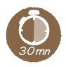Time

Supervised

Training

Teachers with no experience in astronomy may benefit from a teacher training workshop. Please contact your closest UNAWE National Program manager: http://www.unawe.org/network/national/

Credit

Concept | Cecilia Scorza (EU-UNAWE Germany/House of Astronomy)
Project Management | Pedro Russo (EU-UNAWE/Leiden University)  Jaya Ramchandani (UNAWE/Sirius Interactive)
Educational Development | Cecilia Scorza and Natalie Fischer (EU-UNAWE Germany/House of Astronomy)
Educational Support | Sara Khalafinejad (UNAWE/Leiden University) and Jos van den Broek (Leiden University)
Business Development | Jaya Ramchandani (UNAWE/Leiden University)
Editorial Support | Erik Arends (UNAWE/Leiden University)  Jaya Ramchandani (UNAWE)  Proofreading: Sirius Interactive Ltd.
Activity Contribution | Angela Perez (UNAWE Colombia/Astronomy Kids Club)  Curion Education Pvt. Ltd. (India)
Prototype Production | Curion Education Pvt. Ltd. (India)
Images | Image Editing  Charlotte Provot (EU-UNAWE/Leiden University)  Design Support: Diti Kotecha (ditikotecha.com, Graphic Designer)  Note  We have taken care to credit all pictures. Unfortunately, this has not been possible in all cases. Should you be aware of the authorship of these uncredited pictures, please let us know!
Logo | Nikki Hartomo (Design); David Kerkhoff (Font)
Design / Illustrations | Charlotte Provot (EU-UNAWE/Leiden University)
Disclaimer | The Universe in a Box was carefully produced. Nevertheless, editors, contributors and the publisher do not guarantee the information contained in this report to be free of errors. Readers are advised to keep in mind that statements, data, illustrations, procedural details or other items may inadvertently be inaccurate. Educators from the Southern Hemisphere are advised to verify the activity before conducting it.

Our Fascinating Moon

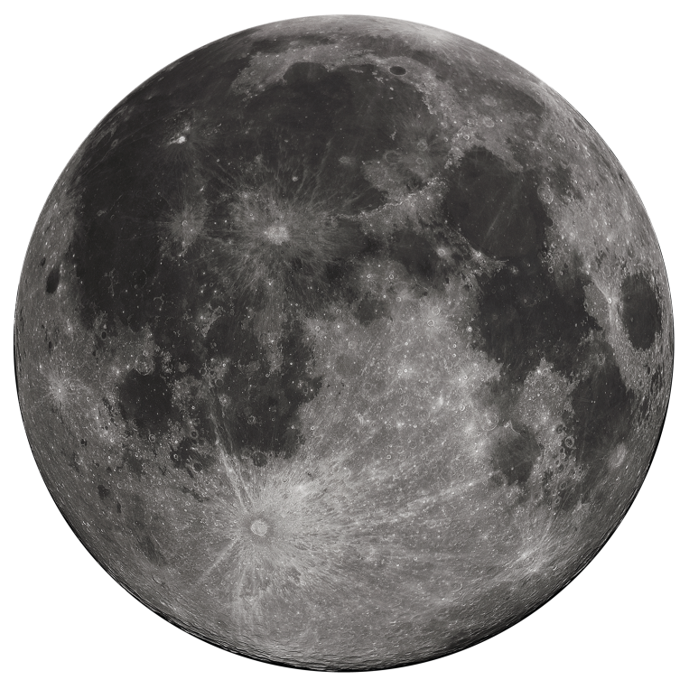

Credit: Gragory H.Revera

Introduction

Our Earth has a moon, as do many other planets in the Solar System. But this has not always been the case. Our moon came into existence billions of years ago, when the Earth collided with a meteorite the size of Mars. Astronomers think that before that event, the Earth rotated very fast around its axis and tumbled back and forth. The weather changed chaotically, and day and night were very short. The attraction between the Moon and the Earth slowed each of their spins down over time. The Earth’s axis became more stable, and day and night grew longer. The Earth evolved into a more hospitable place for life due to the Moon!

Because of its regular and reviewable monthly movement, the Moon is especially suited as an introductory subject into astronomy. With their bare eyes or a simple pair of binoculars, children can discover a new world for themselves.

The Moon has several more advantages as an introduction to astronomy:

- It can be seen from anywhere, be it from a city or the countryside.
- The Moon has a spherical shape, just like the Earth. Whoever has familiarised themselves with the shape of the Moon will more easily get used to the idea of the Earth’s spherical shape. This is especially important for children of the first elementary grade.
- The Moon continuously changes shape, which makes observing it more interesting. Observing is possible even during the day.
- With the Moon as an observational target, children can more easily understand what a big step the development of the telescope has been for astronomy.
- In all cultures, the Moon has played a very important role in dividing the time into months. Each lunar cycle takes about one month.
- The (manned) lunar missions of the 1960s and 1970s fascinate children.
- The Moon is multicultural: on and around the Moon, all people of Earth have immortalised characters of their culture through fairy tales and myths.

Moon Phases

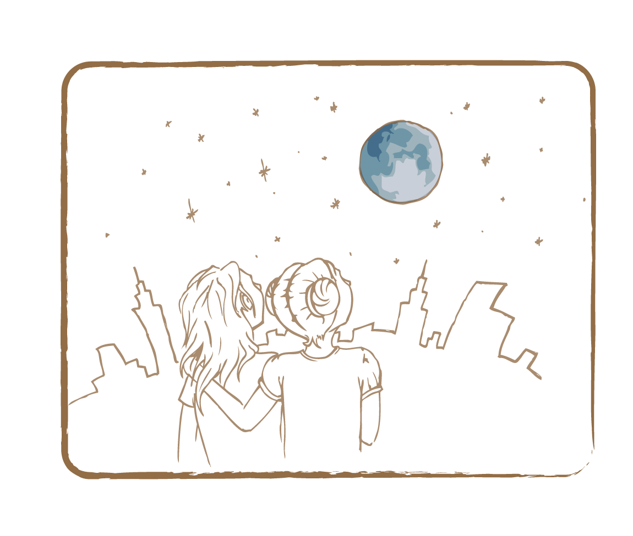 Credit: UNAWE / C.Provot

Unlike stars, the Moon doesn’t shine by itself. It merely reflects the light it receives from our Sun. And like on Earth, only one half of the sphere can bathe in daylight: on the other half it’s night time. As the Moon revolves around the Earth, each day we see different parts of the ‘day side’ of the Moon. During full moon, the Moon faces us with its complete day side. During new moon, it’s the other way around: we see the Moon’s full night side. In between these situations, we see different lunar phases, where parts of the day side and night side are visible at the same time, in changing proportions.

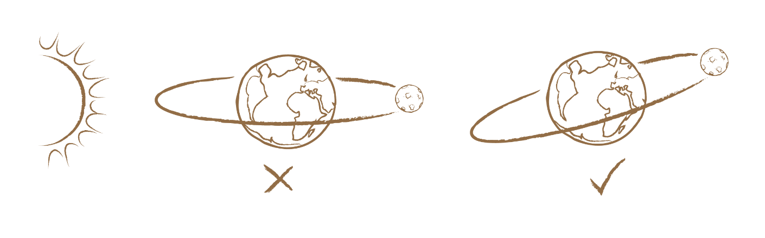

The Earth revolves around the Sun. However, in relation to this orbital plane, the Moon’s orbit is not horizontal (see left picture) but inclined (see right picture).

The lunar phases go from new moon to full moon and back to new moon in a cycle of about 29.5 days. The Moon circles around the Earth in a slightly shorter period of time (27.3 days), but because the system made some progress in its orbit around the Sun, the Moon needs to fly a bit longer to get in between the Earth and the Sun again and become a new moon once more. The Moon flies its rounds in an inclined plane, not in a horizontal plane.

To understand lunar phases better, let’s take the example of little Maria who lives in Spain. Maria often sits in her backyard to look at the Moon. As seen from her standpoint, the Moon is completely dark in position 1 because the Sun is behind it (see figure). It is a new moon: . In position 2, Maria can only see the part of the illuminated lunar surface that faces her: .
In position 3, the side of the Moon visible to Maria is completely illuminated. This is a full moon: . In position 4, Maria again sees only one half of the Moon illuminated, but here it’s the other half: . After 29.5 days, the Moon returns to position 1.

4

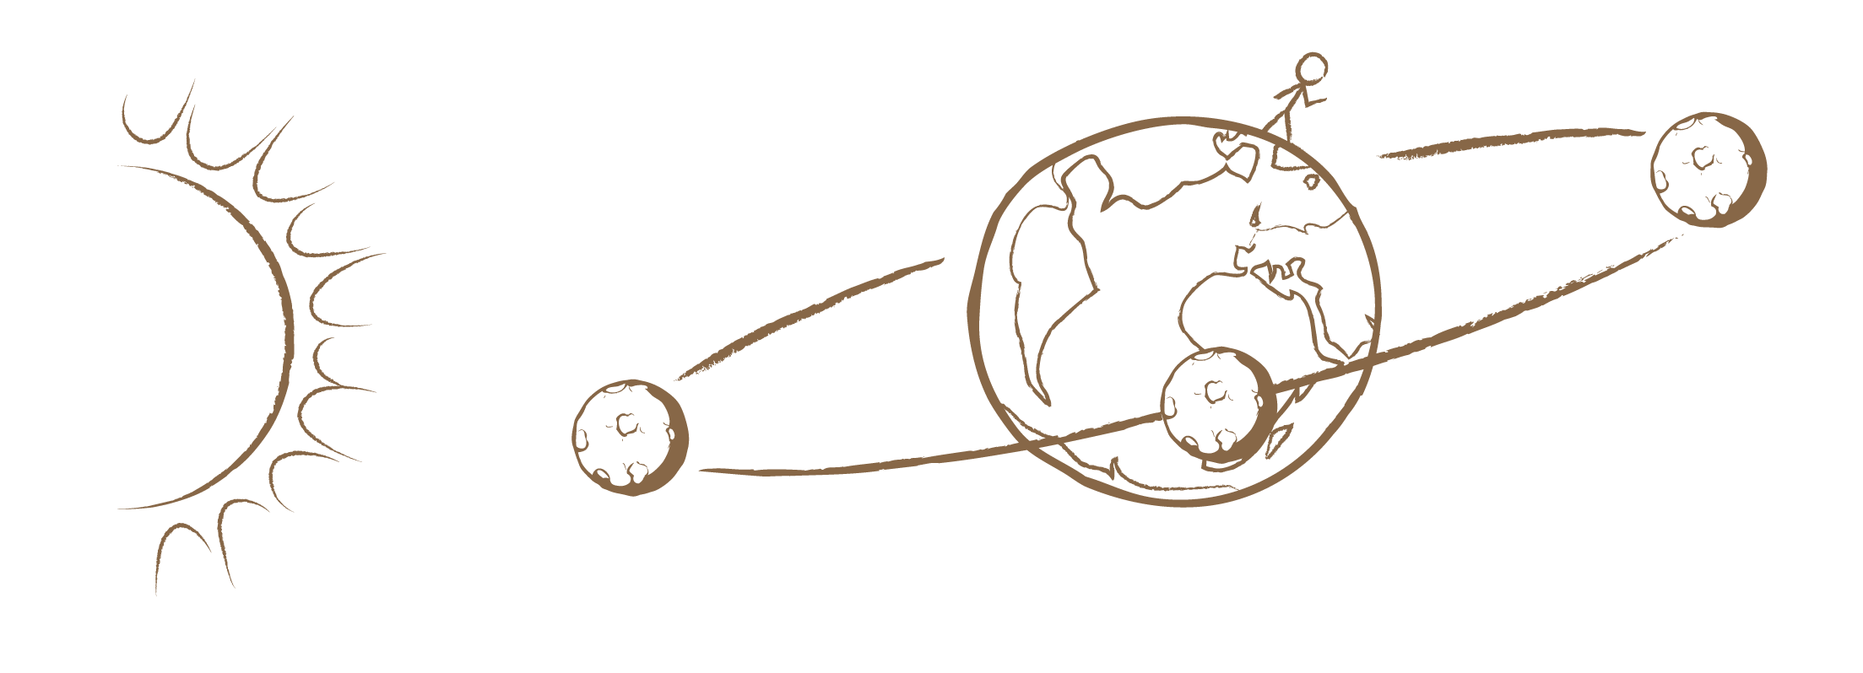
1
2
3

Credit: UNAWE / C.Provot
Maria stands on Earth and observes the Moon at different times. Depending on where the Moon is relative to her at each instant, the Moon shows a certain portion of his illuminated side. The Moon’s orbit is inclined by about 5 degrees, which is why we do not have a lunar and solar eclipse every month.

Facts about the Moon

Age | About 4 billion years
Diameter | 3,472 km (a quarter of Earth’s; the Moon fits on Australia)
Mass | 73,477 billion billion kg (7.3 × 1022 kg)
Average distance from Earth | 384,400 km
Rotation period around own axis | 27.3 days (about one month)
Orbital period | 27.3 days (about one month)
Temperature | Can be more than 100 °C (day side) and lower than -200 °C (night side)
Gravity | On the Moon, things are six times lighter than on Earth
Fun fact | The Moon is the only celestial body man has ever set foot on

1.1 Fact File on the Moon

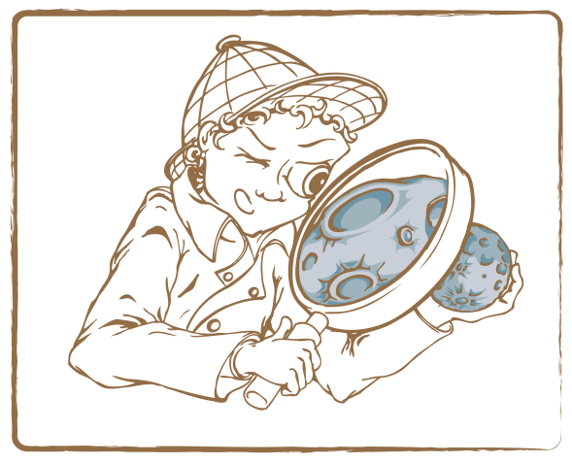 Credit: UNAWE C.Provot

Brief Description

Make a fact file of the Moon by looking up fascinating astronomical information about it.

Keywords

• Moon
• Fact file

Materials

• Image of the moon (Appendix)
• Pen
• Paper

Learning Objectives

Learn about the properties of the Moon, in comparison to Earth.

Background Science

The Moon is about 4 billion years old. Its diameter is 3,476 kilometres, corresponding to one-fourth of the Earth’s diameter, which is about the size of Australia. The mass of the Moon is about one ninetieth of the Earth’s mass, or 7.3 × 1022 kilograms (that is, a seven with 22 zeros!). It is made up of ferrous rock.

The Moon revolves once around the Earth in 29.5 days (about one month), which is exactly the duration of one lunar day. That is why we always see the same side of the Moon. On the day side of the Moon, temperatures can reach up to 100° Celsius, while on the night side they can drop below –200° Celsius.

The distance between the Moon and the Earth (i.e., 384,400 kilometres) could contain the Earth 30 times. It is the farthest humans have ever travelled: the Moon is the only celestial body that man has ever set foot on. On 21 July 1969, American astronaut Neil Armstrong stepped on the lunar surface as the first human being. On the Moon, you can jump especially high and far: your weight is only one sixth of your weight on Earth.

Other sources: Get more information on our Moon through NASA’s website: http://goo.gl/6H9sK

Full description

- Ask children to search for information about the Moon from the fact sheet and books or websites.
- Let them compare the obtained values to familiar things or other celestial objects and write them down in a fact file.
- Encourage the children to use orders of magnitude (e.g., the Moon is 19 times lighter than the Earth) instead of absolute numbers.

Tip: The same exercise can be done for other celestial bodies, to get an understanding of the relative sizes in the universe.

1.2 Distance to the Moon

Brief Description

Use a to-scale model of the Earth and Moon. Learn to understand the relative distances between them.

Keywords

• Moon
• Earth
• Distance

Materials

• Globe (Box)
• Moon sphere (Box)
• Folding rule

Learning Objectives

Learn about the relative distances of the Earth-Moon system.

The Moon and the Earth circle around each other at an average distance of 384,400 kilometres. In many artist’s impressions, this length is pictured as much too small in relation to the sizes of both bodies. In reality, there is a lot of space between them: about 30 times the size of the Earth.
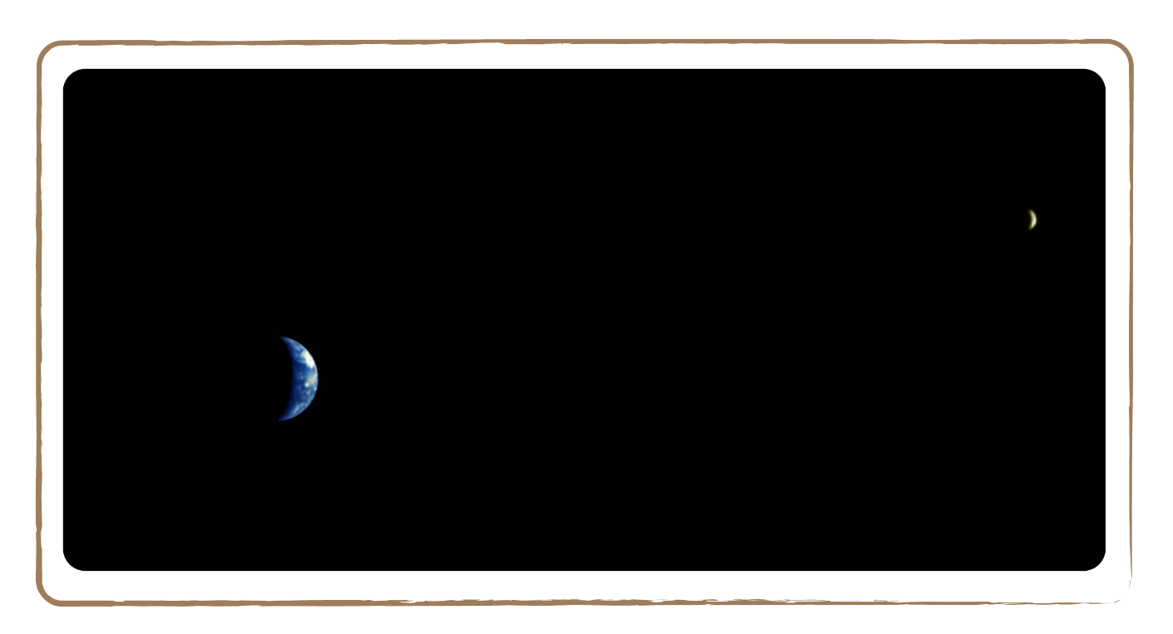

Credit: ESA / DLR / Freie Universität Berlin

Picture of the Earth-Moon system, taken by the Mars Express in 2003

Full description

- Ask the children to compare the Moon and the Earth: How large is the Moon relative to Earth, and how distant are they from each other?
- Let them use a globe and a model of the Moon. We use a scale of 1:100,000,000 where a distance of 1 cm corresponds to a real distance of 1,000 km. The Moon is 384,400 km away from Earth, which corresponds in our model to a distance of 384.4 cm = 3.84 m. That seems surprisingly far apart! The reason for this is that the Moon is depicted as much too close to the Earth in many pictures, for practical reasons. Hence, the feeling for the real distance is often lost. Give the children this feeling back by asking them to form pairs and stand 3.84 m away from each other while holding the models.
- Tip: Tell the children about the relatively thin atmosphere on Earth. If the Earth were an apple, then the atmosphere would be as thick as the apple’s skin. The Earth’s vulnerable small air layer is of vital importance for life. It offers us oxygen to breathe and protects us from dangerous radiation from space and incoming meteorites. So we have to be careful with our atmosphere. By the way, the Moon has no atmosphere at all!

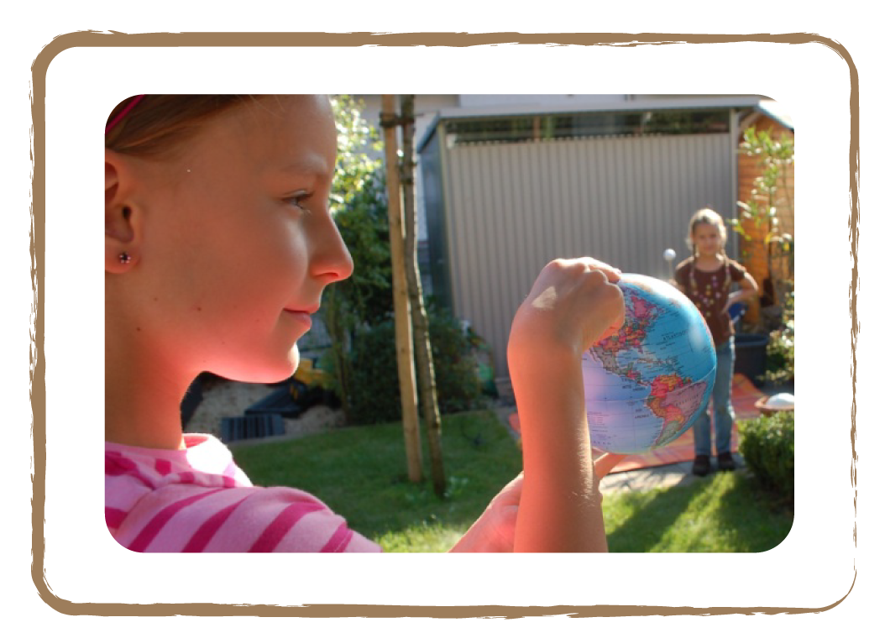

Credit: Natalie Fisher

1.3 Lunar day

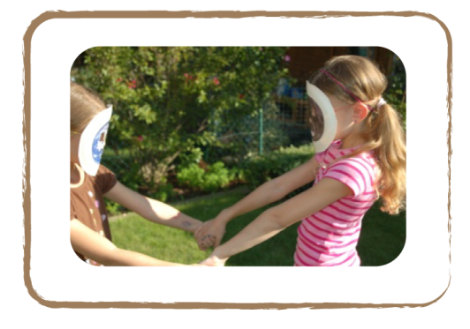 Credit: Natalie Fisher

Brief Description

Interactive role play between the Earth and Moon with masks.

Keywords

• Moon
• Earth
• Moon Face

Materials

• Earth mask (box)
• Moon mask (box)

Learning Objectives

Learn why the Moon always faces us with the same side.

Background Science

Have you ever noticed that the Moon always turns the same side to us? This is because in the past, the Earth created tidal forces on the Moon, just like the Moon is still doing on Earth. A planet or moon slows down when it experiences tidal forces, because of the energy lost by friction. Think of the tidal waves on Earth: water moves and therefore experiences friction. On Earth, the effects are clearly visible in the oceans. However, the rotation of our planet isn’t affected as much as that of the Moon, because it’s heavier. In fact, the Moon even stopped rotating at all from our point of view. We always see the same side of the Moon, because the Moon’s rotation slowed down until it reached the point where it completes one rotation in exactly the same time the Moon circles around the Earth. This phenomenon (the Moon is said to be tidally locked) can be observed in other planet-moon systems as well.
Other sources: Short movie about the Moon in tidal locking:
http://goo.gl/qZSI8

Full description

- Ask two children to put on an earth and moon mask, thus playing the part of the Earth and the Moon.
- Let them stand opposite to each other, take each other’s hands and slowly turn around each other. The earth child should try to keep standing in one spot as much as possible.
- She/he clearly recognises that the moon child always turns the same side to her/him. From her/his point of view, the Moon does not rotate!
- But what do those children see who observe the activity from outside? If they watch closely, they will realise that the moon child continuously changes her/his direction of view. So the Moon does in fact rotate around herself/himself. One revolution around the Earth takes the Moon just as long as one rotation around itself! Thus, a lunar day lasts 29.5 days (it takes the Moon 29.5 days to orbit around the Earth).

Tip: You should realise that the Earth isn’t depicted in the correct way in this activity. The earth child should actually spin around its axis much faster. However, this is not possible when the children are holding hands. In reality, the Earth doesn’t always have the same side directed at the Moon. Every person on earth has seen the Moon, no matter on which side he/she lives!

1.4 Lunar Landscape

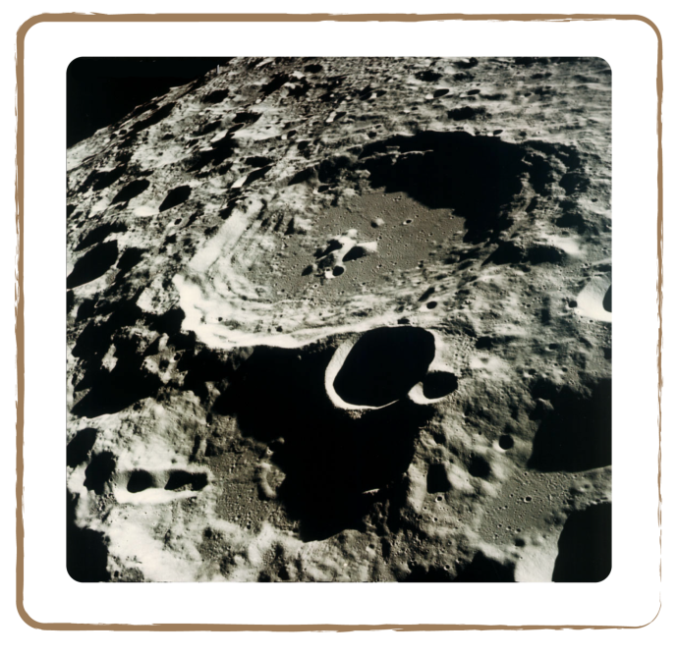 Credit: NASA

Brief Description

Create a lunar landscape forming different patterns of craters with stones, cocoa and flour.

Keywords

• Moon
• Crater
• Landscape

Materials

• Baking tin
• Cocoa
• Flour
• Stones of different sizes (0.5 – 3 cm)
• Image of Moon (Appendix)

Learning Objectives

Learn about the Moon’s landscape and how its craters are formed.

Background Science

Galileo Galilei, an Italian astronomer and mathematician from the 16th century, was the first man to take a close look at the Moon with a telescope. As he stared through the telescope for the first time, he couldn’t believe what he saw. Huge mountains, craters, highlands and valleys made up the breathtakingly beautiful lunar landscape.

Several years after Galilei’s discovery, another Italian astronomer named Giovanni Battista Riccioli created a map on which he named the largest ‘seas’ of the Moon (see image below). In reality, these seas are dark valleys that look like seas. No liquid water exists on the lunar surface, just some ice in deep craters. Because Riccioli believed that the Moon was directly influencing the weather on Earth, he called some of the seas ‘Sea of Tranquillity’, ‘Sea of Serenity’, ‘Sea of Rain’, ‘Sea of Clouds’ and ‘Ocean of Storms’.

The many craters on the Moon were created a long time ago by meteorite impacts. They all have different sizes and some of them have bright rays around them, an indication of their relatively young age (the dark zones are older). On Earth, the impacts of meteorites disappear over time because of erosion: rain, wind and water smooth the surface by wearing away irregularities until only the most recent ones are still visible. On top of that, the Earth’s atmosphere burns most meteorites before they crash onto the surface. The Moon, however, has no atmosphere, which means that all craters stay intact. This is why the Moon is scarred with so many craters—and they keep increasing in number as time goes by!

Other sources: Images of Moon craters (http://goo.gl/D0r2p)

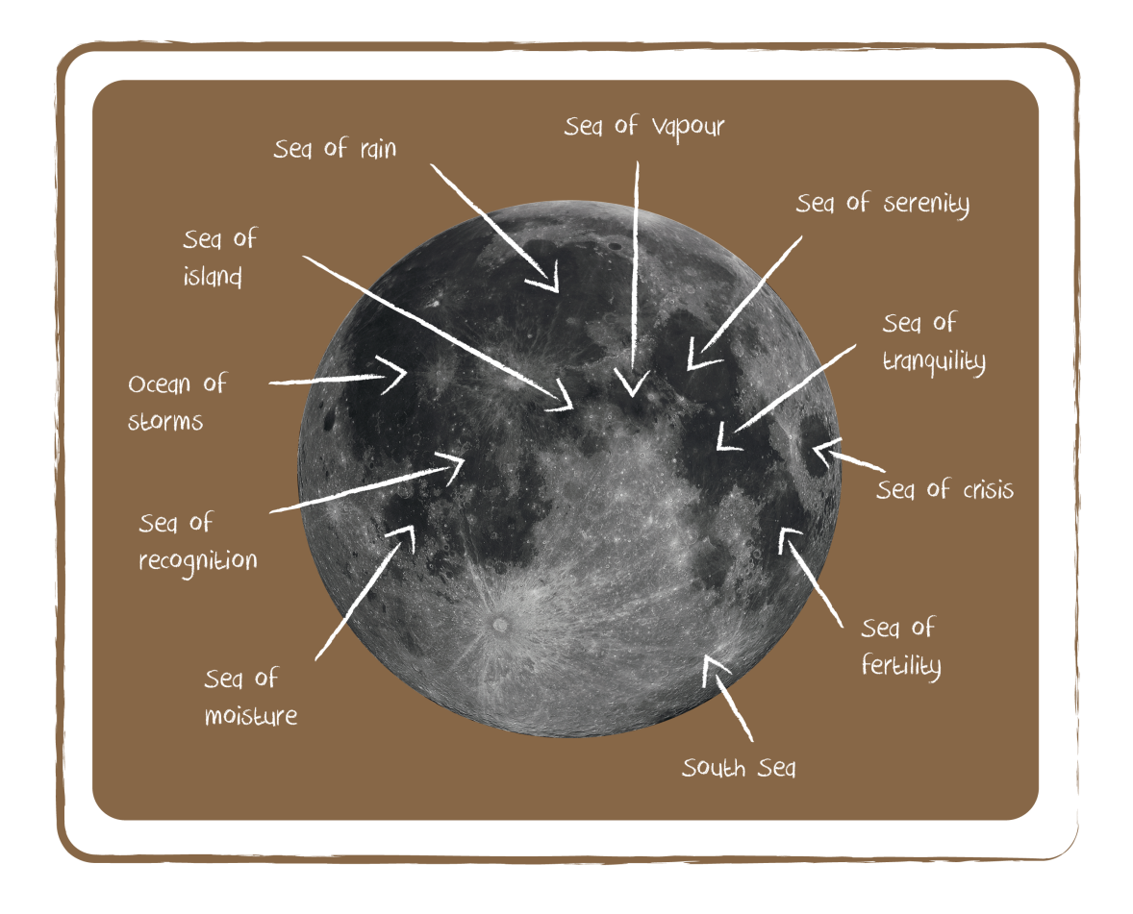
Credit image: Gregory H.Revera / Credit graphic: Unawe C.Provot

- Spread out a thick layer of flour on a baking tin, followed by a thin layer of cocoa on top of it, using a sieve.
- Ask the children to collect stones of different sizes and throw them on the tin at different speeds and from different angles. In this way, many different craters will appear.
- Next, ask the children to compare real lunar craters on a picture of the Moon with the craters they have made. What does the star-like shape of the throw-offs tell about the direction and velocity of the projectile? What does the crater size depend on?
- Tip: You could also ask the children to craft the different features of a lunar landscape with paper maché and paint. You would need just a wooden board, newspapers, paste, paint, brushes, spray glue and fine sand. First make paper maché out of a newspaper and paste. Then let the children create a lunar landscape on a wooden board using cage wire and the paper maché. Don’t forget the craters! After the landscape dries up, ask the children to paint it. Using spray glue and sand, they could model the landscape even more realistically. Additionally, they could build little astronauts and moon cars (e.g., with Lego).

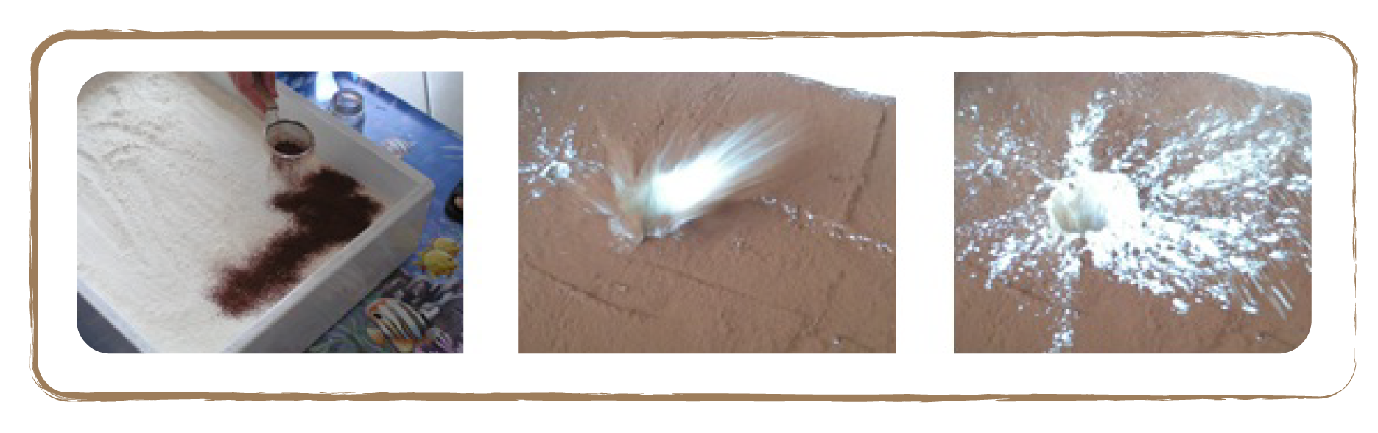
Credit: Cecilia Scorza

A meteorite hits our lunar landscape from the left. One can clearly recognise the star-shaped throw-off of white flour, which is more pronounced in the direction of flight (to the right).

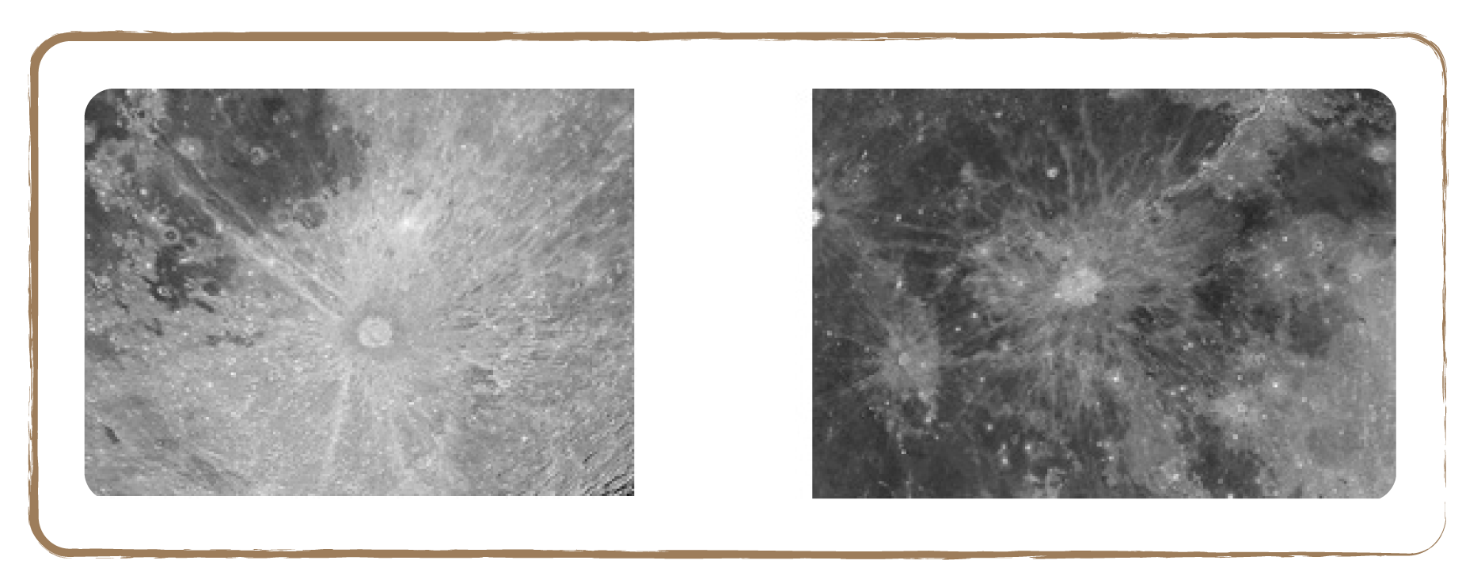

Credit: NASA

1.5 Reflecting Moon

Brief Description

Shine a flashlight on a white sphere from different directions to create different lunar phases.

Keywords

• Moon
• Reflected light
• Lunar phases

Materials

• Moon sphere (Box)
• Wooden spit (Box)
• Flash light

Learning Objectives

Learn why the Moon shines in different lunar phases.

Background Science

See introduction

Full description

- Show the children the moon sphere attached to the wooden spit.
- Now turn off the light: the children will realise that they cannot see the sphere in the dark because it doesn’t shine by itself.
- Light up the sphere with a flash light (representing the Sun): it will look very bright on the side that is lit.
- By changing the direction of the light, you can show that a full sphere (full moon) or half a sphere (first- or third-quarter moon) are the result of the Sun shining on the Moon from a specific direction.
- Let the children try for themselves and explain which lunar phases they are observing from every position.

Tip: For ages 8–10, instead of illuminating the sphere from different directions, you could move the sphere around the children (keep illuminating the room with one fixed light source). This way, they see how the moon phases actually shift: the Moon orbits the Earth, with a fixed background light (Sun).

Related activities: 1.6, 1.7, 1.8, 1.10

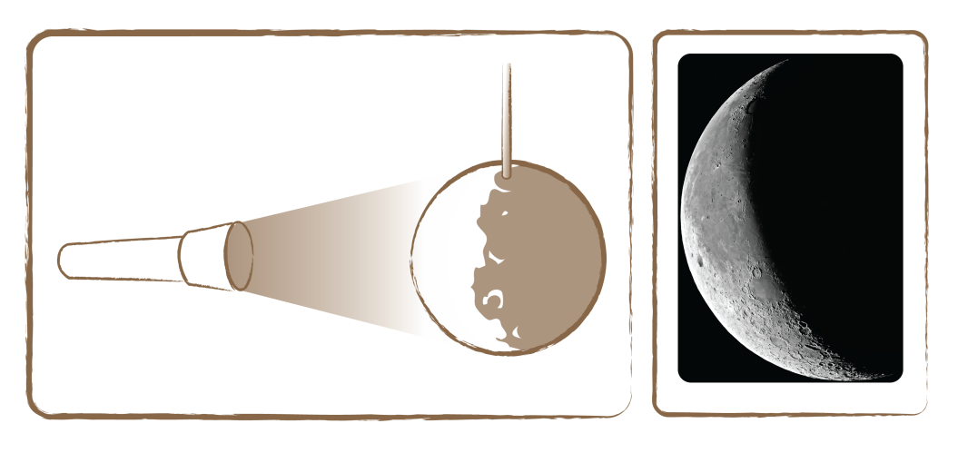

Credit: ESA

Credit: Unawe C.Provot

1.6 Lunar Phases Visualised

Brief Description

Watch the Moon shift phases by revolving an artificial moon around a globe with a fixed light source shining from one direction.

Keywords

• Moon
• Lunar phases

Materials

• Light stand (Box)
• Light bulb (Box)
• Earth model (Box)
• Moon sphere (Box)
• Wooden spit (Box)

Learning Objectives

Visualise how the Moon shifts phases in the Earth-Moon-Sun system

Background Science

See introduction

Full description

- The best way for children to visualise lunar phases is to play the role of the Earth, the Moon and the Sun themselves. For this, you need a light source (e.g., a light stand with a bulb, or an overhead projector) as the Sun, a globe and a suitable moon model fixed to a wooden spit.
- Darken the room and make sure the fixed light source is pointed towards the centre of the classroom.
- Now ask one volunteer to stand in the middle holding the Earth, and another child to hold the Moon at the edge of the room.
- Let the rest of the class stand around the Earth to observe the Moon from there. Ask the moon child to revolve around the Earth. What do the children say about the shape of the Moon (lunar phase)? What happens?

Tip: To distinguish one semi-moon from the other, you could use the capital ‘B’ and the lower case letter ‘a’. When the right side is lit, it looks a bit like a ‘B’, and it is waxing. Here ‘B’ stands for ‘before full moon’. When the left side of the Moon is lit, it looks somewhat like an ‘a’, and it is waning. Here the ‘a’ stands for ‘after full moon’ (see pictures). However, this only goes for the Northern Hemisphere. On the Southern Hemisphere, it is the other way around: left side lit means waxing and right side lit means waning.

Related activities: 1.5, 1.7, 1.8, 1.10

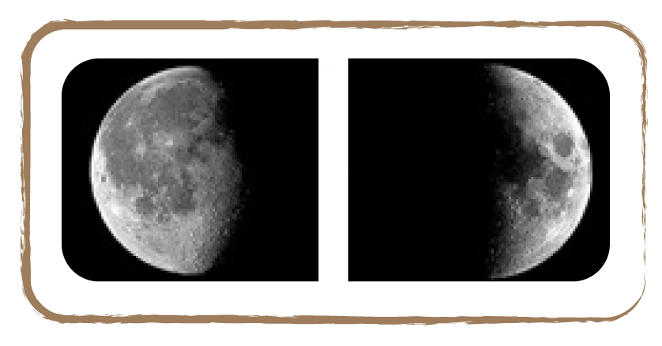
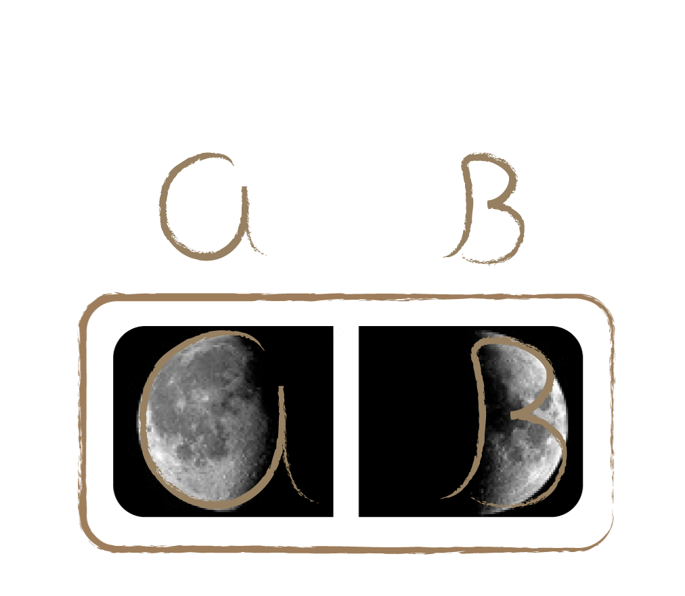
Credit: Wikimedia Commons

1.7 Lunar Phases Box Model

Brief Description

Build a simple shoe box model with spyholes to see the four main phases of the moon.

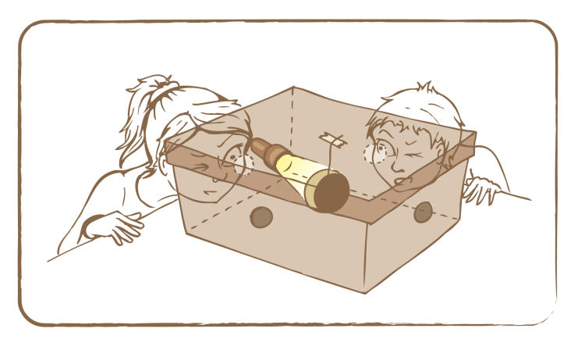
Credit: UNAWE C.Provot

Keywords

• Moon
• Lunar phases

Materials

• One shoe box per pair
• Cotton ball (30 mm in diameter)
• Black paint, wooden spit (Box)
• Glue, brush
• Small flash light
• Scissors

Learning Objectives

Learn about the four main phases of the moon.

Background Science

See introduction

Full description

- Divide the class up into pairs and ask them to paint the inside of a shoe box black.
- Let them cut a spyhole in the centre of each of the four sides. In one of the two narrow sides, they drill another hole, which is just big enough for a flash light to be inserted from the inside out.
- They fix a cotton ball, on which little craters have been painted, on a wooden spit in the centre of the cover, which is then closed.
- Next, they light the flash light. The children can now observe four different lunar phases (full, new, first-quarter and third-quarter) through the four spyholes.

Related activities: 1.5, 1.6, 1.8, 1.10

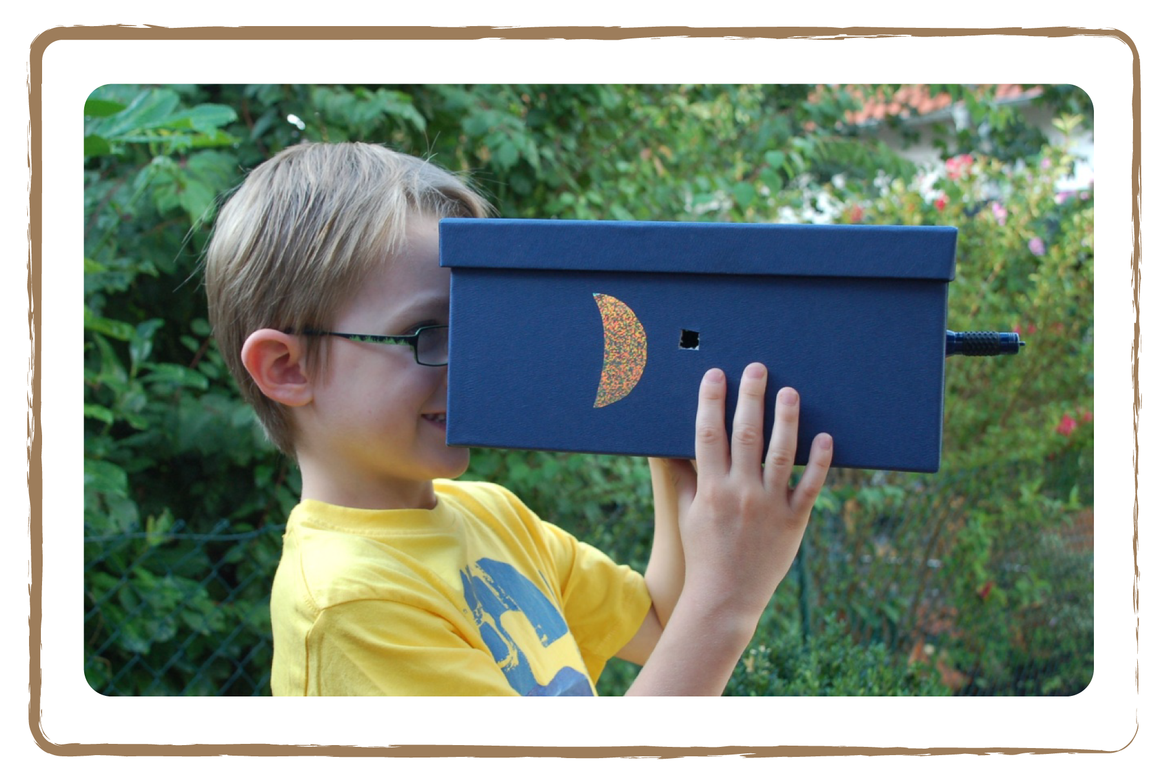
Credit: Natalie Fischer

1.8 Lunar Phases in Action

Brief Description

Arrange pictures of the lunar phases in the right order to see the progression from new moon to full moon and back.

Keywords

• Moon
• Lunar phases
• New moon
• Full moon

Materials

• Set of lunar phases images (Appendix)

Learning Objectives

Learn about the progression of lunar phases through the month.

Background Science

The current phase of the moon depends on the angle at which the Sun shines on the Moon.. Because the Moon rotates around the Earth counterclockwise, with the Sun as a relatively fixed background light, the boundary between day and night on the Moon shifts from right to left from the perspective of the Northern Hemisphere. This goes for both waxing and waning moon. As viewed from the Southern Hemisphere, the boundary shifts from left to right.

Full description

- Cut out the picture cards with the different lunar phases, shuffle them and distribute them. Each group of four children needs a set of cards.
- Ask the children to place them in the right order (see bottom series for the correct order). Because the cards were cut out, it’s not clear anymore what is up and down. This makes it harder to determine which quarter moon is waxing and which is waning. On the Northern hemisphere, a lit right half means a waxing moon. On the Southern it’s the other way around.
- Therefore, ask the children to pay attention to the ‘man in the Moon’ (see picture in the Appendix). Let them hold the cards in a way that this figure is on the right side. The upper series in the image below is an example of how you could do it the wrong way: the cards only form half a cycle, in which the second and fourth card are upside down.

Tip: For ages 6–8, it is sufficient to arrange the cards from the narrow crescent to full moon or reversely. In contrast, the surface details should strike children ages 8–10. They should learn to look closely.

For ages 8–10, the children can also make an animated flip book of the lunar phases. A sample flipbook is available in the Box.

Related activities: 1.5, 1.6, 1.7, 1.10

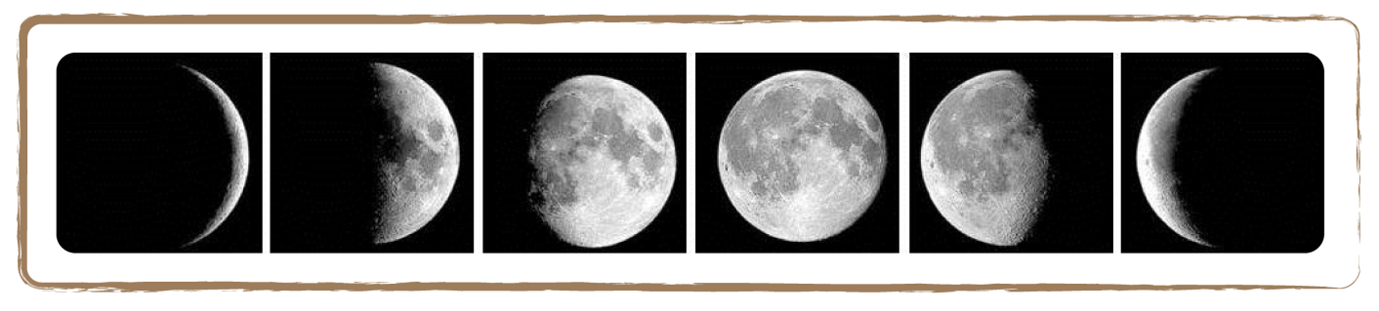
Credit: Wikimedia Commons

Wrong series: the second and fourth card are upside down. Also, this is only half a cycle.

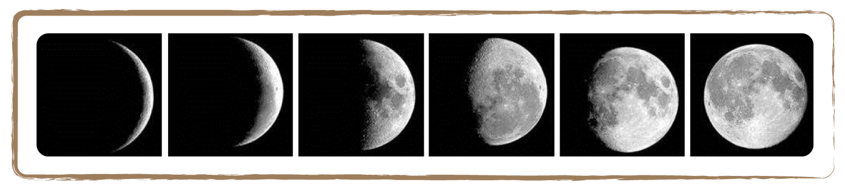
Credit: Wikimedia Commons

Correct series: all cards are placed right-side up and the complete cycle is depicted, from new moon to full moon and back to new moon.

1.9 Multicultural Moon

Brief Description

Identify characters on the Moon’s surface by placing transparent outlines of people or animals from different cultures on a picture of the Moon.

Keywords

• Moon
• Culture
• Characters

Materials

• Image of the Moon (Appendix)
• Transparent moon-figures of Man, Woman, Rabbit, Lion, Crocodile (Appendix)
• Markers

Learning Objectives

Learn about other cultures’ perspectives on the Moon.

Background Science

If you look at the Moon more closely, you can get the impression that the Moon’s ‘seas’ (which are, in reality, dark valleys) look like figures. People from different countries and cultures often see different things.
The figures usually correspond to the culture and environment. For example, why do the Chinese see a rabbit and no crocodile? Because there are no crocodiles in China, but many rabbits. In Germany, people see a ‘Man in the Moon’.

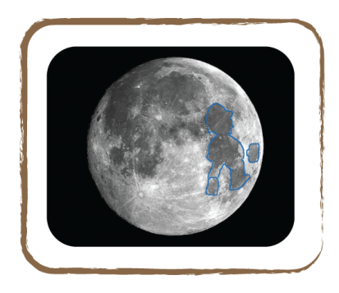

Germany
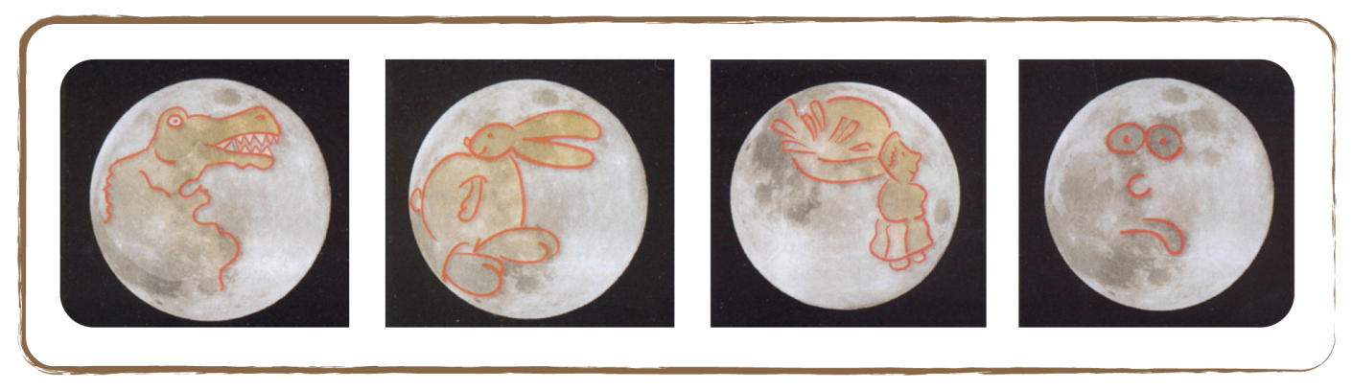

Credit: Cecilia Scorza

Kenya China Congo Universal

Full description

- Show the children the figures in the Moon from different countries simply by putting one Moon-figure transparency after the other on the picture of the Moon.
- Now you can ask the children: Why don’t people in Congo see any rabbits? And why don’t the Chinese see a crocodile?

Tip: If you have children in the class who originate from different countries, let them ask at home which characters their relatives see, based on their culture. The stories about the moon figures are also very suitable for theatre plays!

Related activities: 1.10, 2.3

1.10 Moon Storytelling

Brief Description

Share stories and inspire children to write stories on the Moon.

Keywords

• Moon
• Figures
• Culture
• Storytelling

Materials

• Image of the Moon (Appendix)
• Transparent moon-figures of Man, Woman, Rabbit, Lion, Crocodile (Appendix)
• Markers
• Stories about figures in the moon (Appendix)

Learning Objectives

Learn about other cultures’ perspectives on the Moon through story telling.

Background Science

See 1.9

Full description

- Hand out pictures of the Moon and transparencies.
- Ask the children to place the transparency over the moon picture.
- Let them draw their own characters onto the full moon picture.
- Let them write a story about it and read it to each other. The children can now see how people in different cultures came up with their own figures, which they have eternalised in fairy tales and myths.
- Read the stories from the Appendix to the children.

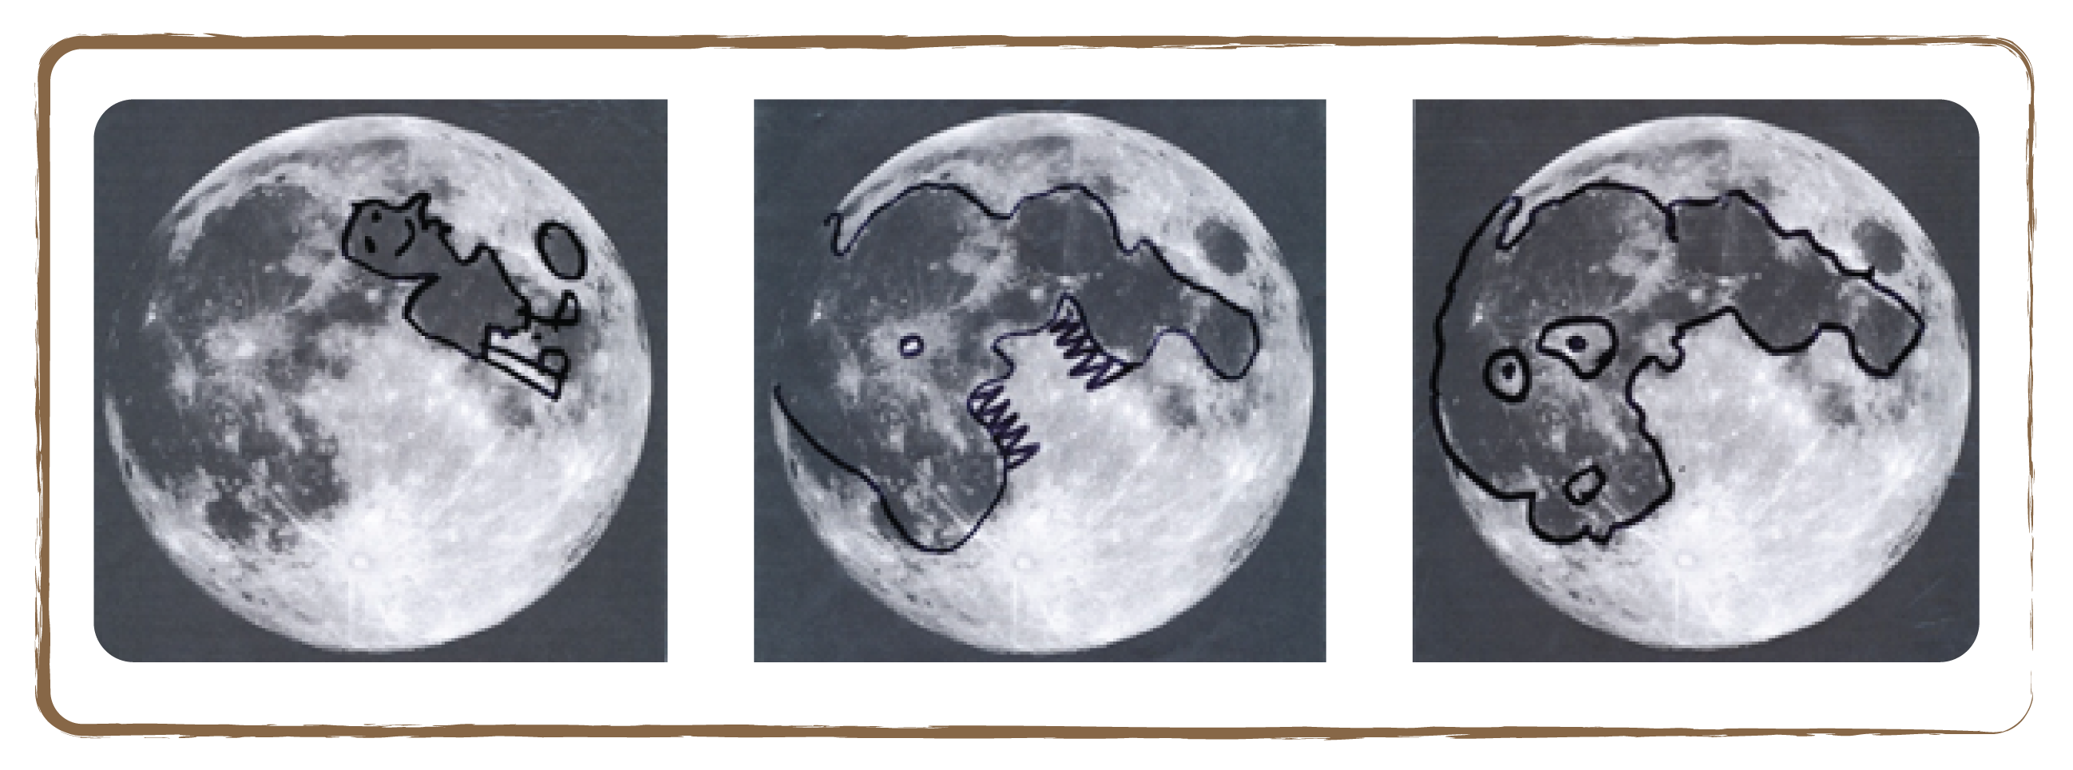
Here, children see, for example, a soccer player, a shark or a monster on the Moon

Tip: If there are children from different cultures in the classroom, you can emphasise the influences from a culture on how people look at the Moon. The children might have learnt different fairy tales and myths from their parents, which may make them see different figures in the Moon. If the class is not multi-cultural, you can explain the figures from different cultures yourself (see Appendix).

Related activities: 1.9, 2.3

1.11 Mini Research Project: Revolution of the Moon and Lunar Phases

Brief Description

Explore how the Moon shifts phases and revolves around the Earth by drawing the Moon every night for five weeks in a row.

Keywords

• Moon
• Lunar phases
• Revolution

Materials

• Moon observation form (Appendix)
• White marker

Learning Objectives

Learn about the revolution of the moon by observing its phases.

Background Science

The Moon continuously changes shape: sometimes it looks like a banana-shaped crescent, and sometimes it looks round as a ball. All these different faces of the Moon are called moon phases. The Moon is clearest visible during the night, but you can also watch it during the day!
There is always a period of about one month in between two new moons. During this time, the moon phase shifts from new moon to waxing crescent, to first quarter, to waxing gibbous, to full moon, to waning gibbous, to third quarter, to waning crescent and finally back to new moon.

Credit: Wikimedia Commons

The moon phases shift from new moon, to full moon, and back to new moon

Full description

Over a timespan of five weeks, let the children observe the Moon every day/night (if possible) and draw it on the observation form. The form is made up of five rows with seven black areas each, according to the days of the week from Monday through Sunday. They can start at any day of the week. Every day on which the children have a chance to observe the Moon, they draw it in a new black box using a white marker. Emphasise that they should also note the date and time. If the sky was cloudy or has not been observed, leave out the corresponding box.

If the Moon is already visible in the morning, the children should paint the date box blue. On the days on which the Moon can already be observed in the afternoon, they should paint the date box green. If the Moon is only observable in the evening or if the children haven’t paid attention to the Moon during the day, the box is left white.

Evaluate the observations after five weeks:

- Count the days between two of the same lunar phases. What is this timespan also called?
- How about the Moon’s crescent? Can you infer from its orientation whether the crescent will become thicker or thinner in the coming days?
- In which lunar phase can we already see the Moon in the morning or afternoon, respectively?
- From the children’s sketches, you can estimate the duration of a month as 29 to 30 days. If you are on the Northern Hemisphere, when the moon is waxing, the right half of the moon is illuminated; when the moon is waning, the left half is illuminated. On the Southern Hemisphere it is the other way around. In the days after new moon (waxing moon), the Moon is already visible in the afternoon. In the days before new moon (waning moon) you can see the Moon in the morning.
- Note that the orientation of the crescent changes after each new and full moon, respectively.

Tip:

Astronomically, the most interesting phase of the moon is the first- or third-quarter moon, or when its crescent is still small. Then, using binoculars or a small telescope, the craters at the transition boundary from the illuminated to the unlighted side of the Moon can be observed best. This is because the light falls in from one side and the higher areas of the Moon cast long shadows over the valleys. When Galileo Galilei did the same about 400 years ago, he and the world were surprised that there are such beautiful landscapes on the Moon.

The full moon is a beautiful object rather for its overall appearance: during that time the bright and dark areas on the Moon are completely visible and reveal funny characters like the ‘Man in the Moon’.

Some activities during an observation might include:

- drawing the lunar craters (after having a look through a telescope)
- drawing the Moon with its dark and bright areas
- photographing the Moon

For the observation, a simple pair of binoculars (preferably fixed to a tripod so it doesn’t shake) is sufficient. As an introduction you might, for example, tell a story about the life of Galileo Galilei. This way, a special connection is established between the children’s own actions and this historical person.

Astronomical websites or lunar calendars put together the most important information beforehand for a successful observation:

- When does it get dark?
- Which lunar phase can be seen when?
- When does the moon rise and set?
- How high is the moon in the sky?

Before the observation night, try out where you can best observe the Moon (school yard, open field, private garden).

Related activities: 1.5, 1.6, 1.7, 1.8

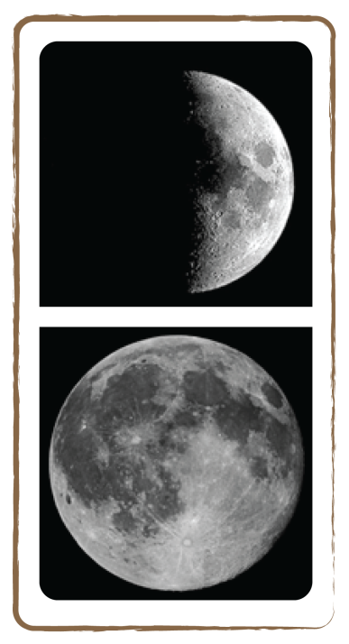
Credit: Wikimedia Commons

The Earth, Our Home Planet

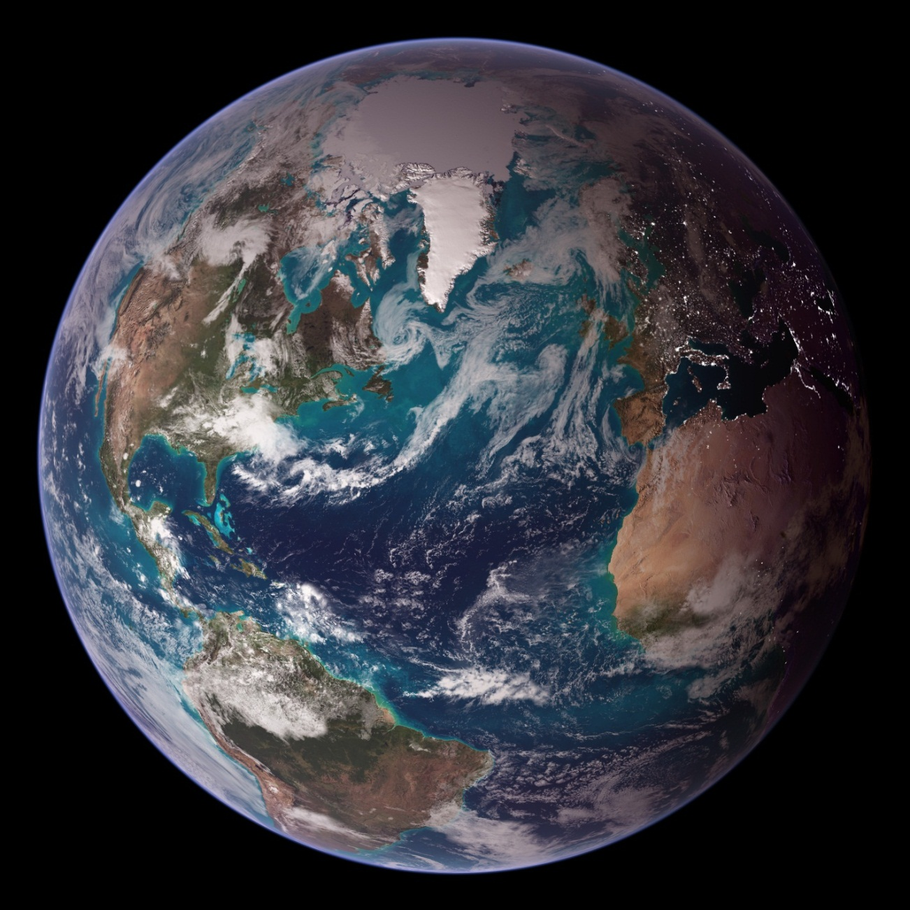

Credit: NASA

Introduction

The Earth is a very special planet: it is our home. When astronauts first stepped on the Moon in 1969 and brought home a photograph of the Earth taken from space, many people realised that we all live together on one tiny planet. From space, no political, cultural or linguistic boundaries are visible: we are all inhabitants of this one blue dot in a sea of emptiness.

About 4.5 billion years ago, when the Sun was born, the Earth formed from the dust circling around it. Because the distance from the Earth to the Sun is just right, life can exist on our home planet. We need fluid water to survive, and water only takes on a liquid form at certain temperatures. If the Earth were a little closer to the Sun, all water would have evaporated. If it were farther away, the whole planet would be frozen over. In addition to the convenient temperatures, we can thank the Earth’s atmosphere for protecting us. It burns up dangerous meteors that come flying in from space, it keeps away harmful radiation, and it collects sun rays to regulate the temperature and to trap some of the heat at night.

You don’t see the Sun at night because the Earth rotates around its axis. When you are on the side of the Earth facing the Sun, it’s daytime. Twelve hours later, the Earth has spun half a rotation, causing you to be in the Earth’s own shadow, meaning it’s night time.

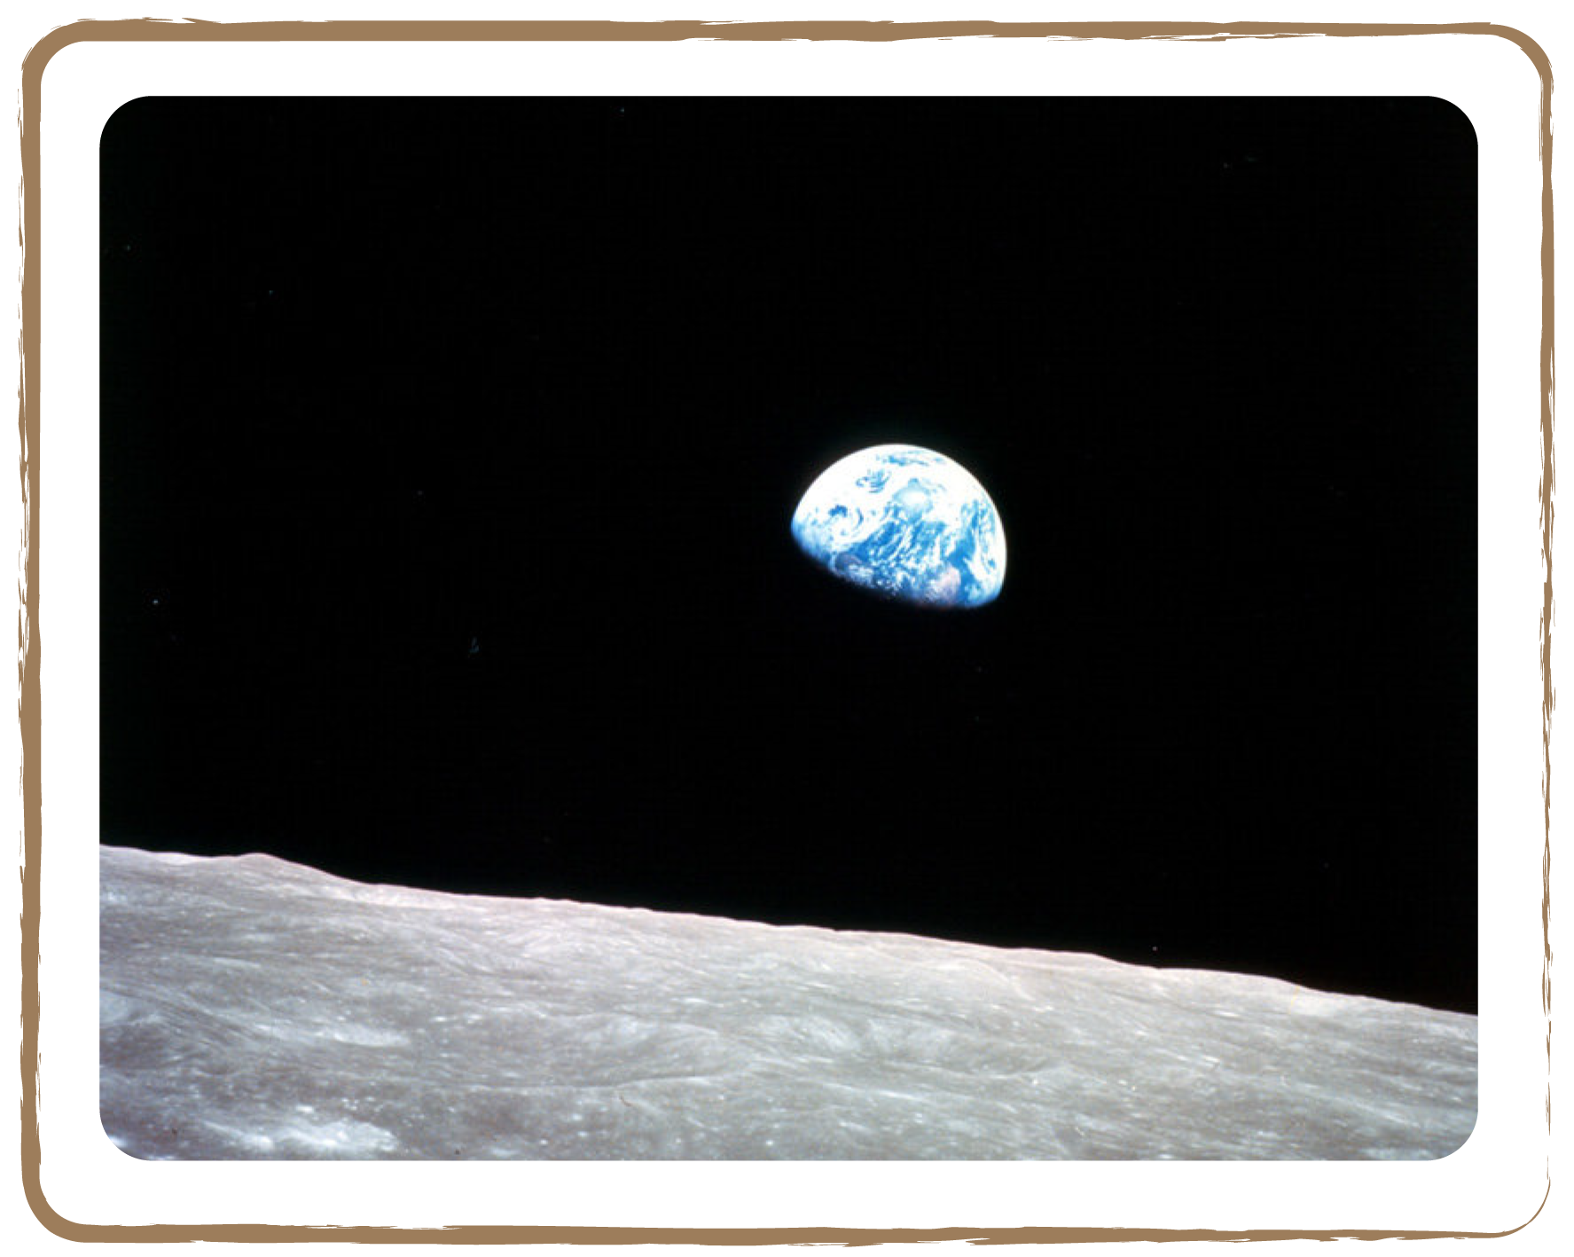
Credit: NASA

Earth Facts

Age | About 4.5 billion years
Diameter | 12,742 km
Mass | 5,974 million billion billion kg (5.974 x 1024 kg)
Distance to the Sun | 150,000,000 km (1 astronomical unit)
Rotation period around own axis | 23 hours 56 minutes (about one day)
Orbital period | 365.24 days (about one year)
Temperature | Between –90°C and 60°C
Gravity | After one second, a falling object reached a speed of 9.81 meters per second.
Inclination rotation axis with respect to orbital plane around Sun | 23.4 degrees

2.1 Spherical Earth

Brief Description

Watch a ship ‘sink’ down the horizon over a flat surface and a globe to perceive Earth’s shape.

Keywords

• Earth
• Shape
• Globe

Materials

• Globe (Box)
• Origami ship (Appendix)
• Toy figures (Appendix)

Learning Objectives

Perceive the spherical shape of the Earth.

Background Science

Children can make a simple observation to determine for themselves that the Earth is round. A captain standing on the seashore observes a ship going away from him. He will realise that the ship not only becomes smaller at the horizon (because distant objects seem smaller), but it also seems to sink: the hull is the first part to disappear, and the mast top is the last. How can all this be explained? Some centuries ago, people noticed ships sinking in or rising from the horizon, from which they concluded the Earth must be round. If the Earth were flat, ships wouldn’t sink while moving away, they would just keep getting smaller and smaller.

Full description

- First, ask the children to make a small origami ship (see Appendix).
- Take the origami ship and a toy figure (see Appendix) and place them on a table top, representing a flat Earth.
- Let the children watch the ship sail away from the perspective of the figure. They will see the ship getting smaller and smaller.
- Now put the origami ship and the toy figure on a globe, which represents a round Earth.
- Again, ask the children to watch the ship move away from the perspective of the figure. They will notice the ship not only gets smaller, but it will ‘sink’ as well. Let them describe in their own words what they see.

Related activities: 2.2

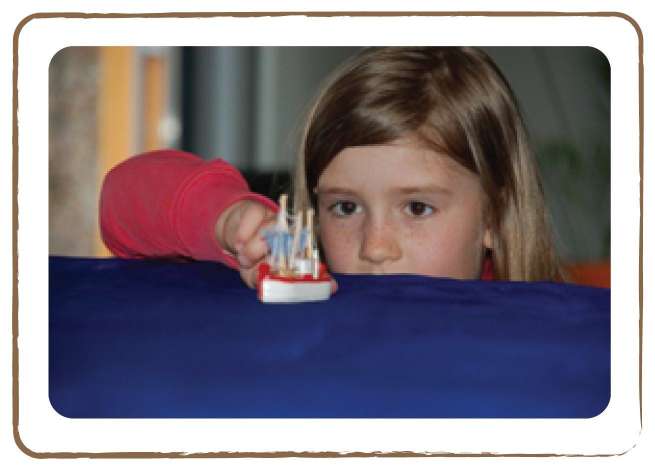

Credit: Natalie Fisher
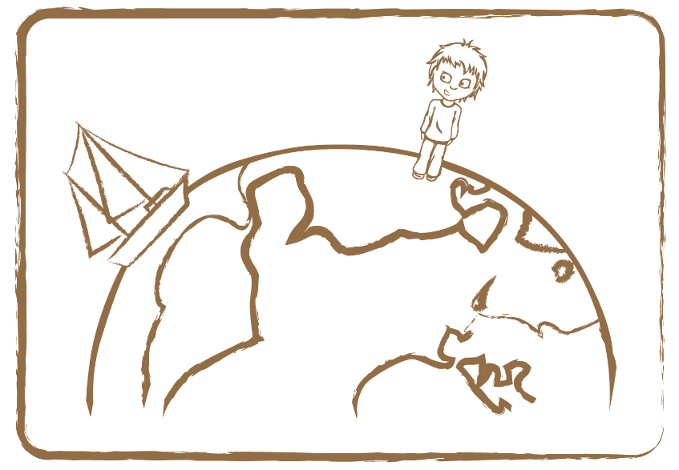

Credit: UNAWE C.Provot

On a flat surface, you only see a ship getting smaller and smaller (top). On a spherical shape, you see the ship getting smaller and also sinking in the horizon (below).

2.2 Up or Down

Brief Description

Show that the Earth has no ‘up and down’ by putting an ice bear on the North Pole of a globe and a penguin on the South Pole and explain the direction of Earth’s gravitation.

Keywords

• Earth
• Gravity
• Up/down

Materials

• Globe (Box)
• Toy penguin (Appendix)
• Toy ice bear (Appendix)

Learning Objectives

Obtain a feeling for the direction of the Earth’s gravitation. Learn that in reality, there is no ‘up’ or ‘down’; this is merely our perception.

Background Science

Adults consider some concepts obvious that give children difficulty: for example, imagining people standing on the Earth’s surface. If the globe’s North Pole faced ‘upwards’, then people in Europe would be standing on a slippery slope. It is even stranger to imagine people living on the equator, not to mention inhabitants of the Southern Hemisphere. Why don’t they fall off the planet?

In our everyday experience, the world is limited to everything within our horizon. On such a small scale, the Earth’s surface is flat, and gravity seems to pull everything ‘down’. What is up, must come down. Children easily translate this local perspective onto the whole world. On a global scale, however, there is no force that pulls everything down. There is only a force that pulls everything towards the centre of the Earth. For people on the South Pole this means an ‘upward’ force. But from their perspective, it’s just a regular downward force.

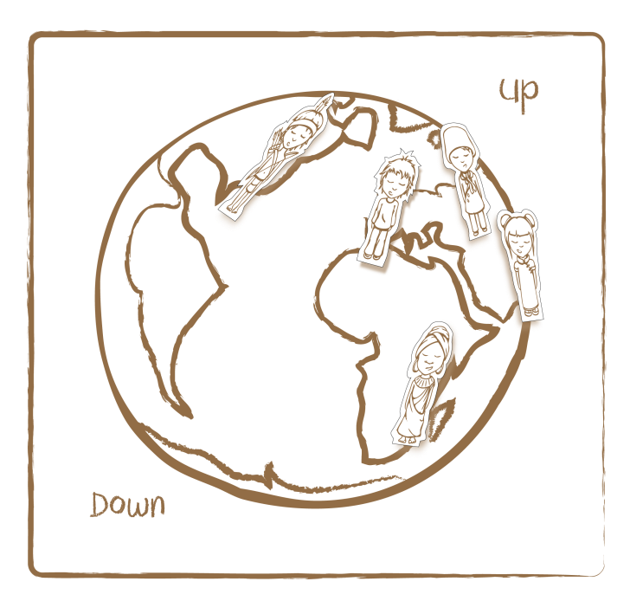 Credit: UNAWE C.Provot

This is the way people from the Northern Hemisphere perceive gravity. However, gravity points to the centre of the Earth, meaning there is no real “up” and “down”, which prevents people on the Southern Hemisphere from falling off the Earth.

Full description

- Show the children a globe with an ice bear on top, and a penguin on the bottom.
- Ask one child to be the ice bear’s voice, and another to be the penguin’s. Let them start the following dialogue.
- Ice bear: “Hey, down there! How’s that, living with your head down? That must be very uncomfortable, right?”
- Penguin: “Me??? You are the one that lives with his head down, not me!”
- While the penguin is answering, quickly turn the globe upside down and alternately let the penguin stand ‘on top’.
- Both animals (and also the children) will understand that because the Earth’s gravitation is always directed to the centre of the Earth, there is no ‘up and down’ and therefore, neither of the animals is standing upside down, let alone falling off the Earth.
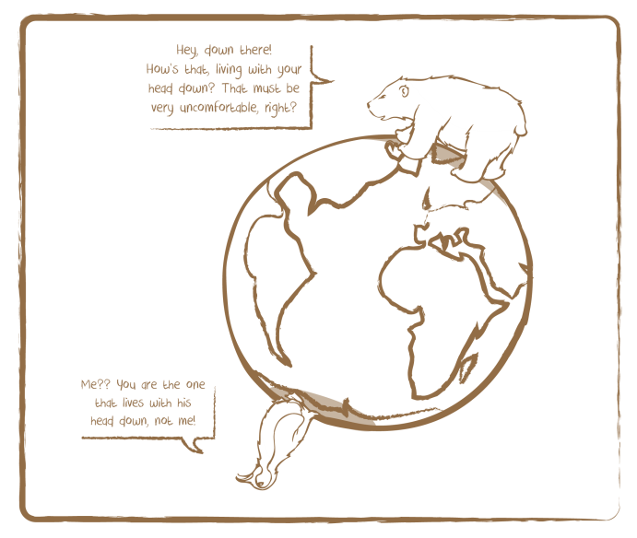 Credit: UNAWE C.Provot

Tip: Distribute ‘earth mosaic’ templates (Appendix) amongst the children and ask them to draw a landscape on it with coloured pencils (above the dashed line they can draw houses, mountains and forests, and below it the seabed or mines or rocks). This way they create a picture with an upper and lower section. Then let them cut out the template. Now ask the children (preferably a group of 16) to lay their templates on the floor in a circle, to form a round mosaic. Let the children search the ‘up’ and ‘down’. They will notice there is no real ‘up and down’ anymore! Depending on which side you are looking from, the pictures are only oriented differently! This exercise helps to break the fixation on ‘up and down’.

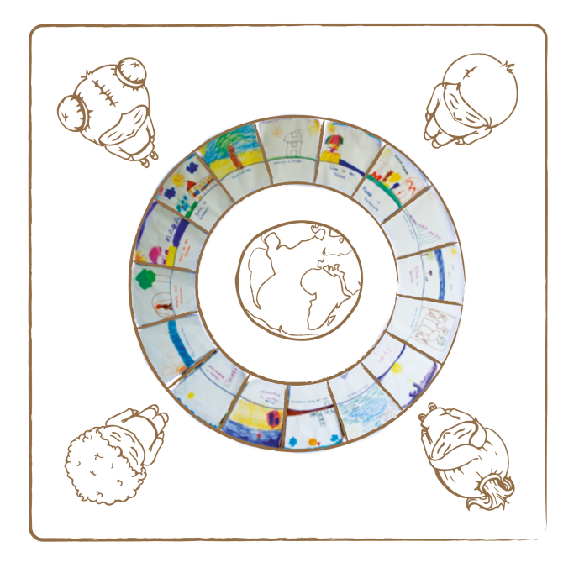 Credit: UNAWE C.Provot

Related activities: 2.1

2.3 Our Home Planet

Brief Description

Understand the concept of the Earth as one sphere on which all people live, by painting different people and animals on a paper maché globe.

Keywords

• Earth
• Cultures

Materials

• Blue stability ball (120 cm in diameter)
• Paper maché
• Colour paint
• Brushes

Learning Objectives

Obtain a feeling of being a ‘terrestrial’ or ‘earthling’, rather than being part of one culture or country.

Background Science

The Earth is not only a natural habitat for plants, animals and human beings: it also offers space to many different cultures. A central experience that children should have in this project is to perceive themselves as terrestrials. The awareness of being a German, Turk, Russian, Italian or whichever nationality should then lead to the invitation: ‘Show me your world and I’ll show you mine.’ Different cultures are like coequal windows through which the world can be viewed.

Full description

- Take a blue stability ball (120 cm in diameter) and glue paper maché continents on it. Leave them blank and don’t include any country borders.
- Ask the children to paint or stick humans and animals with which they can identify themselves. If there are few different cultures in the class, then provide the children with some information about other cultures (e.g., in the Sahara desert a man in white clothes with a camel).
- The end result will provide different cultures on one and the same sphere, which will give children the feeling they are ‘terrestrials’, rather than just part of their own culture or country. In addition, this exercise gives an easily comprehensible insight into the different habitats on Earth.

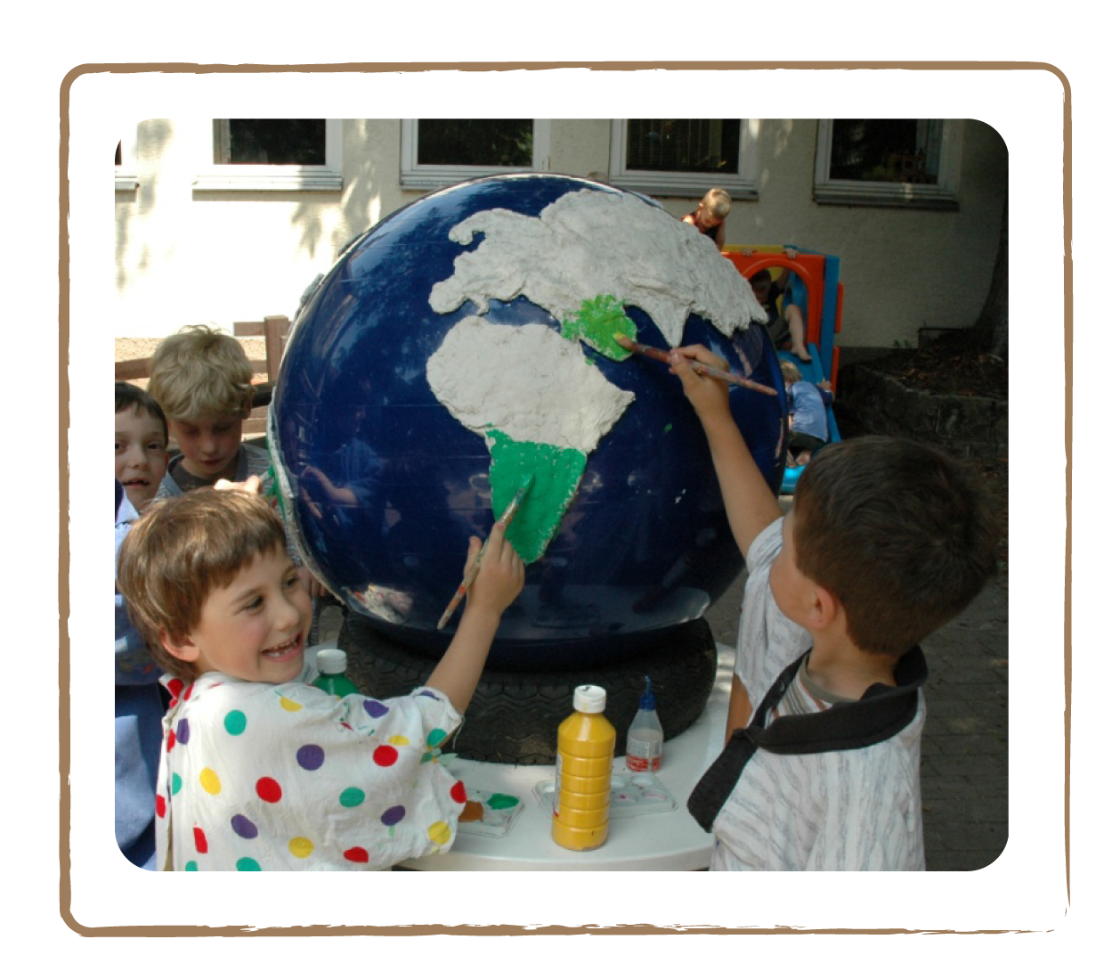 Credit: Cecilia Scorza

Related activities: 1.9

2.4 Day and Night

Brief Description

Perform a story about two people living on opposite sides of the Earth, who experience night and day at different moments.

Keywords

• Earth
• Time
• Day and night

Materials

• Globe (Box)
• Light stand with bulb (Box)
• Two toy figures (Appendix)
• Glue pads

Learning Objectives

Learn what causes day and night.

Background Science

The most ‘everyday’ interaction between the Earth and the Sun is the change of day and night. This is because the Earth spins around its own axis. When you are on the side of the Earth facing the Sun, it’s daytime. Twelve hours later, the Earth has spun half a rotation, causing you to be in the Earth’s own shadow, meaning it’s night-time.
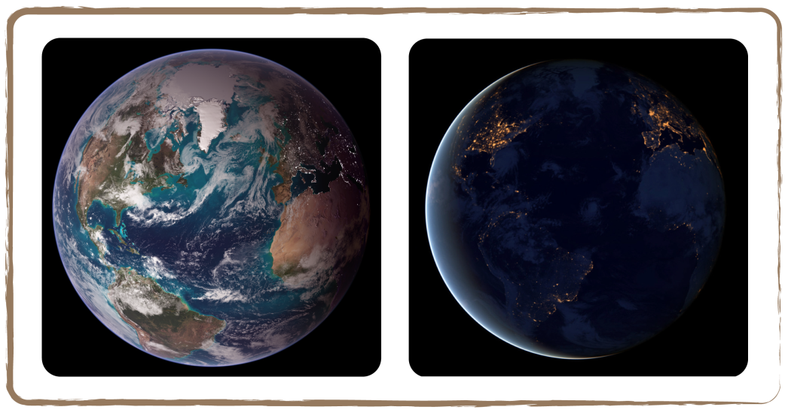 Credit: NASA

From an outsider’s view, the Earth performs one complete rotation around its axis in 23 hours, 56 minutes and 4 seconds. Our ‘Earth day’, however, is 24 hours long, which is four minutes longer. This is because we define a day such that at noon, the Sun stands exactly in the south again. And for that to be also the case on the next day, the Earth has to rotate a bit more around its axis, as it has proceeded further on its orbit around the Sun. To do so, takes the Earth four minutes.

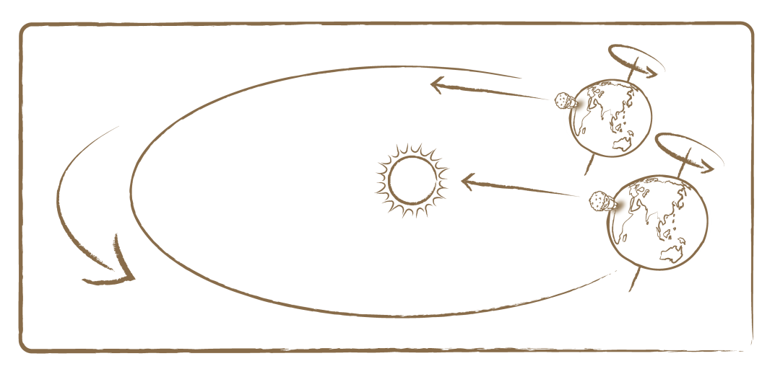
The Earth spins around its axis in 23 hours and 56 minutes. However, since it has travelled further along its orbit around the Sun during this time, the planet must rotate slightly more to put the Sun in the same position in the sky for any specific time as the day before. This is why we have 24 hours in a day.
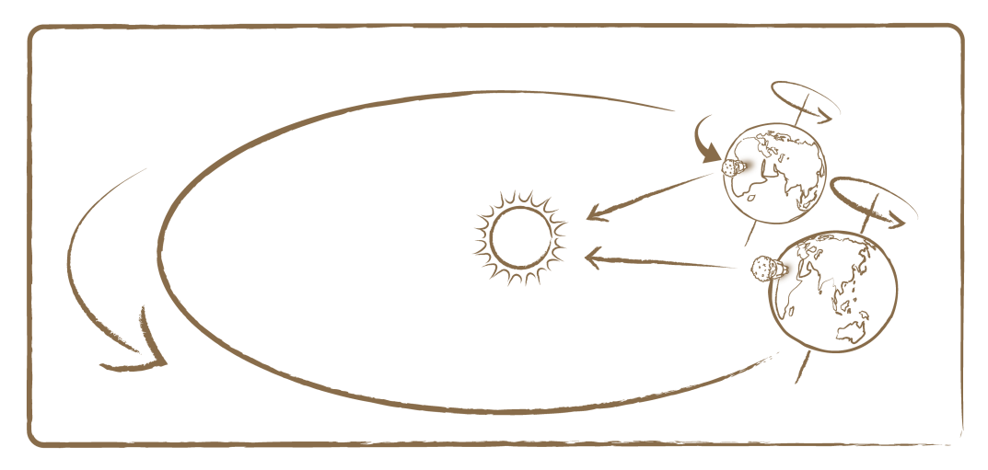
Credit: UNAWE/C.Provot

In one year (365 days and about 6 hours), the Earth revolves once around the Sun at an average distance of 149.6 million kilometres (which corresponds to a chain of 100 Suns). There is an apparent discrepancy between a year (365 days) and the time it takes the Earth to orbit the Sun (365.24 days). To make up for this quarter day difference, we have a leap year every four years — an additional day on February 29th. Without this leap day, the seasons would shift one day every four years, eventually resulting in a summer Christmas (on the Northern Hemisphere)!

Then there still is the problem that the difference is not exactly one quarter (0.25), but actually 0.24 days. To solve this, we don’t have a leap day on the turn of a century (e.g., there was no leap day in 1900). But then why was there a leap day in 2000, you ask? Because to really make it all fit — and to make it more confusing — we do have a leap day on the turn of a century that’s divisible by 4 (e.g. 1600, 2000 and 2400).

Full description

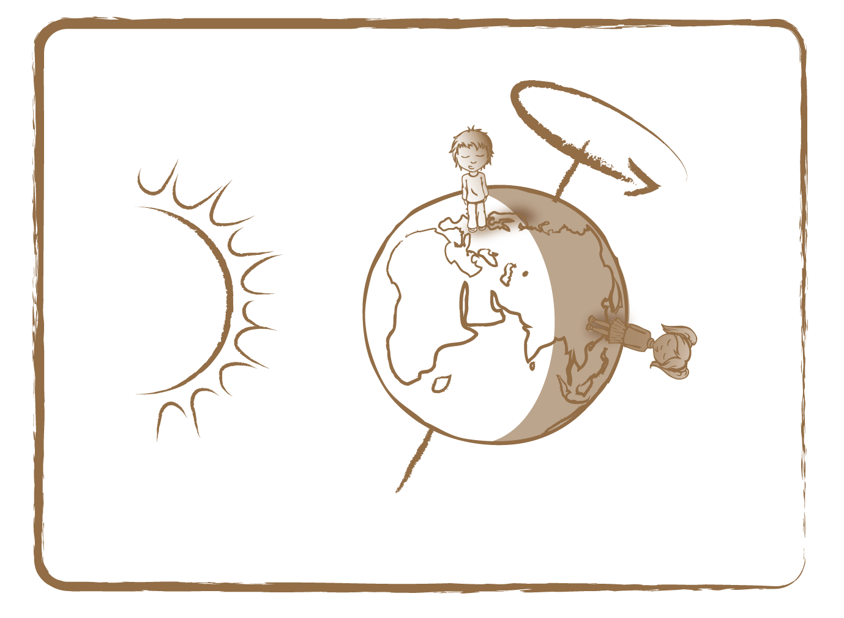 Credit: UNAWE C.Provot

- Put two toy figures (see Appendix) on a globe: one on Germany and one on China. While telling the children the following story, shine a bright lamp (the Sun) on the globe.

Moni and Michael are brother and sister and live in Germany. Moni’s godmother enjoys travelling a lot, and this time she has taken Moni with her to China. In the meantime, Michael stays in Germany and attends kindergarten. On one afternoon, Michael comes home hungry and his mother cooks his favourite dish for him: spaghetti bolognese. While the boy enjoys his lunch, he wonders if his sister is having a good time in China and tries to call her mobile phone.

Moni’s phone rings once, rings twice, again and again. Only after the seventh ring Moni answers with a sleepy voice: ‘Who is there?’ ‘It’s me, Michael! I’m just eating spaghetti for lunch and wanted to call you… So what are you doing?’ ‘Me? I’m sleeping, Michael.’ ‘But why are you sleeping, Moni? Are you ill?’

- Now ask the children what’s going on.
- To explain, slowly rotate the globe in the direction of the arrow ‘from west to east’ (see figure). The children will realise that at some point, night will fall where Michael is and day will break where Moni is, and vice versa. How long does Michael have to wait until he can reach Moni without waking her?

Tip: This story is also very suitable for introducing the time zones on Earth!

Related activities: 3

2.5 Seasons

Brief Description

Tell a story about different seasons on two hemispheres, while holding a globe tilted towards a light bulb.

Keywords

• Earth
• Seasons

Materials

• Globe (Box)
• Light stand with a bulb (Box)
• Two toy figures (Appendix)
• Glue pads
• Flashlight

Learning Objectives

Learn how the position of the Earth in relation to the Sun causes seasonal changes.

Background Science

The Earth is not isolated in space: the Sun and the Moon create exciting phenomena on Earth like day and night, the seasons and eclipses.
In the context of the seasons, it is important to stress that the Earth has a fixed orientation in space: the Earth’s rotation axis is stable, i.e., not wobbling. It always points in the same direction: the north end points towards the Polar Star, which consequently is located exactly north in the sky, regardless of where you are (on the Northern Hemisphere). This stable axis is not perpendicular to the Earth’s orbital plane around the Sun, but is inclined to the latter by about 23 degrees. This causes the seasons.

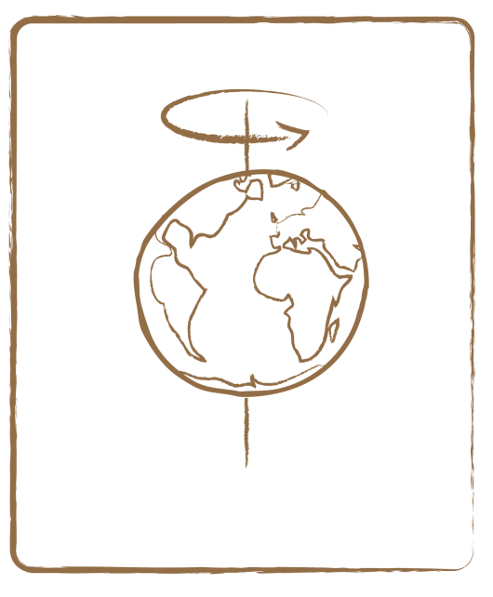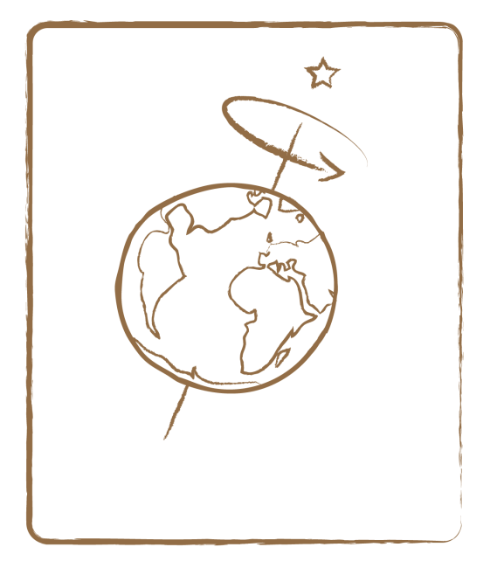

Wrong: Earth axis is not inclined Right: Inclined Earth axis

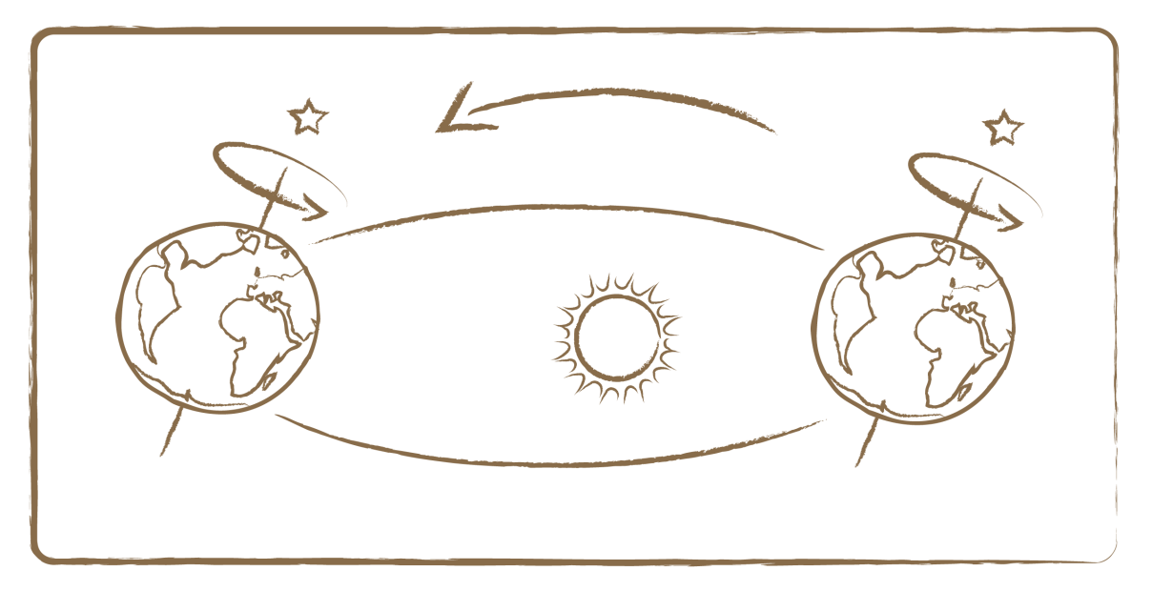

Credit (all three): UNAWE C.Provot

Depending on the stage of orbit the Earth is in, the Northern or Southern Hemisphere collects sun rays at a more direct angle, causing summer on that hemisphere.

Dates

If you are at 23 degrees southern latitude (Tropic of Capricorn) on 21 December at noon, the Sun’s rays fall on your head exactly at a right angle: you don’t have a shadow! This right angle means the sun rays have maximum impact, making it summer on the Southern Hemisphere. At the same time, children are having snowball fights on the Northern Hemisphere. It’s winter there, because the sun rays are falling in at a wide angle, having minimum impact.
On 21 March, the sun rays are impacting the equator at a right angle. Now the Northern and Southern Hemisphere share the same temperature: on the former it’s spring, on the latter it’s autumn. Three months later, on 21 June, the Sun’s rays fall in at a right angle on Tropic of Cancer (an imaginary ring at 23 degrees northern latitude). Now they have maximum impact on the Northern Hemisphere: it’s summer in Europe. Again three months later, on 21 September, the equator gets sun rays from a right angle once again. The Northern and Southern hemisphere once again have the same temperatures, only this time it’s autumn on the former, and spring on the latter.

Misconceptions

As you see, all that matters is the angle at which the sun rays fall on the Earth’s surface. As the Earth orbits the Sun, both hemispheres take turns facing the Sun at a right angle, because the Earth’s axis is tilted. This eliminates two misconceptions about what causes the seasons. Some people think the seasons change because the Earth’s distance to the Sun varies. It actually does, but this has very little effect, and is not what causes seasonal changes. (Besides, this wouldn’t distinguish both hemispheres from each other: it would be summer on all places at the same time.) Furthermore, it is sometimes wrongly assumed that due to the Earth’s tilted axis, each hemisphere is at turns closer to the Sun, at which point it is summer in that spot. The hemispheres indeed are closer to the Sun at turns, but this is such a minor difference that it has no effect. The real cause is the angle of the incident sun rays!

Moni and Michael

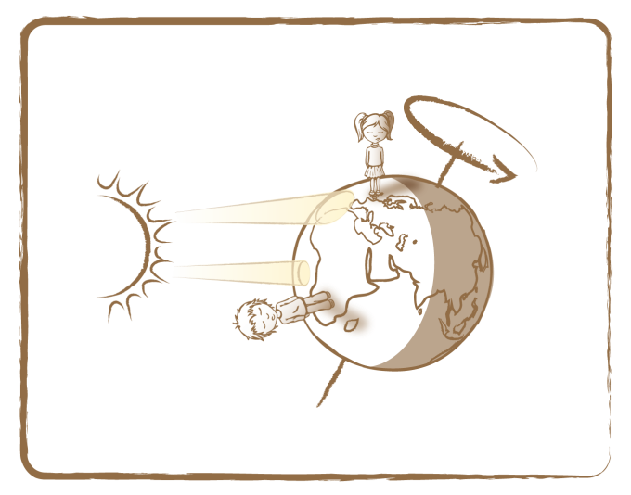 Credit: UNAWE C.Provot

To illustrate the effect of this angle, let’s look at the picture. Moni and Michael both stand on the day side of the Earth. Moni stands in Ireland (Northern Hemisphere). There, a bundle of sun rays strikes the surface with some inclination and disperses over an area. Michael stands in South Africa (Southern Hemisphere). The bundle of sun rays strikes on him almost at a right angle, and disperses over a much smaller area as compared to Moni’s location.

The story of Moni and Michael depicts winter on the Northern Hemisphere and summer on the Southern Hemisphere (1) (see figure on the next page). But six months later, when the Earth is on the other side of the Sun, the situation is opposite (3): The Sun’s rays now reach Moni almost at a right angle (summer in the north), while at Michael’s location they fall in skewed (winter in the south). Intermediate position (2) corresponds to spring on the Northern (N) and autumn on the Southern (S) Hemisphere. At intermediate position (4), the situation is exactly opposite.
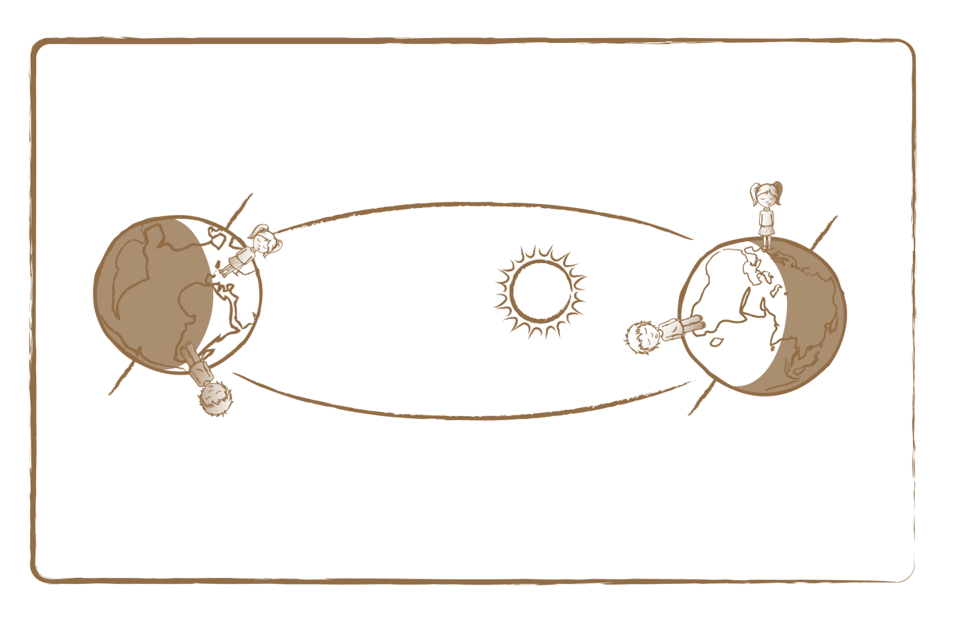
Summer (S)

Autumn (N)
Spring (S)

Winter (S)

3 Summer (N)

1 Winter (N)

2 Spring (N)
Autumn (S)

Credit: UNAWE C.Provot

Other sources: Short movie of Earth’s orbit: http://goo.gl/eQW4l

Full description

- Glue two toy figures (see Appendix) on a globe: one on Ireland and one on South Africa.
- While telling the children the following story, shine a bright lamp (the Sun) on the globe.

Moni and Michael are brother and sister and are from Germany. They love travelling, so they each go on holiday abroad. Michael flies to South Africa (Southern Hemisphere) with his godfather, and Moni goes to Ireland (Northern Hemisphere) with her godmother. After they have arrived, the children want to call each other and exchange their experiences. Moni calls Michael: ‘Hello Michael! How are you? What are you doing right now?’ Michael answers: ‘I’m fine! I’m just about to go to swimming in the sea.’ ‘Say again????’ Moni shouts out, surprised. ‘At such low temperatures?’ ‘What low temperatures?’ Michael answers. ‘It is 29 degrees Celsius and I’m sweating all the time! But what are you doing, Moni?’ ‘I’m going to go sledding. It’s freezing cold here!’

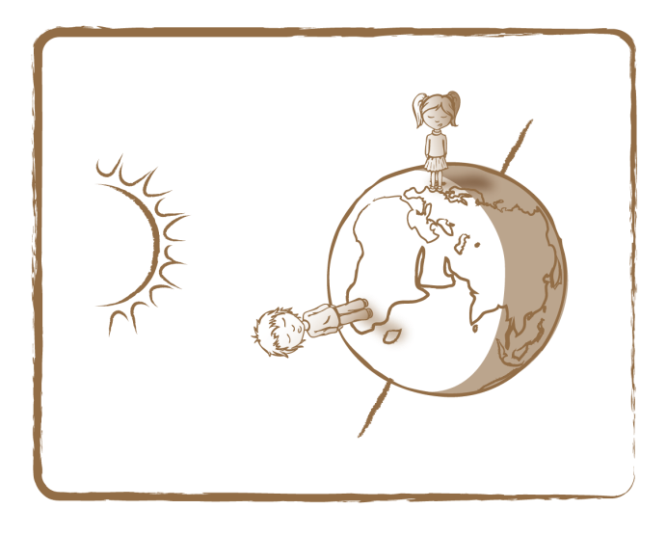 Credit: UNAWE C.Provot

- How is it possible that Moni is cold and Michael sweats, although it’s the same time of day for both children (they are in the same time zone)? Explain to the children the intensity of light reaching Michael (South Africa) and Moni (Ireland). At Moni’s location, the light falls in with some inclination: it appears weaker. At the same time, Michael is standing directly under the strong, blazing Sun (lamp).
- At this point, it may be helpful to light the floor with a lamp: if you hold it vertically, a smaller area is lit, which appears very bright. When the lamp is skewed, the light cone is much larger and the brightness much lower.
- Now hold the globe next to the lamp while holding it at an inclined angle. Make sure that Southern Hemisphere points in the direction of the lamp (see illustration). South Africa is much more brightly lit than Ireland!
- Next, hold the globe on the other side of the lamp. You just skipped half a year (or half an orbit around the Sun). This time, Moni receives the light more directly (summer in the north) and Michael gets the sun rays from a wide angle (winter in the south).

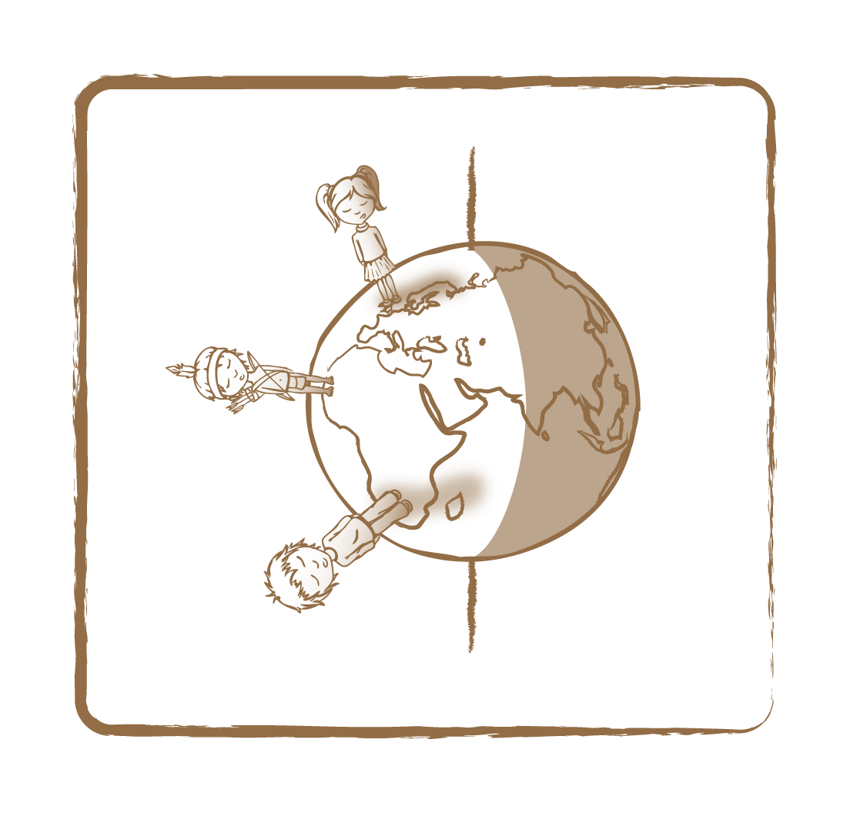 Credit: UNAWE C.Provot

Tip:

- While carrying out the activity, don’t forget that the Earth’s axis always points in one and the same direction (to the polar star)!
- Now put a third toy figure – Pedro – on the globe, on the equator in the middle of Africa. Repeat the activity. Does it matter for Pedro where the Earth is in its orbit around the Sun? For him, the consequences of an inclined axis are much less extreme. For this reason, people on the equator don’t know seasons like for example Europeans do.
- To emphasise that there would be no seasons if the Earth’s axis were perpendicular to its orbit, you could do the activity again, but this time you hold the axis straight up. While the globe turns around the lamp, the light intensity doesn’t change anywhere. In this case, we would only speak of (horizontal) climate bands. Pedro would always catch the sunlight from a straight angle. Moni and Michael, who are farther away from the equator, receive less sunlight and are colder. Moving farther away, towards the poles, it gets increasingly colder.

Related activities: 3.5

2.6 Solar Eclipse

Brief Description

Visualise a solar eclipse by creating a shadow on a globe with a small ball.

Keywords

• Earth
• Sun
• Moon
• Eclipse

Materials

• Globe (Box)
• Moon sphere (Box)
• Flash light

Learning Objectives

Learn the mechanisms behind a solar eclipse.

Background Science

By sheer coincidence, the apparent sizes of the Moon and the Sun in the sky are equal. The Moon is many times smaller than the Sun, but it is also closer to Earth, in the right proportion. As a consequence, when the Moon is exactly between the Sun and the Earth, the solar disk on the sky is exactly covered by the Moon. This makes a solar eclipse extra special!

On the picture below, Moni is standing in Africa. It is shortly before noon, and the Moon — circling around the Earth — is exactly aligned with the Sun and the Earth. And then it happens: as seen by Moni, the Moon shifts in front of the Sun, covers it and Moni is standing in the Moon’s shadow. The temperature drops and it gets dark as night. The animals think it’s time to sleep!

The Moon is too small to put the entire Earth at once in its shadow. During a solar eclipse, it only marks the Earth with a small black dot. This shadow travels across Earth’s surface, because the Earth spins and the Moon moves. When you experience a partial solar eclipse, you live just outside the area where the Moon fully blocks the Sun.
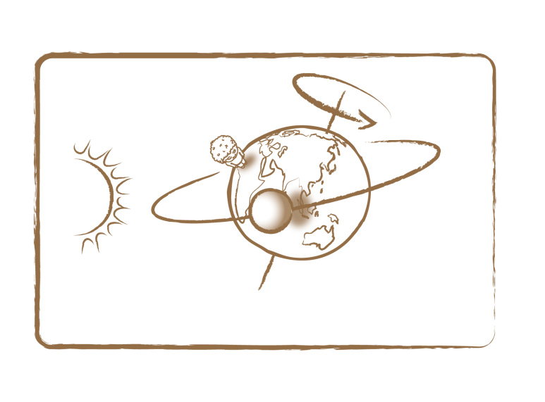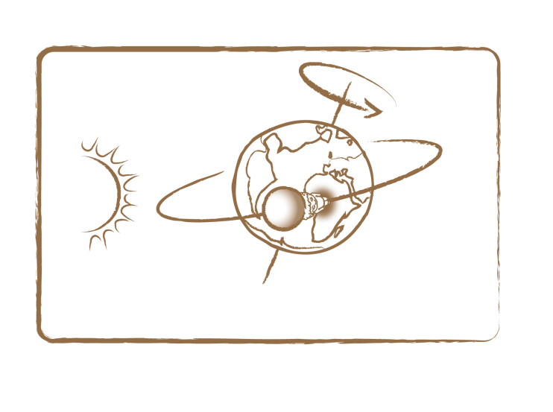 Credit: UNAWE C.Provot

Other sources: Movie explaining solar eclipse: http://goo.gl/7Z4HJ

Moni is in Africa. Because the Moon is exactly between the Sun and the Earth, it will shortly cover the Sun on the sky and cast a shadow on the Earth (left picture). Soon thereafter, the shadow reaches Moni: everything turns dark and the animals go to sleep. The left image also reveals the umbra, or complete shadow on Earth, which is darkest, and the penumbra, or partial shade, which is not as dark.

Full description

- Place a globe (Earth) on a table and glue a toy figure (see Appendix) on the country you are in.
- Now shine a flash light on it (Sun) and hold a small white ball (Moon) between the globe and the light, creating a shadow just east (right) of the toy figure.
- Then slowly spin the Earth from west to east (left to right), eventually covering the figure with the shadow.
- Explain to the children that this is what happens during a solar eclipse.
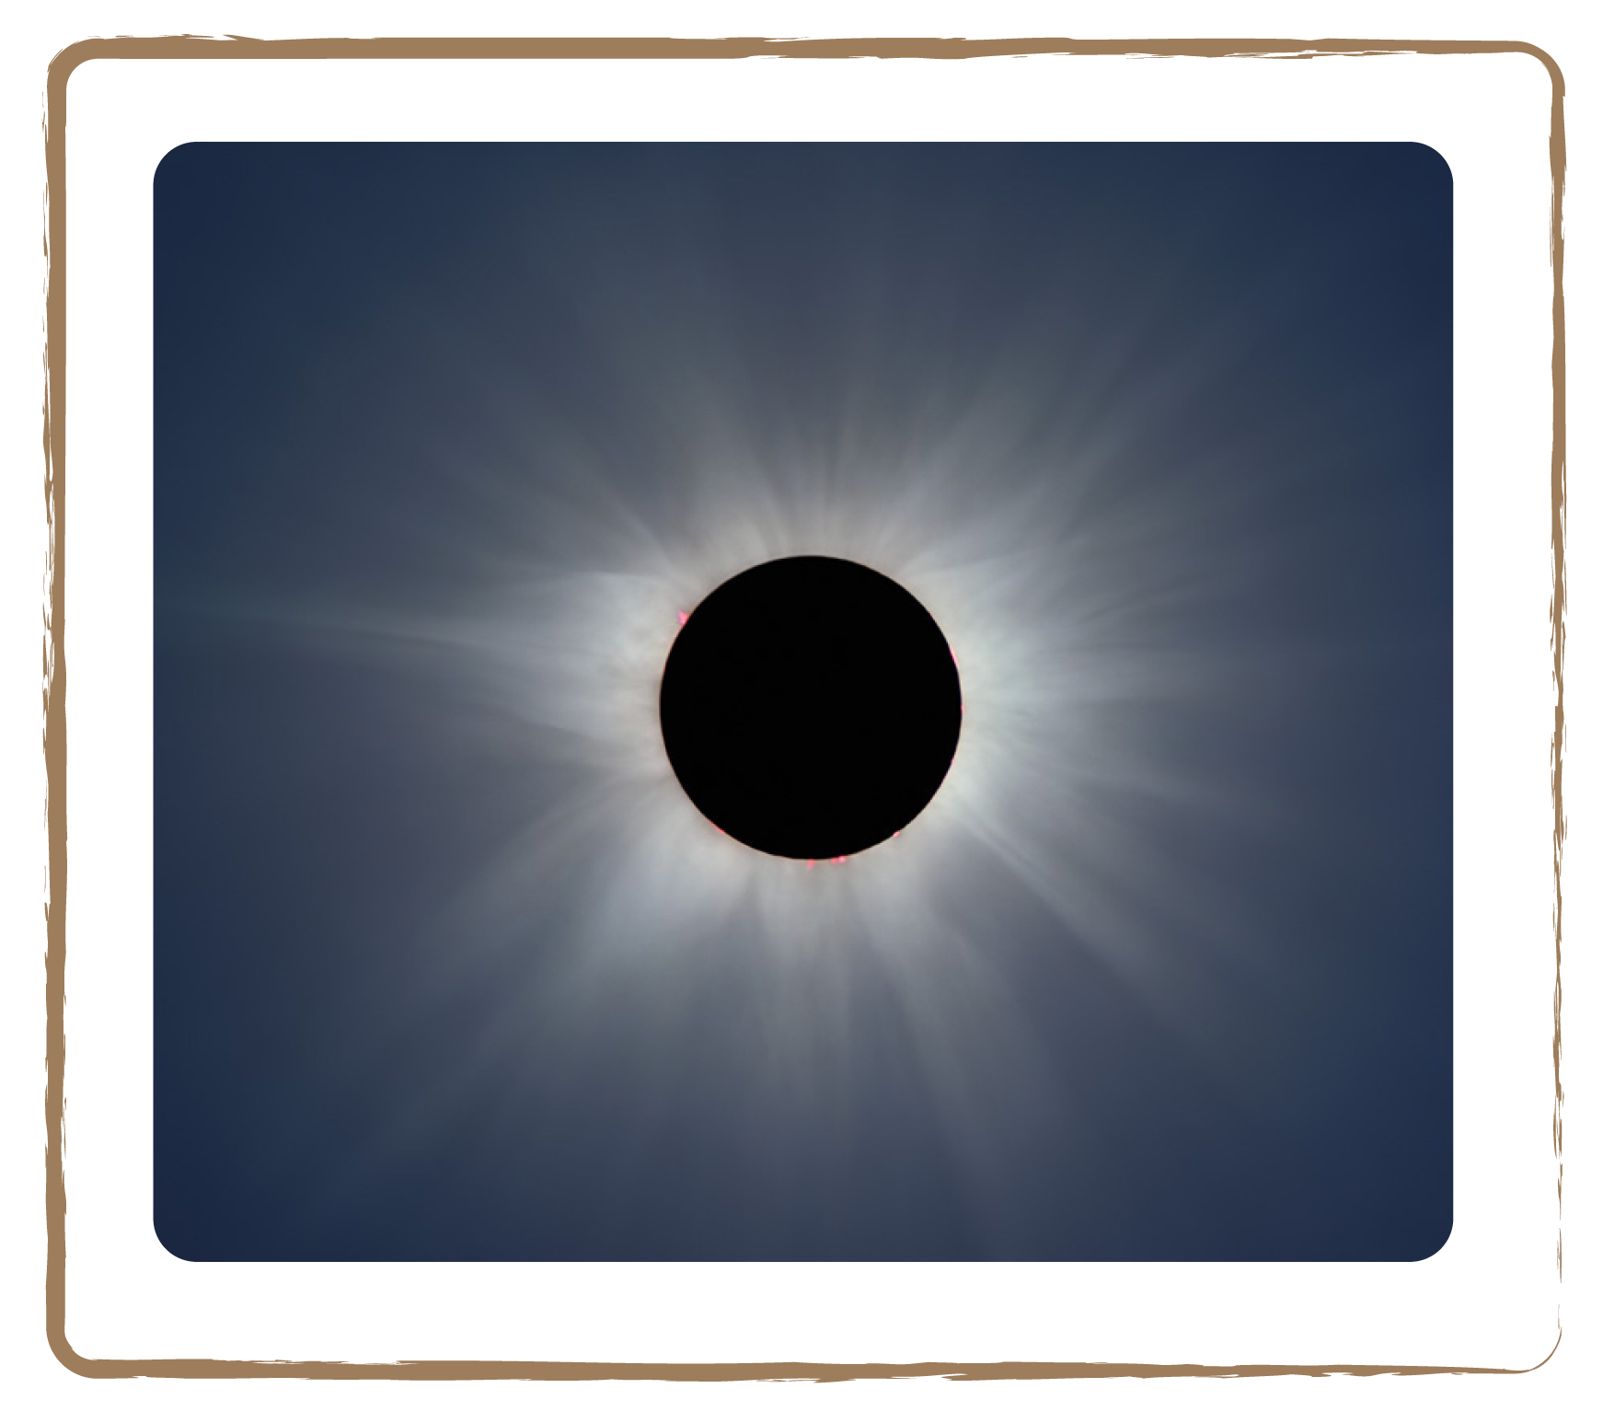
Credit: ESO

Tip: To make the story more vivid, tell a short introduction in which the figure is doing something fun, and then suddenly it gets dark.
Related activities: 2.8, 3.2

2.7 Lunar Eclipse

Brief Description

Visualise a lunar eclipse by creating a shadow on a small ball with a globe.

Keywords

• Earth
• Sun
• Moon
• Eclipse

Materials

• Globe (Box)
• Moon sphere (Box)
• Flash light

Learning Objectives

Learn the mechanisms behind a lunar eclipse.

Background Science

The Moon not only causes solar eclipses, it can also get dark itself. How does that happen? As the Earth is illuminated on one side by the Sun, it casts a shadow behind it at the same time. So when the Earth gets in between the Sun and the Moon, a lunar eclipse occurs. In this situation, the Earth covers the Moon with its shadow. If there were people living on the Moon, they would see this as a solar eclipse! However, instead of getting completely dark, the lunar surface glows reddish. The Sun’s light is refracted into the shadowed area by the Earth’s atmosphere. Because the light has travelled a long distance through our Earth’s atmosphere, it is reddish as in a sunset. Thus, the Moon looks rather coppery than black during a lunar eclipse. It is interesting to note that the redder the Moon, the dustier our atmosphere!

In ancient Greece, philosopher and scientist Aristotle closely observed lunar eclipses and concluded from it that the Earth must be round. How? If you look very closely at the photograph on the right, you clearly recognise the Earth’s shadow is round! This is proof of the spherical shape of the Earth!

Other sources: Movie explaining lunar eclipse: http://goo.gl/UJCdW

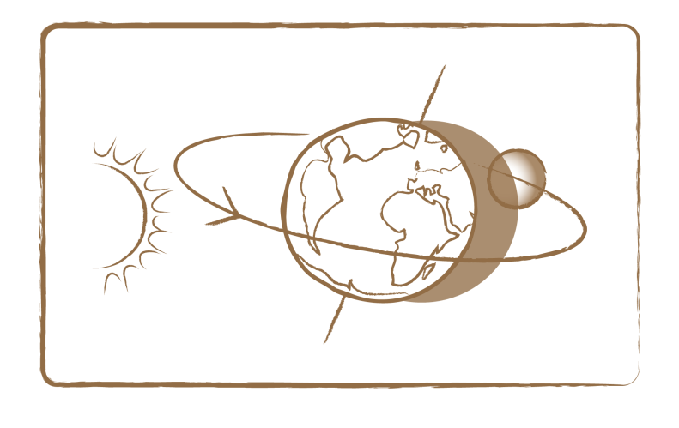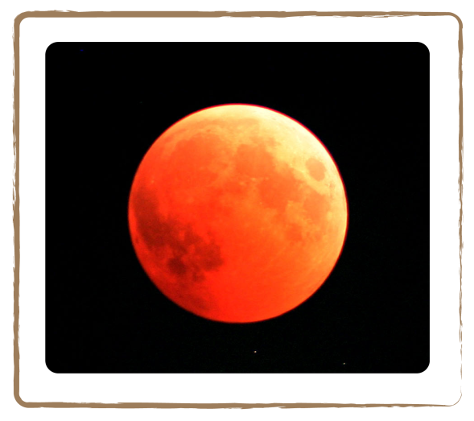

Credit: UNAWE C.Provot Credit: University of South Africa

The Moon glows red during a lunar eclipse.

Full description

- Place a globe (Earth) on a table and shine a flash light on it (Sun).
- Now slowly move a small white ball (Moon) behind the globe, making it travel through the Earth’s shadow.
- Explain to the children that this is what happens during a lunar eclipse.

Tip: Notify the children when there will be a lunar eclipse, or organise a class activity around the subject! Lunar eclipses occur two to three times a year.

Related activities: 2.7

The Sun, Our Home Star

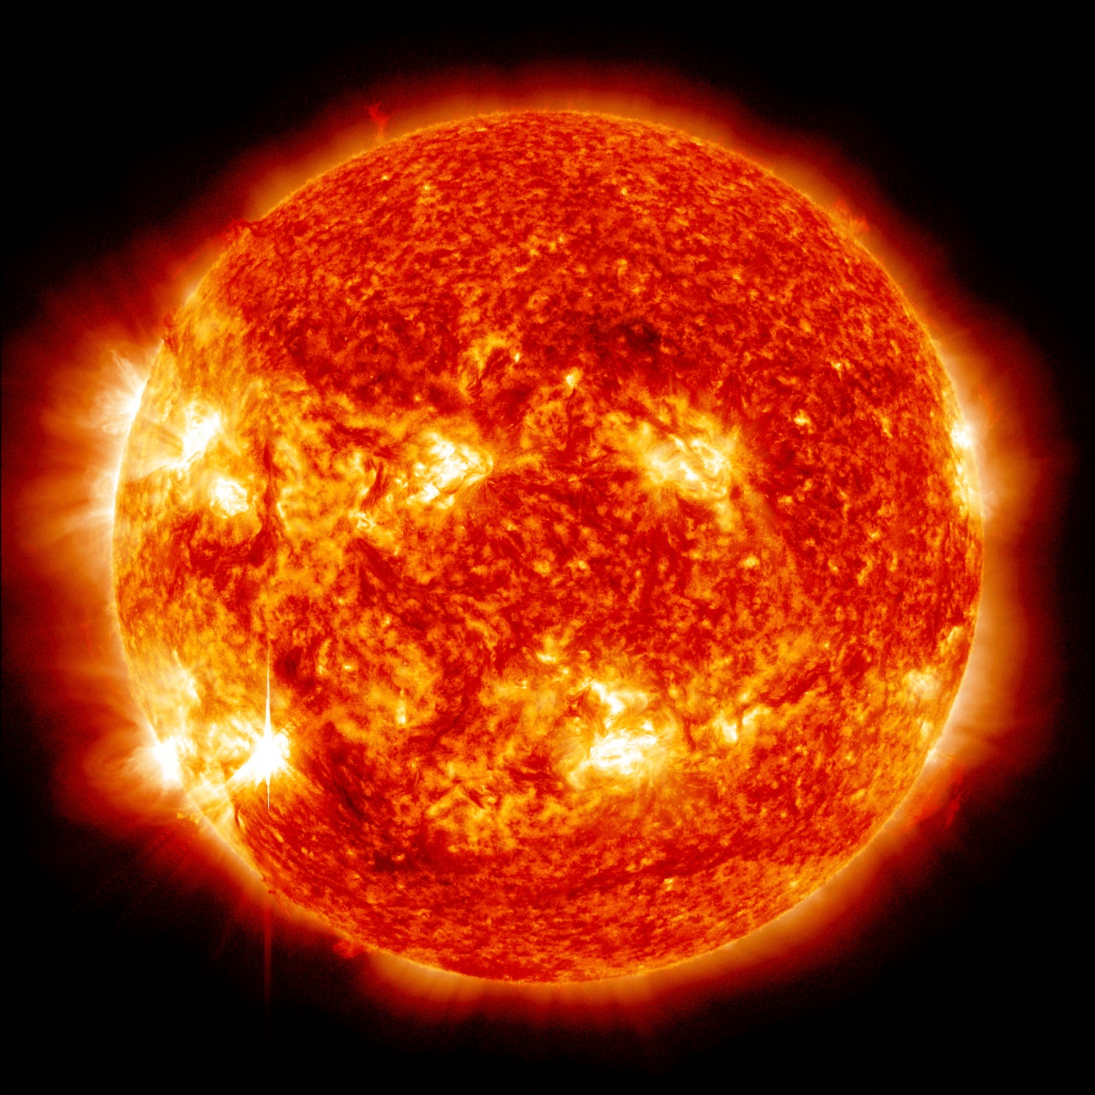

Credit: NASA

Introduction

As seen from Earth, the Sun is the brightest and most noticeable celestial body — much brighter than the Moon and, above all, much brighter than the little stars in the night sky. However, the Sun actually is just a regular star: it is just as big as most stars. It seems so much brighter to us because the Sun is by far the closest star. Much of what we know about stars we have learnt from closely observing our Sun.

The Sun is about 4.6 billion years old and has a diameter of 1.39 million km. This corresponds to a chain of 109 Earths or 400 Moons! That is so immensely huge that our Earth alone would fit one million times into the volume of the Sun. Its distance to the Earth is about 100 times the Sun’s diameter: 149.6 million km. Within a little over 25 days it rotates once around its axis, even a bit faster on its equator than near the poles.

On the outside, the Sun’s temperature is about 5700° Celsius, and deep within the core it’s about 15 million degrees Celsius. Such high temperatures are caused by a process called nuclear fusion, which occurs in the core. The Sun, like most stars, is a hot ball of gas, composed of about 73% hydrogen and 25% helium. The rest are heavier elements like iron, oxygen and carbon. The Sun’s outer layers push so hard on the inside with their weight that enough pressure builds up in the core to make atoms crash into each other. Atoms are tiny particles that make up any substance. While crashing into each other, atoms fuse, thereby forming a new type of atom. For example, four hydrogen atoms can fuse into one helium atom. During this process, energy is released in the form of heat!

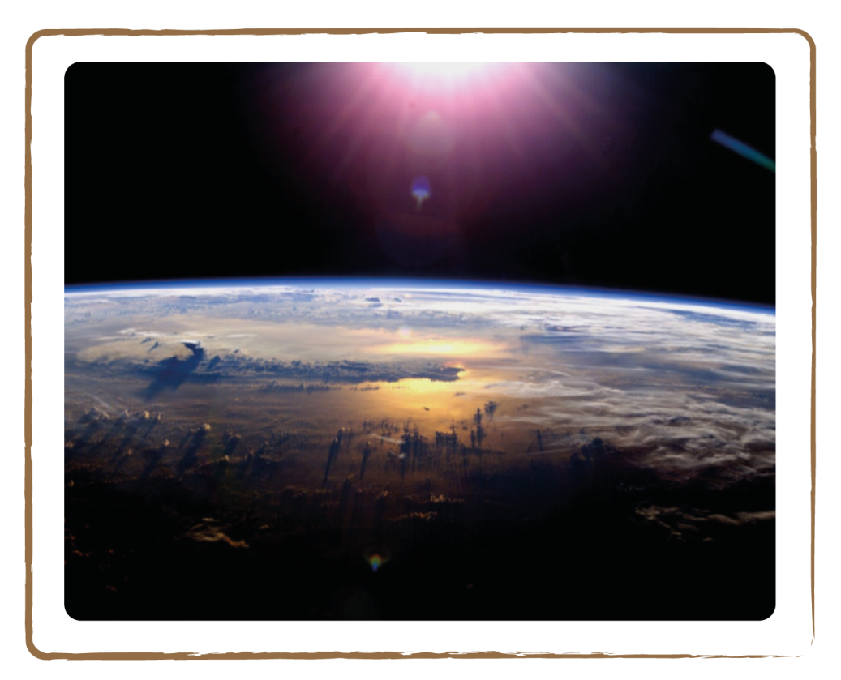

Credit: NASA

Solar Facts

Age | About 4.6 billion years
Diameter | 1,392,684 km (109 Earths in a row)
Mass | 2 thousand billion billion billion kg (2 x 1030 kg)
Distance to the Earth | 150,000,000 km (1 astronomical unit)
Rotation period around own axis | About 25 earth days
Temperature | 5,700 °C on the surface and 15 million °C in the centre
Gravity | If you could stand on the surface, you would be 28 times as heavy compared to your weight on Earth
Composition | 73% hydrogen, 25% helium, 2% other elements, like iron, oxygen and carbon
Fun fact | Although the Sun is just a normal star, compared to a planet it is still huge. The Earth would fit over one million times into the volume of the Sun!

3.1 Apparent Size

Brief Description

Look at the size of spheres on a floor or table top at different distances to understand why some look bigger than others, and understand how eclipses occur.

Keywords

• Sun
• Size

Materials

• 3 balls of equal size
• One large ball (about double the size)

Learning Objectives

Learn why the Moon looks as big as the Sun and why the Sun looks bigger than other stars.

Background Science

Although the Sun looks like the largest star, it’s just as big as most stars that we see in the night sky. The reason why it appears so bright and big compared to other stars in the sky is that it is much closer to us. The stars that we can see in the night sky are simply much farther away from Earth than the Sun, which is why they appear so small and less bright. If we could line up all those stars and our Sun at the same distance from Earth, our Sun would only be of intermediate brightness compared to the other stars. Astronomers therefore differentiate between the ‘apparent’ and the ‘absolute brightness’ of a celestial body.

The Moon is even closer to the Earth than is the Sun. This makes it look like the same size as the Sun, although it’s many times smaller. The fact that the apparent size in the sky is exactly the same for Sun and Moon is sheer coincidence. The Sun is 400 times larger in diameter than the Moon, but by coincidence also 400 times farther away. This has a nice side effect: during a solar eclipse, when the Moon is between the Earth and the Sun, the Moon completely covers the Sun! If the Moon were just a little bit smaller or farther away from us, that wouldn’t be possible.

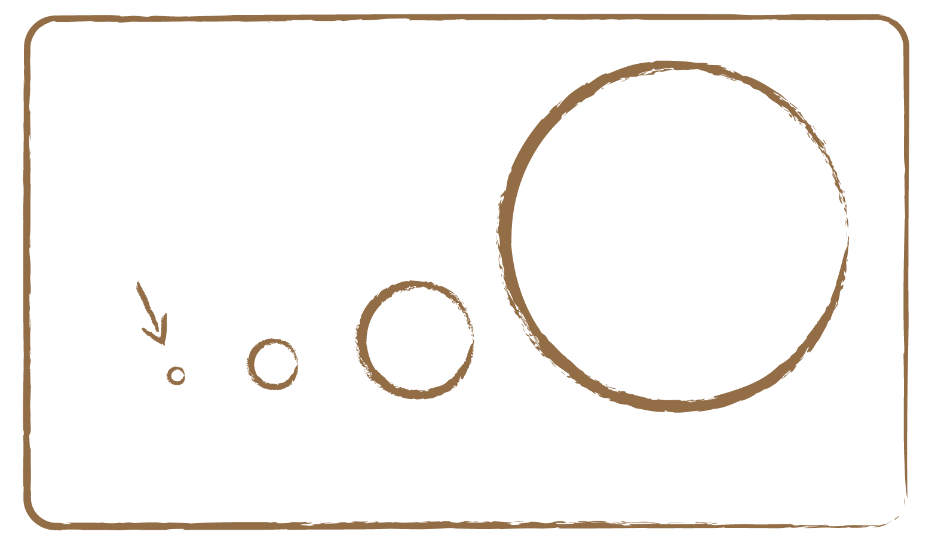
Pollux

Arcturus

Sirius

Sun

Earth is invisible at this scale
Jupiter is about 1 pixel in size

Credit: UNAWE / C.Provot

Some stars are even much bigger than our Sun.

Full description

- Ask the children to put three balls of equal size on the floor, at different distances of 1 meter, 5 meters and 10 meters.
- Now ask them which ball looks biggest to them. But weren’t all balls the same sizes? It seems that the further away an object is, the smaller it appears.
- Put one small and one large ball (about twice the size of the small one) next to each other at about one meter from the children. How could the small one block the larger one?
- Place the large ball one meter farther away, behind the small ball. At this particular distance, the small ball (Moon) completely covers the large ball (Sun). Because the balls’ diameters differ by a factor of two, they look the same size if their distance also differs by a factor of two!

Related activities: 2.7

3.2 Invisible Light

Brief Description

Make infrared radiation visible by looking at a remote control through the camera of a mobile phone to discover invisible light.

Keywords

• Sun
• Light
• Infrared

Materials

• Infrared remote control
• Mobile phone with camera

Learning Objectives

Learn about the special invisible light that the Sun emits, such as infrared.

Background Science

The Sun provides us with light and heat. Without this source, life could not have developed on Earth. The indispensable sunlight looks white to us. White seems to be one specific colour, but actually is a composition of many colours. In the same way orange is a composition of red and yellow, white is a composition of all colours. So sunlight consists of all colours we can see, and a rainbow clearly shows this. When the Sun shows its face on a rainy day, its light is refracted in the water drops and split into its components. All visible colours can be seen in a rainbow. We call this the ‘visible’ light because our eyes can see it. Above the red line and below the blue line, however, there are two additional colours, infrared and ultraviolet (UV), respectively. It’s just that our eyes are not made to see those. Above and below these ‘special’ colours, there are even weirder sorts of light. These invisible types either have very high energy, like for example X-rays, which we use in hospitals to see through our bodies, or low energy, like infrared radiation, whose properties are used in TV remote controls. In order to be able to see this special light, we need appropriate instruments.

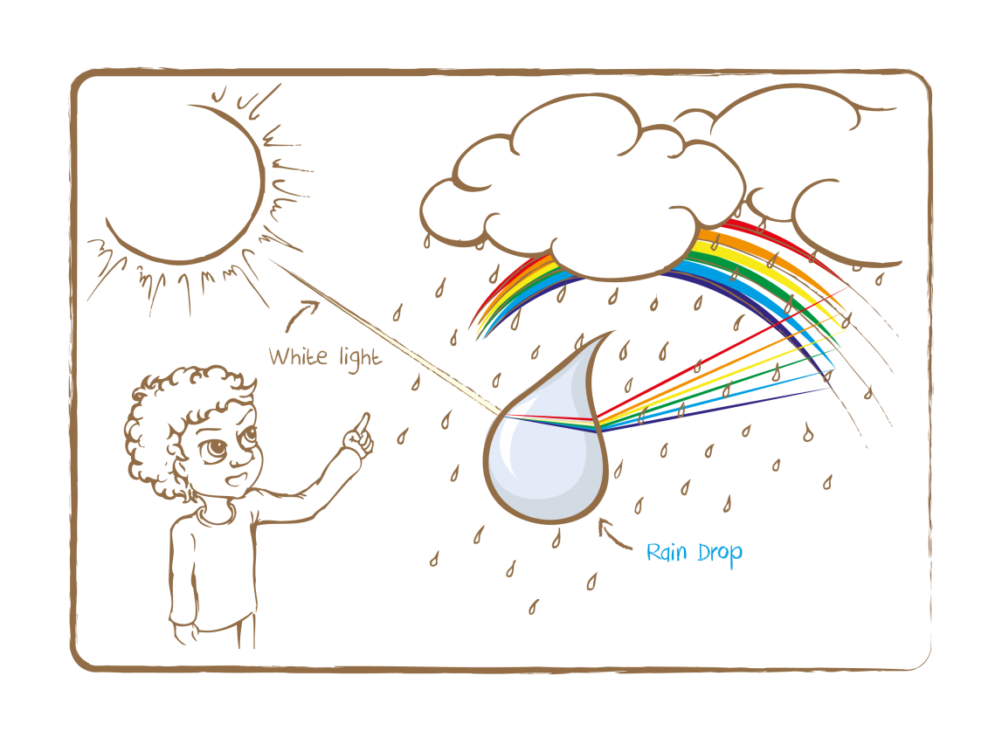
Credit: UNAWE / C.Provot

But why exactly does the Sun shine with all this light? In its interior, the Sun transforms hydrogen into helium. This process – called nuclear fusion – releases lots of energy. This energy keeps the Sun as hot as it is. And like a light bulb in a lamp, the Sun glows because of its high temperature. If you look inside a toaster, you can also see it glow. Because it’s not as hot as the Sun, it only shines with red light. The Sun, however, is so hot that it shines with all possible kinds of light, including X-rays, infrared and UV!

Other sources: Electromagnetic spectrum: http://goo.gl/NS21B

Full description

- Ask the children to take a remote control and press a button. An infrared signal should be coming out of the remote, but why can’t you see it? Is it broken?
- Now let them do the same thing again, but this time make a movie of it with their mobile phone instead of looking at it with their bare eyes.
- Ask them to look at the screen: a light signal does appear, the remote still works! The reason they can now see the signal is that the camera of their phone can see infrared light and projects it on the screen as visible light. Human eyes cannot see infrared.

Tip: You can also ask the children to perform the activity themselves at home. Let them surprise their parents!

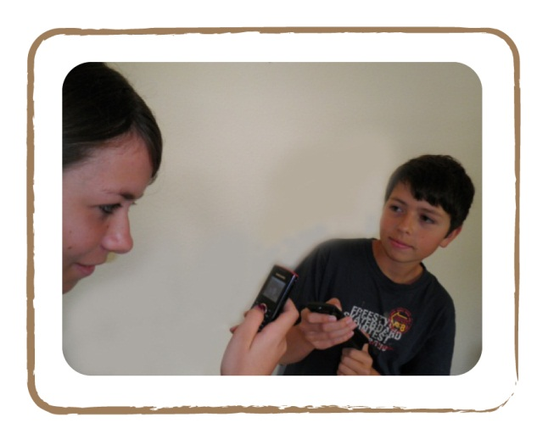

Credit: Cecilia Scorza

3.3 Sun’s Shadow

Brief Description

Watch shadows during the course of day to explore the influence of the Sun’s position in the sky.

Keywords

• Sun
• Shadow

Materials

• Nice weather

Learning Objectives

Discover the influence of the Sun’s position on shadows, and learn about the solar path in the sky.

Background Science

If the Sun’s rays are incident on an object, it will cast a shadow oriented away from the Sun. Our experience shows that the shadow always moves clockwise around the object casting it and its length continuously diminishes between sunrise and noon and, afterwards, prolongs again correspondingly.

However, the shadow length does not only change in the course of a day but also during a year: for example, a noon shadow is much shorter in summer than in winter!

For more background science, see activity 3.4.

Full description

- Ask the children to explore everything in their school related to the solar shadow. For example, how do the shadows of the trees in the schoolyard change during a day? Which parts of the classroom does the Sun shine into in the morning or at noon? What direction does the shadow point to relative to the Sun? When is the shadow smallest, and when is it largest? Is there a practical application for our observation?

Tip: Repeat the exercise in the next season. Did the shadows at noon get bigger? This will be the case if the season got colder (e.g., from autumn to winter). Did the shadows at noon get smaller? This will be the case if the season got warmer (e.g., from winter to spring).
The cardinal directions can be memorised by means of a mnemonic (in clockwise direction): “Never Eat Soggy Waffles!”

Related activities: 3.4
3.4 Sun’s Path and a Sundial

Brief Description

Build a sundial and a horizon model to analyse the sun’s path across the sky.

Keywords

• Sun
• Sundial
• Solar path
• Time

Materials

• Wooden plate with landscape motives
• Toy figures (Appendix)
• Transparent acrylic half-sphere (sky sphere)
• Circular stickers of different colours for three solar paths (summer, spring/autumn and winter)
• Copy of the sundial on stiff cardboard (Appendix)
• Colour pencils
• Scissors
• Glue

Learning Objectives

Learn about the path of the sun during the day at different times of the year.

Background Science

Depending on whether we can see the sun in the sky or not, we call it ‘day’ or ‘night’. Our day begins with sunrise and ends with sunset; accordingly, the night begins with sunset and ends with sunrise. Thereby, the sun always rises in the east, reaches its highest point in the south and sets in the west. At least on the Northern Hemisphere. On the southern, the sun moves from east to west through the north. These observations are easily reconstructed using a horizon model:

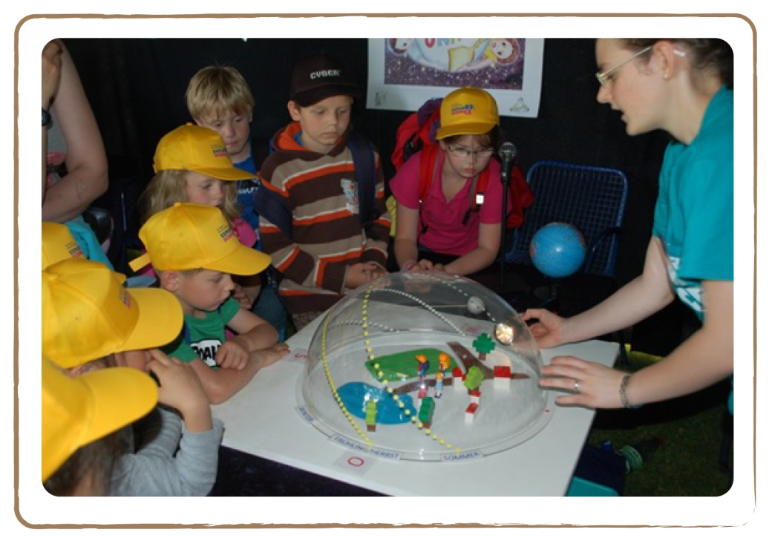
Credit: Natalie Fischer

With this self-made model, students can easily reconstruct the sun’s path on the sky, as in the Explore Science exhibition in the Luisenpark Mannheim in 2011.

The model consists of a white wooden plate with landscape motives. In the middle stands the figure of a child, Oscar. Over the plate there is a transparent acrylic half-sphere (sky sphere), on which the three solar paths (summer, spring/autumn and winter) are glued. In the picture, the paths represent the situation in Germany. The horizon is where the landscape disk and the sky sphere touch. The Sun is represented by a strong torch, which the children can move across the sphere.

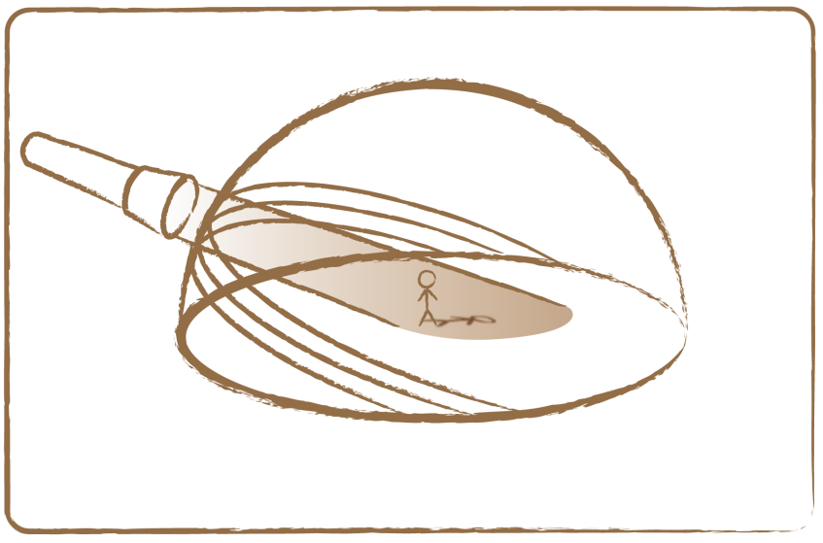Credit: UNAWE / C.Provot
S

w

E

Horizon

N

Atmosphere

Spring path (middle path)

On 21 March, the sun moves along the middle path on the sky. Oscar’s shadow is longer when the Sun is at a low point. At noon, when the Sun is at its highest point, Oscar’s shadow is as short as it gets during that day.

Summer path (upper path)

The sun’s path rises more and more during spring, until it reaches its highest level on 21 June. That day, the sun follows the summer path. The children will notice that the sun has to travel a longer path across the sky than in spring: the days last longer. The sun does not rise exactly in the east anymore, nor does it set exactly in the west, as both points are shifted northwards along the horizon. As compared to the situation on 21 March, Oscar’s shadow is smaller at noon. Still, his shadow length changes during the day.

Autumn path (middle path)

On 21 September, the sun’s path has reached the same level it has on 21 March; the autumn path is the same as the spring path. The shadows at noon are the same, just like the length of a day.
Winter path (lower path)

On 21 December, the sun’s path reaches its lowest point: the winter path. Again, the sun does not rise exactly in the east or set exactly in the west. Only this time, both points are shifted southwards along the horizon, instead of northwards. 21 December is the shortest day of the year, and the shadows at noon are the longest compared to the noon shadows during the rest of the year. Still, the shadow lengths change during the day.

Other parts of the world

The above descriptions of the solar paths during the year only account for the Northern Hemisphere. On the other half of the world, summer and winter are exactly the other way around.

At the equator and the poles, the extreme regions on Earth, it is a different story.

At the North or South Pole, the sun’s path is parallel to the horizon. It has a height of 23.4 degrees above the horizon in summer at the North Pole. This corresponds to the inclination of the Earth’s axis. A horizontal path means that there is no night. During the year, the path sinks down and vanishes below the horizon on 21 September. From then on, it stays dark for half a year, until the sun’s path peaks above the horizon again on 21 March. On the South Pole, the opposite happens. During the eternal night on the North Pole, penguins at the South Pole enjoy daylight that lasts for six months. If Oscar stands on one of the poles, his shadow length doesn’t change during the day.
At the equator, the sun’s path is vertical to the horizon.

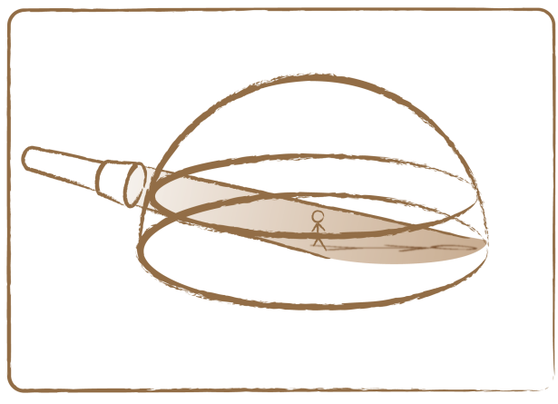
Atmosphere

Horizon
e

Pole

On 21 March and 21 September, the sun moves across the sky from east, through the zenith, to the west. If Oscar would stand on the equator on 21 March at noon, he would have no shadow at all!

On 21 June and 21 December, the paths are shifted by 23.4 degrees to the north or south, respectively. It is noticeable on the equator that the twilight is very short, because the sun sets and rises at a right angle with the horizon. The sun doesn’t slowly slope down sideways, as in, for example, Europe, but instead goes straight down.

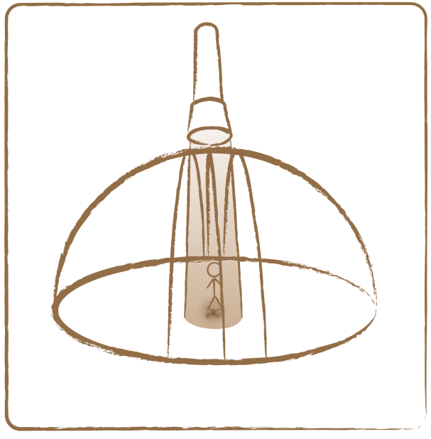
E

S
N

W

Horizon

Atmosphere

Equator

Full description

Because we know all about the different paths the Sun travels across the sky at different locations and different dates, we can use a sundial to measure time!

- Ask the children to cut out and paint all three parts of the sundial from the Appendix.
- Then let them fold them according to the instruction on the copies (see picture): the big clock-face is folded by 90 degrees with the coloured surface to the inside, and so are the two small quarter circles at the two triangles.
- Next, they glue both triangles to each other such that a pair of quarter circles form one half circle.
- Finally, they glue these half circles on the top and bottom of the big clock-face.
- Let the children place the finished sundial on a sunlit place (e.g., the windowsill) and rotate it until the edge of the shadow casts onto the clock-face. Now the triangle indicates the time like a clock-hand. Around noon, the triangle casts no shadow (it points south).

Tip: With a wooden plate, toy figures (see Appendix), round stickers and a glass sphere you can build a horizon model. With this, the children can discover themselves how the sun’s path influences Oscar’s shadow, in relation to both the time of the day and the year.

Related activities: 3.3

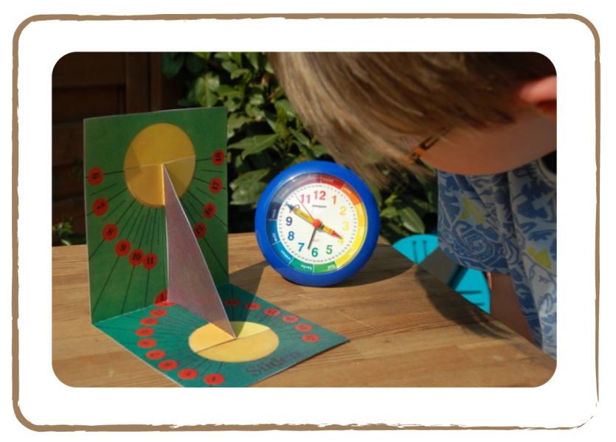

Credit: Natalie Fisher

3.5 Varying day lengths

Brief Description

Observe that different places on Earth have different day lengths by shining a light bulb on different sides of a spinning globe.

Keywords

• Earth
• Time
• Day length

Materials

• Globe (box)
• Light bulb on a stand (box)

Learning Objectives

Understand the cause of variation in day lengths: why winter days are shorter than summer days.

Background Science

Day and night are caused by the spinning of the Earth around its own axis. If that axis were perpendicular to the Earth’s orbit around the Sun, every day would last exactly twelve hours on any location, as would every night. In reality, the Earth’s axis is tilted causing day lengths to vary. During winter, days are short and the cold nights seem to last forever, while the sultry summer days are seemingly endless, merely interrupted by short nights.

Dates

In December, the Earth has its Southern Hemisphere slightly turned to the Sun (see figure). This causes the South Pole to receive sunlight 24 hours per day. During the Christmas period, there are literally days with no end on Antarctica! At the same time, people in the Arctic Circle (around the North Pole) live in eternal darkness: the sun doesn’t rise for days on end! (On the exact geographic North Pole, it is dark continuously for six months straight between September and March.) In June, the situation is the other way around: it’s summer on the Northern Hemisphere and around the North Pole days do not end.

On 21 September and 21 March, the Earth has its equator turned at a right angle to the Sun. These are the only days when day and night each last twelve hours on any location. On the Northern hemisphere, daytime lasts less than twelve hours between September and March, with a minimum on 21 December (shortest day). However, between March and September days last longer than twelve hours, with a peak on 21 June (longest day).

Summer (S)

Autumn (N)
Spring (S)

Winter (S)

3 Summer (N)

1 Winter (N)

2 Spring (N)
Autumn (S)

Credit: UNAWE C.Provot

Locations

The farther away from the equator you go, the more extreme variations in day lengths get. We already discussed the extremes of the North Pole above, where the Sun doesn’t set or rise for months on end. In less extreme regions, for example, in Europe, the sun rises and sets every day. In for example, Denmark, winter days get as short as seven hours, while summer days get as long as 18 hours. Further south, in Switzerland, the variation is not so extreme: winter days last a minimum of eight hours, while summer days don’t get longer than 16 hours. And at the most southern place of the Northern Hemisphere – the equator – the variation in day lengths is at an absolute minimum: zero. For example, Quito (Ecuador) lies on the equator, and there days always last twelve hours, regardless of the season.

Full description

- Take a globe (on a tilted axis) and hold it next to a bright light bulb (at the same height). The room should be dim, so you can clearly see the light bulb shining on the globe.
- To start, put the light bulb on a spot where most of its light will shine on the Southern Hemisphere (see figure). This represents winter on the Northern Hemisphere.
- Now slowly spin the globe around its axis. Focus on the country you are in. As an example, we will use Germany. Why does Germany spend more time in the dark than in daylight?
- Move the globe to the other side of the lamp. You just skipped half a year (half an orbit of the Earth around the Sun). Now the Northern Hemisphere is more directed towards the light bulb: it’s summer in Germany.
- Spin the globe again. The children will notice that this time, Germany spends more time in daylight than in the dark. They will understand that the position of the Earth in relation to the Sun, together with Earth’s tilted axis, cause day lengths to shift.
- Now spin the globe again, and this time ask the children to focus on the North Pole. Why does it stay lit all the time? The Sun doesn’t set there in summer! Also watch the South Pole: it stays dark, even though you are spinning the globe!
- Place the globe to the other side of the lamp again, where you started the activity. Look at the poles again: why is the light distribution the other way around now?
- Continue with the activity by watching Ecuador – on the equator – while the globe is spinning. Notice that it is lit equally as long as it is dark, no matter how you hold the globe. Apparently, countries on the equator are not affected by summer or winter. Place the globe wherever you want: a day in Ecuador always lasts 12 hours. The children will notice that the further you move away from the equator, towards the poles, the variations in day lengths get more extreme.
- To end with, place the globe in a position where it’s spring on one hemisphere and autumn on the other (a quarter orbit around the light bulb from where you started). Again, spin the globe. Any place on Earth receives 12 hours of daylight. 21 March and 21 September are therefore the true switching points between summer and winter.

Tip: While carrying out the activity, don’t forget that the Earth’s axis always points in one and the same direction (to the polar star)!

Related activities: 2.4, 2.5, 3.4

3.6 Solar Surface

Brief Description

Imitate the solar surface by boiling water with herbs.

Keywords

• Sun
• Granulation

Materials

• Cooking plate
• Pan
• Water
• Dried herbs (2 table spoons)
• Oil
• Beaker

Learning Objectives

Learn about the texture of the Sun, what its surface looks like and the convection of gases within it.

Background Science

With the naked eye, the Sun looks like a yellow disk without any surface features. In reality, however, it is more like a pot of bubbling soup, which sometimes splashes enormously and whose surface sometimes changes from minute to minute. We don’t notice this fact, because the Sun is so bright that it overshines all surface details. This is also the reason that it is very dangerous to observe the Sun without any suitable equipment: if we looked at it directly, the Sun would blind our naked eyes!

Astronomers do not only observe the Sun in the ‘visible’ light. They take pictures in, for example, ultraviolet light. These pictures look very unusual and often reveal what we cannot see with the naked eye.

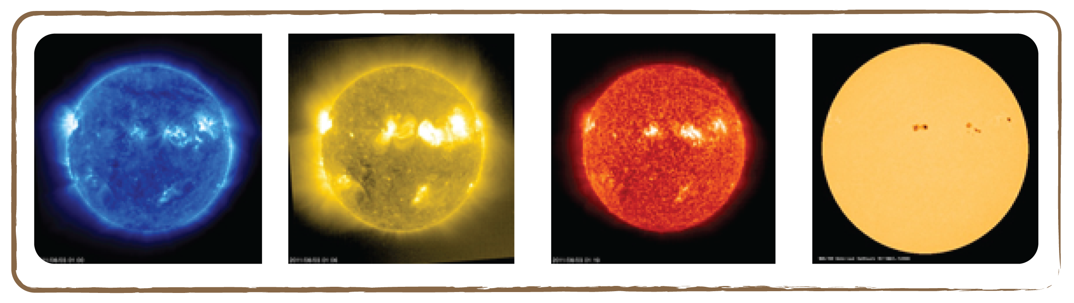

Credit: NASA / SOHO

Various pictures of the Sun photographed at the same time but with different sorts of light. The right picture was taken in visible light. (Source: NASA/SOHO)

Protuberances

If all of the solar disk is covered, like during a solar eclipse, we recognise arcs of light at the edge of the Sun, so-called protuberances. By the way, some of these arcs are so large that the Earth would fit into them several times!

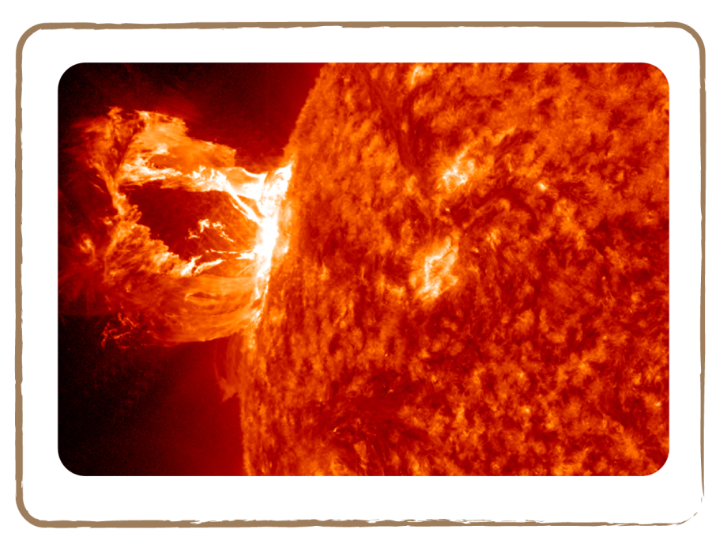 Credit: NASA

Granulation

If we looked at the Sun through a larger, sufficiently protected telescope, we could see a honeycomb-like structure, so-called granulation. This structure covers the whole Sun like a net. Here, again, the comparison with a pot of bubbling soup is suitable the soup heated at the bottom of the pot rises up in many places, cools down a bit at the top and sinks down again. In this way, a continual motion is created. Because the cooled and sinking matter on the Sun appears less bright than the rising, hot matter, we get the impression of seeing a net of cells. These cells are called convection cells.

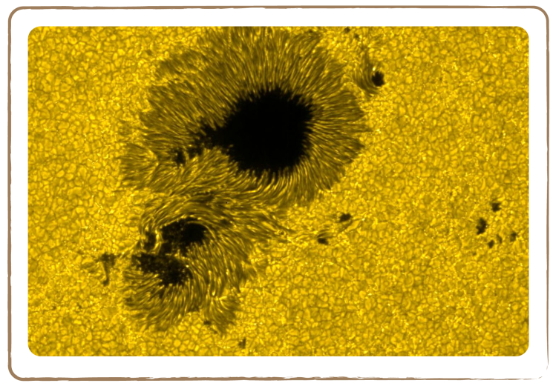 Credit: NASA

Other sources: Short movie of solar granulation: http://goo.gl/339lN

Full description

- Pour a 2-cm layer of water in a pan with 2 tablespoons of dried herbs.
- Now turn on the cooking plate. After a while, convection cells will begin to form. Inside, water rises up, and at the edges, it sinks back down. There, the herbs concentrate. The whole scene will look like granulation at the Sun’s surface (see figure).

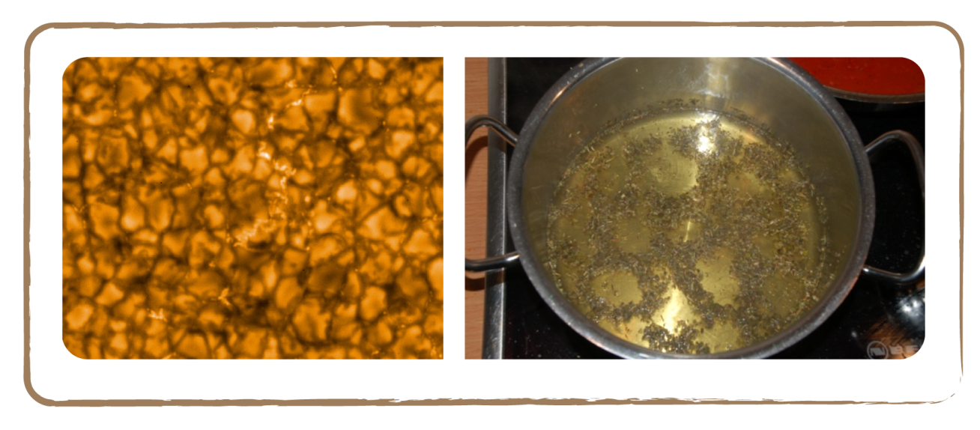
Credit: NASA Credit: Natalie Fisher

Sun granulation in the cooking pot: the situation on the solar surface (left picture) is like the one in our experiment (right picture)

Next let’s look at convection more closely. Fill a beaker with oil and herbs and put it on the lit warmer. Observe the result. Above the warmer, the fluid starts to move. You will notice that the herbs get carried along by the fluid. The herbs rise up. After several minutes, you can observe the herbs sinking down at the rim. A circulating convection movement develops.
3.7 Mini Research Project:
Sun’s Rotation

Brief Description

Determine the rotation of the Sun by observing sunspots over the course of a few weeks.

Keywords

• Sun
• Sunspots

Materials

• 1 SolarScope, several sheets of ISO A5 transparencies

Learning Objectives

Learn about the Sun’s rotation about its own axis.

Background Science

The Sun needs about 25 days for one rotation around itself. In order to measure this ourselves, we need to look out for an object on the solar surface that shares this motion. To do so, so-called sunspots are suitable.

If we look at the darkened Sun, e.g., through eclipse glasses filtering out 99.999% of the light, we can sometimes recognise sunspots on the solar disk. They look like black spots circled by a somewhat brighter seam. In reality, they are also very bright, but they look darker compared to the surrounding glistening surface of the Sun. They look darker because of the temperature difference of several hundred degrees between the cooler sunspots and their hotter surroundings.

The look of the sunspots continuously changes. Some spots get bigger and bigger, and additional spots often form in the immediate vicinity. This is called sunspot groupings. The lifetime of a sunspot or sunspot grouping is several days as a rule, but it can sometimes reach several weeks. Every 11 years, the number of sunspots strongly increases. Astronomers call this an 11-year sunspot cycle. With an increasing number of sunspots, the general activity of the Sun also increases. As the Sun rotates around itself, the sunspots also change their position: they rotate with the Sun. If we observe a sunspot over a longer time span, we can assess the Sun’s rotation period on the basis of its movement.

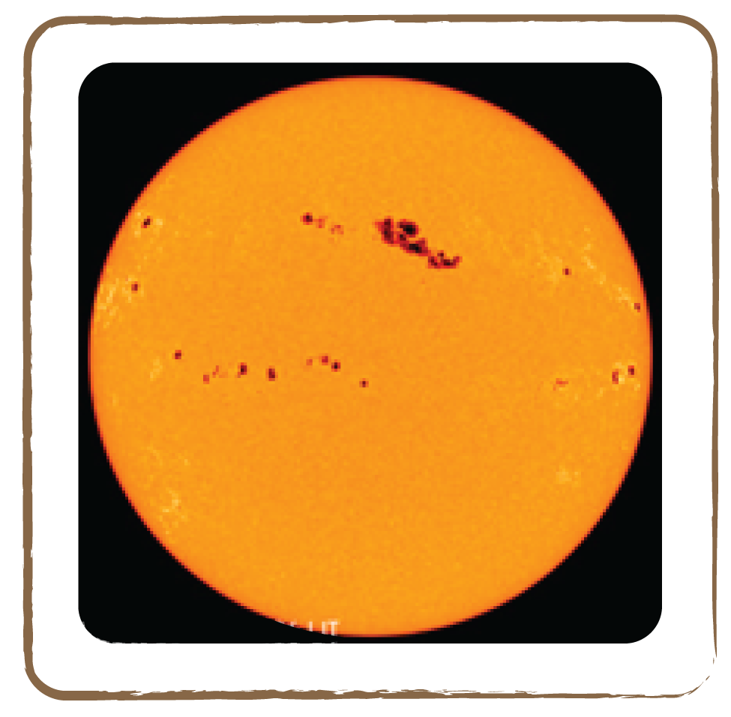
Credit: NASA

Full description

- Ask the children to observe the Sun every two to three days through a SolarScope.
- Let them stick one ISO A5 transparency to the projection side. The SolarScope projects the image of the Sun, which enters the interior of the SolarScope through the small telescope, onto the opposite side of the projector, by means of a small mirror.
- Then have them draw the visible edge of the Sun on the sheet with a pen.
- Subsequently, they draw all projected sunspots onto the sheet (little dots are sufficient). But beware: as the Earth is rotating, the solar disk is always moving away from the sheet. The children therefore should work expeditiously and re-adjust the SolarScope from time to time by rotating it.
- Finally, they label the transparency with the location, date, time and observers’ names.
- Only a few days later, the children will notice all sunspots have changed their positions. They have moved on as the Sun rotates around its axis. In the course of the next few weeks, some spots appear for the first time at the edge, move across the solar surface and disappear again at the other edge. Other spots suddenly appear in the midst of the solar surface and/or disappear again.
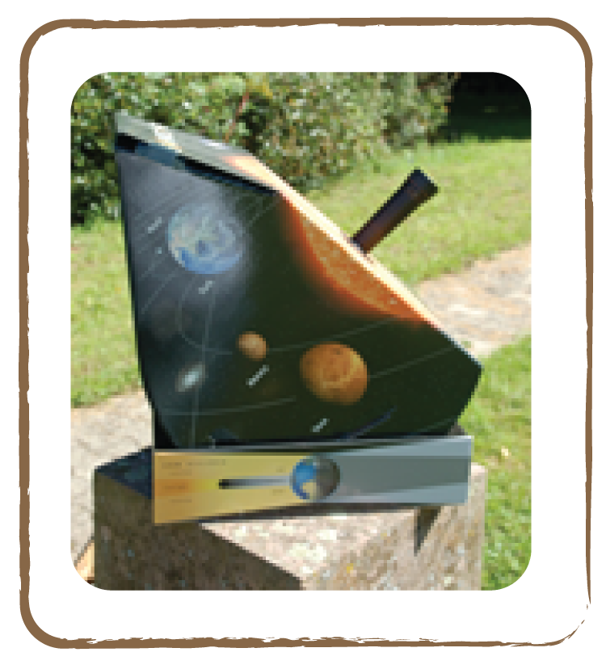
Credit: Natalie Fisher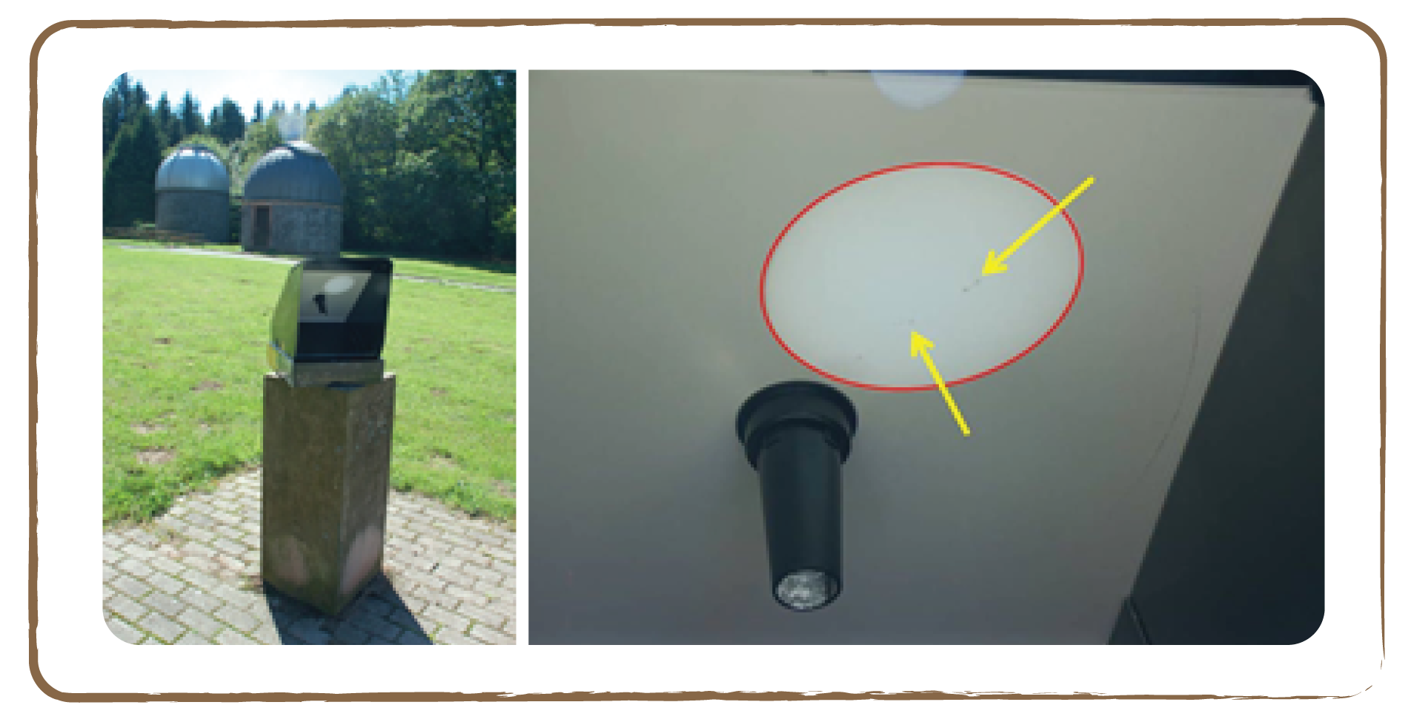
Credit: Natalie Fisher

Evaluation

- After several observations, the children can analyse their drawings.
- First, they identify the spots. Thereafter, they number them beginning with the first sheet. If a spot appears again in a successive observation, it keeps its number. If the spot has disappeared, its number is not further used. If a new spot appears, it is assigned a new number.
- If we now stack the transparencies on an overhead projector, we see that all sunspots traverse the Sun. In doing so, they travel a certain distance on the sheet. The spots need half a Sun rotation to move from one solar edge to the other. Hence, we are able to determine the duration of one solar rotation: pick a sunspot that could be observed as long as possible, and measure its distance on the transparency in centimetres. Then compare this with the distance it would have travelled if one had observed it from one solar edge to the other. The ratio of these two numbers equals that of the observation time span and half(!) a solar rotation period (as we cannot observe the path of the sunspot on the backside of the Sun). We can do this calculation with several spots and then average the results.
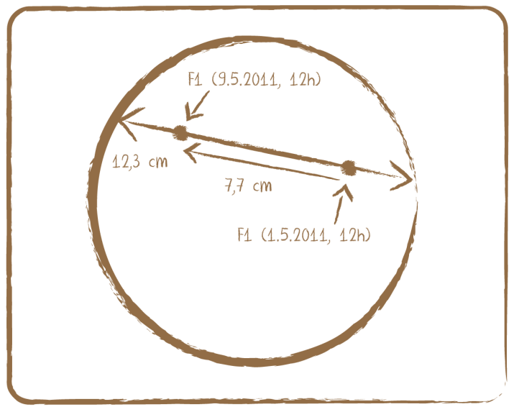
East
West

Example

Sunspot F1 has travelled 7.7 cm (red line) in 8 days of a maximum possible 12.3 cm (blue and red lines), which corresponds to a ratio of 7.7 cm / 12.3 cm = 0.63. Travelling the complete distance (from edge to edge) would have taken the spot 8 days / 0.63 = 12.7 days. This corresponds to a rotation period of 2 × 12.7 days = 25.4 days. You have measured the Sun’s spin!
Tip: Watch out: observing the Sun is a dangerous exercise! The Sun is the most school-friendly observational object in astronomy, as it can be observed during school time. Also, it changes its appearance in reasonable time spans and is always easy to find. HOWEVER, looking at the Sun directly, i.e., without protection, will severely damage your eyes! A careless look at the Sun through an optical device (e.g., a telescope) is enough to be blinded forever. The Sun burns into the retina and irreparably destroys the optic nerve.

There are, however, effective methods for observing the Sun. One possibility is to buy eclipse glasses. These are ‘glasses’ made of a special foil that filters out 99.999% of the light. Such foils are also available for telescopes and binoculars.
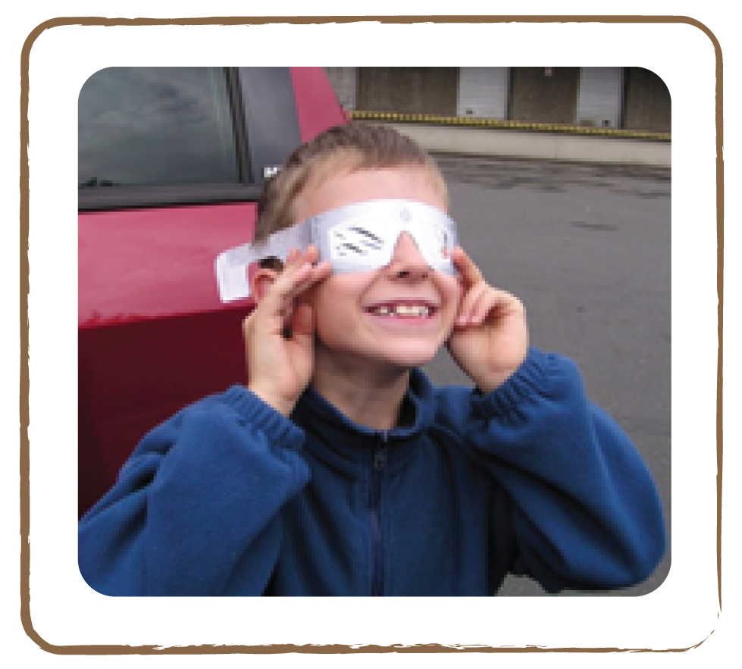Credit: Natalie Fisher

Ideas for incorporating the Sun into other subjects

Arts

Children are fascinated and inspired by the enormous power of the Sun and its continuously changing surface. Look at real pictures of the Sun with the class. Just search online for the keywords ‘Sun’, ‘sunspots’ or ‘protuberances’ and look at the pictures. Let the children draw the Sun, if possible on a large sheet of paper. You can also try to draw sun images on black-coloured cards with bright chalk.

Mathematics

The Sun is huge. A pearl chain with 109 Earth-sized pearls would correspond to its diameter, and 1 million of these pearls would fit into its interior. Such mental exercises can be reconstructed with suitable vessels and little spheres (marbles, pearls, cubes, etc.). If we used pearls of the Moon’s size, we would need 400 of them in a row to get from one solar edge to the other.

Environment

The heat of the Sun is essential to us. Some things on earth, however, get warmer than others if they are lit by the Sun. For example, most children have once burnt their feet on the hot beach and jumped onto the cooler towel. Ask the children to re-enact different situations on earth, e.g., the sea, desert, forest etc. For this activity, let them select different materials that are lit by the Sun. They should feel the temperature with their hands and/or measure it with a thermometer. Suitable materials include two tubs of water (one with much water, one with little water), one tub of water with a black bottom, one tub of sand, another tub of flower soil (a part shaded by plants, another not), concrete stones, etc.
Another possible question could be: Couldn’t one utilise this heat? A visit from an energy representative or a visit to a solar park is always enriching.

Humanities

The Sun was worshipped as a deity in many cultures. Ask the children to research this topic.

Our Solar System

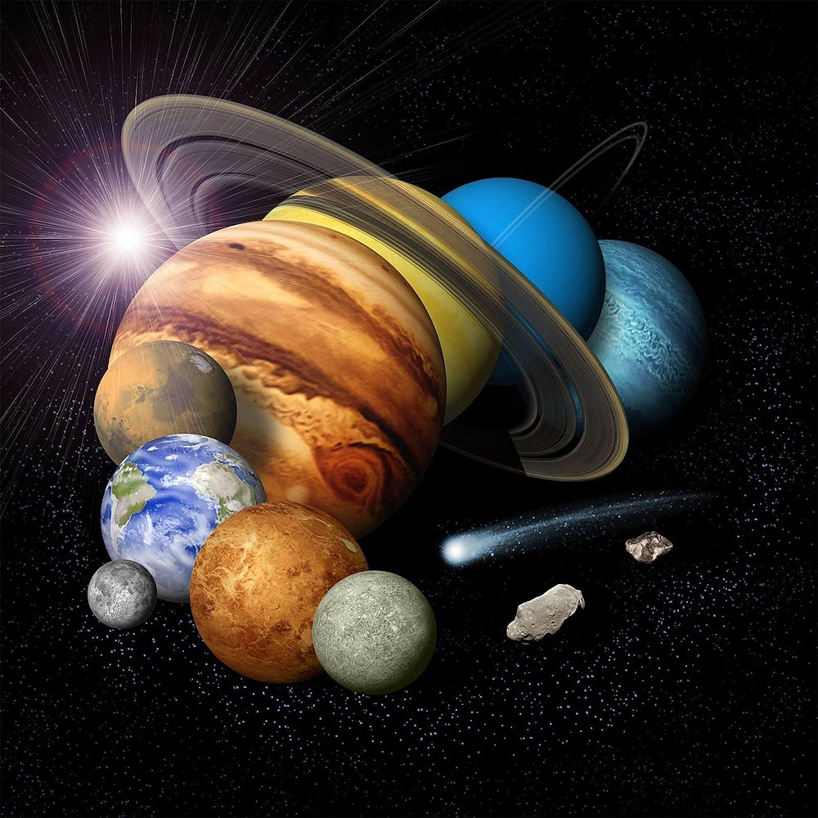

Credit: NASA / JPL

Introduction

The Solar System, in which we live, consists of the Sun as its central star, eight planets with their moons and several dwarf planets. Together with hundreds of thousands of asteroids (boulders) and comets, these celestial bodies orbit the Sun.

The Earth is a very special planet among these celestial bodies. It is our home! In order to understand its uniqueness, children need to compare the Earth to the other planets in the Solar System. As the Earth is located about 150 million kilometres from the Sun, the temperature is exactly right for liquid water to be present on the surface, unlike on most other planets. This proved crucial for the development of life!

The Solar System as a whole is part of the Milky Way system, a collection of about 200 billion stars that are arranged in a spiral, along with gas and dust. Billions of these stars have planets and these, in turn, have moons. This suggests that we are probably not alone in the Milky Way, but the distances between the stars are so big that a visit to another world would be very difficult.

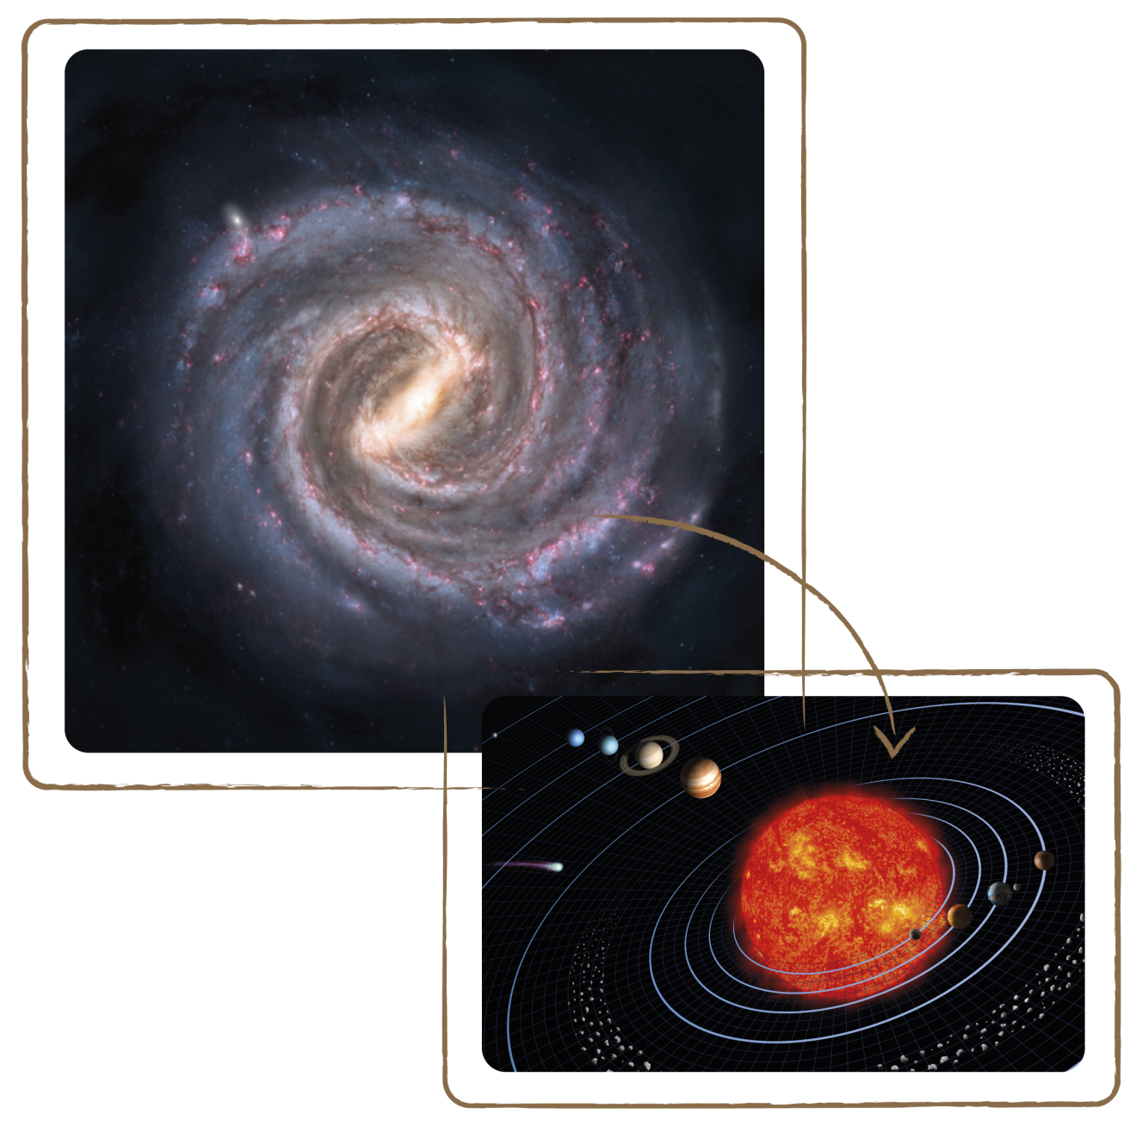
Credit: Wikimedia Common / Nick Risinger Credit: NASA / JPL
Even the star nearest to us, Proxima Centauri, is 4.22 light years (i.e., over 40 trillion km) away from us. This is so distant that a journey there would take generations of human lives.

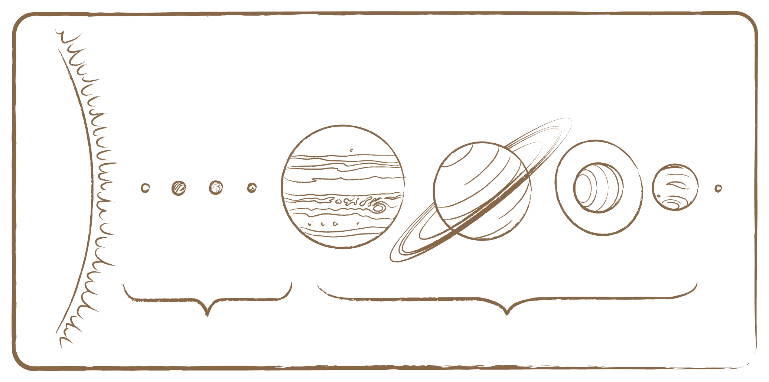
Gas Giants

Rocky Planets

Neptune

Pluto

Uranus

Saturn

Jupiter

Mars

Earth
Venus
Mercury

Credit: UNAWE / C.Provot

Planets that orbit other stars than our Sun are called extrasolar planets or exoplanets for short. Astronomers have already discovered more than 900 of these exoplanets.

We can categorise the planets of our Solar System into two types: the rocky planets, which are nearest to the Sun and have a solid surface, and the gas giants, which are farther from the Sun and are more massive and mainly composed of gas. Mercury, Venus, Earth and Mars appear in the former category, and Jupiter, Saturn, Uranus and Neptune make up the latter. Pluto, our formerly outermost planet, has been considered one of the dwarf planets since 2006. Between Mars and Jupiter is a so-called asteroid belt, which circles the Sun like a ring. It consists of thousands of smaller and larger boulders. The largest of these have their own names, just like the planets. One of them, Vesta, is so large that it is considered a dwarf planet.

4.1 Know Your Planets

Brief Description

Play a card game with the Sun and its planets. Ask questions and read answers from the cards.

Keywords

• Sun
• Planets
• Solar System
• Cards

Materials

• Card game (Box)
• Planets and Sun (flat) (Box)
• Coloured pencils
• Scissors

Learning Objectives

Learn about the properties of the different planets.

Background Science

Planets are spherical bodies orbiting a star. They have sufficient mass to have purged their orbits of all larger and smaller boulders thanks to their gravitational pull. Dwarf planets are also spherical and orbit a star, but they have small masses and therefore such a weak gravitation that they are not capable of attracting smaller boulders in their vicinity. Moons are often spherical as well, depending on their size, but they orbit planets.

Each of the planets in our Solar System has very specific features. We have summarised them in the fact files below. The following rule of thumb is valid in the Solar System: small planets lie close to the Sun and are made of solid material, while large planets are farther away from the Sun and are mainly composed of gas.

Rocky Planets

The four rocky planets (Mercury, Venus, Earth and Mars) are very dense (solid) and comparatively small. Their atmospheres are very thin, with the exception of that of Venus.

Mercury

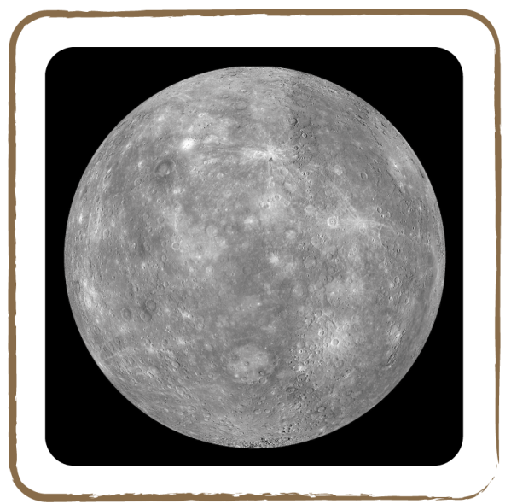 Credit: NASA

Mercury is the planet nearest to the Sun. It has no atmosphere and its solid surface, like that of our Moon, is covered with many craters. Mercury orbits the Sun once in just 88 days and has no moons. There are severe temperature differences on its surface: 380° C on the side facing the Sun, and -180° C on the night side! This is because day and night shift very slowly on Mercury, because of its slow spin. Also, there is no atmosphere to trap the heat at night.

Venus

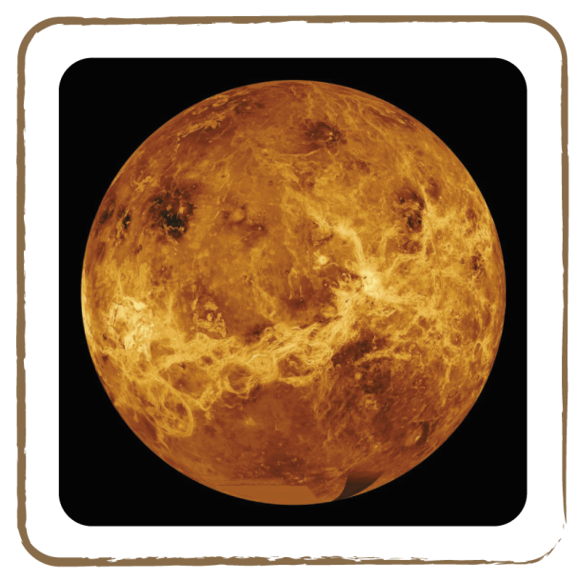 Credit: NASA

Venus is about as large as the Earth. Carbon dioxide (a greenhouse gas) makes up 99% of its atmosphere, which causes sunlight to get trapped in this mega greenhouse. Whether it is day or night, it is always very hot on Venus: almost 500° C! Venus’ spin on its own axis is inverted compared to the spins of other planets.

Earth
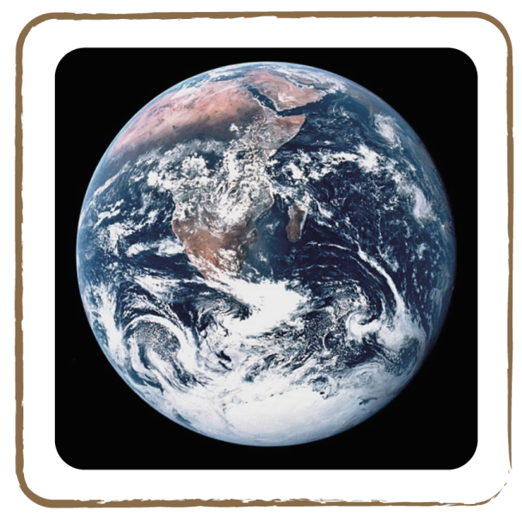 Credit: NASA

Earth is the only planet in the Solar System that has liquid water on its surface, significant amounts of oxygen in the air and moderate temperatures. It orbits the Sun once a year. Its stable axis (inclined 23 degrees) results in seasons. Furthermore, it is the only celestial body on which we have found life so far.

Mars

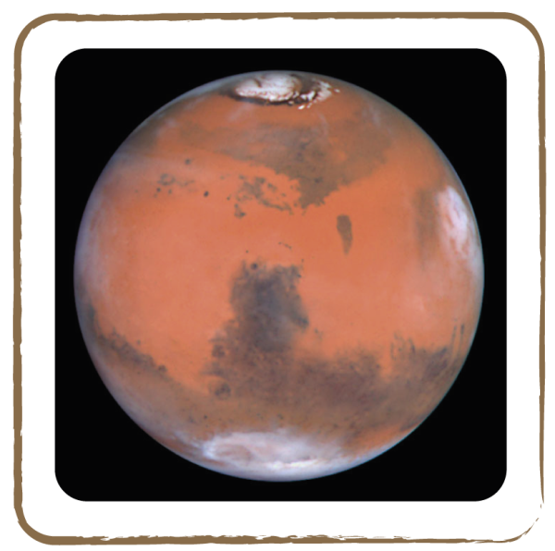 Credit: NASA

Mars is half the size of the Earth. Its reddish colour is caused by iron oxide (rust). It has a very thin atmosphere, which mainly consists of carbon dioxide. One of its special features is its many volcanoes, which reach heights of up to 23,000 metres! Mars has two moons and needs about twice as much time as the Earth to orbit the Sun. Like Earth, it also has seasons, as its rotation axis is inclined.

Gas Giants

The ‘gas giants’ (so-called because they are larger compared to other planets) consist of a mighty atmosphere and a relatively small solid core.

Jupiter

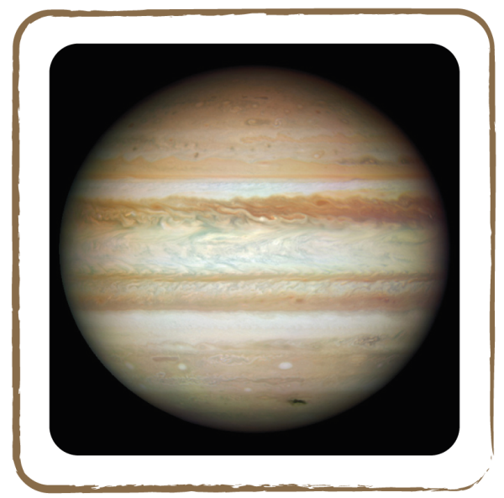 Credit: NASA

Jupiter is the largest planet in our Solar System. Like all giant planets, it mainly consists of gas and has a solid core. It has a remarkable red spot on its surface, that is two times the size of the Earth! This spot is a huge cyclone which has been raging for more than 400 years. Due to its significant gravitational pull, Jupiter attracts many asteroids and thus protects us from their impact. It has around 50 moons and is composed mainly of hydrogen and helium.

Saturn

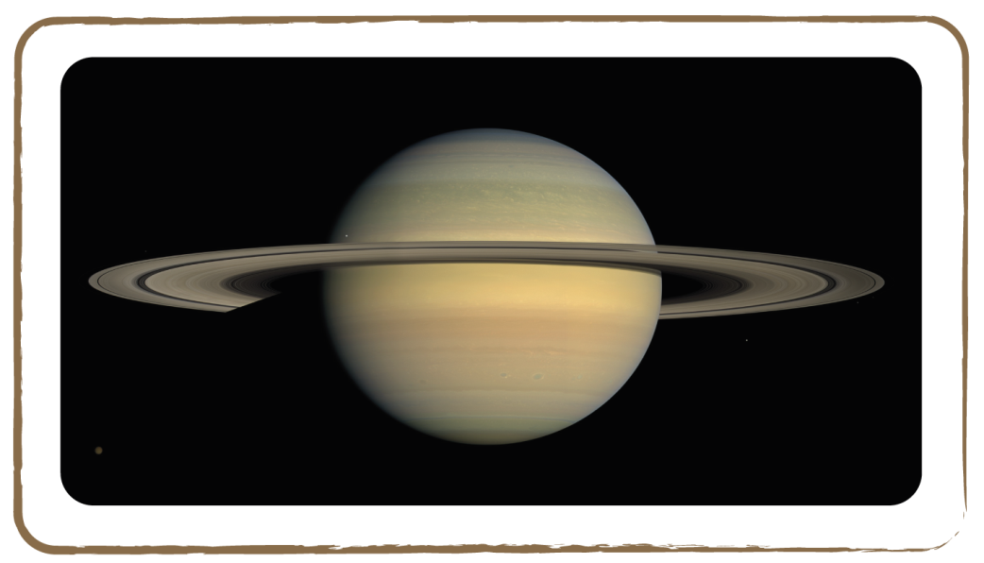 Credit: NASA

Saturn is surrounded by large rings and therefore earns its nickname ‘Lord of the rings’. These rings consist of numerous small ice grains. Saturn’s atmosphere has a fairly low density: Saturn is the only planet in the Solar System that could float on water. It has many moons: more than 60!

Uranus
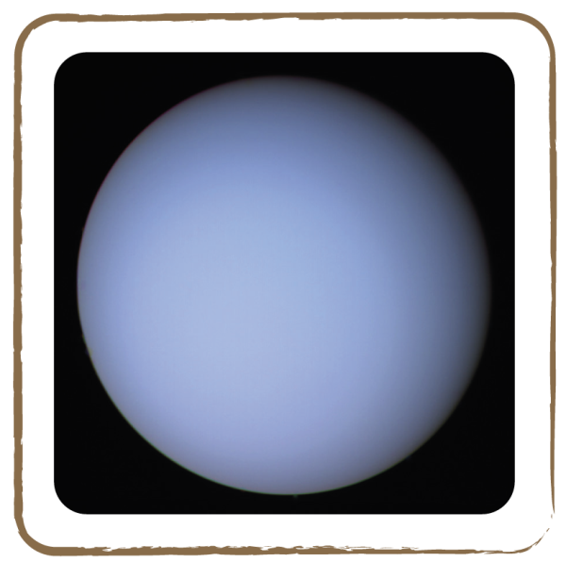 Credit: NASA

Uranus has a few thin rings. It rotates around the Sun ‘on its belly’, which is probably due to the fact that it was overturned by a collision. Its surface looks very smooth and barely shows any structure. It has 15 moons.

Neptune

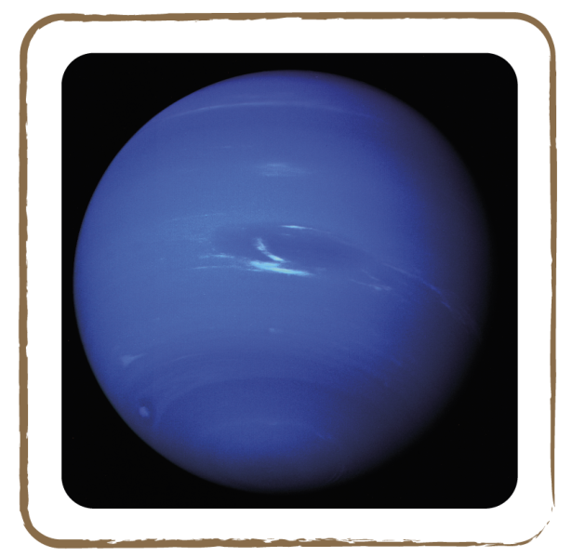 Credit: NASA

Neptune’s surface has a blue colour, like that of Uranus. White clouds fly over its surface at speeds of over 1000 km/hr. Neptune’s path sometimes crosses the orbit of dwarf planet Pluto.

Dwarf Planet

Pluto

Pluto is composed of ice and rock. In 2006, astronomers decided that Pluto is no longer a planet but only a dwarf planet, although it is spherical. Due to its low mass, it cannot attract smaller boulders in its vicinity, as the ‘real’ planets do. Pluto has one larger and two smaller moons. It is so small and far away that astronomers haven’t been able to take a clear picture of it!
Full description

- First, ask the children to identify the pictures of the planets: which planet is seen in which photo?
- Let them arrange the photographs of the Sun and its planets in the ‘right’ order.
- Next, the children paint the pictures of the card game: which peculiarities have to be taken into account?
- Let the children cut the ten cards along the lines. On the back of each card, there is a summary of the most important features of the individual planets. At the bottom, there is a question, whose answer indicates another celestial body in the Solar System. You need ten children to play the game.
- Shuffle the cards and hand every child one card.
- Ask the children to memorise the exact properties of ‘their’ celestial body.
- The child with the sun card reads out loud the question on the bottom of the back of its card. The answer should be called out only by that child whose celestial body was sought. Then, this child can read out loud the question on his/her card.
- The game ends when it’s the turn again of the child with the sun card.

Tip: In order to better memorise the order of the eight planets in our Solar System, use the following mnemonic: My Very Eager Mother Just Served Us Nachos.

4.2 Solar System Model

Brief Description

Paint and arrange spheres to form a model of the Solar System.

Keywords

• Sun
• Planets
• Solar System

Materials

• Plastic planets (Box)
• Plastic Sun (Box)
• Paint and brush (Box)
• Planet pictures (flat) (Box)
• Clay, cotton, papier mâché

Learning Objectives

Learn about the sizes and order of the planets in the Solar System.

Background Science

See introduction 4.1

Full description

- The instructor and a small group of children should initially paint the plastic spheres according to the pictures of the planets: Mercury (3.5 mm), Venus (10 mm), Earth (10 mm), Mars (5 mm), Jupiter (100 mm), Saturn (85 mm), Uranus (35 mm) and Neptune (35 mm), and Sun (150 mm).

Note that the sizes of the planetary spheres are not all to scale, so that they can be handled better by the students.

- Let all spheres dry.
- Next, draw concentric circles at the outer edge of Saturn’s plastic ring. Pull the ring over Saturn and fix it at its equator.
- Using the plastic spheres and the pictures of the planets, together with the children, create models of the planets and Sun by making balls of cotton, clay, or papier mâché. Use the table in activity 4.6 if you would like them to use the exact diameter (to scale).
- Place all planets on the table in the right order
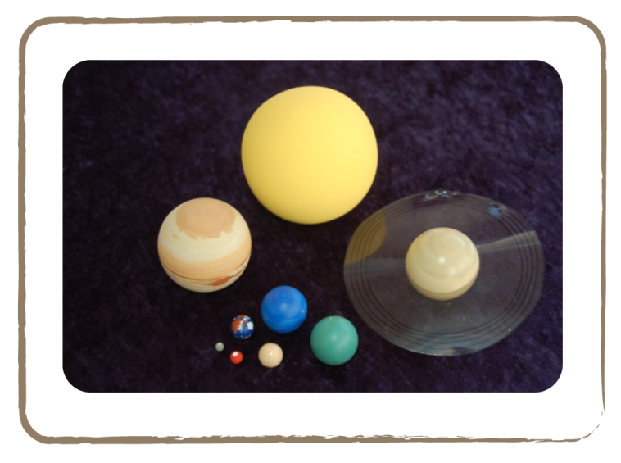 Credit: Natalie Fischer

Related activities: 4.3, 4.6

4.3 Seeing Planets

Brief Description

Place the model of our solar system on a cloth against a banderol of stars to analyse when the planets of the Solar System are visible.

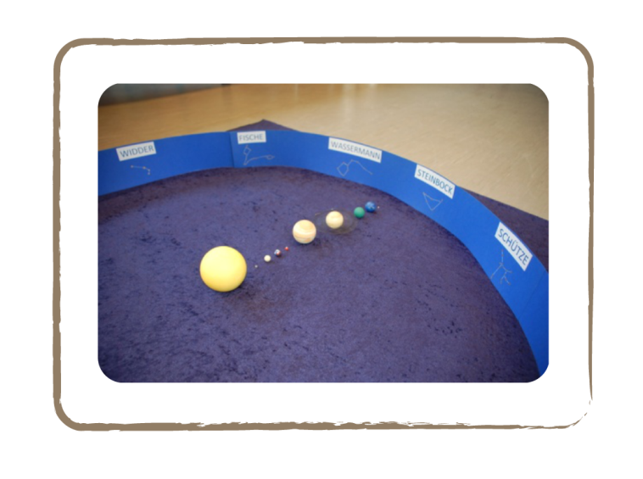Credit: Natalie Fischer

Keywords

• Sun
• Planets
• Solar System

Materials

• Plastic planets (Box)
• Plastic Sun (Box)
• Blue cloth (Box)
• Banderol of Zodiac (Box)

Learning Objectives

Learn about the locations of planets in our Solar System, and when we can see them from Earth.

Background Science

See introduction and activity 4.1

Full description

- Spread a blue cloth on the floor.
- Put a big yellow sphere — representing the Sun — in the centre, with the planets around it in the right order. Two of the planets (Mercury and Venus) should be located between the Sun and the Earth, with the others behind the Earth.
- First, remove all planets except Venus, Mercury and Earth. Where is the day and night side of the Earth? When is the only time we can see Venus and/or Mercury? Venus and Mercury are only visible on the day side of the Earth. Therefore, they can only be observed during the day (especially during twilight, when the sunlight is not so bright anymore). They can be observed in the western direction in the late evening (after the Sun has just set there) or in the eastern direction in the early morning (just before the Sun rises). In everyday language, Venus is called an evening or morning star, because of its apparent brightness during those parts of the day. However, Venus merely reflects sunlight, instead of producing light itself, like stars. In contrast, Mercury is difficult to see because it’s even closer to the Sun, giving us a narrower time span to observe it. Furthermore, it’s smaller and farther away.
- For simplicity, we now only leave the Earth and Jupiter on the cloth, in addition to the Sun. When can we see Jupiter (and the other outer planets)? This depends on where it is in its orbit. Sometimes it can be seen at night, which makes it much easier to spot. Also, Jupiter is – just like the other gas giants – much bigger than Mercury and Venus. The only disadvantage in terms of visibility is that the gas giants are farther away from us.

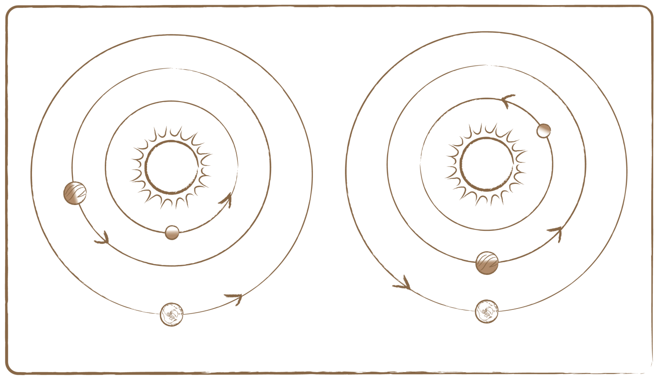
Earth
Mercury
Venus

Earth
Mercury
Venus

Credit: UNAWE / C.Provot

Related activities: 4.2, 4.6

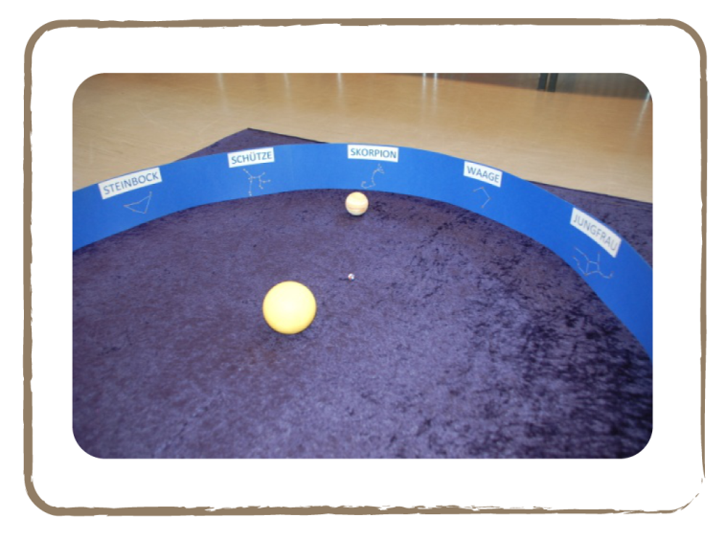Credit: Natalie Fischer

4.4 Asteroids

Brief Description

Make models of asteroids with clay and paint.

Keywords

• Asteroids
• Planet formation

Materials

• Clay
• Brushes
• Paint

Learning Objectives

Learn about the characteristics and location of asteroids, and how planets and asteroids form.

Background Science

Asteroids are boulders orbiting the Sun, with sizes ranging between some hundred metres and several kilometres.

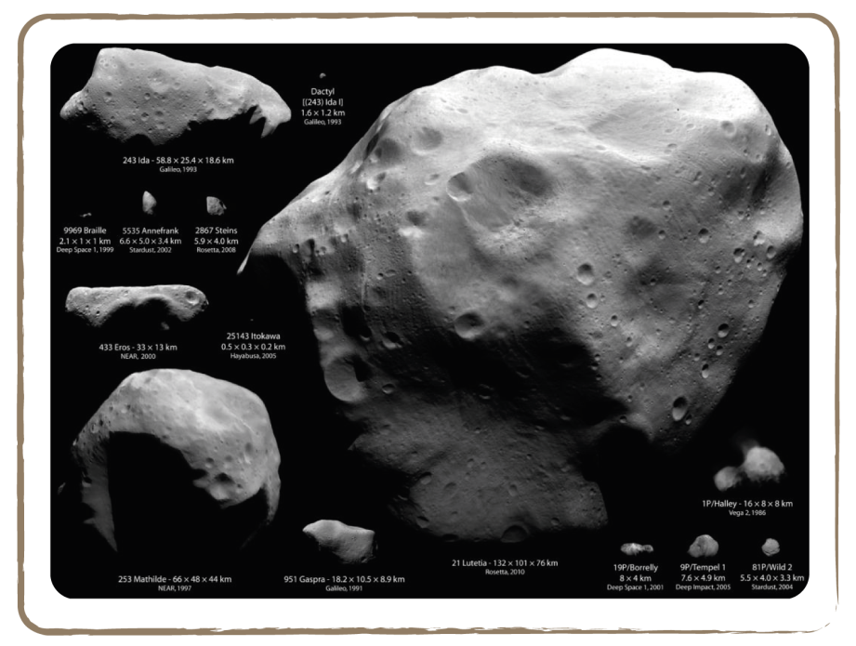
Credit: NASA / JAXA / Arecibo / NSF / ESA

An asteroid is called a meteorite if it hits the Earth. If it completely evaporates in the Earth’s atmosphere before crashing on the surface, it’s called a meteor. People usually refer to meteors as ‘shooting stars’. Most meteorites are predominantly composed of silicates or a mixture of iron and nickel. In the past, some huge meteorites have struck the Earth. Sixty-five million years ago, almost 90% of animal species were eradicated (among them the dinosaurs) when a meteorite hit Yucatan, Mexico. Luckily, this happens very rarely! We owe this to Jupiter, which attracts many asteroids with its gravitational pull.

Many asteroids form large rings or belts around the Sun. There are two asteroid belts in our Solar System: the main belt (or simply called asteroid belt) between Mars and Jupiter, with thousands of asteroids (see picture below), and the Kuiper belt, named after its discoverer, a disk-shaped region that extends outside of Neptune’s orbit and contains countless asteroids and many dwarf planets, of which Pluto is the most famous.

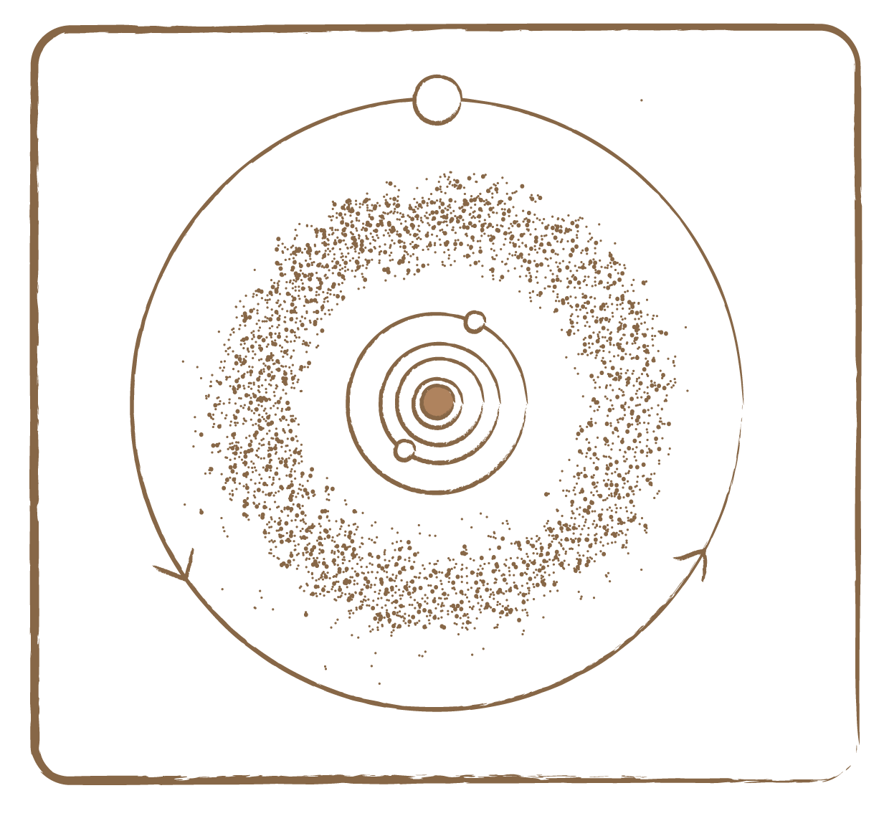
Asteroids

Mars

Earth

Jupiter

Credit: UNAWE / C.Provot

Full description

- Ask the children to take a piece of clay the size of their fist.
- Let them divide it into small pieces and place these fragments on a table.
- Now ask them to squeeze all the pieces together to form one large asteroid, without kneading it.
- Let them hit the clay chunk with the knuckle of a finger a few times.
- After washing their hands, they can paint the asteroid.
- Explain to the children that asteroids really form this way: little pieces clump together to form one giant rock. Planets also form this way. Around every young star is a disc of little pieces of dust, out of which planets and asteroids form.
Tip: You can also tell the children about comets. Comets are like dirty snowballs or icy lumps of mud. They consist of a mixture of ice (from water as well as from frozen gases) and dust. Like asteroids, comets revolve around the Sun. However, their orbits are strongly elongated compared to planets, meaning they occasionally get very close to the Sun, and at times they get very far away. When they cross a planet’s orbit, they could collide with it. This happened, for example, in 1994, when the comet Shoemaker-Levy collided with planet Jupiter and broke into pieces. When comets come close to the Sun in their orbit, the ice in their core melts and evaporates. This causes a beautiful tail, which can be clearly seen in the night sky if the comet passes by the Earth closely enough.

In 2061, Halley’s Comet will once again come close to the Earth. It orbits our Sun once every 76 years. Remember to mark its arrival on your calendar!

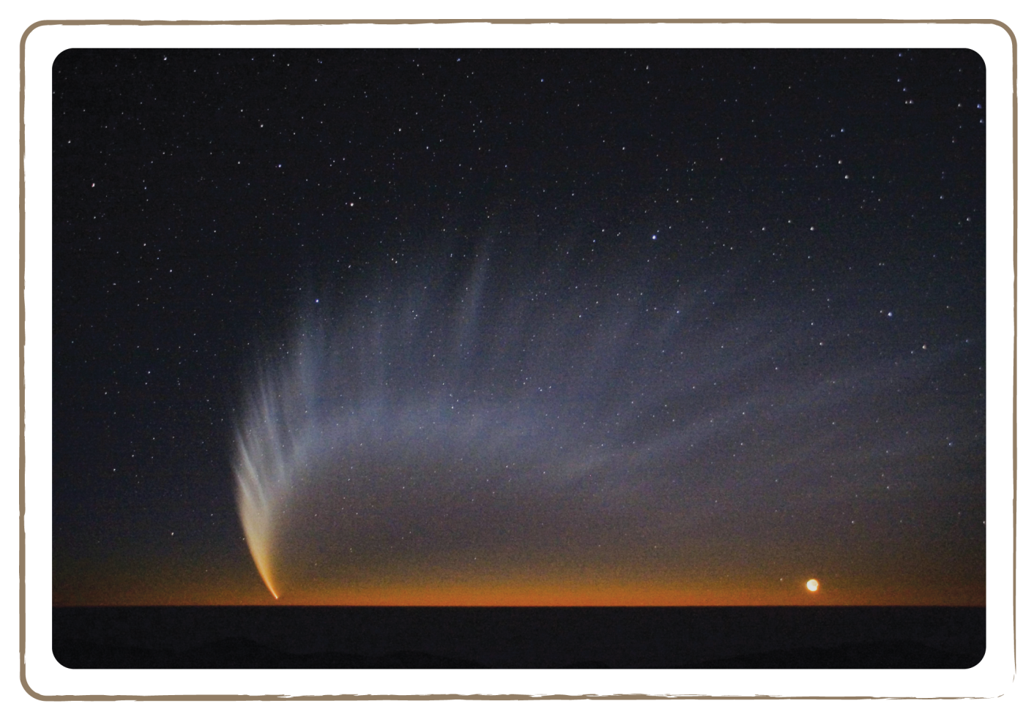
Credit: S.Deiries / ESO

4.5 Planetary Orbits

Brief Description

Create the elliptic orbit of the Earth around the Sun by drawing orbits with a large-scaled compass.

Keywords

• Sun
• Planets
• Orbit
• Ellipse

Materials

• Plastic planets (Box)
• Plastic Sun (Box)
• Yellow rope (Box)
• Two full bottles of water
• Chalk

Learning Objectives

Learn about the elliptical orbits of planets.

Background Science

Planets do not orbit the Sun in perfect circles, but in ellipses. The definition of a circle is that every point on the circle has the same distance to the centre. For an ellipse, the definition is that every point on the ellipse has the same combined distance to both focal points. In a planet’s orbit, the Sun acts as one of the focal points. The other (imaginary) focal point is very close to the Sun (compared to the large scales in question), making the ellipse almost a circle.

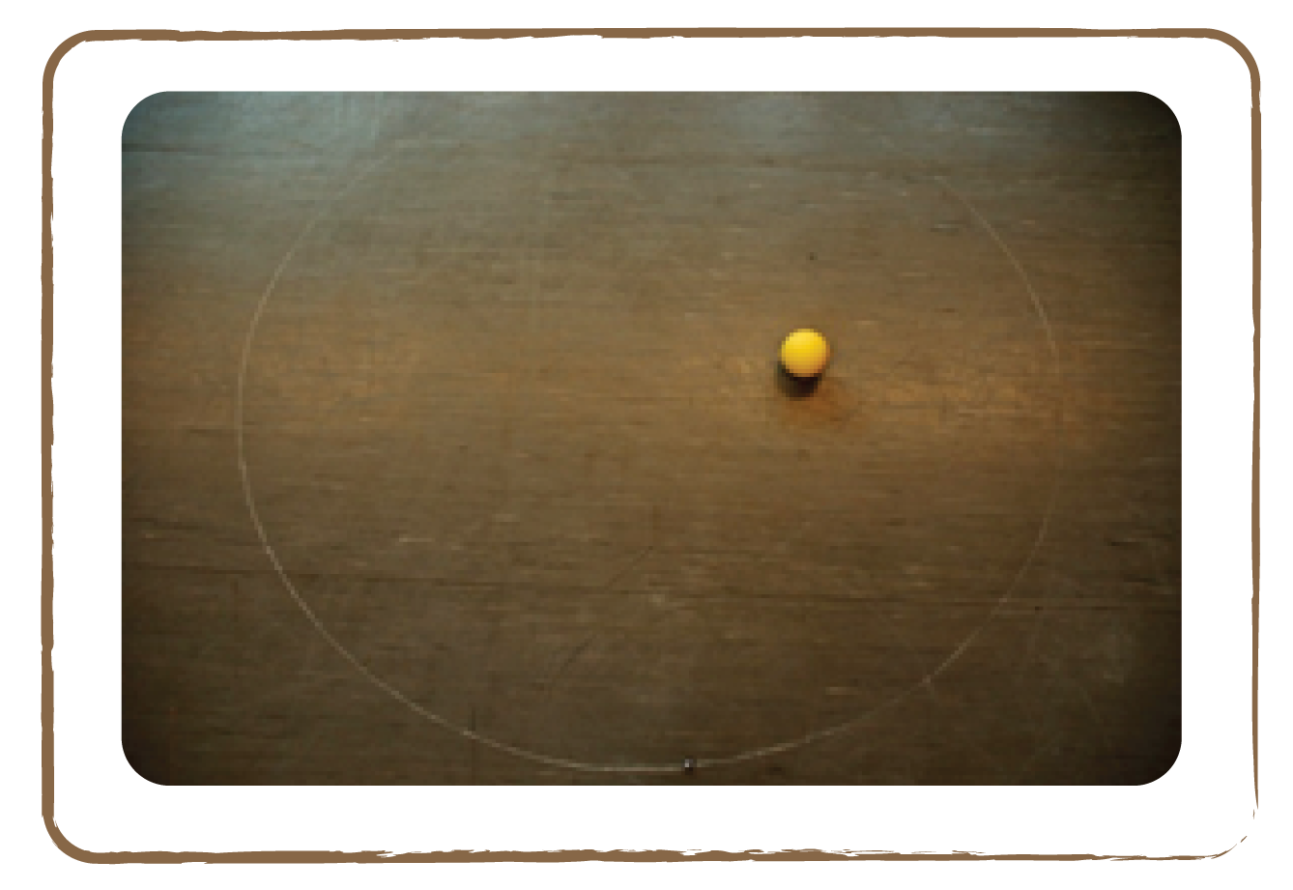 Credit: Natalie Fisher

Why are planetary orbits elliptical? There are three possible shapes of an object’s path (apart from a straight line, which isn’t realistic since there are always gravitational forces around): a parabola, a circle and an ellipse. In the case of a parabola, a planet would fly in from outer space; its orbit would be bent by the Sun, and it would fly off again to infinity. Of course, the Solar System would run quickly out of planets if the orbits were shaped like this. That leaves circular and elliptical orbits. Circular orbits are simply too perfectly round to occur in nature. It would be infinitely coincidental if a planet were to fly in a perfect circle. Hence, planets have elliptical orbits.

Full description

- In order to graphically represent a circular orbit, knot two ropes together and place them around a water-filled bottle and a piece of chalk. Make sure the distance between the chalk and the bottle is such that the rope is tensed.

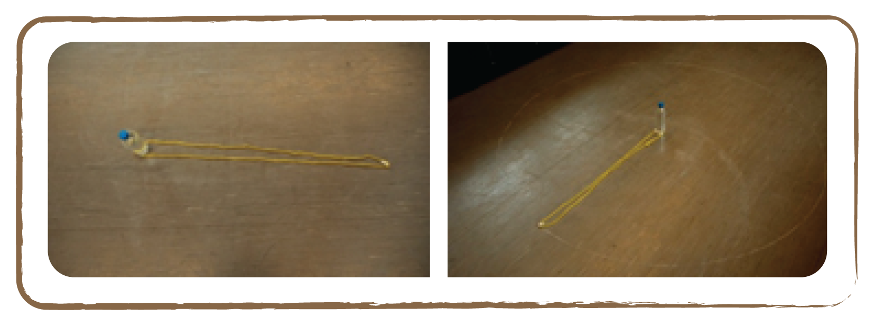
Credit: Natalie Fisher

- Now move the chalk around the bottle, like a compass, while keeping the rope tensed. This way, a circle forms on the floor with the bottle in the centre.
- Next, remove the bottle and put the Sun’s model in its place. Put the model of the Earth into the orbit. This completes the circular orbit. We now have an approximation of Earth’s orbit, but not an exact model: the orbit should be elliptical!
- To construct an ellipse, we need two bottles filled with water, and a piece of chalk.

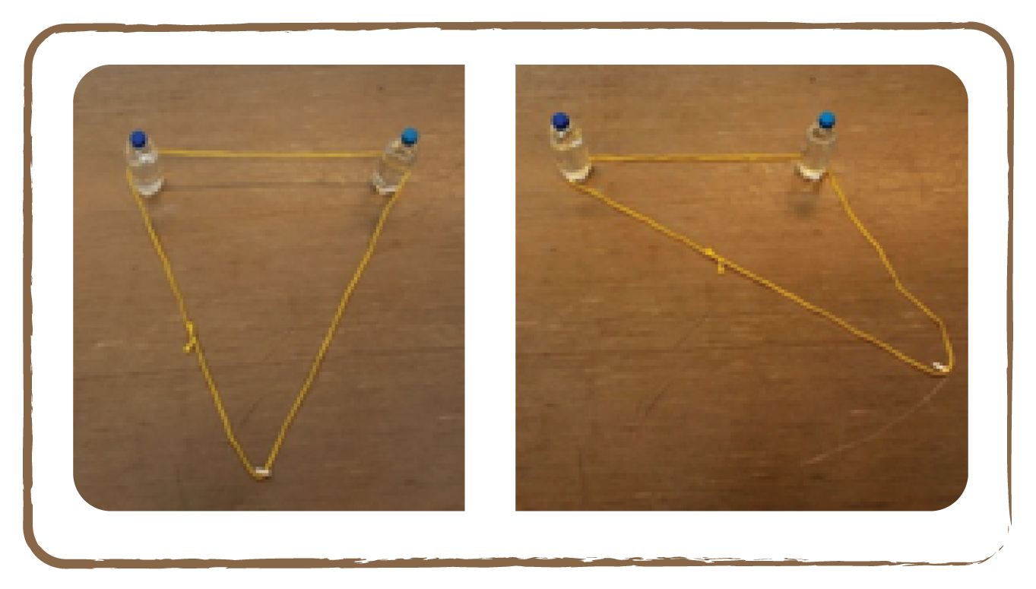 Credit: Natalie Fisher

- Place the rope around both bottles and the piece of chalk, and tense it again. This time, the rope is shaped in a triangular form.
- If the chalk now goes around both bottles with the rope tensed, the result is an ellipse. In this model, the position of one of the bottles would represent the Sun and the piece of chalk would be the planet.
- Now replace one bottle and the chalk with the models of the Sun and the Earth, and remove the other bottle. We have a realistic (although probably exaggerated) model of Earth’s elliptical orbit around the Sun!

With the help of this method, very different ellipses can be constructed.
How does the shape of the ellipse change if we diminish the distance between the bottles?

- How does the shape of the ellipse change if we increase the distance between the bottles?

In reality, the two focal points (bottles) are very close to each other, making Earth’s orbit almost circular. Think about it: we don’t even notice the varying distance in temperature!

Mathematically, the weights or nails in our construction mark the so-called ‘foci’ of an ellipse. The larger their distance, the more elongated the ellipse becomes. If a planet revolves on a very elliptic orbit, its distance from the Sun will vary widely in the course of a revolution around the Sun: sometimes it is very large, sometimes comparatively small.

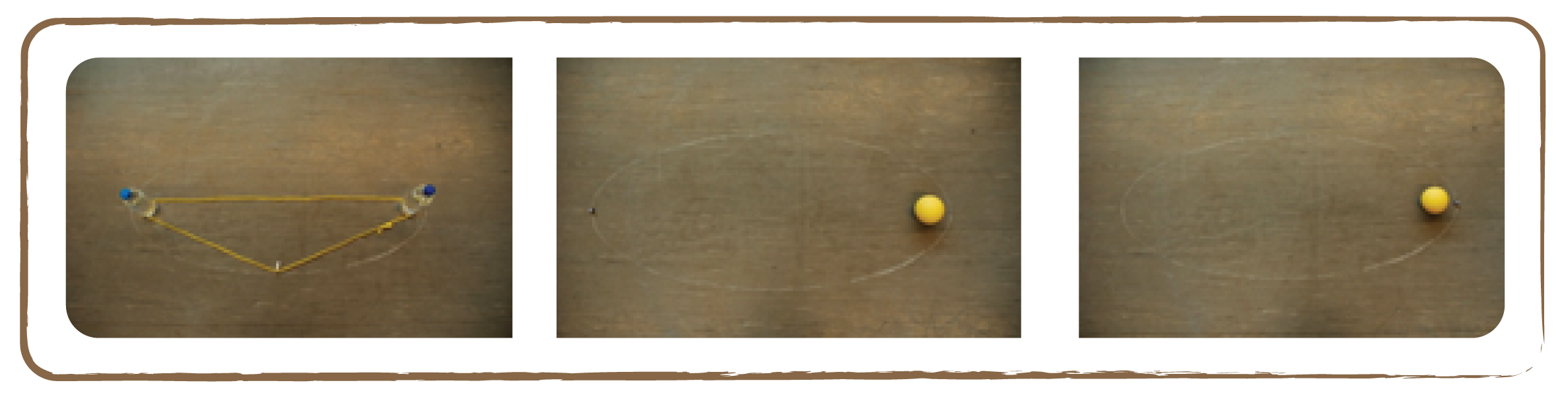
Credit: Natalie Fisher

Tip: Note that the slightly varying distance of the Earth to the Sun does not cause the seasonal changes (see activity 2.5).

The children can also build their own models: with a panel made of Styrofoam, wood or cork, a sheet of paper as a drawing plane, two nails or pins, a cord and a pen, every child can draw and examine different ellipses.

Related activities: 4.6

4.6 Distances and Paths

Brief Description

Create a large model of the Solar System to scale by placing proportionately sized balls at correct distances from each other in an open field.

Keywords

• Sun
• Planets
• Solar System
• Scale

Materials

• Plastic planets (Box)
• Stability ball Sun (Box)
• Tape measure

Learning Objectives

Develop a feeling of the vast distances in the Solar System, relative to the planet sizes: the Solar System consists mostly of empty space. Learn to calculate these distances with scales.

Background Science

The planets’ distances to the Sun and to each other are huge compared to their sizes. Thus, one cannot sensibly depict all planets together. Consequently, composite photographs are used in many textbooks. This may create the false impression that the distances between all planets are the same!

To fix this, you can construct a model of the Solar System yourself!
If you want to construct a model of our planetary system, you have to get a sense of the sizes of the celestial bodies and their distances from the Sun. Then you will realise that you have to use a different scale for the planet sizes than for their mutual distances. Otherwise, either the planets’ paths will be several kilometres long or the planets become so small that they can’t be seen.

The following table reproduces the distances and sizes of the planets (sources for columns 1 and 2: dtv-Atlas Astronomie, 2005).

If you prefer to build a small planetary system, you can also interpret the distance from the Sun column as specifications in cm: the only important aspect is the ratios between these numbers. Neptune would then be 2.25 m from the Sun.

Celestial body | Diameter in reality [km] | Diameter scale 1:1.39 billion [cm] | Distance from Sun in reality [million km] | Distance from Sun scale 1:20 billion [m]
Sun | 1,392,000 | 100.0 | - | -
Mercury | 4,878 | 0.35 | 57.9 | 2.9
Venus | 12,104 | 0.87 | 108.2 | 5.4
Earth | 12,756 | 0.92 | 149.6 | 7.5
Mars | 6,794 | 0.49 | 227.9 | 11.4
Jupiter | 142,984 | 10.27 | 778.3 | 38.9
Saturn | 120,536 | 8.66 | 1427.0 | 71.4
Uranus | 51,118 | 3.67 | 2869.6 | 143.5
Neptune | 49,528 | 3.56 | 4496.6 | 224.8

Full description

• Take the children outside, preferably to an open space (e.g., a lawn in a park).
• Divide the children into ten groups and assign one ball to each group.
• Starting from the edge of the park, ask the children to move away from you according to the distances in the right column of the table. Now they have made a (somewhat) realistic model of the Solar System.
• Notice the large distances: the Solar System mainly consists of vast emptiness! In reality, the distances should even be 20 times larger! Because the balls would then get too small, doing so would not be practical. Using a scale of 1:1.39 billion, all planets have acceptable sizes, but Neptune would be 3.2 km from the Sun. On the other hand, with the use of a scale of 1:20 billion, Neptune would be only 225.4 m away from the Sun, but some planet diameters would be less than 1 mm. Therefore, using two different scales is indeed practical, while still giving the children a good sense of the vast distances in our Solar System.

Tip: If it’s raining outside, or there is no open place nearby, you could just do the exercise with the Sun and the Earth, which will still leave an impression, especially if you tell the children that in reality the distance should be 20 times larger.

Related activities: 4.2, 4.3, 4.5

4.7 Journey to Planets

Brief Description

Use an origami paper rocket to travel through the large distances of our solar system.

Keywords

• Rocket
• Origami

Materials

• Template for building an origami rocket (Appendix)
• Coloured square papers

Learning Objectives

Learn about the large travel times in space.

Background Science

We want to travel to the planets and get to know them more closely. Our card game and the planets’ paths already told us a lot about the planets. But we also need suitable rockets and surely have to think about how long our journey will take.

Celestial body | Escape velocity (at the equator) [km/h]
Mercury | 15,480
Venus | 36,720
Earth | 40,320
Mars | 18,000
Jupiter | 214,560
Saturn | 127,800
Uranus | 76,680
Neptune | 83,880
Pluto | 3,960

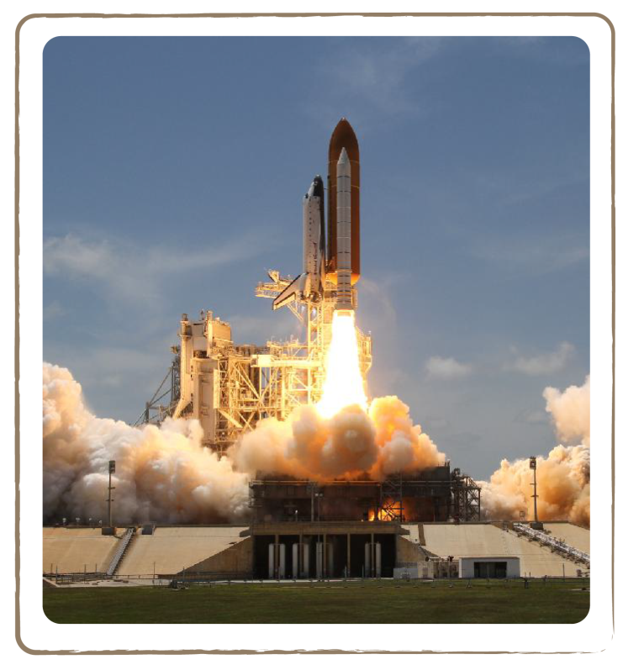
Credit: NASA

Travelling to other planets takes lots of time. It takes slightly less than one year to even reach our closest neighbour, Mars. Flying to Pluto would take almost a lifetime: about 45 years.

To take off, we have to conquer Earth’s gravitational field. To do that, our rocket needs to reach the so-called escape velocity. If we want to leave the planet we visited and return home, we need to escape that planet’s gravity as well. The higher a planet’s gravitational field, the higher the escape velocity.

For the Earth, this escape velocity is 40,320 km/h, or 40 times the speed of a plane! In the table above, you can see the values of all the planets. To leave Jupiter, for example, would take lots and lots of fuel. However, since Jupiter is a gas planet, you cannot land on it, so we’ll never encounter this problem. The four terrestrial planets have comparatively low escape velocities.

The direct flight times to individual planets are in the table below.

Destination | Distance from Sun [million km] | Distance from Earth [million km] | Flight time at 1000 km/h [years] | Flight time at 40,300 km/h [years]
Sun | 0 | 149.6 | 17.08 | 0.42
Mercury | 57.9 | 91.7 | 10.47 | 0.26
Venus | 108.2 | 41.4 | 4.73 | 0.12
Earth | 149.6 | 0 | 0.00 | 0.00
Mars | 227.9 | 78.3 | 8.94 | 0.22
Jupiter | 778.3 | 628.7 | 71.77 | 1.78
Saturn | 1,427 | 12,77.4 | 145.82 | 3.62
Uranus | 2,869.6 | 2,720 | 310.50 | 7.70
Neptune | 4,496.6 | 4,347 | 496.23 | 12.31
Pluto | 5,900 | 5,750.4 | 656.44 | 16.29
However, matters are not that simple in practise. The flight paths to the planets are much more complicated. Planets, the Earth and the Sun keep pulling on the spacecraft during the whole journey. The following flight times are more realistic:

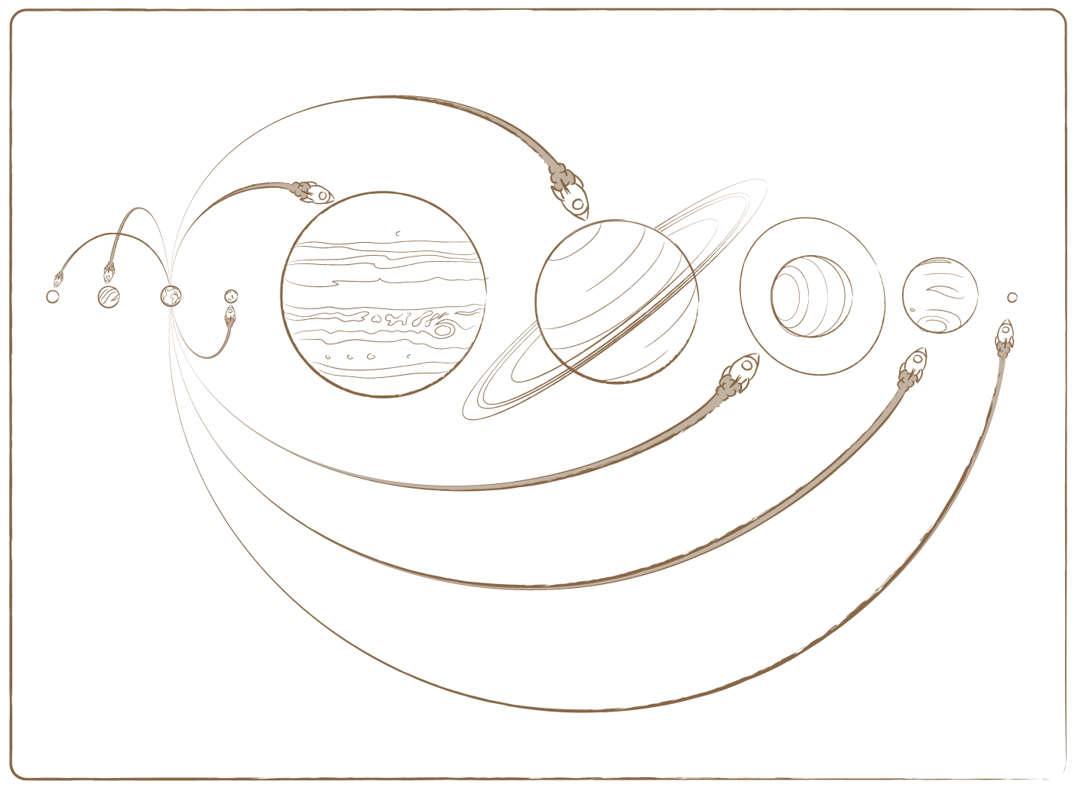
Pluto
45.5 years

Neptune 30.6 years
Uranus
16.1 years
Mars
0.71 years
(ca. 3.5 months)

Saturn 6.05 years

Jupiter 2.73 years

Venus
0.29 years (ca. 3.5 months)

Mercury
0.4 years
(ca. 5 months)

Credit: UNAWE / C.Provot

Full description

- Build an origami paper rocket with the children from the instructions found in the Appendix.
- Now hold a discussion with the children about what would be the requirements for the rockets to travel to each planet, and how much time each journey would take. Consider not only the distance to a planet, but also its surface conditions. Which planets can we land on (see activity 4.1)? How do we get through the asteroid belt that lies between Mars and Jupiter? What happens if we change the speed of the rocket?

Tip: This activity can also be combined with 4.6.

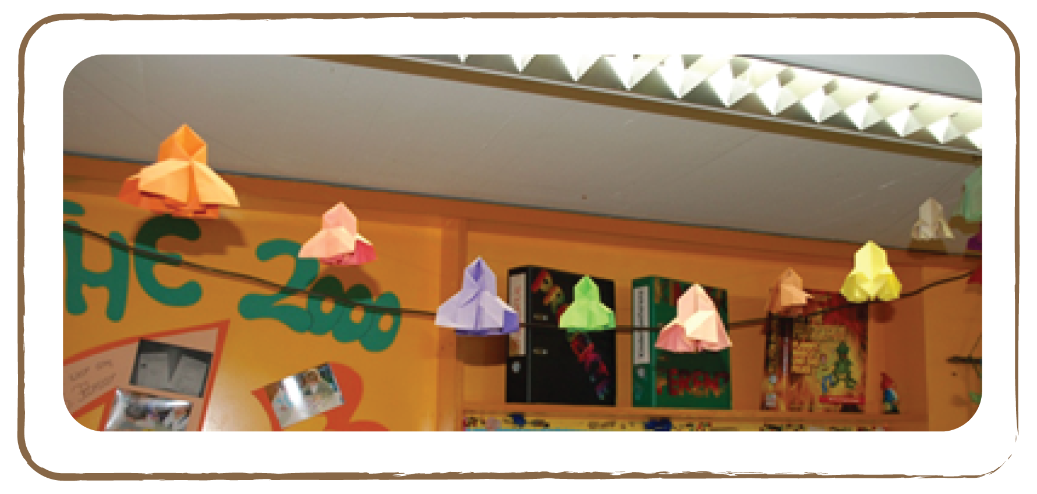

Credit: Natalie Fisher

4.8 Lighter or Heavier

Brief Description

Calculate how much children would weigh on other planets.

Keywords

• Gravity
• Mass
• Weigh
• Planets

Materials

• Paper
• Pen

Learning Objectives

Learn about the influence of gravity on the weight of objects on different planets.

Background Science

An astronaut carried out a very special experiment during a moon landing more than 40 years ago. He held a feather in one hand and a hammer in the other, and then released both objects simultaneously. Which one reached the ground first? They both hit the floor at the same time! If there’s no atmosphere, the feather doesn’t experience any air friction, just like the hammer would barely feel any on earth. In a vacuum, all objects fall at the same speed, regardless of their mass.

When astronauts landed on the Moon, they had a lot of fun jumping on the lunar surface. Due to the weak gravitation, they could effortlessly jump very far and high. They felt extremely light.

How much an object weighs on another celestial body depends on the so-called gravity acceleration. The higher this value, the stronger the celestial body attracts this object, i.e., the more it weighs. Note that the ‘mass’ of an object is always the same anywhere in the universe. One kilogram of sugar remains one kilogram of sugar. It just appears as if it had less mass on the Moon, because it weighs less there. The Moon attracts one kilogram of sugar with less force than the Earth does.

To see how much one kilogram of sugar and a child of 30 kilograms weigh on the surface of each planet, see the table below.

Celestial body | Gravity acceleration at the equator [m/s2] | Multiplier | Example 1 kg  sugar [apparent kg] | Example 30 kg child  [apparent kg]
Sun | 273.7 | 27.9 | 27.9 | 837
Mercury | 3.7 | 0.38 | 0.38 | 11.4
Venus | 8.87 | 0.9 | 0.9 | 27
Earth | 9.81 | 1 | 1 | 30
Moon | 1.62 | 0.17 | 0.17 | 5.1
Mars | 3.71 | 0.38 | 0.38 | 11.4
Jupiter | 24.79 | 2.53 | 2.53 | 75.9
Saturn | 10.44 | 1.06 | 1.06 | 31.8
Uranus | 8.69 | 0.89 | 0.89 | 26.7
Neptune | 11.15 | 1.14 | 1.14 | 34.2
Pluto | 0.7 | 0.07 | 0.07 | 2.1

On the Moon, a child with a mass of 30 kg would weigh only 0.17 x 30 kg = 5.1 kg, while on Jupiter it would weigh as much as an adult weighs on Earth: 2.36 x 30 kg = 70.8 kg.

Other sources: An astronaut carries out a famous experiment on the Moon with a feather and a hammer: http://goo.gl/TIvEI

Full description

- Hand out the left two columns of the table from the background science, with the gravity acceleration for each planet and the multiplier.
- Ask the children to write down how much a child would weigh on each planet, given that it weighs 30 kg on Earth.

Tip: Note that the surface gravity not only depends on the mass of a planet, but also on its size. The bigger a planet is, the farther away you are from the centre when you stand on its surface. Distance decreases the amount of gravity you feel.

Related Subject Ideas

Arts

Searching for extra-terrestrials is exciting. What could they look like? You could ask the children to draw their own versions of extra-terrestrials, or make clay models of them.

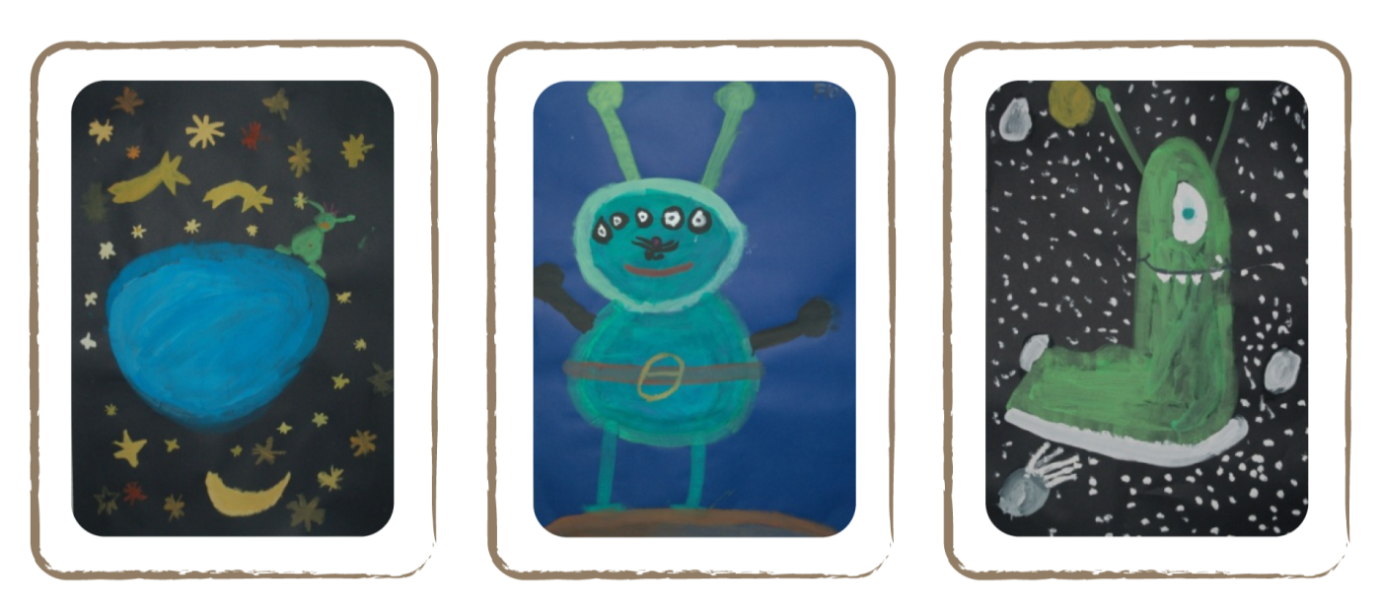
Credit: Natalie Fisher

Baking

You could also incorporate stories of the planets and other celestial objects with astro-art on cookies.
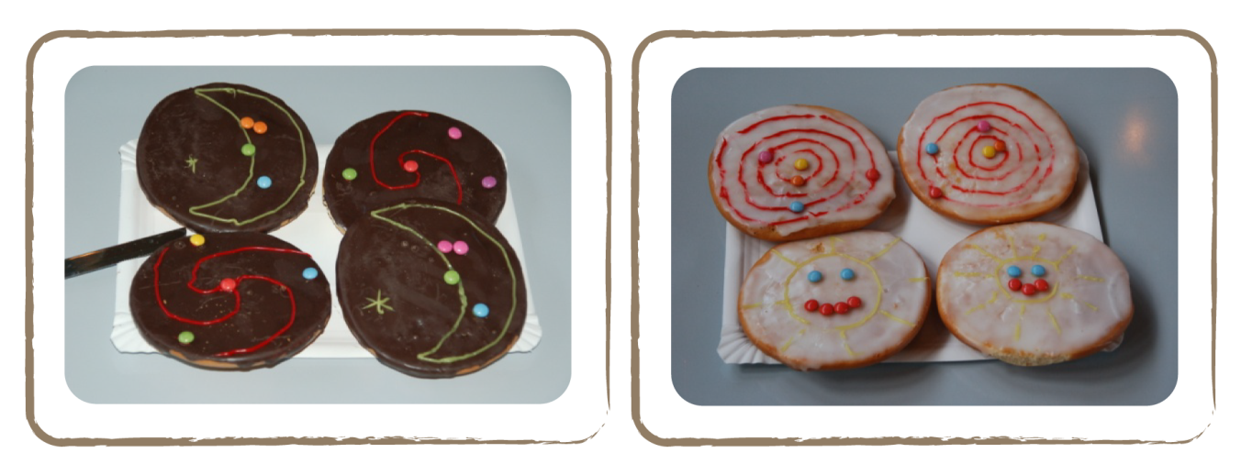

Credit: Natalie Fisher

The World of Constellations

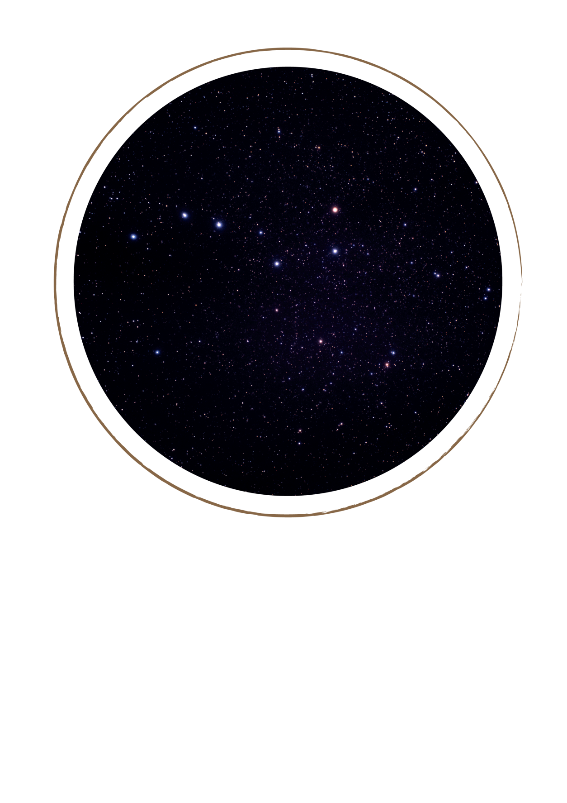
Credit: ESA/ A.Fujii

Introduction

On a clear, moonless night, we can see many stars in a softly gleaming band in the sky. This is the Milky Way. In fact, we are in the Milky Way, and this band is a side view of other stars in the same galaxy. Especially from September until December, we can go searching for wonderful phenomena in the sky, because then Earth’s night side is turned to the Milky Way’s centre, where the largest concentration of stars is. Except for the Milky Way as a whole, we can recognise individual constellations across the sky. These groups of stars have nothing to do with each other, astronomically speaking, but they have been thought to represent various figures throughout human history. People saw a lion (Leo, left picture) or a balance (Libra, upper picture), for example.

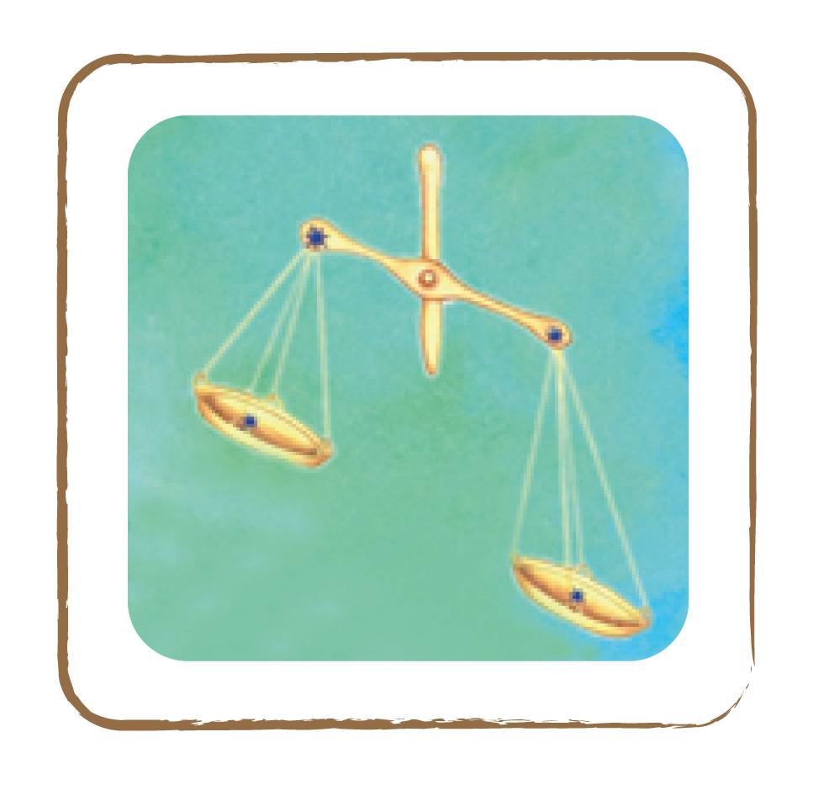 Credit: Cecilia Scorza

Officially, astronomers (represented by the International Astronomical Union (IAU)) have divided the starry sky into 88 constellations.

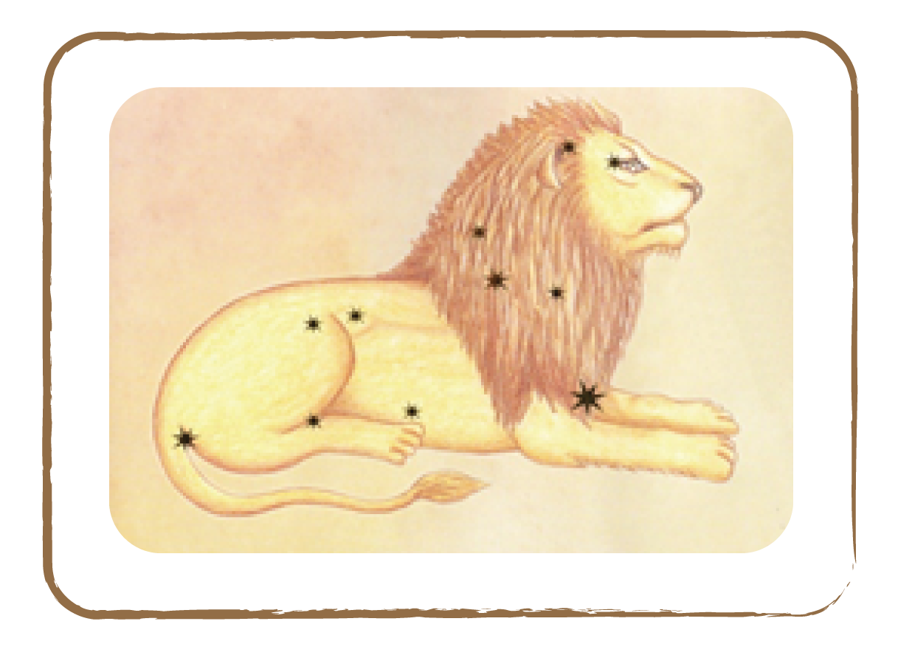 Credit: Cecilia Scorza

Besides these official constellations, each culture has its own constellations that exist alongside the others. In Europe, for example, the most famous constellation is the Plough. It is not an ‘official’ constellation, but part of Ursa Major (the Great Bear). Depending on which country one is in, the name can vary.

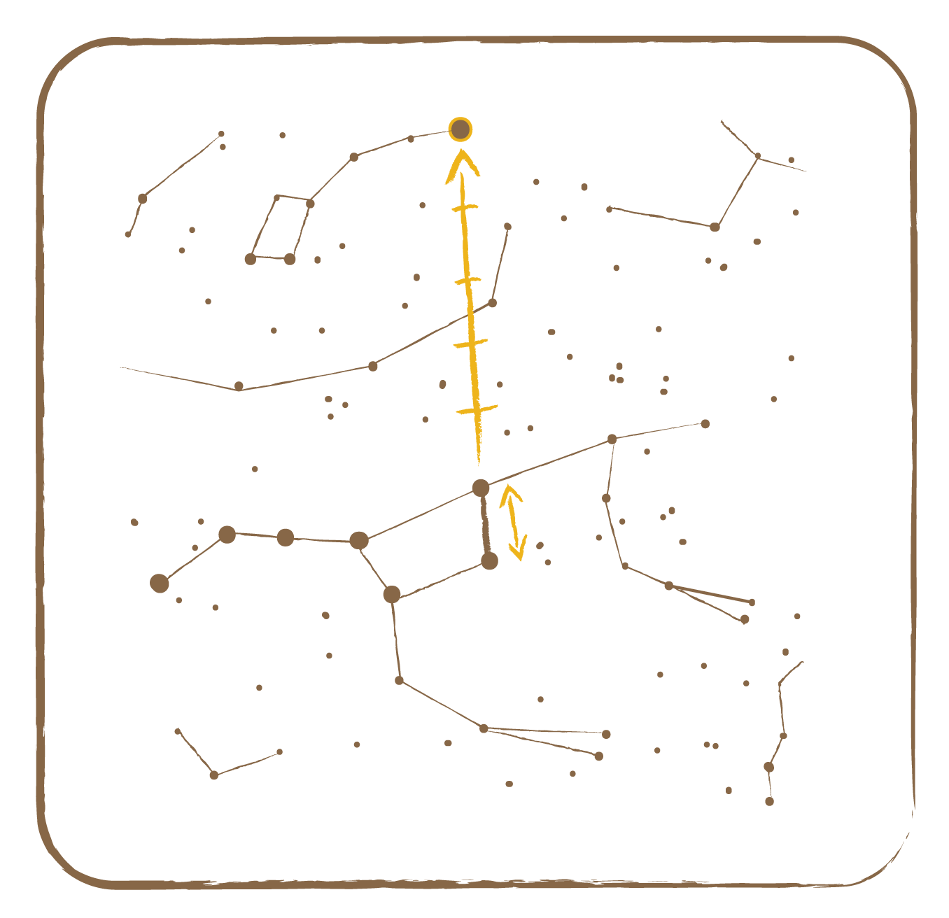 Credit: UNAWE / C.Provot
The Great Bear

Plough
The Little Bear

Polar Star

If we look at the stars at night, we will notice that the constellations are not fixed on the sky. They seem to move, like the Sun, from east to west. For the Sun, we know that this effect is caused by the Earth’s rotation around its own axis. Exactly the same is true for stars.
To see where the cardinal directions are, we can use a trick: the Polar Star is always exactly in the north!

We know that the Earth’s axis is inclined by about 23 degrees with respect to its orbital plane and exactly points north, to the Polar Star. Unfortunately, the polar star is a rather weak star in the constellation Ursa Minor (also called Little Dipper). But there is a trick to find it: we first have to find the constellation Plough, which is one of the most widely known constellations of the Northern Hemisphere (see picture at previous page). The Plough (indicated with yellow dots) is part of the constellation Great Bear. Now, if we conceptually connect the two back stars of the Great Bear (marked red) and extend this line five times upward, we arrive at the Polar Star in the constellation Little Bear! As all stars of the Little Bear are weaker than the Polar Star itself, we can easily recognise the latter.

Since ancient times, sailors have benefited from the Polar Star and the other constellations in order to orient themselves at sea and find their way back home. The height of the Polar Star above horizon corresponds to the geographical latitude of the observational location. Actually, the Polar Star is the only star standing still on sky, since it is located in extension of the Earth’s axis. This is purely by chance! On the Southern Hemisphere, there is no polar star.

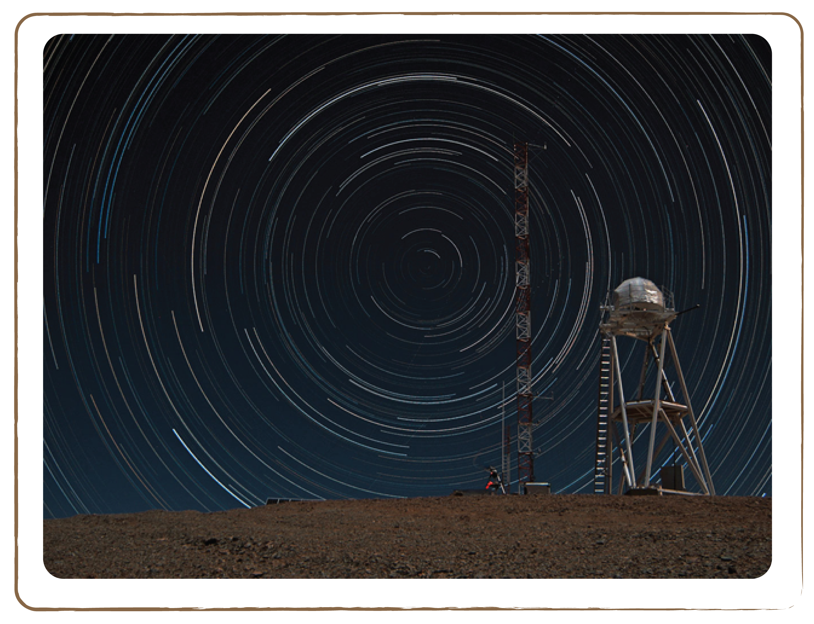

Credit: F. Char/ESO

A multiple-exposure picture taken from the top of the 3060-metre-high Cerro Armazones, the selected site for the European Extremely Large Telescope (E-ELT) in Chile. Because of the rotation of the Earth, the night sky is seen as it rotates around the southern celestial pole.

5.1 Visibility of the Constellations

Brief Description

Determine which constellations are visible at night during different times of the year by placing a banderol with constellations around the Sun and Earth.

Keywords

• Constellations
• Sun

Materials

• Banderol of Signs of the Zodiac (Box)
• Plastic planets (Box)
• Plastic Sun (Box)
• Paperclip

Learning Objectives

Learn how the constellations move across the sky during the year.

Background Science

In order to find constellations and other noticeable objects in the sky, we now imagine — as astronomers have been used to doing for hundreds of years — a transparent celestial sphere around our Solar System, on which we can find all the stars and objects of the universe, no matter how far they are from us. Note that in reality all these stars are at different distances from us. The stars in a constellation seem to belong together, but most of them are actually hundreds of light years apart from each other: they have a somewhat similar location on the sky, but their distance to Earth can be totally different. However, for orientation purposes, we depict them on one sphere.

Credit: UNAWE / C.Provot
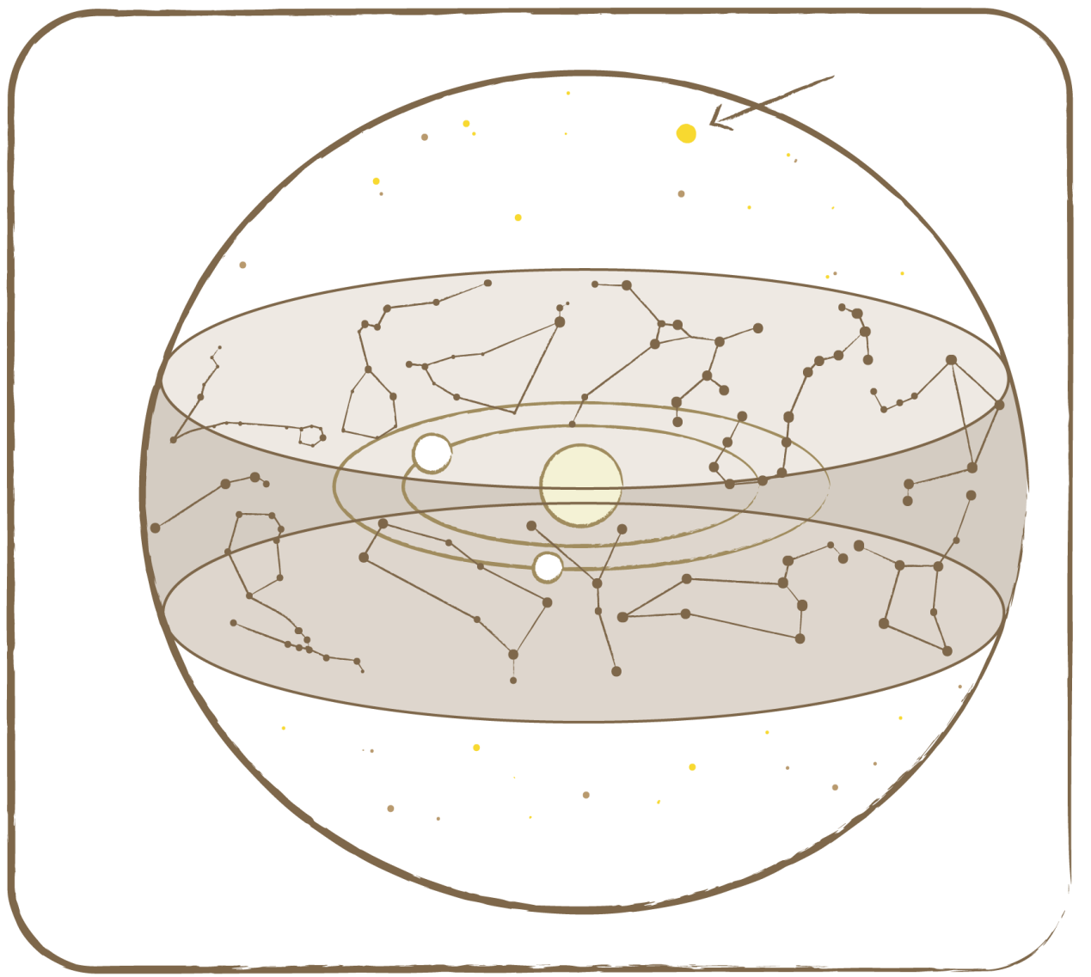
Aries
Pisces
Aquarius
Capricorn
Sagittarius
Scorpio
Libra
Virgo
Leo
Cancer
Gemini
Taurus

Earth
Earth’s axis

Polar star

Celestial Sphere

Credit: UNAWE / C.Provot

The celestial sphere has two halves: a northern and a southern one. In order to keep the picture easily understandable, we have only depicted Sun, Earth and Mars.

Not all constellations can be observed in one night. Some, like the Small Dipper and Cassiopeia, are located near the Polar Star. They can be seen (in Europe) during the whole year and are called circumpolar constellations. Other constellations are only visible in certain seasons. For example, Orion is a typical winter constellation in Europe, but in Venezuela it is a typical summer constellation, where it is, however, more reminiscent of a butterfly than a celestial hunter due to its rotated orientation! Which constellations are currently visible depends very much on the observational location and time.
Of course, stars are also in the sky during the day. We just cannot see them because the Sun is too bright. Only during a solar eclipse, when the Sun is covered by the Moon, one could actually see stars during the day.

Full description

- Put the banderol of Signs of the Zodiac in a circle on the blue cloth and close it with a paperclip.
- Put the Sun in the centre, with the Earth next to it.
- Now ask the children which constellations they can see from Earth.
- To answer this question, they first have to recognise where on earth it’s day and where it’s night. Why can’t all constellations be observed on one night? The Sun always stands in front of a constellation, so you can’t see that one and its neighbours. After half a year the Earth has travelled half a round further along its orbit around the Sun. Then the opposite signs of the Zodiac get blocked by the sunlight.

In the situation sketched in the image above, the constellations Scorpio, Sagittarius and Libra are visible in the night sky. The constellations located in the directions of the Sun, i.e., Gemini, Taurus and Aries, are not. For those to be visible, the Earth first has to proceed on its orbit for several months.

Tip: Of course, there are more constellations that you can observe than just the Signs of the Zodiac. There are several methods to find out which constellations are visible at a given time, e.g., star maps in astronomical almanacs, turnable star maps or the Internet.

On the Internet, a free programme (www.stellarium.org) shows the sky at any time of the day or night and from any location in the world. Projected with a beamer onto a wall, the experience comes close to a real observation! You could also use this programme for orientation on an observation night.

Related activities: 5.2

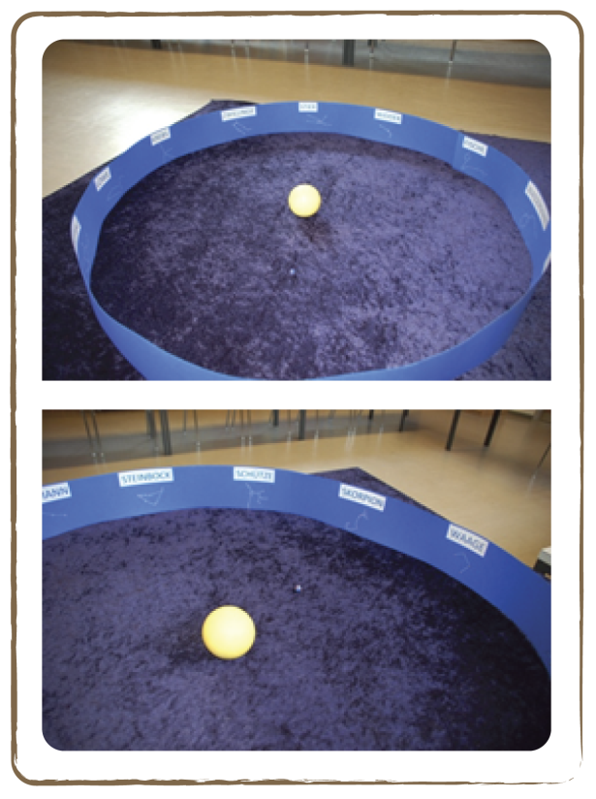

Credit: Natalie Fischer

5.2 The Zodiac and Planetary Movements

Brief Description

Study the positions of the constellations with respect to the planets and the Sun by placing a banderol with constellations around the Solar System.

Keywords

• Constellations
• Planetary movement

Materials

• Banderol of Signs of the Zodiac (Box)
• Plastic planets (Box)
• Plastic Sun (Box)
• Blue cloth (Box)
• Paperclip

Learning Objectives

Learn how the planets move through the constellations during the year.

Background Science

Everywhere on the celestial sphere, stars and constellations can be seen. On the orbital plane of the planets, there are 12 special constellations on the celestial sphere, which we call ‘Signs of the Zodiac’. Actually, this area comprises 13 signs: the constellation ‘Ophiuchus’ is located above the constellations Scorpio and Sagittarius. For historical reasons, it does not belong to the zodiac. These constellations help us to find the planets in the sky. Seen from Earth, planet Mars stands for example in front of the constellation Cancer. But since Mars rotates around the Sun, two months later we find it in front of the constellation Leo. So it ‘wanders’, as seen from Earth, through the signs of the zodiac. Actually, all planets do that. We would therefore never find a planet in the constellation ‘Plough’, because it doesn’t lie in the orbital plane of the planets around the Sun, like the signs of the Zodiac.

Exactly the same phenomenon can be observed with the Sun: seen from Earth, it is located in front of the constellation Virgo in the picture. But as the Earth moves around the Sun, the Sun seems to stand in front of the constellation Libra one month later. This means that the Sun also seems to go along the signs of the zodiac. It takes exactly one year to complete one round.

These motions of the Sun and the planets in relation to the constellations are called positional astronomy.

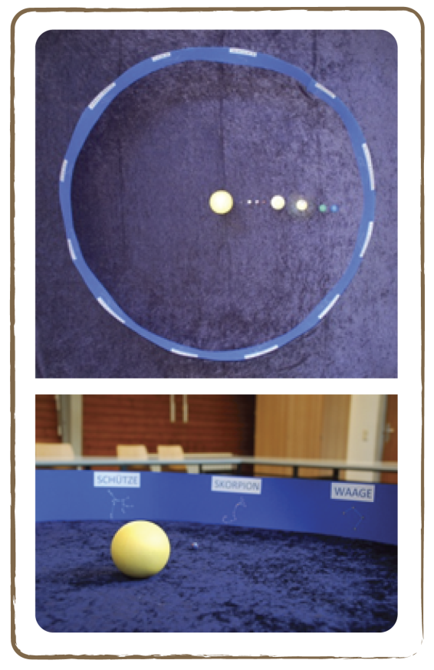Credit: Natalie Fischer

Full description

- Put the banderol of Signs of the Zodiac in a circle on the blue cloth and close it with a paperclip.
- Place the Sun and its planets in the right order within the banderol. Note that the planets move counter-clockwise around the Sun.
- Ask the children to describe the positions of the planets with respect to the constellations behind them. The constellation being blocked by the Sun is the one ascribed to a child whose birthday it was some weeks before.
- Ask each child to place the Earth and the Sun in the positions they are on the child’s birthday.

Related activities: 5.1

5.3 Planisphere: A Turnable Star Map

Brief Description

Make a rotating map or a planisphere that can show the features of the sky at any given time or date.

Keywords

• Constellations
• Sky
• Map
• Stars
• Planisphere
• Orientation

Materials

• Planisphere – Northern/Southern Hemisphere Star Map (Appendix)
• Transparent sheet
• Round split pin
• Scissors
• Glue
• Colour pencils

Learning Objectives

Learn to navigate through the sky and find constellations using a planisphere.

Background Science

A planisphere is a circular star map of the night sky. The star map contains the brightest stars and constellations visible from Earth. The composition of the night sky depends on whether the observer is on the Northern or Southern Hemisphere and the latitude and longitude. A planisphere is constructed to freely rotate about a common pivot point at its centre. Planispheres usually have transparent windows designed for a particular latitude and longitude to show only that part of the sky visible from a given latitude; stars below the horizon are not included.

A full twelve months of calendar dates are marked on the rim of the star map. A complete 24-hour time cycle is marked on the rim of the overlay. The window is marked to show the direction of the eastern and western horizons.

Full description

- Ask the children to make a turnable star map from the copy sheet in the Appendix. You can find a plastic model in the Box. First, the children should cut out the cover sheet and the star map.
- Inside the cover sheet they cut out an oval shaped window. Note that the shape and size of the spy window changes by latitude and longitude. The further from the equator you go, the more circular the spy window would become. The plastic model is suitable for the latitude of Europe (Northern Hemisphere) and Australia (Southern Hemisphere). Depending on your latitude, the children should cut out the window in the right shape.
- Now, a part of the backside of the cover sheet is carefully spread with glue and the overhead foil is stuck onto it. Please take care that no sticky areas remain!
- Then, carefully cut off those parts of the foil that protrude beyond the edge of the cover sheet.
- Both sheets are laid centred on top of each other with the script to the top (the star map lies below).
- Prick a hole just in the centre of both disks, and join them with the split pin.
- Now our star map is ready to use.
- On the lower sheet, surrounding the stars, the months and days are indicated, on the cover sheet you see the hours of the day (noon being omitted). Furthermore, the cardinal directions are indicated around the spy window.
- Through the spy window we see the part of the sky that is visible. Each constellation on the star map is named, its stars joined by lines and the brightest star is also named.

Where is the Zodiac located? The children can colour it. If we turn the cover sheet, other areas of the starry sky with different constellations become visible.

Are there constellations that are always visible? Yes: for example, the Big Dipper, Cassiopeia and so on.

Now, how do we correctly adjust the map? This is very simple: we need to rotate the observational day (outer disk) and the time (spy window) such that both indications exactly oppose each other. Then we have the right sky section.

How do we have to hold the map? In the Northern Hemisphere, to begin with, we search for the Polar Star. That is where north is. We turn in this direction.
Now we also rotate our map (without shifting the maps with respect to each other) in such a way that we can read the word ‘North’ the right way up. Now, we hold the map with our arm stretched in the direction of the Polar Star. You have to visualise the star map like an umbrella above our head. The split pin corresponds to the Polar Star on the map. All stars located below the ‘Polar Star’ on the map are also below the Polar Star on the sky.

We can now turn in an arbitrary cardinal direction (think of ‘Never Eat Soggy Waffles!’ in a clockwise direction) — we just have to also rotate the whole star map such that the corresponding cardinal direction is readable on the card the right way up.

Does one have to ‘re-rotate’ the map in the course of a night? As the Earth rotates around it axis, the sky also seems to rotate: new constellations rise in the east and others set in the west. Thus, one would have to re-rotate the star map repeatedly. But you will see that the spy window does not significantly shift within one hour.

You may have noticed:

- The sky section you have selected for a given date will also be visible at the same time next year! The map works independently from the year.
- You can also see the once-selected sky section on other days, you just have to accept a differing time of the day (e.g. the sky section on 5 April at 10 pm is identical with the sky section of 4 February at 2 am or 10 December at 5:45 am.

Tip: There are great apps for Apple, Android and Windows smart phones that show the starry sky live. You just have to point your phone to the sky area you are viewing and you have a star map with an indication of the planets, stars and other objects on your display.

5.4 Constellation Shapes

Brief Description

Make a model of a constellation and look at it from different angles.

Keywords

• Constellation
• Stars
• Perspective

Materials

• 5 stars (Box)
• 5 wooden spits of different lengths
• Plasticine

Learning Objectives

Learn how constellations form from a number of stars at different distances, and that their shape appears differently from different perspectives.

Background Science

The constellations far away from the zodiac, in the northern or southern parts of the celestial sphere, can be observed at any time of the year. For example, in the Northern Hemisphere, one can always see the Little Bear (including the Polar Star) and Great Bear. These are called circumpolar constellations. Other constellations, closer to the zodiac, are only visible in certain seasons, just like the ones from the zodiac. Orion, for example, is a winter constellation on the Northern Hemisphere.

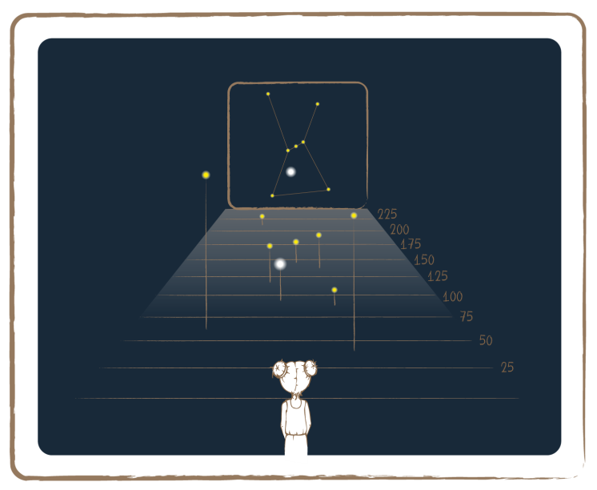Credit: UNAWE C.Provot
Light Years

In the figure above, Orion can be seen on the right. The stars in this constellation appear to be connected somehow, but are they really? The answer is given by the left part of the figure: no, they don’t belong together. They are just located in the same part of the sky, but if you consider the distance from Earth as well, thinking three-dimensionally, you will notice they are in fact far apart. The girl in the lower part of the picture is standing on Earth and looking up at the sky. She sees a constellation, because from her perspective all stars are projected onto the sky sphere as one image. She cannot see that the stars are all at varying distances.

The stars of a constellation do not all have the same brightness. The brightest star of a constellation is called the alpha star, and always carries a special name. For example, in the constellation Leo, the alpha star is called Regulus, which means ‘little king’.

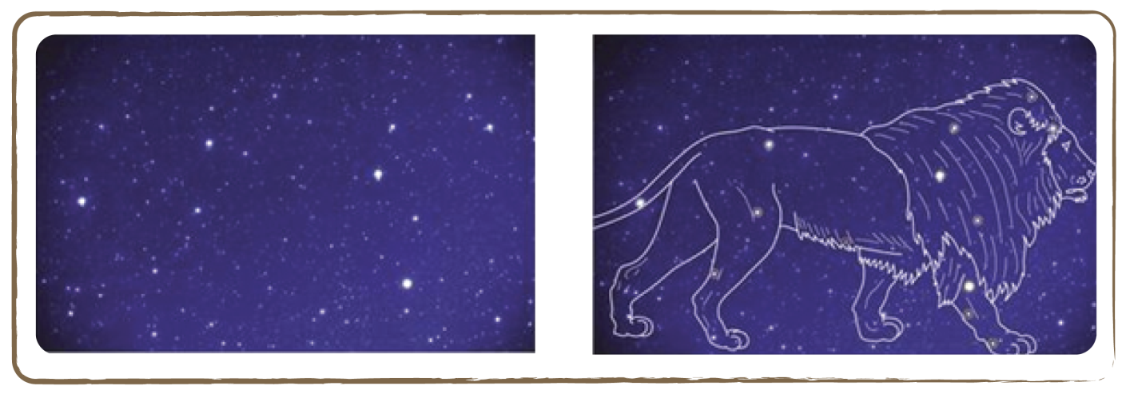

Which image people see in a group of stars in the night sky, depends on the culture. Therefore, the names of stars and constellations reflect on the history of past and present cultures.

The following table lists the names of the brightest stars of several well-known constellations:
Constellation | Abbreviation | Alpha Star
Bootes | Boo | Arcturus
Greater Bear | UMa | Dubhe
Little Bear | UMi | Polaris
Virgo | Vir | Spica
Leo | Leo | Regulus
Aquila | Aql | Altair
Lyra | Lyr | Vega
Cygnus | Cyg | Deneb

Full description

- Stick five stars on five wooden spits of different lengths and place them on a table using plasticine, at different distances from each other, so that from the front they form the shape of the constellation Cassiopeia.
- Let the children have a look from different angles, from the front and from the side, in a darkened room. What do they see? From the front, the stars look like the constellation Cassiopeia, but from the side they form a completely different shape. Apparently, constellations only have their form because we look at them from Earth’s perspective. If you could get in your spaceship and look at them from another side, you would notice that the stars are all at varying distances from Earth: they don’t actually belong together!

Tip: Do the same activity with other constellations.

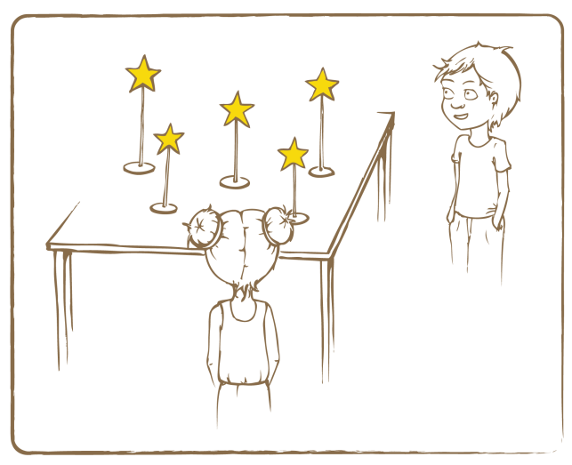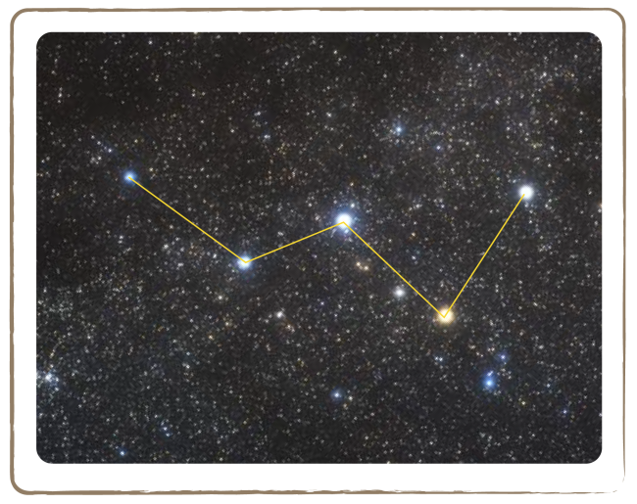

Credit: UNAWE / C.Provot Credit: ESA / A.Fujii

5.5 Viewing Constellations through Stories

Brief Description

Read stories of the constellations and associate the stories with the seasons by viewing the constellations through a constellation viewer.

Keywords

• Constellations
• Cards
• Constellations viewer
• Seasons
• Stories

Materials

• Constellation stories (Appendix)
• Constellation viewer (Box)
• Constellation cards (Box)

Learning Objectives

Learn about the stories behind constellations and their connections to seasons.

Background Science

The images we see in groups of stars have arisen from human imagination for thousands of years. The same is true for the names that we have assigned to individual stars. They reflect the history of past cultures.

On the left picture, for example, we see a group of stars becoming visible in summer. Some children see in them a dipper, a quarter note or a stiletto. With the aid of the connecting lines on the right picture, it will be easier for us to guess what this figure might be. Some children imagine it as a splashing water hose, others as a slide, still others as a waterfall. So which is it?

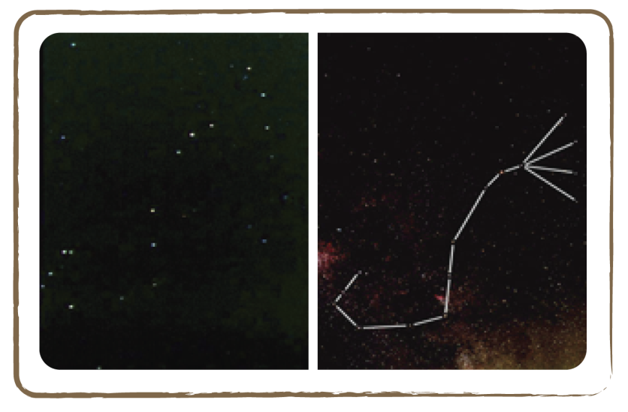

The assignment of shapes to groups of stars depends on what is familiar to us. Female teachers may see a high heel, while musical children may see a note.

It is especially interesting to look at and compare the constellation names of different cultures.
What would a Native American from the Amazon area see in this group of stars in the sky? Surely not a musical note! They would probably see a water snake!

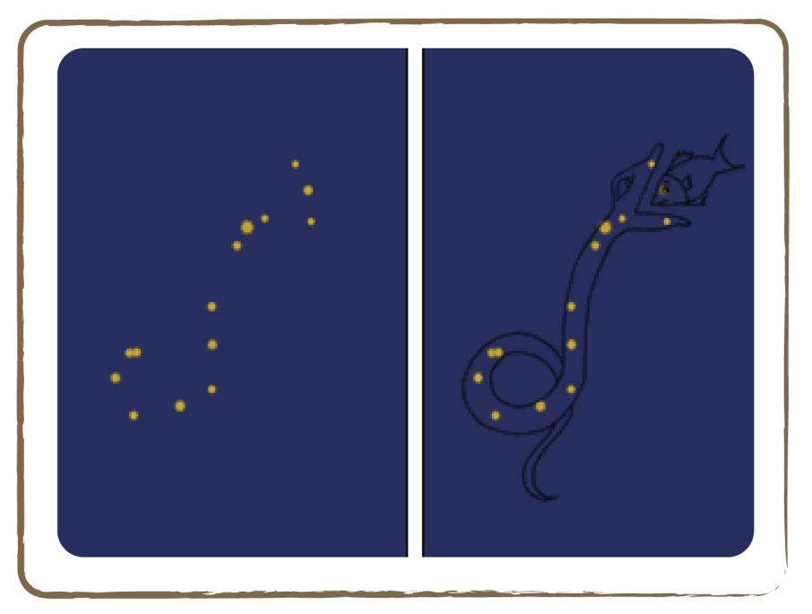 Credit: Cecilia Scorza

Natives from Venezuela see a carrying basket for babies. And what did the Greeks see in the sky 3,500 years ago? They saw a scorpion!

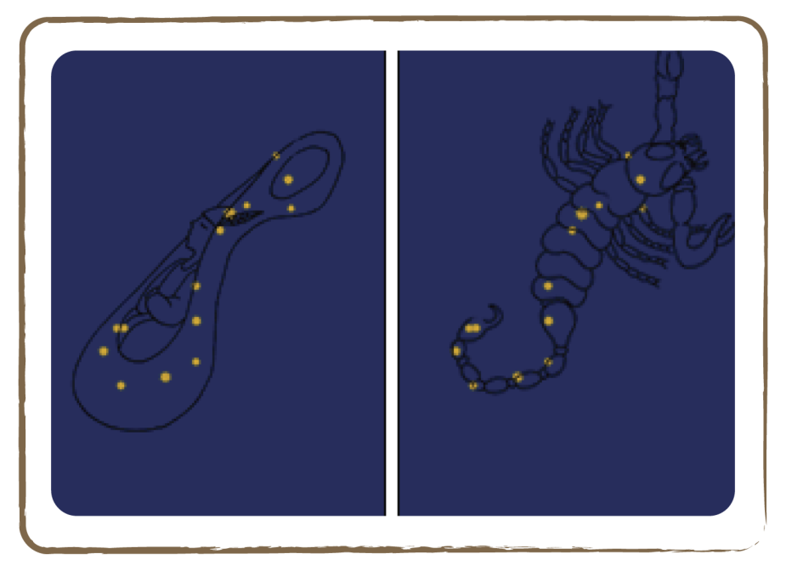 Credit: Cecilia Scorza

Full description

Even during the day you can practise recognising the constellations. The constellation viewer is very useful for this purpose. A set of constellation cards can simply be put into the viewer. These cards have holes at the positions of the stars (lower left picture), with the diameter of the holes corresponding to the respective star’s brightness.

- First, let the children familiarise with the stories about the constellations (see Appendix). They can either read them themselves, or you can read the stories to them.
- Ask the children to assign the constellation cards to the corresponding stories: the Andromeda saga, the story about the Greater Bear, the hunter Orion, etc.
- Every story contains constellations typical of a season: by partitioning the cards into stories, the children also partition them into the corresponding seasons!

Tip: A child puts a card into the constellation viewer. Another child is asked, without having seen the motive of the card, to identify the constellation. Thus, the children jointly practice recognising a constellation in the darkness.

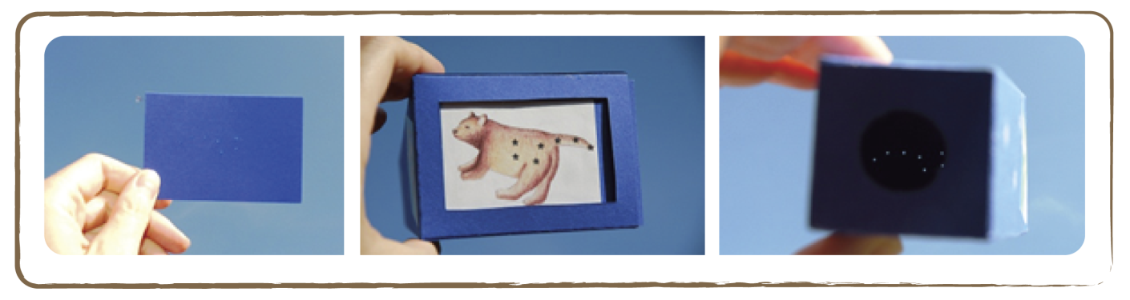

Credit: Natalie Fischer

Appendix

Image of the Moon

Credit: Gregory H.Revera

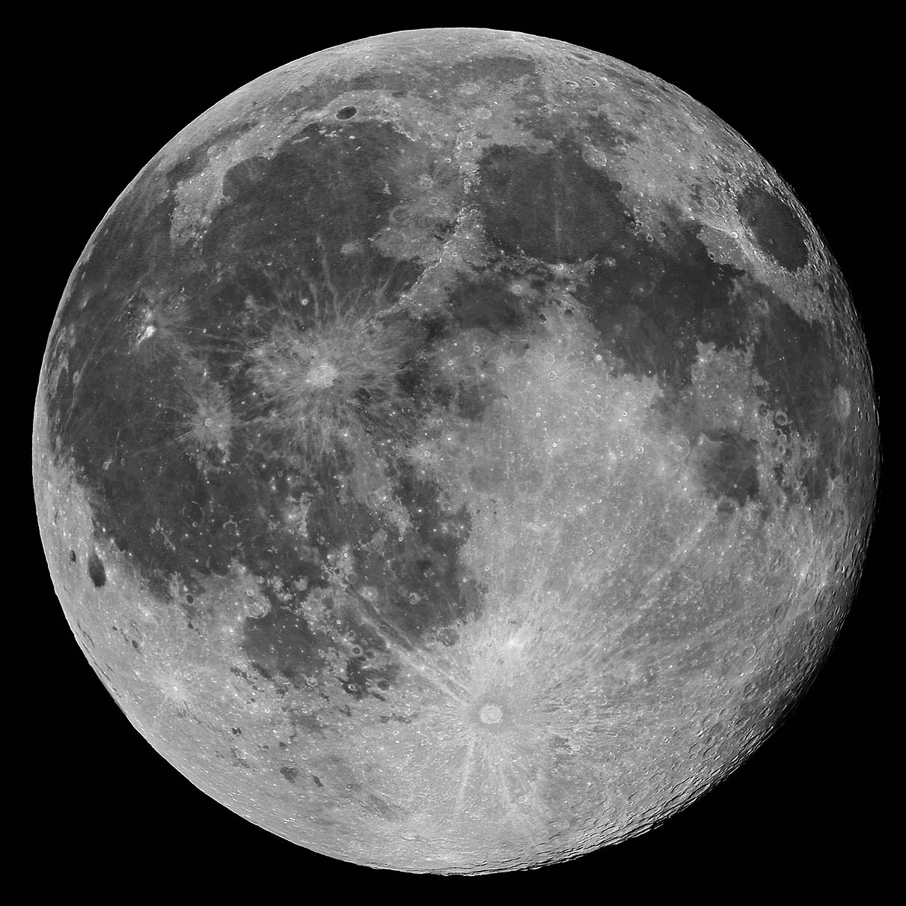

Image of Lunar Phases
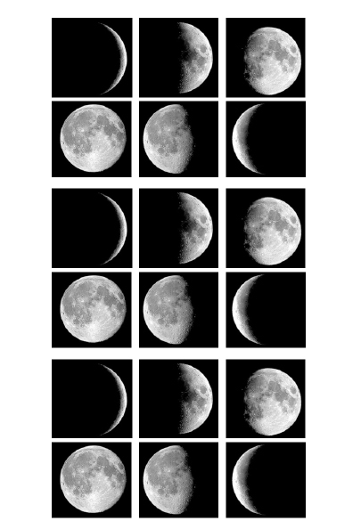

Credit: NASA

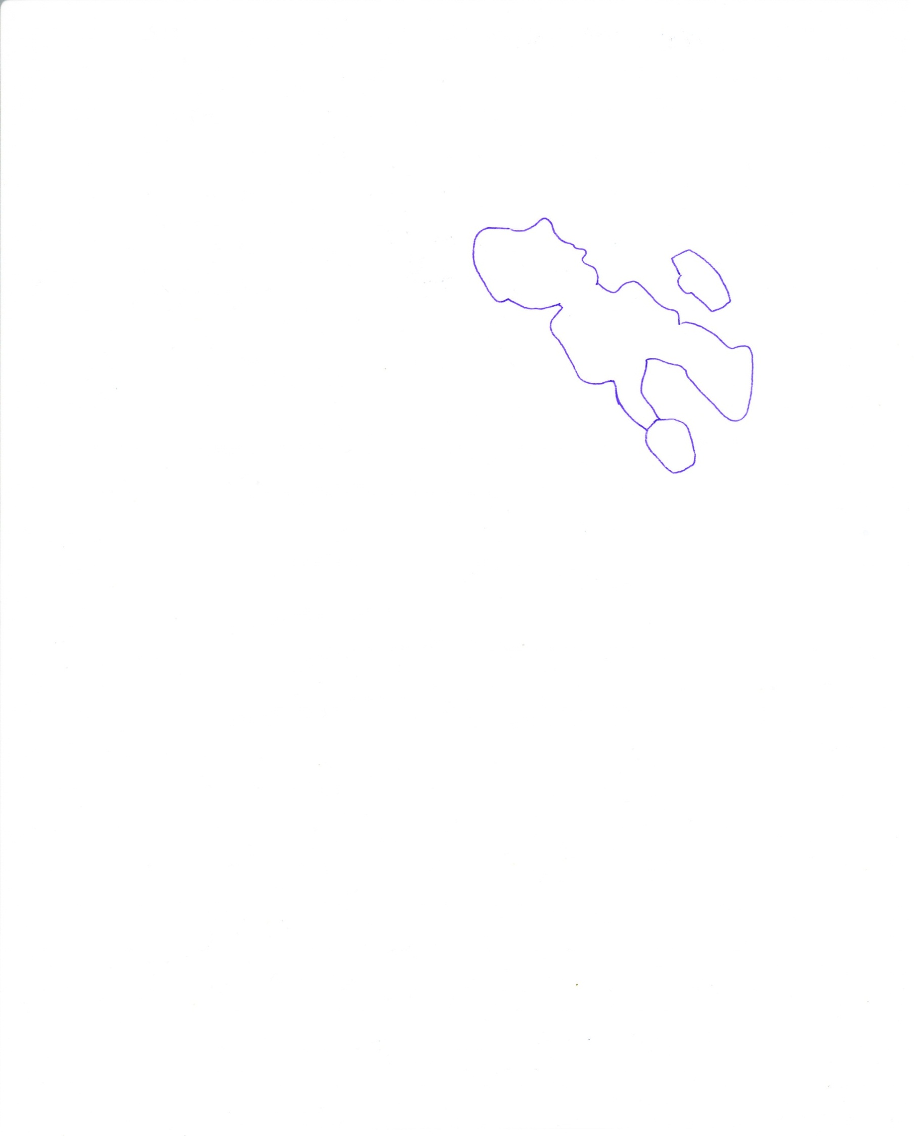
Man in the Moon (Germany)

Credit: Cecilia Scorza and Natalie Fischer (EU-UNAWE Germany/House of Astronomy
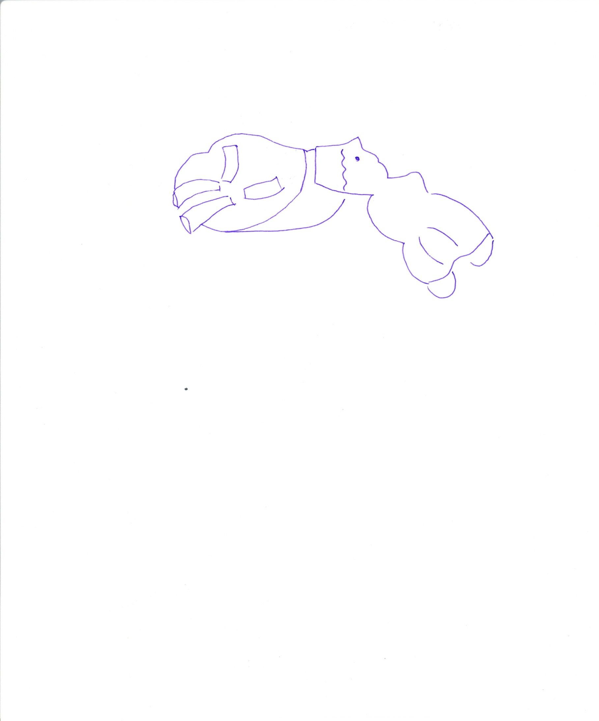
Woman in the Moon (Congo)

Credit: Cecilia Scorza and Natalie Fischer (EU-UNAWE Germany/House of Astronomy)
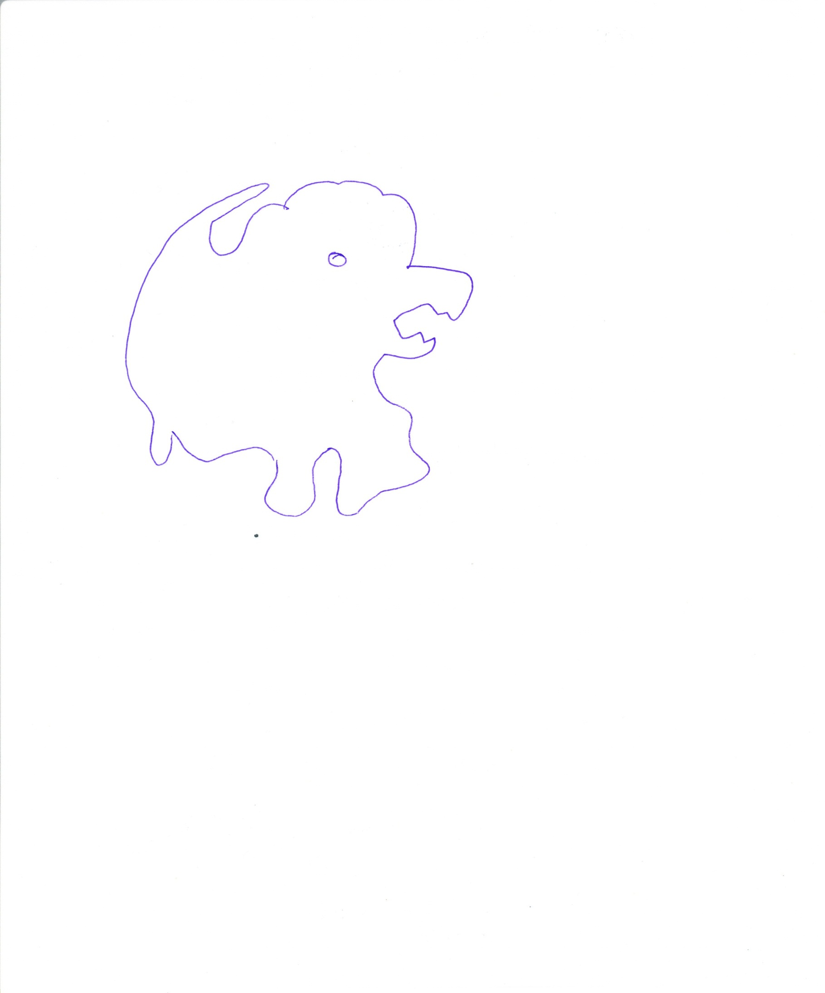
Lion in the Moon (Africa)

Credit: Cecilia Scorza and Natalie Fischer (EU-UNAWE Germany/House of Astronomy)

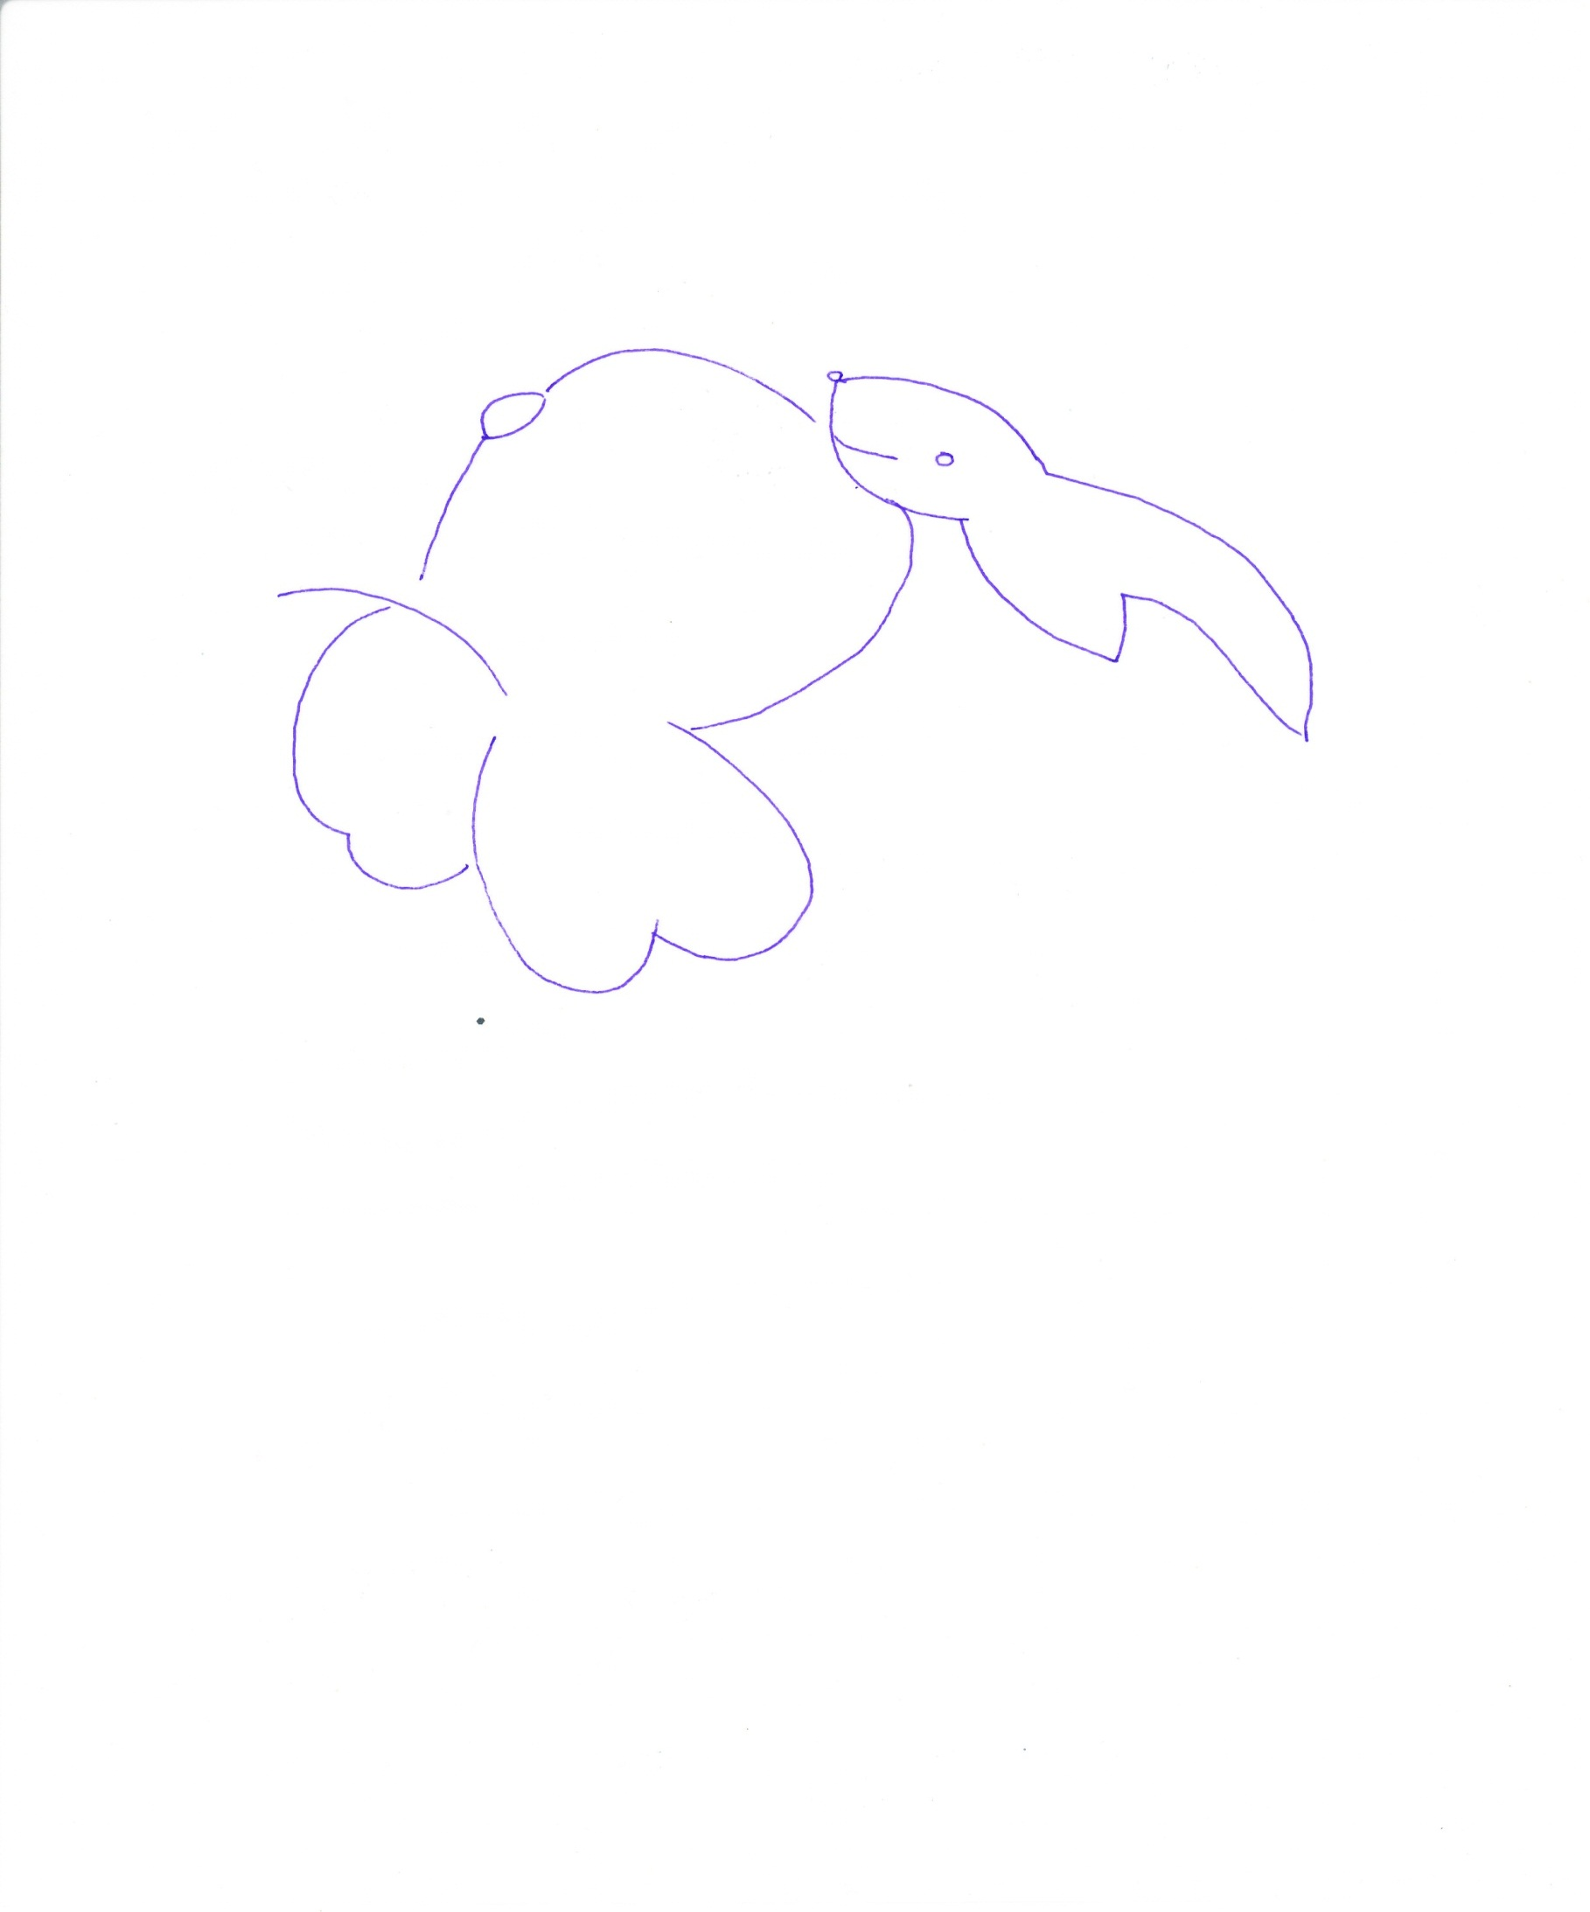

Rabbit in the Moon (China)

Credit: Cecilia Scorza and Natalie Fischer (EU-UNAWE Germany/House of Astronomy)

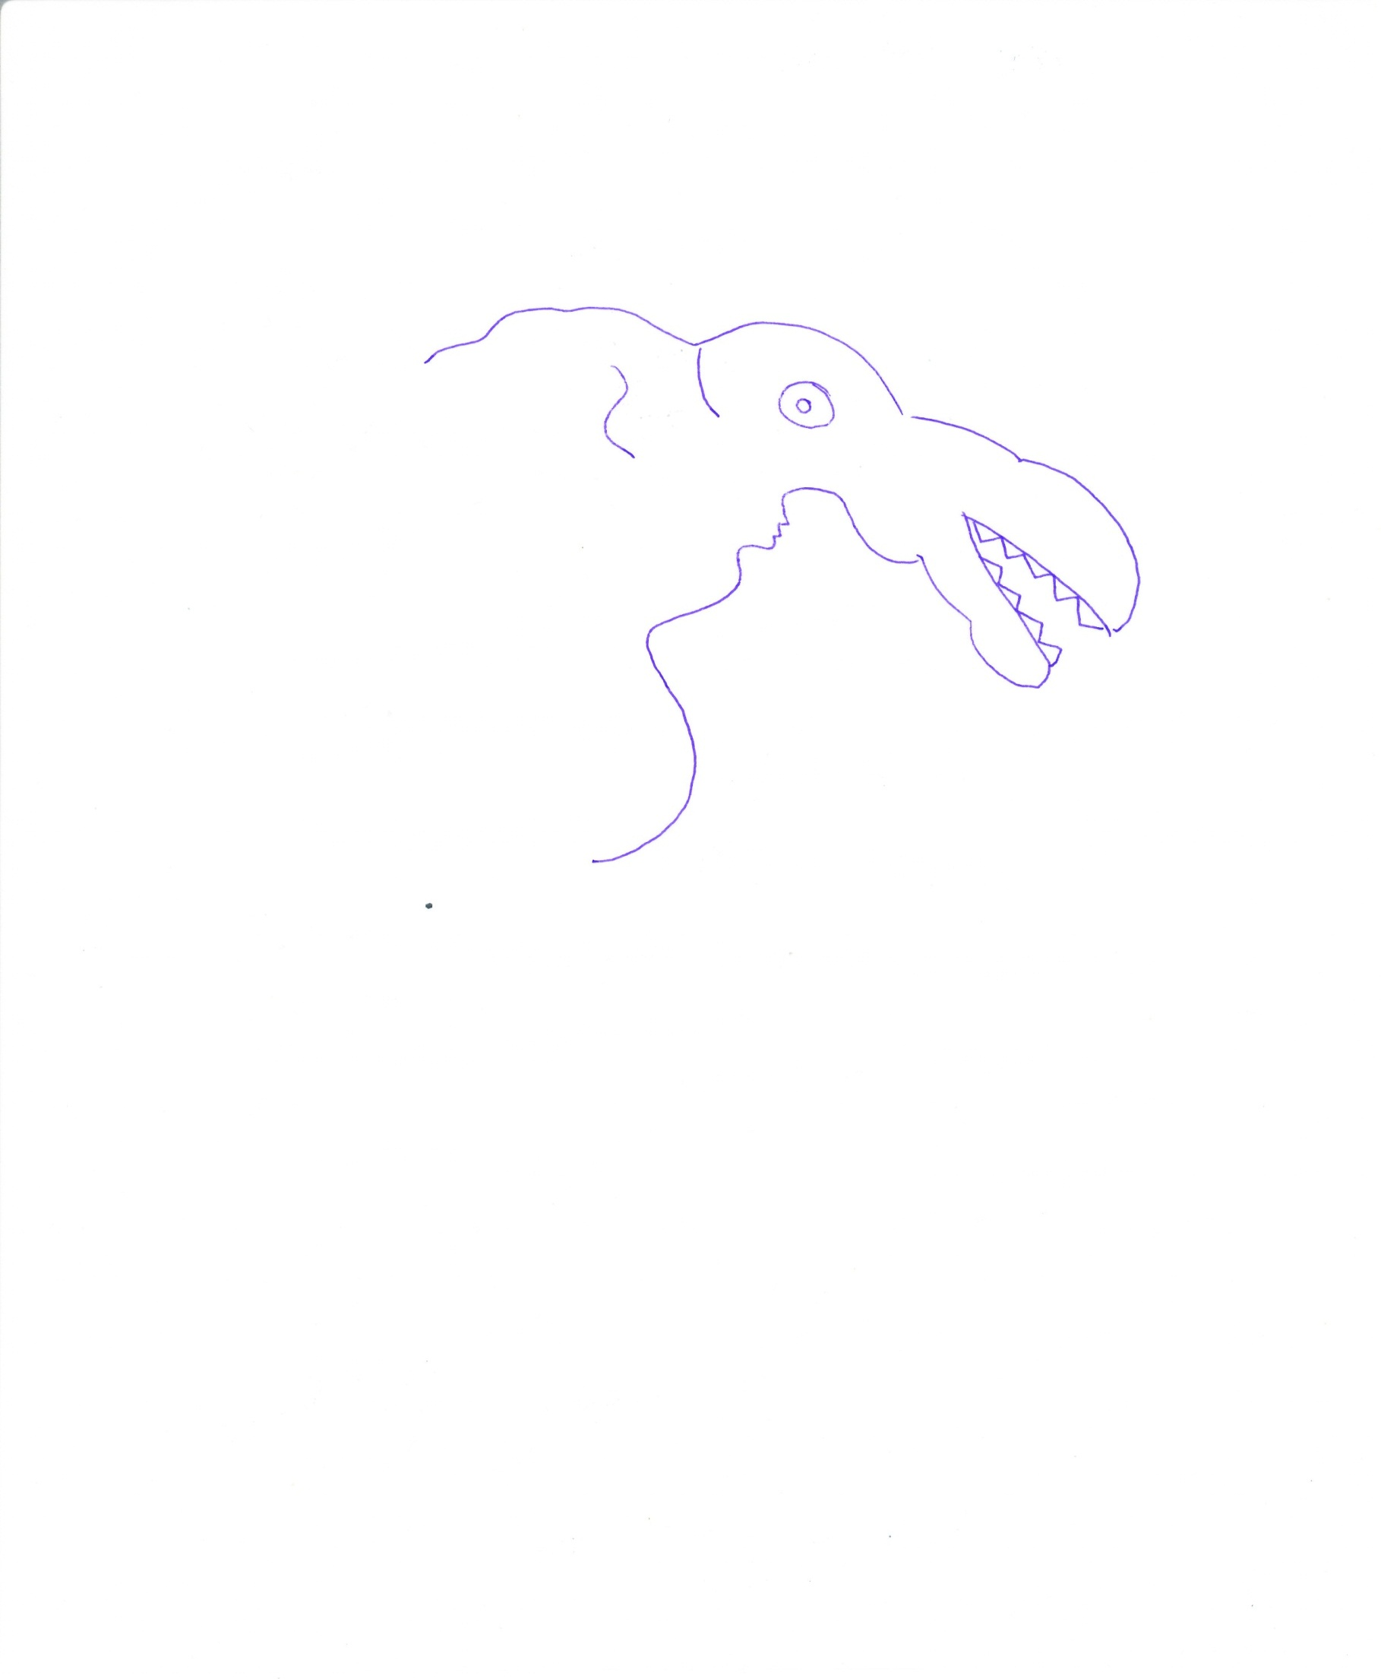
Crocodile in the Moon (Kenya)

Credit: Cecilia Scorza and Natalie Fischer (EU-UNAWE Germany/House of Astronomy)
Moon Stories

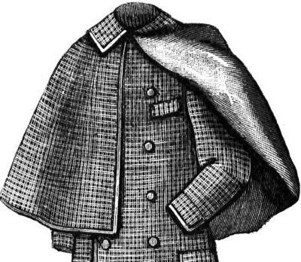
A Coat for Mr. Moon (Germany)

Once there was a tailor, whom people knew for his extraordinary cuts. All gentlemen and ladies of rank only went to him to have their clothes sewn. One day, an exceptional customer entered his shop: the Moon! ‘I would like to order one of those elegant winter coats, which so many gentlemen on Earth wear in winter and which originate from this very workshop,’ he said. The tailor felt honoured and immediately began to take measurements. Round as a ball and shiny, the Moon stood in the workshop and viewed himself, while the tailor eagerly noted down the measurements. In two weeks, the coat was to be finished.

After 14 days, the Moon stood in front of the tailor’s mirror again, this time with his new coat. But – Oh! What was this? Should the tailor have measured him so wrongly? The coat was much large and hung down from the narrow Moon crescent like a sack. This was visibly unpleasant to the tailor, who promised to immediately change the coat. The Moon was measured again and two more weeks went by. When the Moon was trying on his new coat again, he did not believe his eyes: this time, the coat was too tight! After all, how should a perfectly round Moon fit into a coat shaped like a crescent? The Moon was very disappointed and was just about to leave the shop, when the tailor had an idea: he asked the Moon to return another time, and this time he presented him with two different coats: one that he should wear when he was round as a sphere and one that he could wear two weeks later, when he was crescent-shaped. Overjoyed, the Moon left the workshop and, in appreciation of his services, the Moon had the image of the tailor with his portable sewing machine painted on the Moon’s surface, where it can still be seen today.

(Retold from the book by Hans E. Ernst: Was will der Mond beim Schneider, Leipziger Kinderbuchverlag GmbH, 2007).

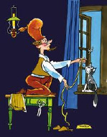Credit: Marschak von Hans / E.Ernst

Moon Stories

Rabbit in the Moon (China)
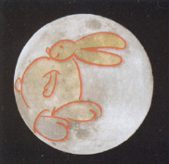
A long, long time ago, a fox, a monkey and a little rabbit lived together peacefully as friends. During the days, they went into the mountains, hunted and played there, and in the evenings they went back into the forest to spend the night there. So it went for many years, until the Moon heard this and wanted to see it with his own eyes. So he disguised and went to them, masked as an old wanderer. ‘I have hiked through mountain and valley and now I’m tired and hungry. Could you give me something to eat?’ he asked, while laying down his stick and joining them.

The monkey immediately left to search for little nuts and brought them to him; the fox gave him a fish he had hunted. The little rabbit, however, was very desperate, because although it had sought everywhere, it had nothing to give the poor wanderer. The monkey and the fox mocked him: ‘You really are good for nothing.’ Now the little rabbit was so discouraged that it asked the monkey to fetch wood, and asked the fox to set it on fire. Both of them did what the little rabbit had asked for. Then, the rabbit said to the Moon: ‘Eat me!’ and was about to throw himself into the fire. The wanderer held him back and was so touched by this willingness to make sacrifices that he cried.
He then said: ‘Everyone deserves glory and recognition. There are neither winners nor losers! But this rabbit has given us a great proof of his love!’ He took the rabbit with him onto the Moon, where he can be seen happy on the Moon’s surface since that time
.
The rabbit on the Moon (in the picture on the left) is shown in an embroidery on an imperial garment from ancient China!
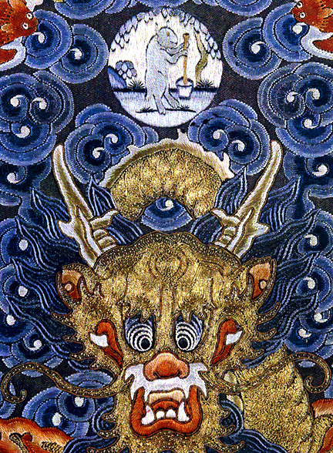Credit: Wikimedia Commons
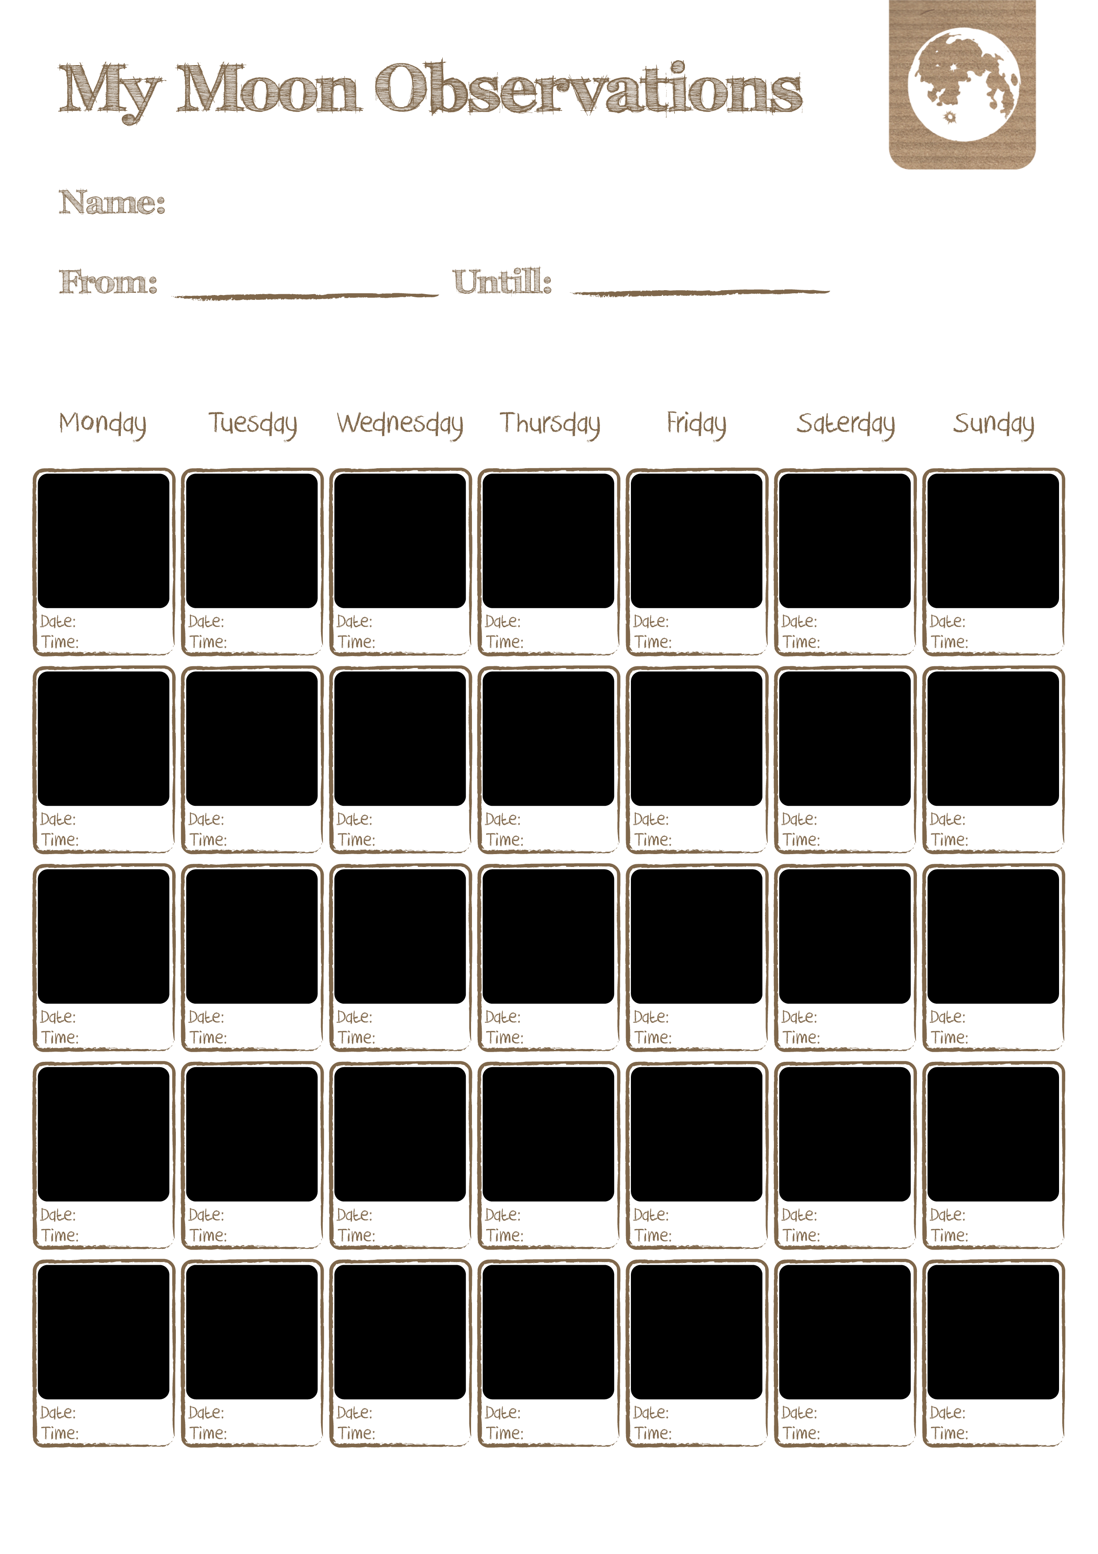
Earth Mosaic

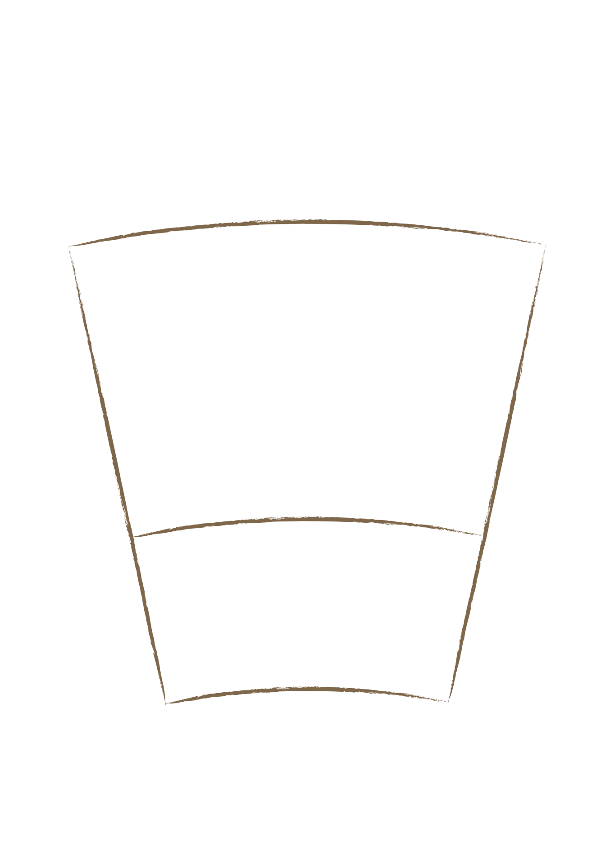

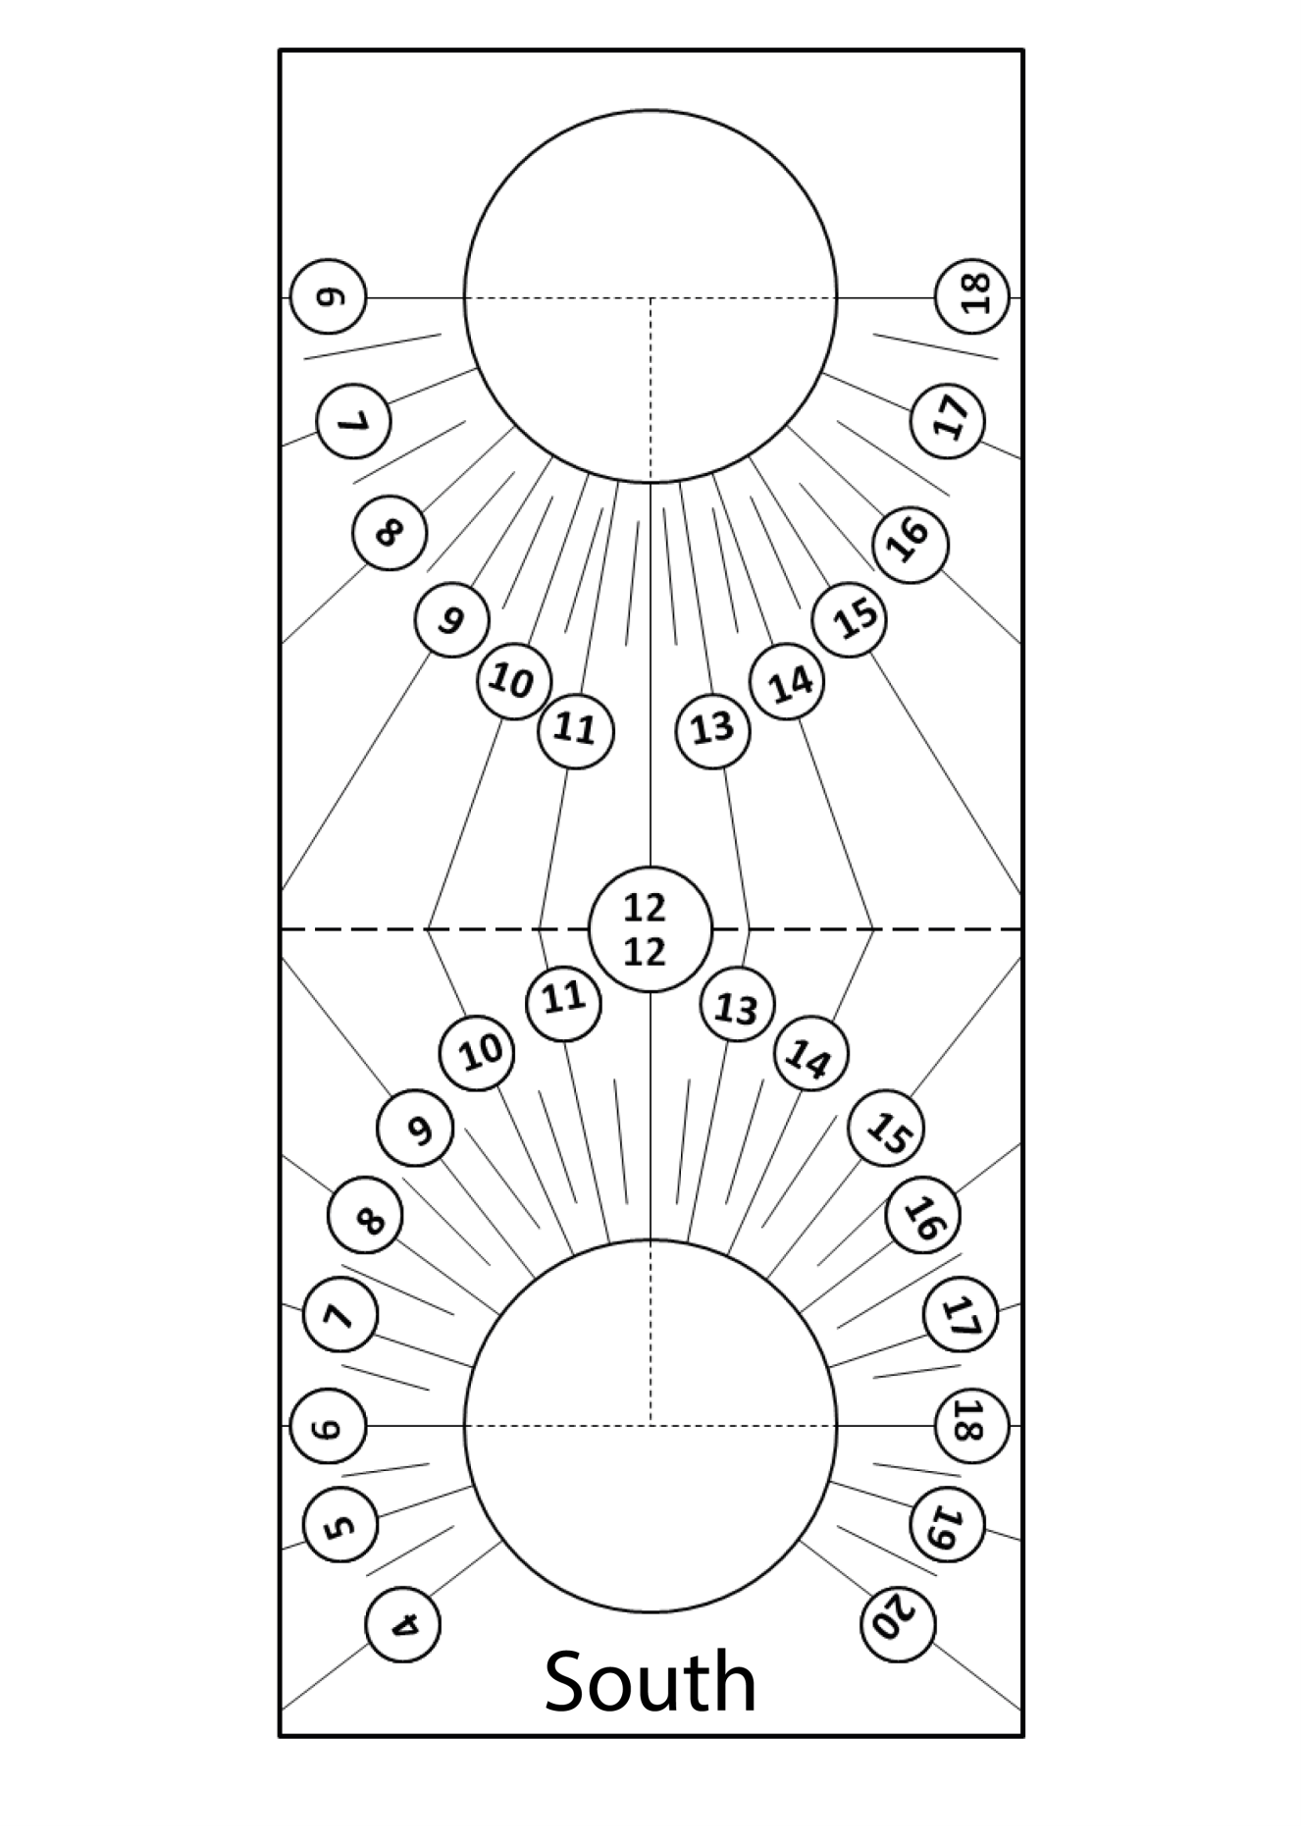
Sundial Part 1

Sundial Part 2

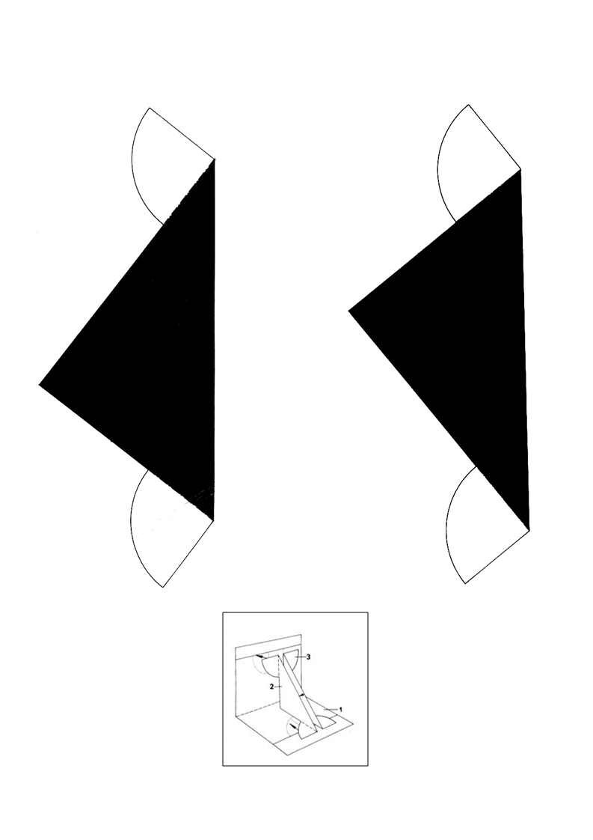

Origami Rocket
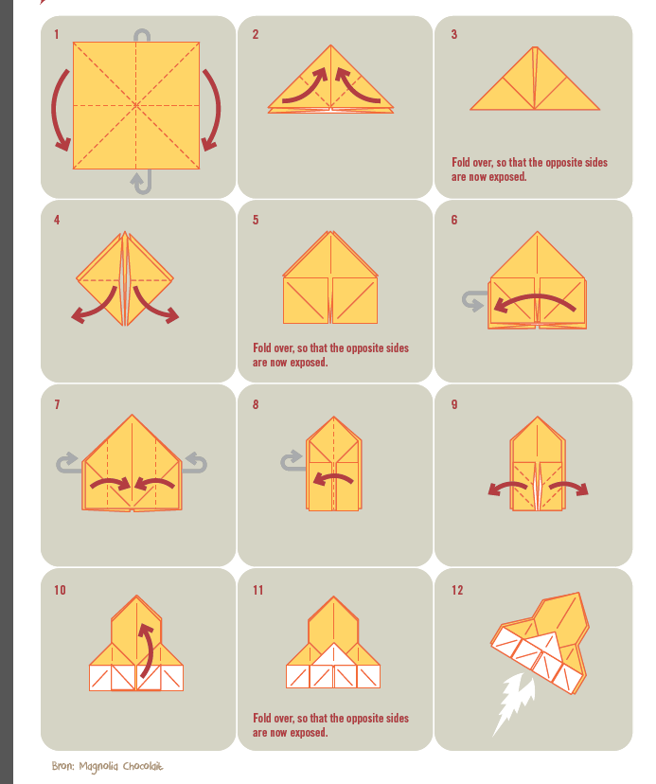

Origami Boat

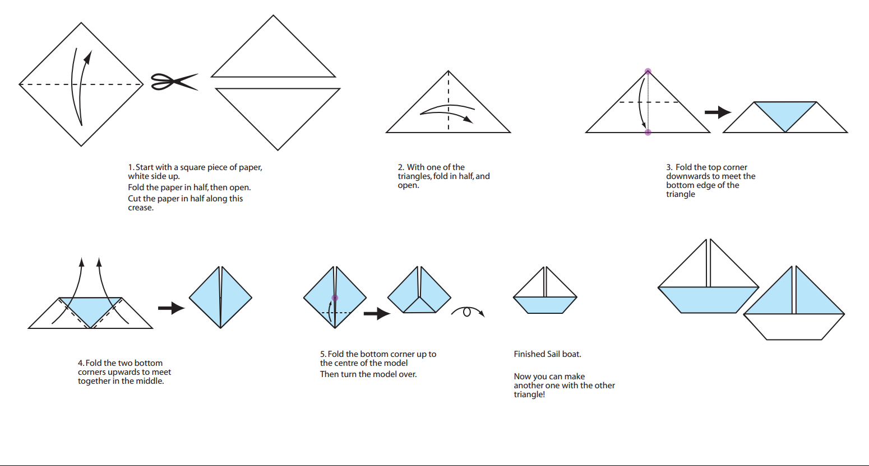

Credit: http://www.origami-fun.com/support-files/origami-sailboat-print.pdf

Planet Card
Game (Front)

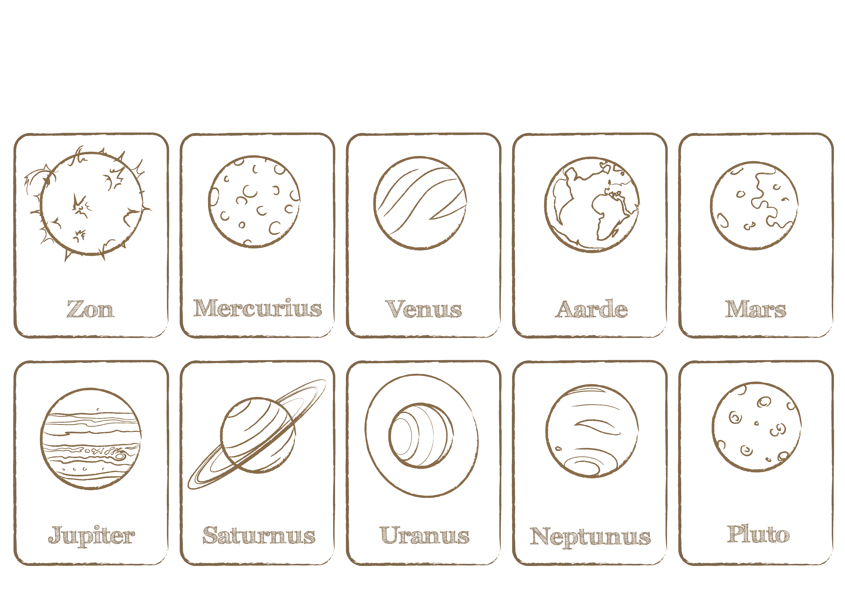

Planet Card
Game (Back)

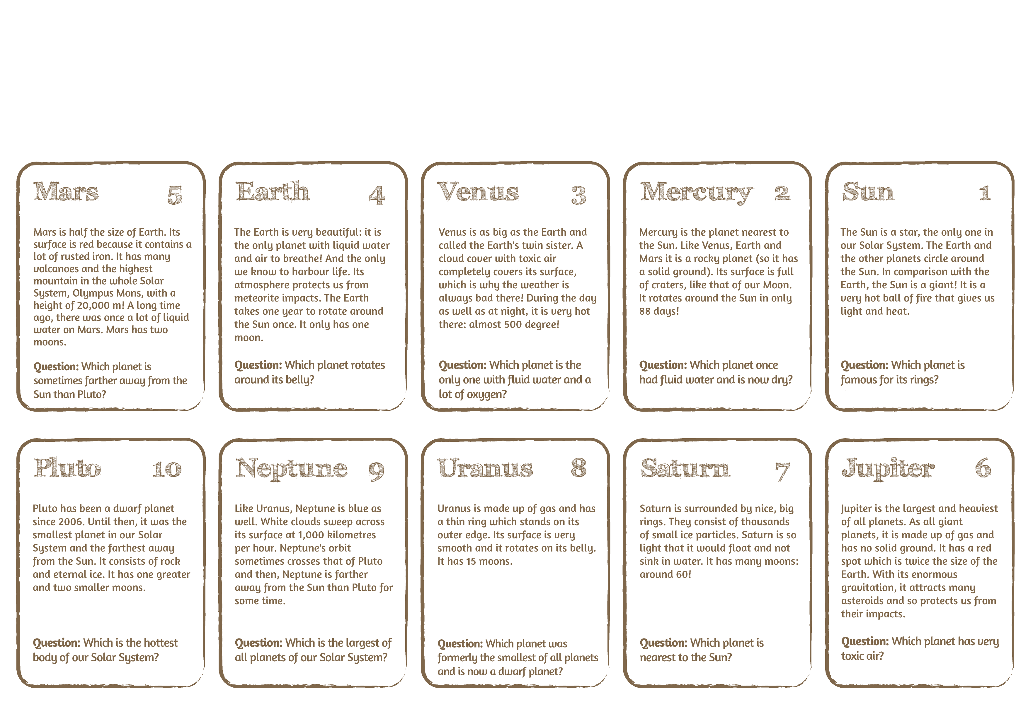

Signs of the Zodiac

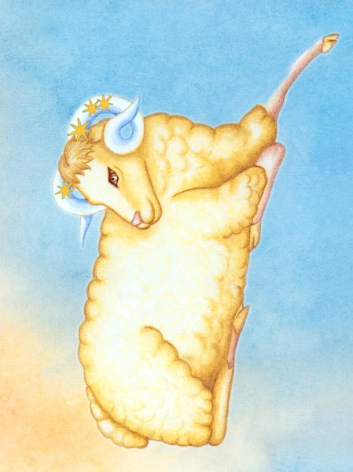 | 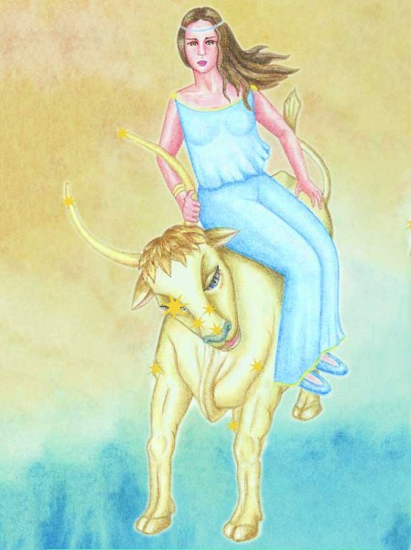 |  | 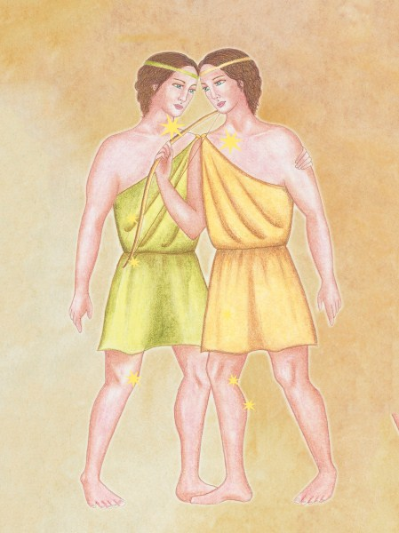
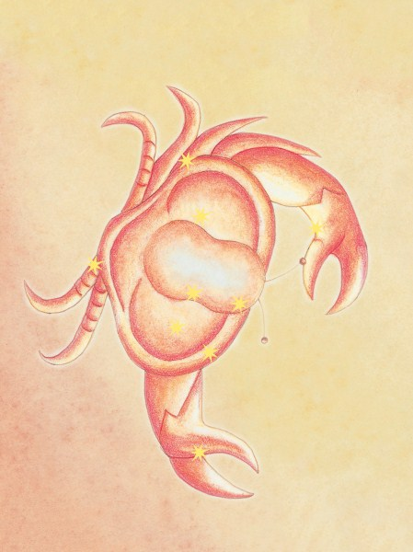 | 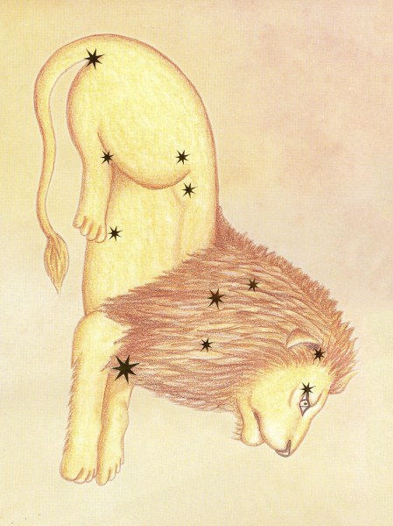 |  | 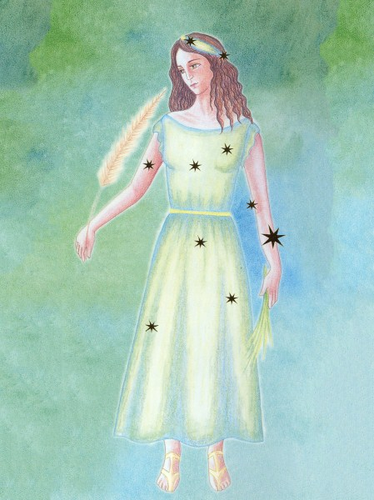
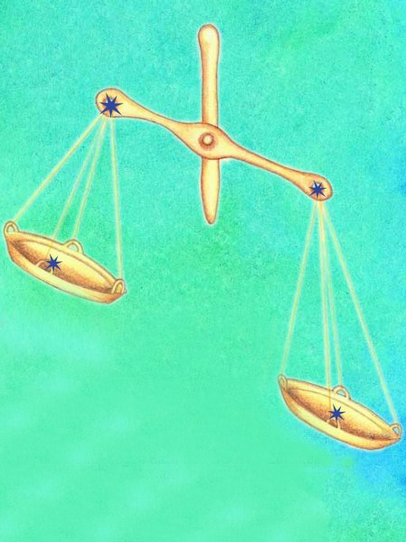 | 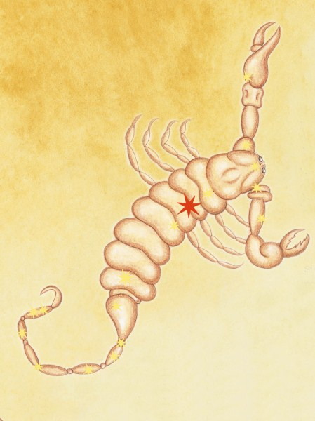 |  | 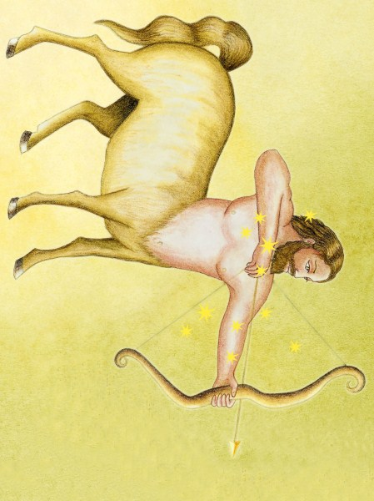
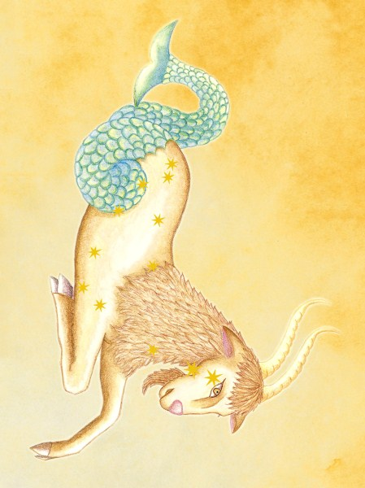 |  | 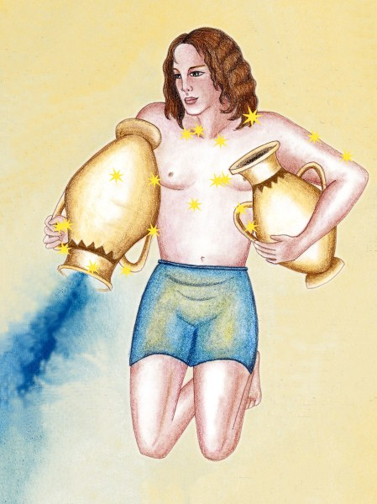 |  | 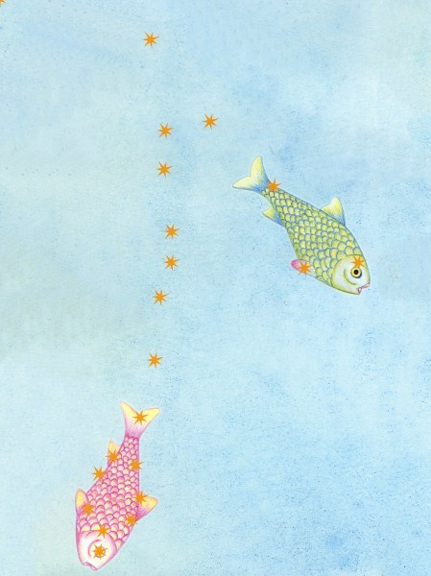

Credit: Cecilia Scorza

Planisphere:
Northern Hemisphere
Star Map

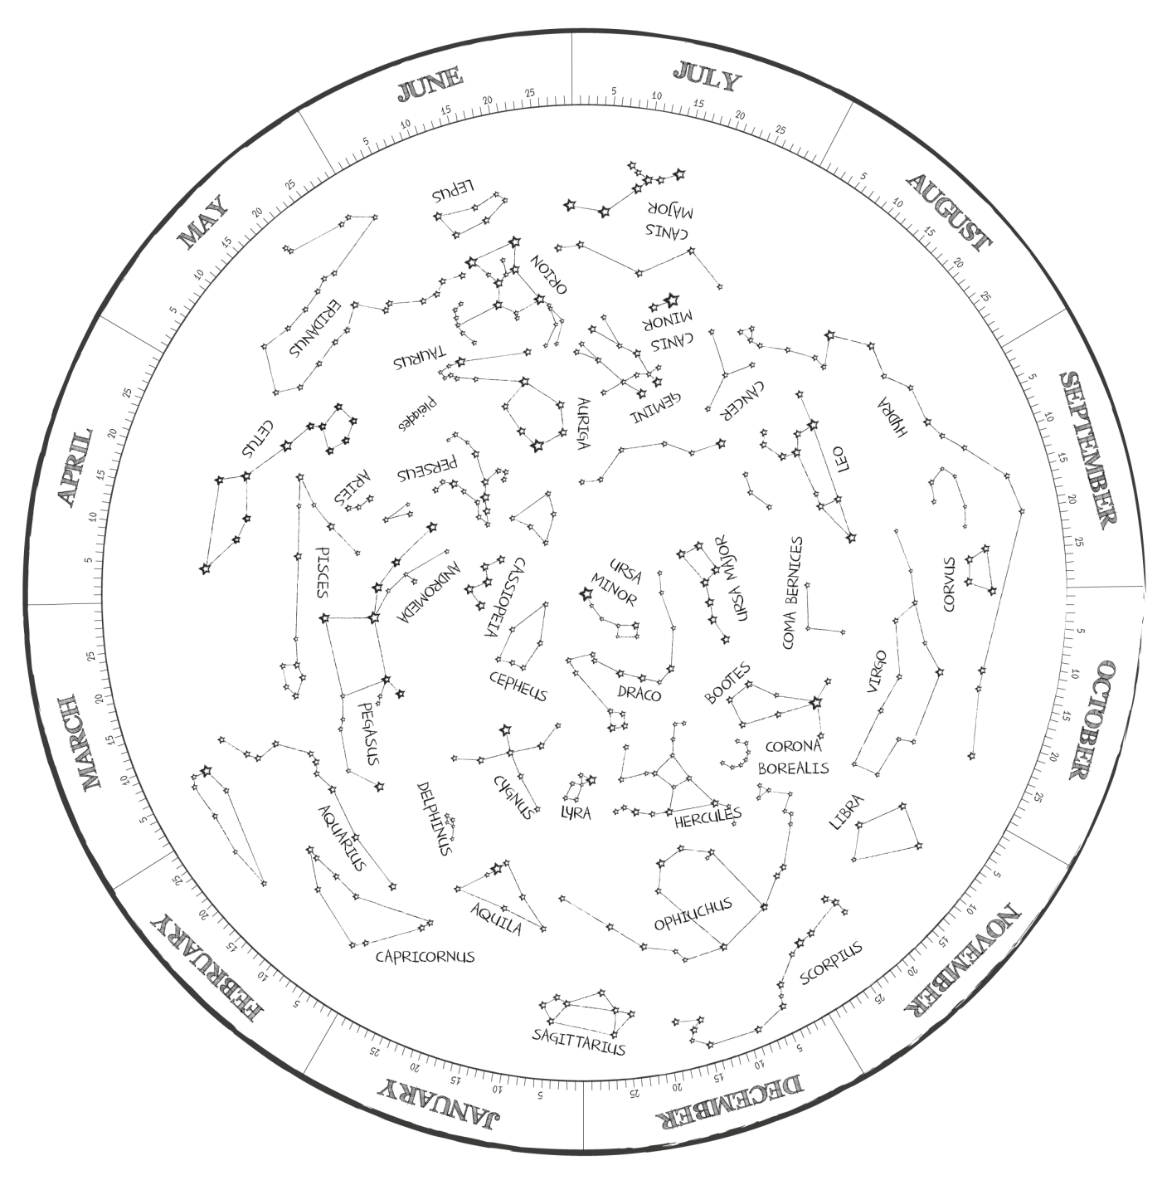

Planisphere:
Northern Hemisphere
Cover (Germany)

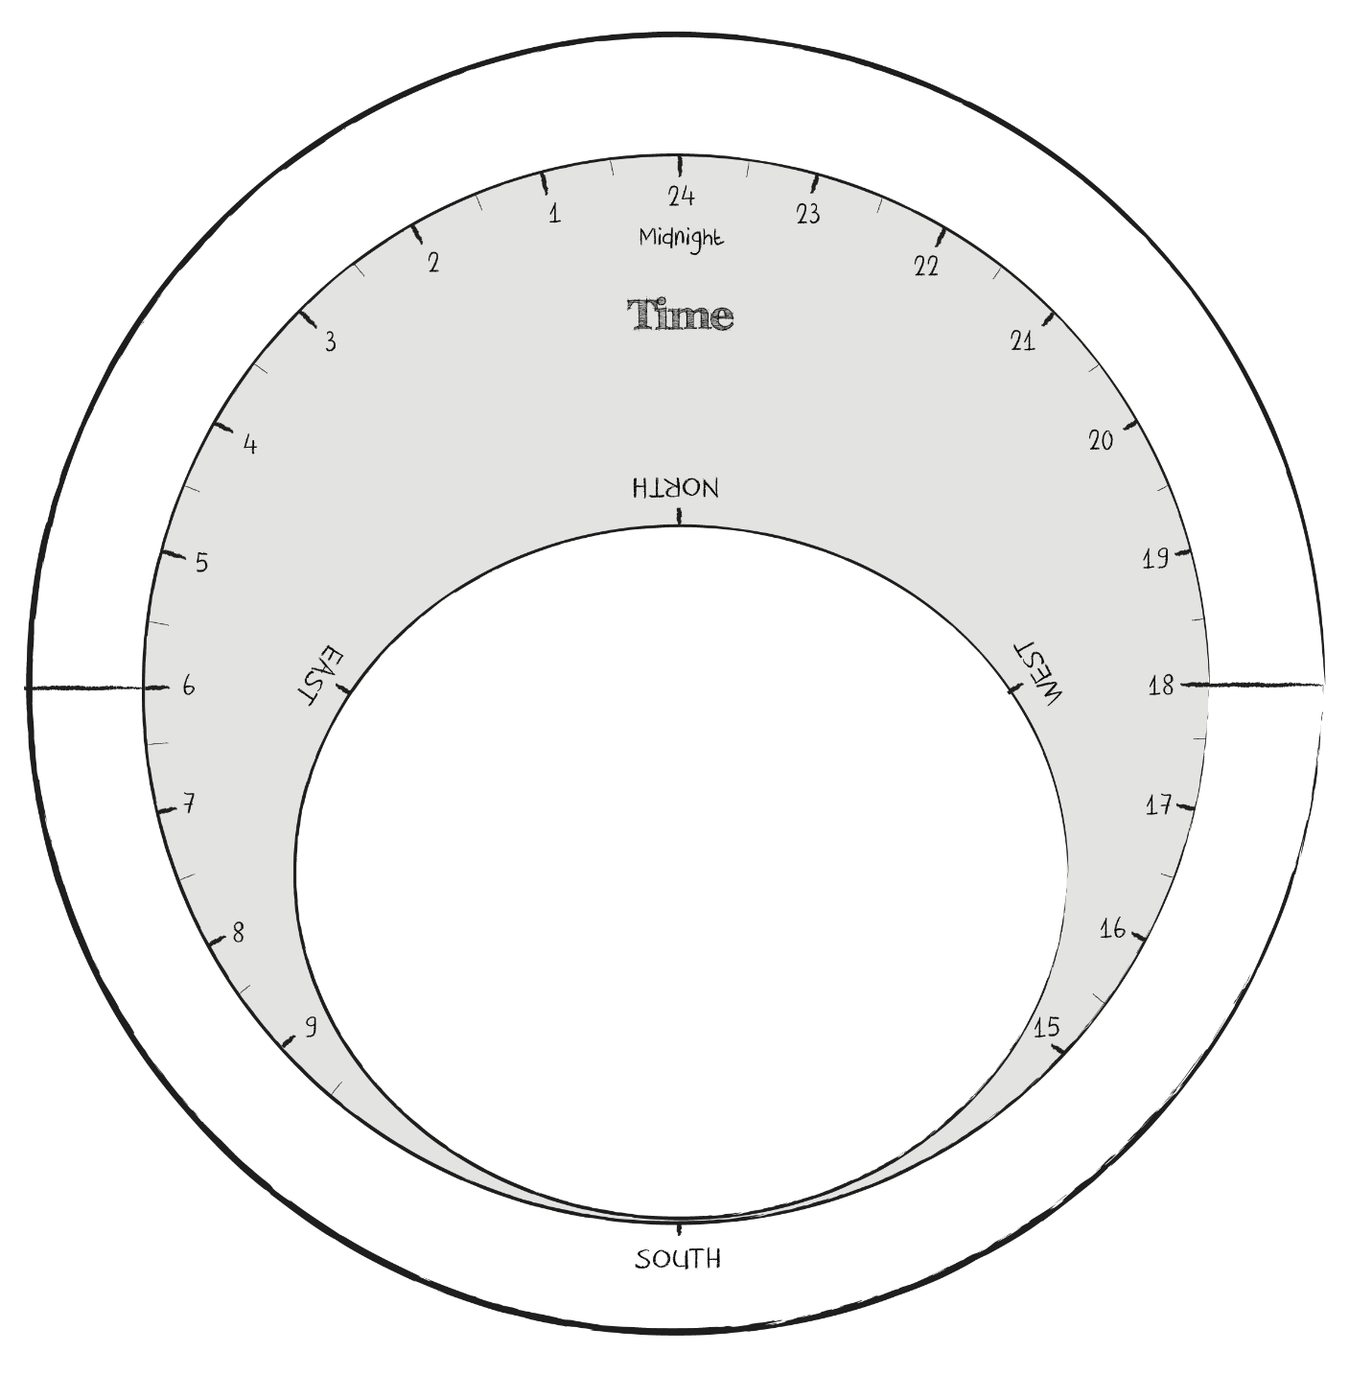

Planisphere:
Southern Hemisphere
Star Map

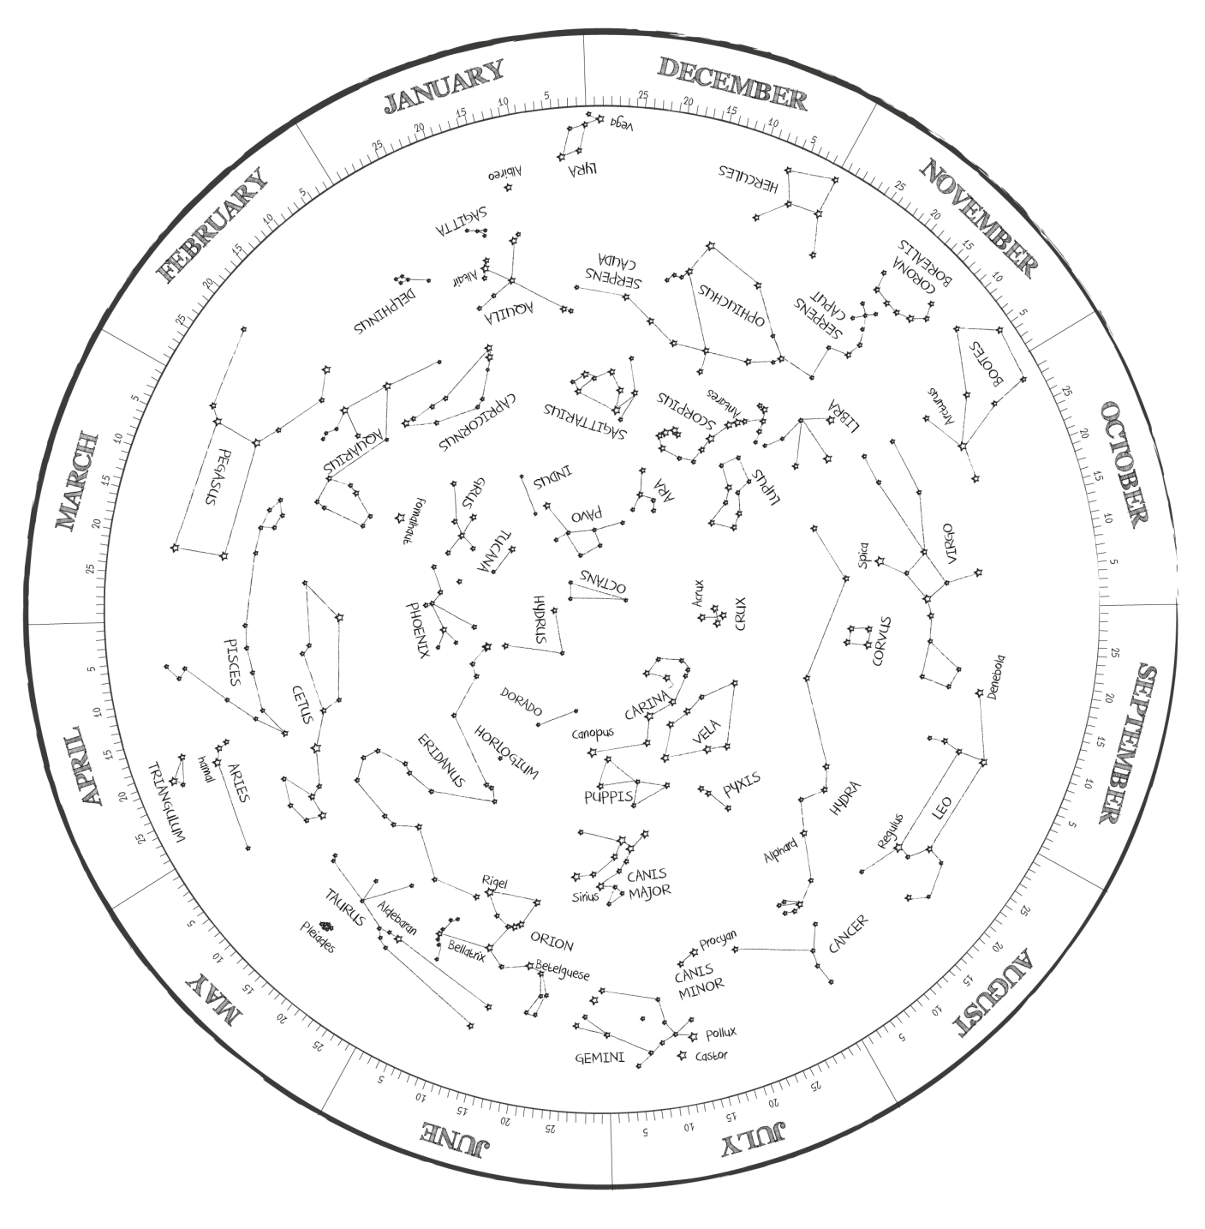

Planisphere:
Southern Hemisphere
Cover (Brazil)

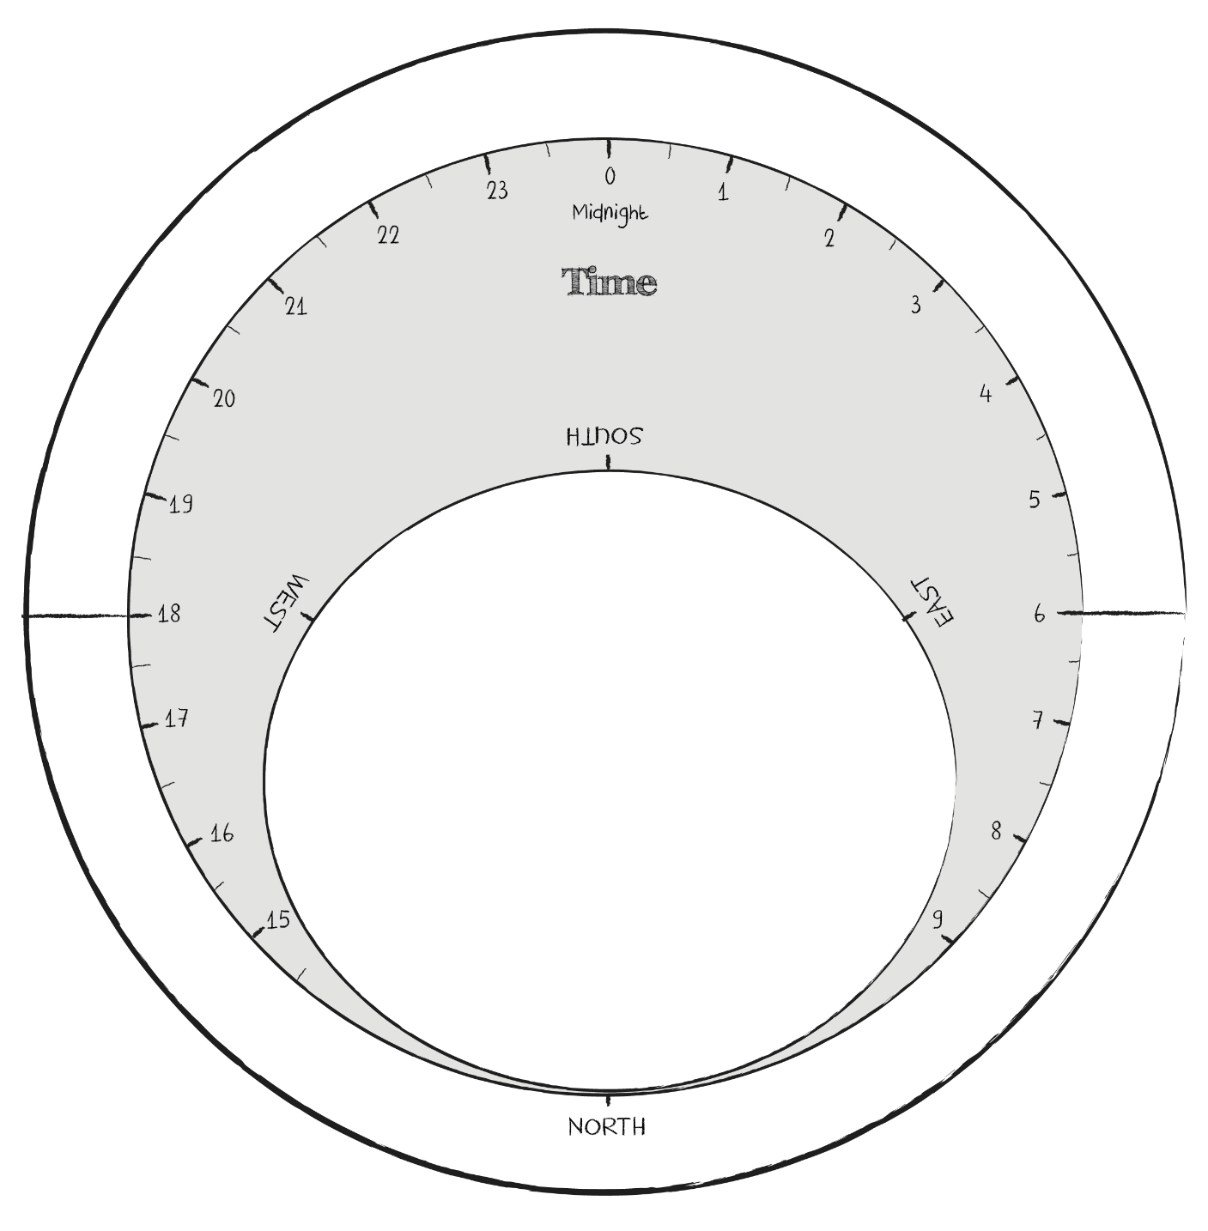

Constellation Stories

What the Greeks saw such a long time ago is immensely important for us, because most constellations used in modern astronomy for orientation in the sky are of Greek origin.

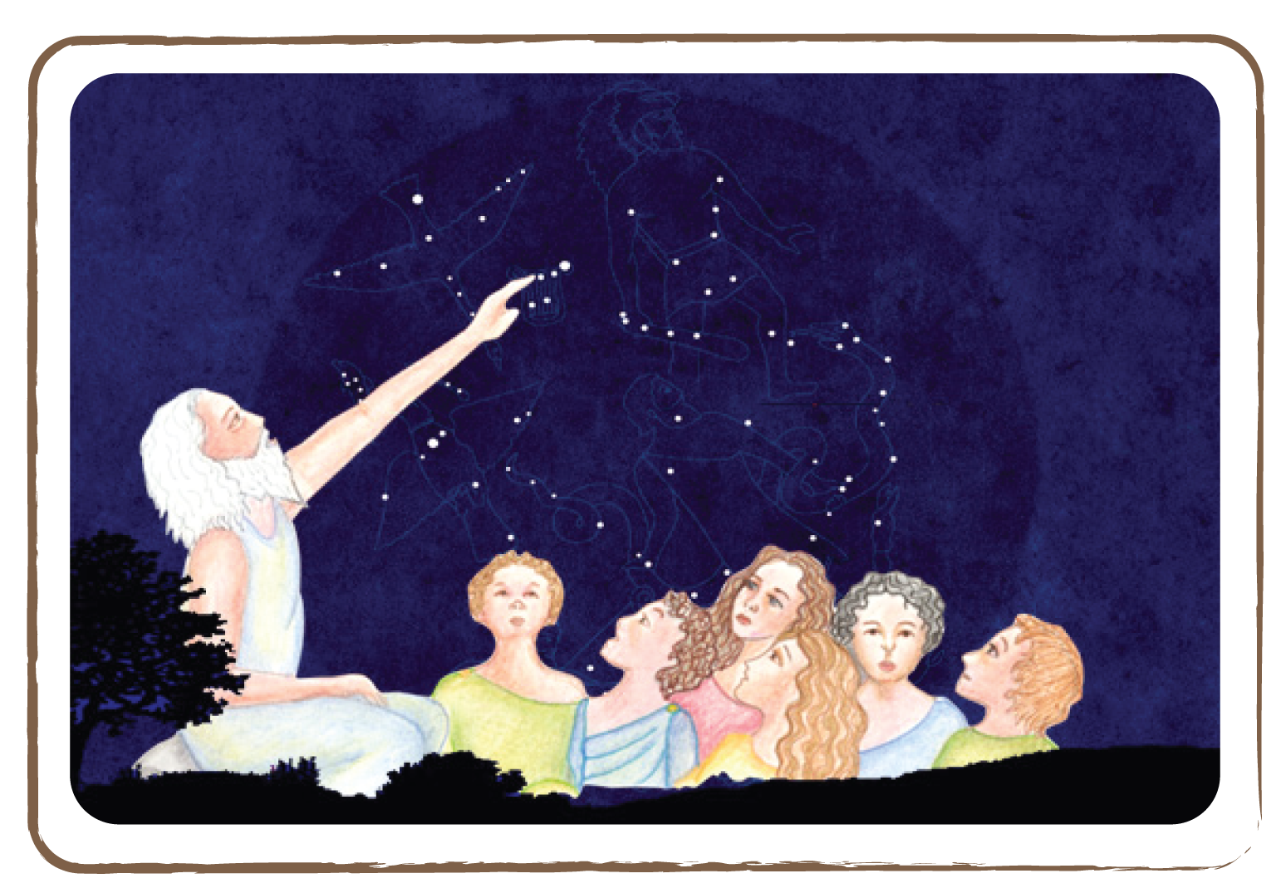

Back then, 3,500 years ago, people sat outside in the evenings and listened to the stories that old men and women told about the starry sky. So, children and adults learned the stories of the constellations Greater Bear, Hercules, Cygnus and Aquila.

As the Earth orbits the Sun, different constellations are visible on the Earth’s night side in different seasons. Thus, those ancient peoples told the stories that were appropriate to their current season.
We have summarised some of these stories on the following pages (from the book C. Scorza: Wie der große Bär an den Himmel kam).

The Great Bear (Spring)

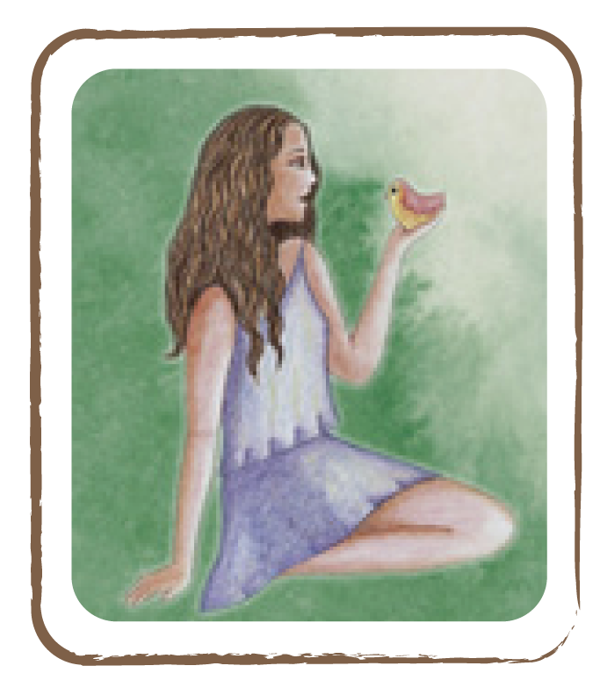
Callisto was a beautiful nymph, who happily spent her days near a well in the forest. One day she encountered Artemis, the goddess of the hunt, amongst her companions. Callisto was so enchanted by the beauty of the goddess that she asked Artemis if she could accompany her. ‘You are welcome to come along with us. But you will have to not to talk to anyone but me and my friends,’ Artemis answered.

Full of joy, Callisto agreed and joined the singing and dancing crowd. One day, Callisto became lost alone in the forest. When Zeus, the highest of all gods, noticed the beautiful nymph, he immediately fell in love with her. In order to get near her, the cunning god assumed the shape of Artemis. And indeed, the nymph initially assumed that he was the beloved goddess and cordially greeted the alleged friend. When Zeus returned her embrace, Callisto saw through his foul play, but the god would not be rejected. And so it went that the nymph was expecting a child some time after.

Although Callisto had broken her promise without being guilty, she feared being rejected by Artemis. She hid deep in the forest, where she fed on fruits and berries. After the tenth full moon, she gave birth to a son, whom she called Arkas. Hera, the spouse of Zeus, had observed her husband and the beautiful nymph. Full of jealousy, she plotted revenge.

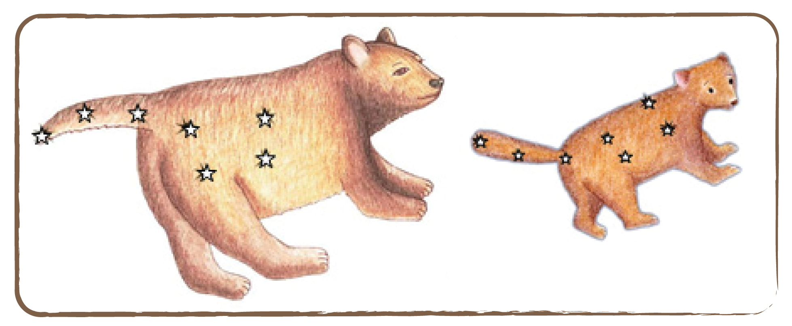

After the child’s birth, she searched Callisto out in the forest and transformed her into a great bear. From then on, poor Callisto strayed around lonely through the forests. She did not join the wild bears because she was frightened of them, but she was also scared of the hunters and their dogs. Most of all, however, she was saddened by the fact that she could no longer look after Arkas.

Two women who found the baby took him to them and raised him. Fifteen years passed and Arkas had grown up to be a stout lad. When one day he roamed through the forest with his hunting dogs, he met the great bear by a well. She had a cub by her side that she had borne in the meantime. Deep in her heart Callisto recognised her son Arkas. She slowly approached him.

But the lad, who did not sense anything about his origin and his mother’s destiny, feared the bear. He lunged out with his mace and was about to hit her — when omniscient Zeus prevented the misfortune. Full of compassion, he raised all of them together to the northern sky as constellations, where they have been seen ever after: Callisto and her cub as the Greater and the Little Bear, and her son Arkas, who circles the two bears as a herdsman with his two hunting dogs.

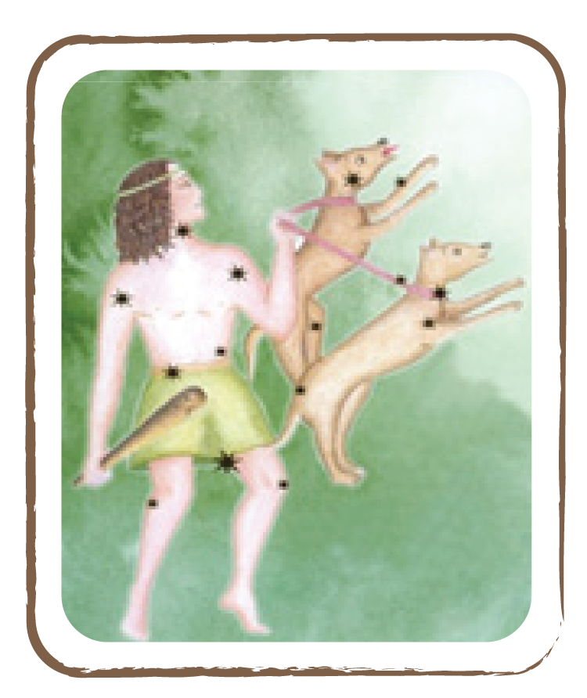

The Lyre (Summer)

A long time ago, there lived a famous singer named Arion. His chant was so magical that he was able to steer creeks and tame wild animals. On a long journey, his arts had earned him many treasures. But now he lingered after his home. So he boarded a ship in order to get back home. But once the coast was out of sight, the hungry and greedy seamen, who knew about the riches, surrounded and threatened the singer.

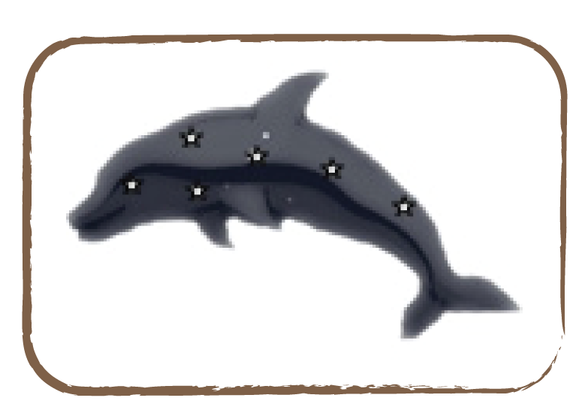

Their leader was already lunging out with his sword. ‘Halt immediately,’ Arion called out in fear of death. ‘Let me at least sing a last song.’ ‘Yes, a song, a song,’ the rogues hooted. They stepped back and Arion took his lyre. Hearing the song that he was now striking up, one felt one was hearing the valedictory chant of a dying swan. It so much fascinated the untrue seamen that they forgot their bad intentions for one moment.

The singer used their heedlessness and jumped into the sea. He feared he would drown. But as if by a miracle, he did not sink in the waves but soon found himself on the back of a dolphin, who had heard his sad song. Full of gratitude, the singer played his lyre. Even the sea quietly listened to his beautiful chant until the dolphin had safely brought Arion to the shore.

In memory of his arts and the miraculous salvation, the gods raised to the sky Arion’s lyre, a swan (as a symbol of his sad chant) and the dolphin, where they remained ever after.
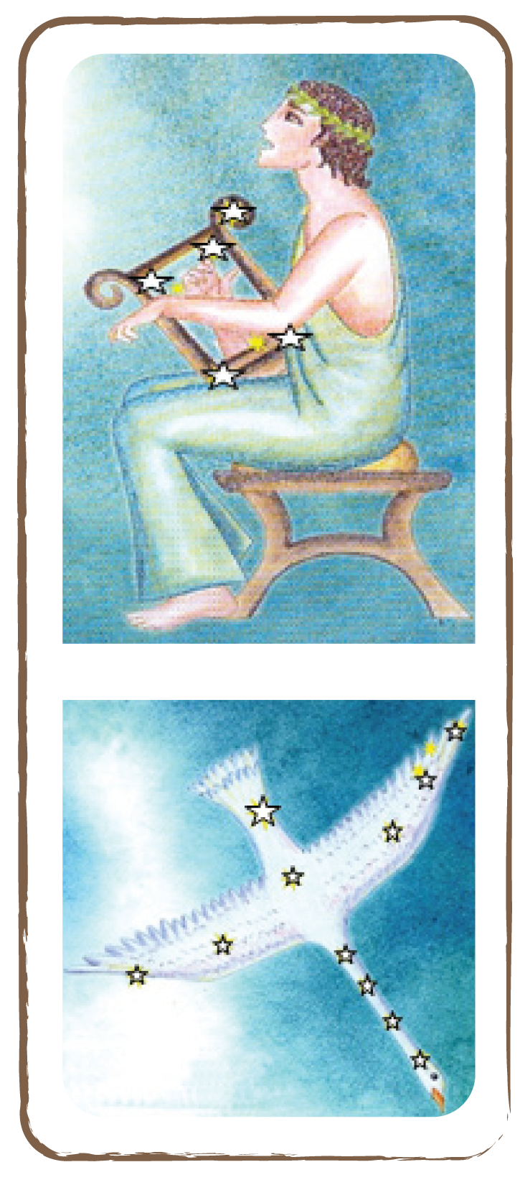

Ophiuchus - The Serpent Bearer (Summer)

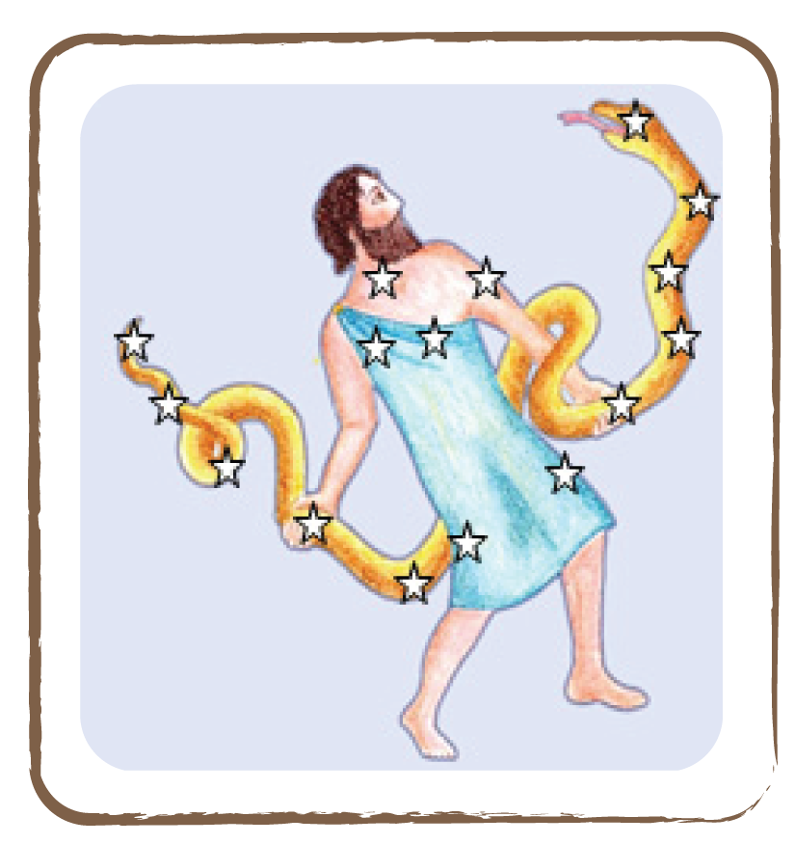

According to Greek mythology, the god Apollo once fell in love with the beautiful princess Koronis, who soon thereafter expected a child. When Apollo had to return to Delphi, he left the princess a white raven, who was to take care of her. Unluckily, Koronis fell in love with a stranger, which did not slip the attention of the raven. He flew to Apollo and brought him the bad news in hopes of a reward. Initially, Apollo was angry with the raven as the bringer of the bad word and turned his plumage into black. Since then, all ravens have black plumage and are known as hoodoos. In order to restore her brother’s honour, Apollo’s sister Artemis killed the princess with an arrow. When Koronis’s body lay on the stake, Apollo sympathised with the princess. He wrested the child that she was still bearing from the flames and handed it to the wise centaur Chiron. Asclepius, which was the name the father gave his child, learned the art of healing from Chiron and became a famous doctor. He could not only heal the sufferers but could even recall the dead to life. This command of life and death was the fate of Asclepius: because the gods could not bear his power, Zeus slew him with a deadly flash. To conciliate Apollo, he transferred Asclepius, who had also prepared healing elixirs with the help of snake poison, among the stars as a snake bearer.

Corona Borealis - The Northern Crown (Summer)

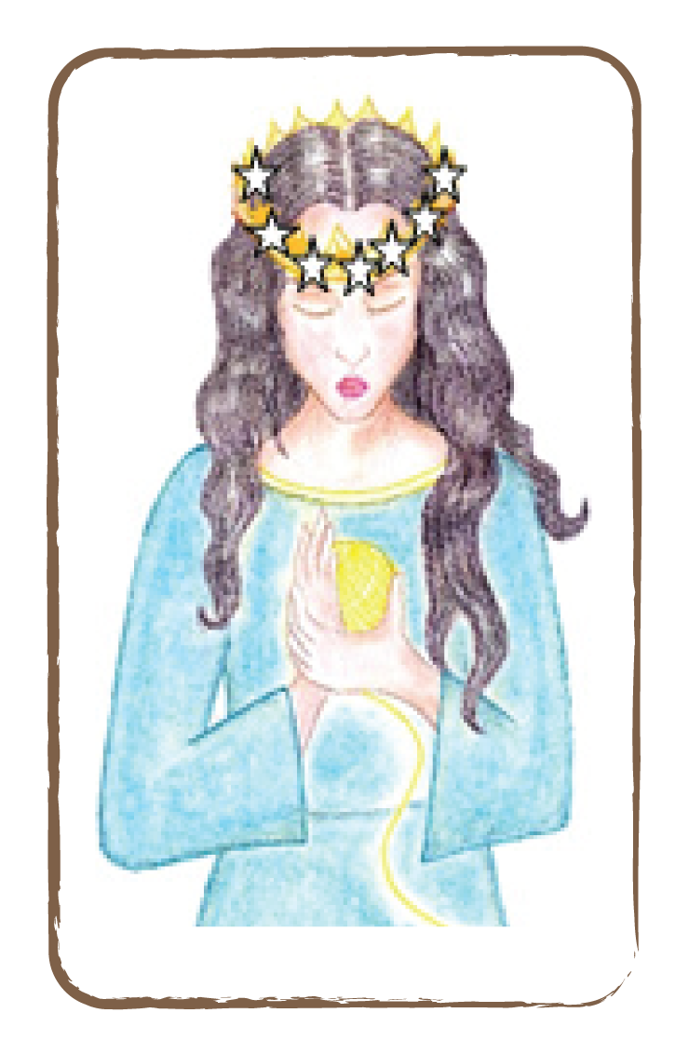

Once on the isle of Crete, there lived the Minotaur, a monster that was half human, half bull, lived in a maze and fed on human sacrifices. King Minos, the gruesome ruler of the island, had defeated the Athenians in a war. Thus, he demanded from the Athenians to deliver him seven of the most beautiful younglings and virgins, in order for them to be fed to the Minotaur.

Theseus, the son of the king of Athens, went to Crete voluntarily as one of these younglings, for he wanted to free the people from the beast. But so far, no man had been able to find to exit from the maze. When Theseus arrived to Crete, Ariadne, the beautiful daughter of king Minos, beheld him and readily fell in love with him.

In order to help Theseus, Ariadne secretly gave him a knot of golden thread. The king’s son bound fast the end of the thread to the entry of the maze. With the crown on his head and the sword in his hand, he faced the monster. The beast was so blinded by the bright gleam of the crown that Theseus could defeat it in a horrendous fight. Now he only had to follow the golden thread and so he found the way out of the maze.

After his return, Theseus took Ariadne to his ship. In appreciation of her help, he gave her his crown and promised to make her his wife. But on the way back, the goddess Athena appeared in his dream. She revealed to him that Ariadne had already been promised in marriage to Dionysus, god of wine. And so, Theseus left sleeping Ariadne on the island of Naxos, where she was soon to be married to Dionysus.

Hercules, Aquila - the Eagle - and Sagitta - the Arrow (Summer)

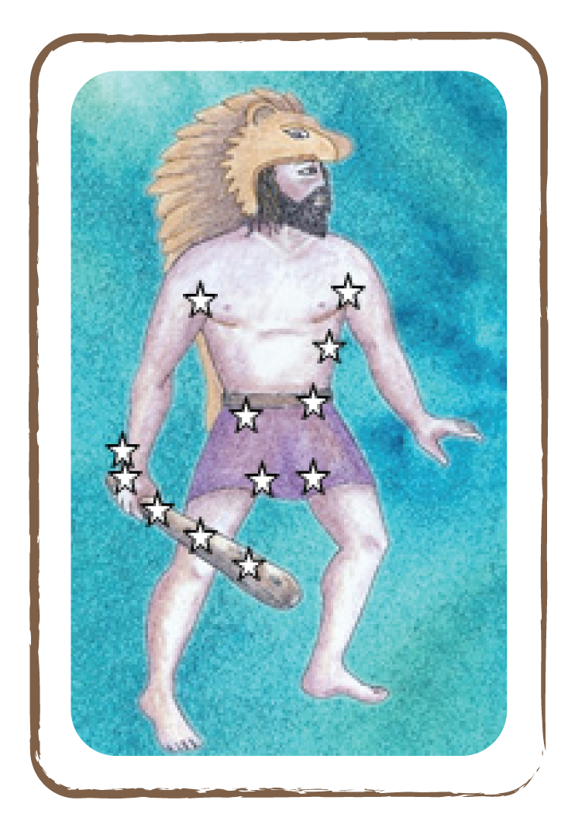

Hercules was a human son of god Zeus, who was to accomplish heroic deeds on Earth. His mother was queen Alkmene from Argolis. Zeus wished for the immortality of his son and thus instructed god Hermes to secretly put the child to sleeping Hera’s breast: the godly milk would make him immortal. But the little one nursed so strongly that the goddess awoke of a sudden pain and tore him from her breast. Thereby, her breast milk squirted over the sky — and so, the Milky Way was created! Time passed and Hercules grew up to be a strong man. One day, he learned from an oracle that the gods would afford him immortality if he could accomplish twelve difficult tasks for the harsh king Eurystheus of Mycenae.

His last task was to fetch the golden apples which grew in a sacred garden in the west. Four virgins, called the Hesperides, guarded the apples along with a terrible dragon who never slept. On his way there, Hercules met Prometheus. Zeus had caused him to be forged to a rock because he had once stolen the fire from the sky for the humans. Every day, an eagle came and picked at Prometheus’s liver.

Hercules killed the eagle with an arrow and relieved the tormented of his agony. Full of gratitude, Prometheus advised him: ‘Go to my brother Atlas, who carries the sky on his shoulders. He will help you to obtain the apples of the Hesperides.’ Soon after, Hercules found the giant Atlas and asked him to fetch the golden apples for him. Hercules offered to sustain the firmament in the meantime. Atlas agreed because he was glad to be relieved from the heavy burden. He euthanised the dragon by stratagem, took the apples from the Hesperides and returned with them to Hercules.
But now, Atlas did not want to carry the firmament on his shoulders any more. ‘Just hold it for a moment so I can recover,’ sly Hercules asked him then. The gullible giant agreed and Hercules could make a move with the golden apples. After having finished the last task, the gods admitted him in the circle of immortals.

Andromeda (Autumn)

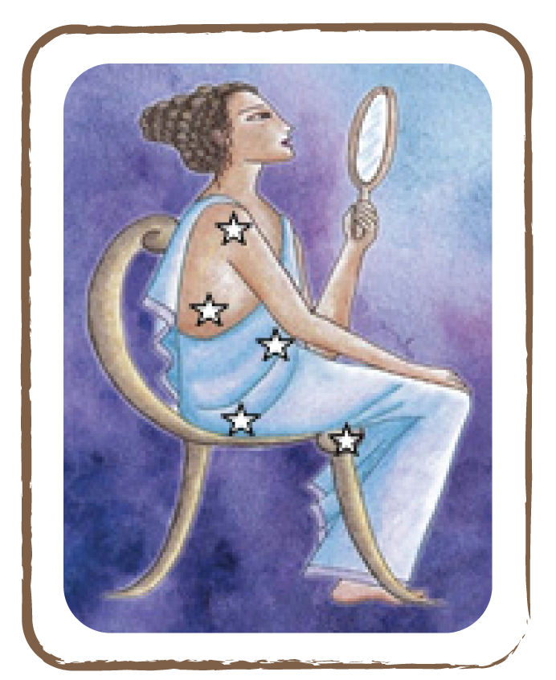
Once in Ethiopia, there lived a gorgeous queen called Cassiopeia, who was, however, very conceited. When she sat on the beach one day, she bragged of being even more beautiful than the mermaids. Their protector, sea god Poseidon, flew into such a violent rage over this that he threatened to flood all of Ethiopia.

Extremely concerned, Cassiopeia’s husband, king Cepheus, sent an envoy to the oracle; for he wanted to know how to appease the god. The oracle’s answer was gruesome; in order to evade the flood, their daughter, princess Andromeda, would have to be sacrificed to the sea monster Cetus.
The parents were desperate. But the brave princess was ready to do what the oracle demanded. For her, the misfortune of her country was more terrible than her own agony. And so, on the same day she was forged to a rock by the sea in front of the people.

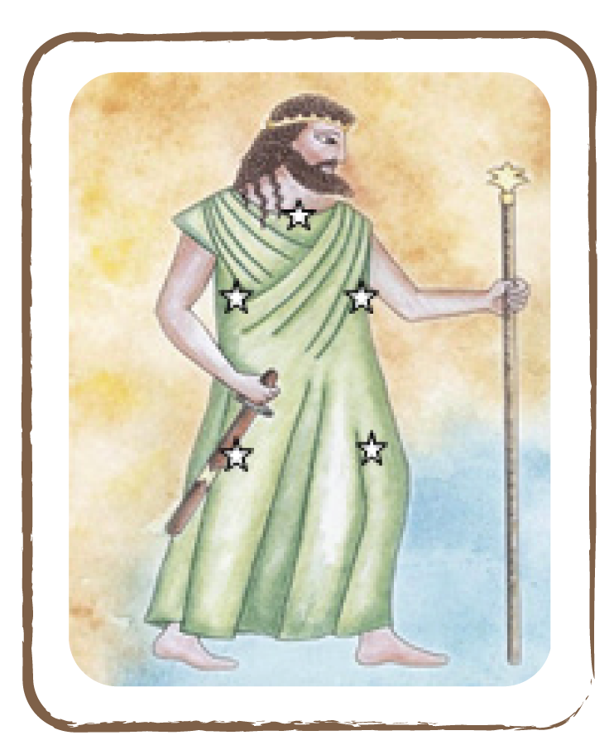

While the rays of the setting sun painted the sky reddish, Perseus appeared among the clouds on his flying horse Pegasus. The hero was on his way back home; he carried with him the head of horrible Medusa, the sight of which petrified people. As he saw the wonderful Andromeda below him at the cliff, he first considered her to be a lifeless statue.

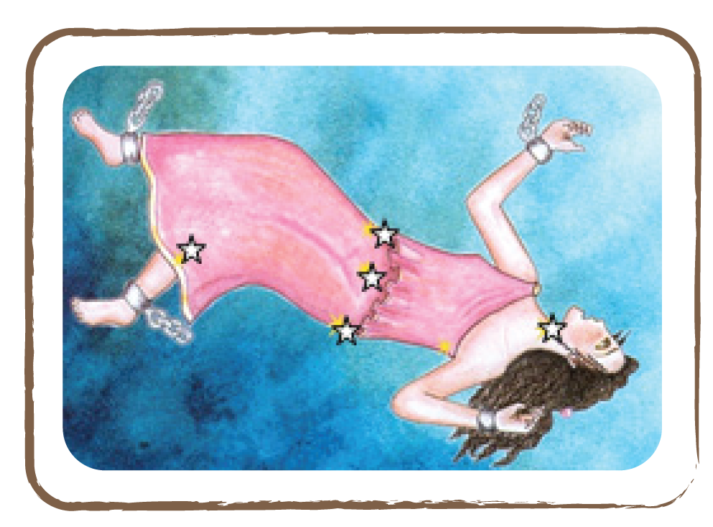

But the wind ruffled through her hair and tears ran from her eyes. Mystified by her beauty, Perseus flew down and asked her: ‘Who are you and what fate chains you to this rock?’ ‘I am Andromeda,’ she replied through her tears, ‘the daughter of king Cepheus. As punishment for my mother’s pride, I am to be sacrificed to a sea monster.’

The poor princess had just spoken these words when an outcry went through the people. From the depth of the sea, Cetus appeared, so suddenly that even the fish tried to flee from the water. The princess feared for her life. Desperate, the parents clung to her shackled daughter.

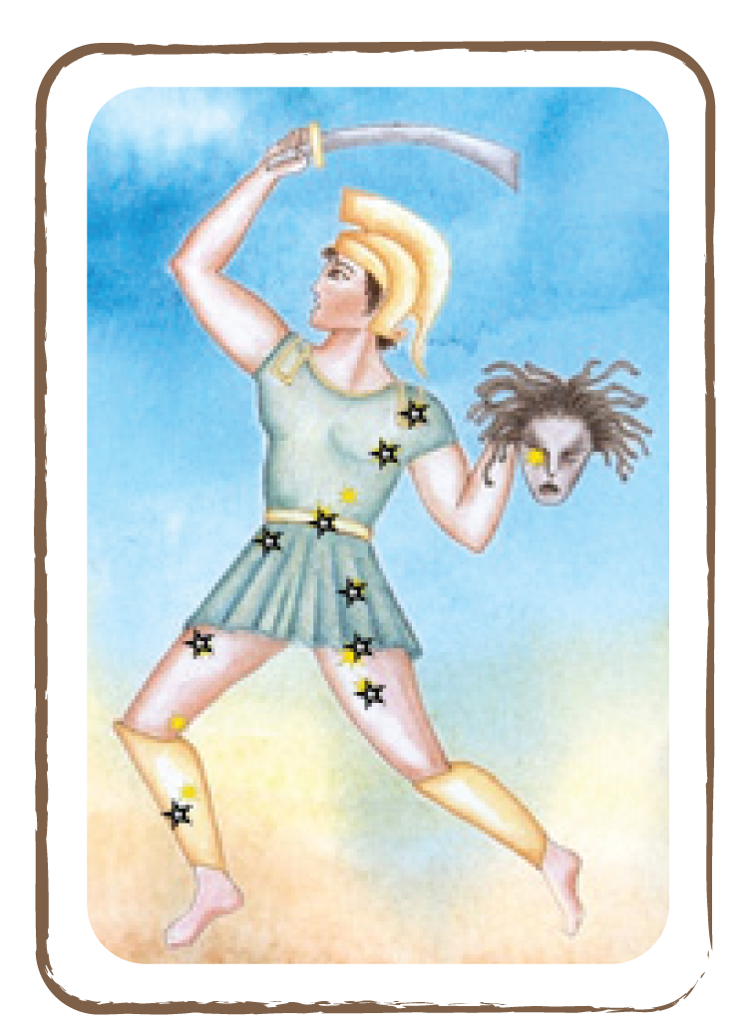

Determined, the hero took to the air. The beast already wanted to devour Andromeda, when Perseus descended rapidly like an eagle and stabbed his sword into the back of the monster. Wild with pain and fury, it fought back but Perseus did not cease until it sank dead into the waves.

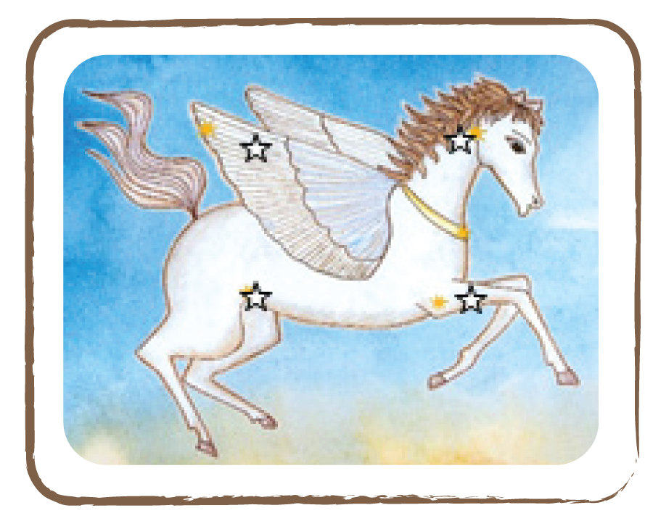

Perseus released Andromeda from her shackles and brought her to the royal palace. As thanks for saving his daughter, Cepheus allowed him to marry Andromeda. After their marriage, Perseus and Andromeda lived together happily for many years until their deaths. Cassiopeia lived as a very modest woman in those years.

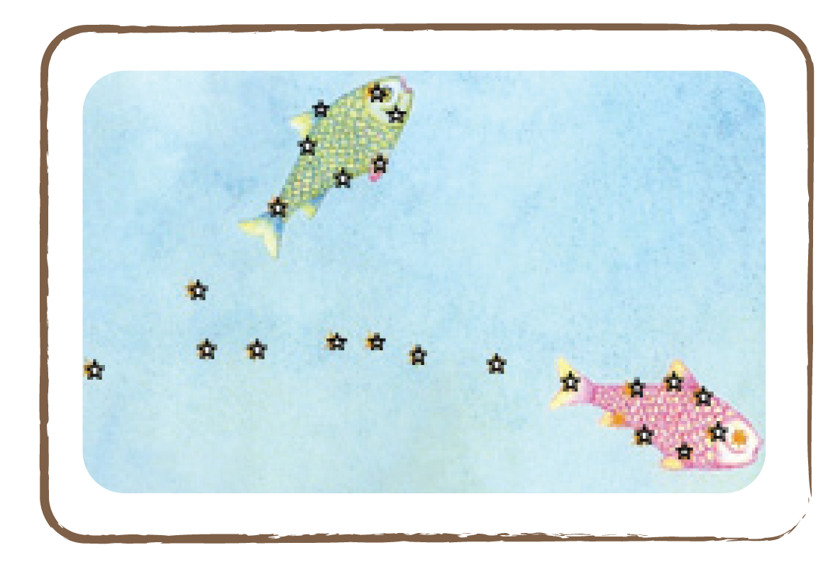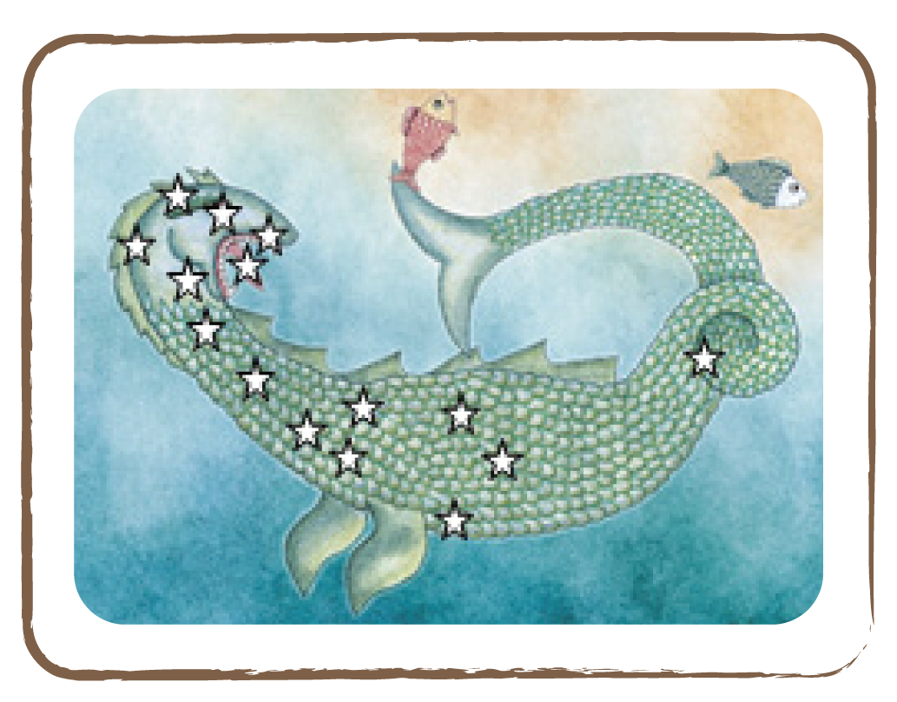

Orion (Winter)

Once there lived a beautiful and fearless hunter named Orion. One day, when he was hunting in the forests on the isle of Chios, he met the wonderful Merope. Orion fell in love with her and wanted to marry her. Her father promised to agree to the marriage, but before Orion was to kill all the dangerous animals of the island.

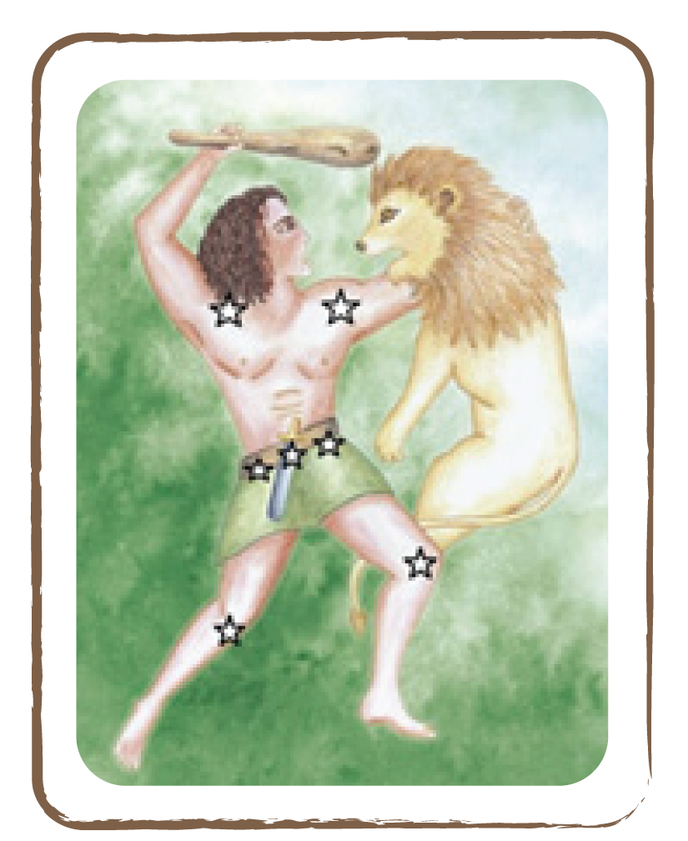

Orion immediately left. His two hunting dogs, a greater one and a smaller one, joined him. But instead of helping him with the hunt, the cheeky dogs ran jauntily after a rabbit. All by himself, Orion slew bears, wolves and many other wild animals. Only a huge bull escaped and hid deep in the forest.

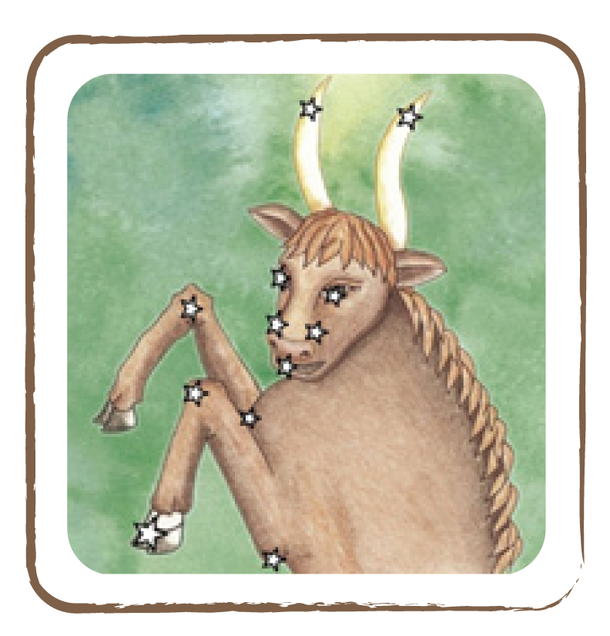

After the successful hunt, he asked Merope’s father for the promised spouse. The father, however, declined because he could still hear the roaring of the wild bull at night. Upset, Orion left the island. In his boundless rage, he swore to kill all the animals on Earth.

This, in turn, incited earth goddess Gaia so much that she sicced a huge scorpion on Orion. Fearlessly, the hunter attacked the dangerous animal, but his furious sword thrusts recoiled: the scorpion’s shell was harder than iron. Orion’s only choice was to flee. He ran as fast as he could, but the scorpion came closer and closer.
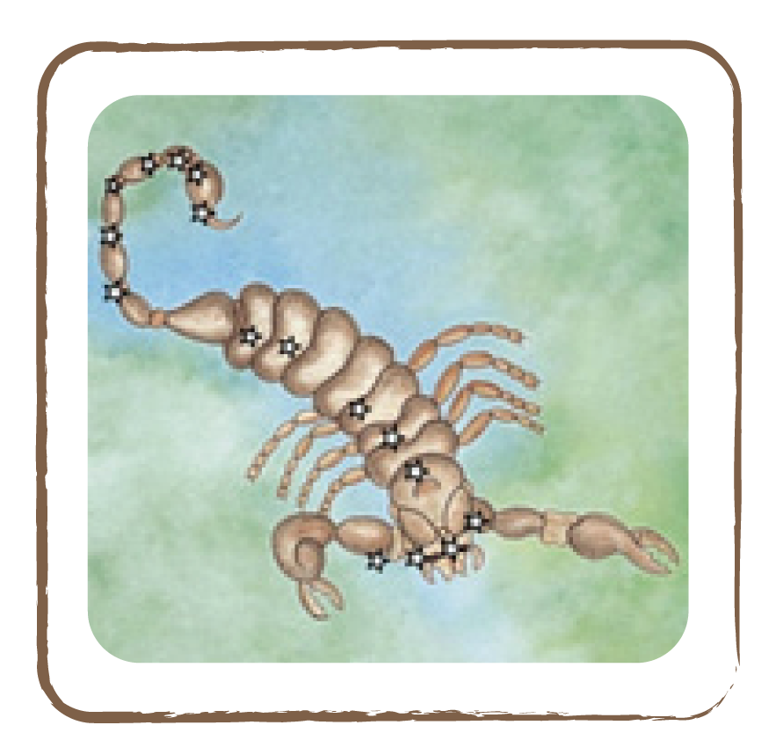
The scorpion had already threatened the hunter with his sting when Artemis, goddess of hunt, transformed Orion into a constellation and thus saved him from the beast. Today, Orion is seen on the winter sky, along with the greater and the smaller dog, a rabbit and the wild bull. Even now, the terrible scorpion chases him, but at a safe distance as a summer constellation. Therefore, Orion and Scorpius are never visible at the same time.

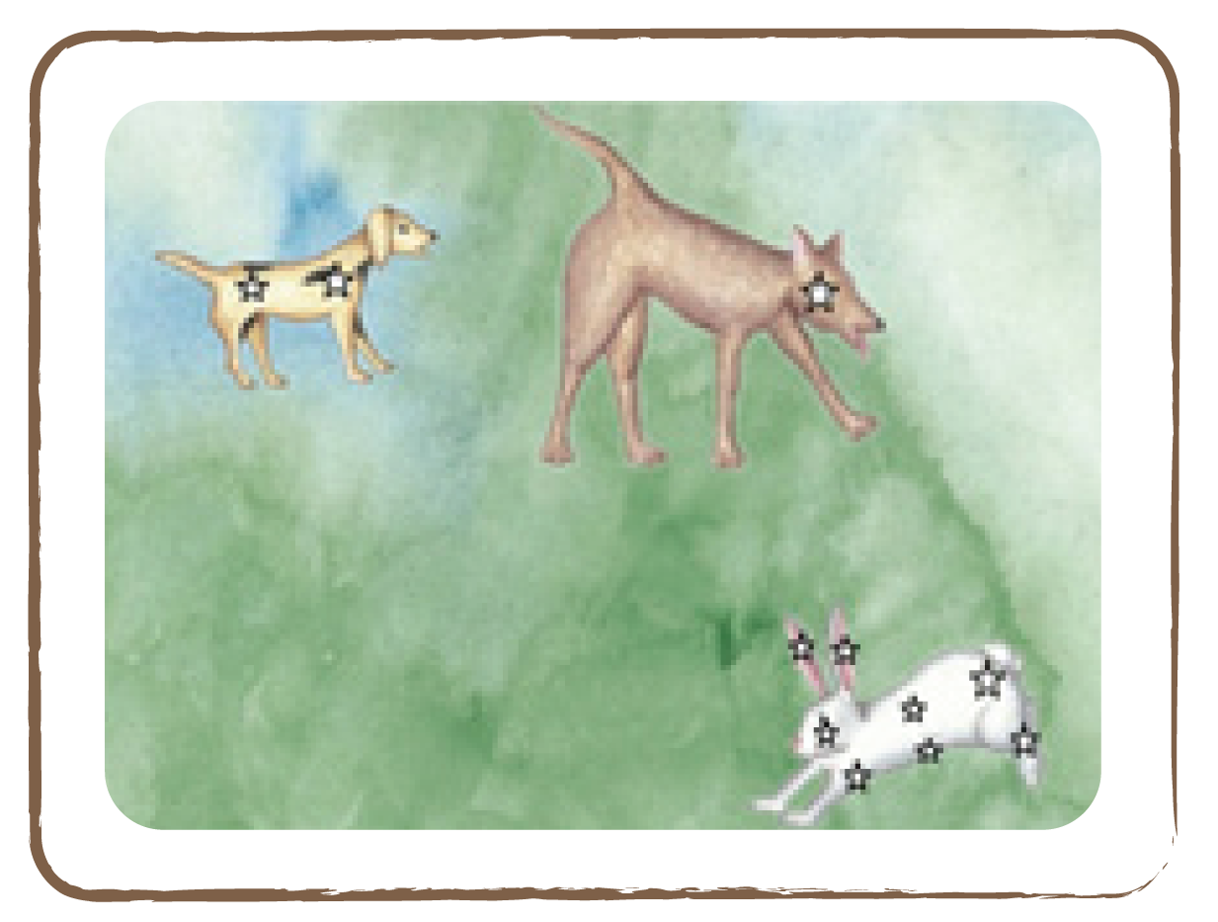

Credit: All illustrations in this section are made by Cecilia Scorza

Character figures used throughout the activities

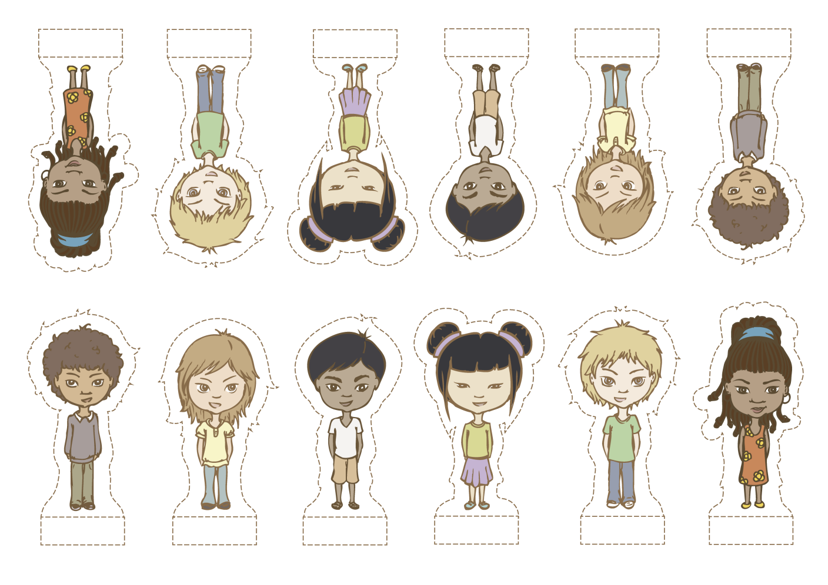

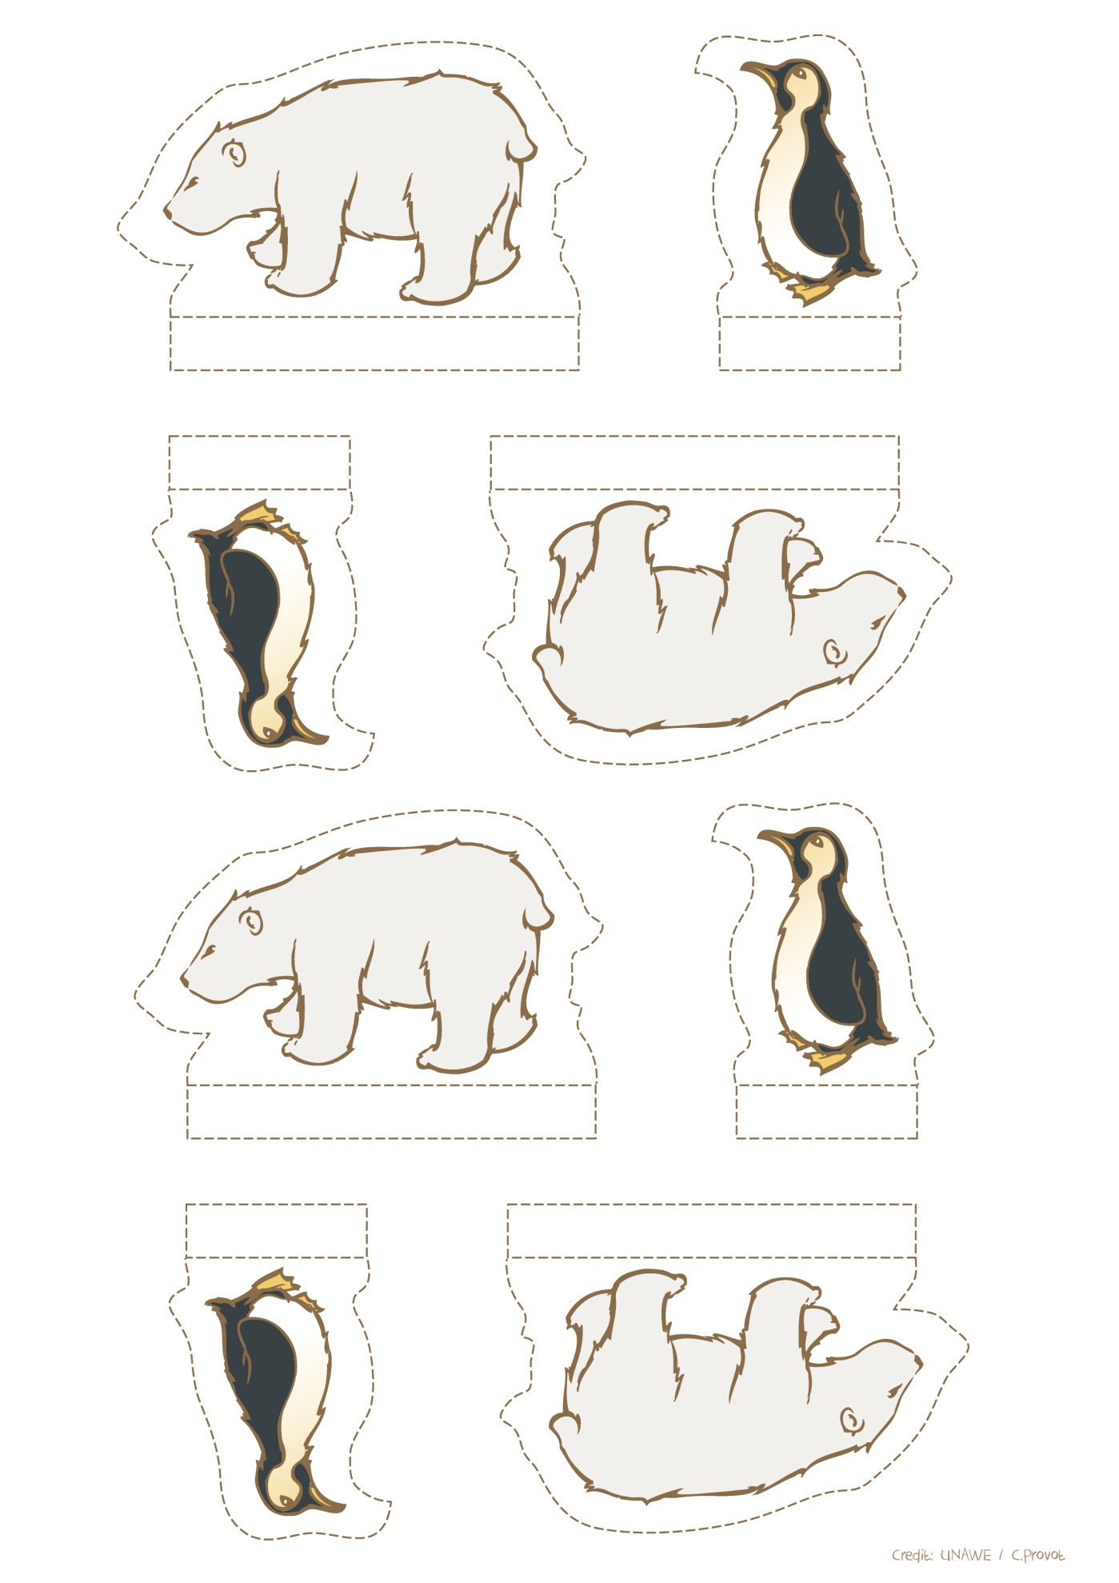

Credit: UNAWE / C.Provot

